Chapter 10: The Leaning Ivory Tower

I arrived at Amherst Massachusetts in August 1966, and enrolled at the department of Exercise Sciences working toward my degree of M.S. in Exercise Sciences which I completed in one year in May, 1967, and submitted my Thesis which was published in the well respected Journal, Ergonomics. This Journal is distributed worldwide.
In 1969, I was enrolled in the Doctoral program at the Exercise Sciences department at the University of Massachusetts and was introduced to the field of Biomechanics. I was studying and teaching. Also, I was publishing more than anyone in the department, and was by all counts a very good student.
While I was a student in the department, I started my own company with my girlfriend Ann at the time and my wife at the present. The company name was and is: Computerized Biomechanical Analysis Inc. (CBA). The company still exist today and was profitable every year from its inception. Regardless to any economical situation up and down, our CBA company always was profitable. We have never had a lost year. All the years from 1969 until 2011 are profitable. So, by all means, the University achieved its goal with us. They thought us, prepare us and made us successful over the years. What else a University could expect from their students.
In 1972, I received my Ph.D. as the first student in the Department of Exercise Sciences. Then I registered as a student of Computer Sciences, at the department of Computer Sciences pursuing another Ph.D. degree in Computer Sciences. In 1975, I received a Post Doctoral in Computer Sciences.
In 1973 I was appointed as an Assistant Professor to the Department of Exercise Sciences. And, I was teaching two courses in the graduate program in addition to research in the field which resulted in number of publications.
However, all these accomplishment had to suffer many consequences while I was a student and a professor in the University. My success in my profession in Academia and my success as a businessman and Inventor, caused big problems among two of my professors. Especially my Professor and Mentor in Physiology Dr. Ricci and my Professor and Mentor in Biomechanics, Dr. Plagenhoef. Both professors turned against me and tried to destroy me in any way they could.
While being still a student, one day, Dr. Ricci, my advisor called me to his office and made a comment that I need to be careful mixing my school with business. I have told him that I do not see any problem since them, the professors supposed to teach me to be a successful in life, and the fact that I am using what they thought me to start a successful company, should not conflict with academia. He did not agree and told me to think about it which I agreed.
Leaving the meeting with Dr. Ricci really upset me. What the hell he is thinking? What he wants me to be? To be another professor that teaches other students to be professors that teaches their students to be professors? What the hell the purpose of higher education? I was aware that in other department such in Chemistry, to seek grants from business was a common practice. In fact the department of Chemistry could not exist without the support from outside business grants. I realize that my professors in the Computer Sciences Department, large part of their salary was deriving from grants that came from the outside of the University. So, what is the problem in starting a business while I am a student?
So, while I was teaching in the department I decided to publish an article thinking of what will happen in 2001 year. What will be the objects of teaching at that year. At the time it was 1973. I was working on this article which was published in the research Quarterly Journal:
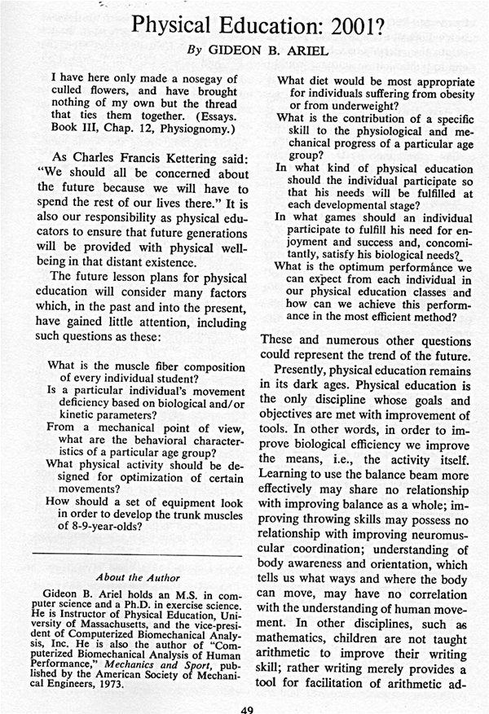
In this article I predicted the teaching objectives of the next millennium. The content is still realistic today.
Professor Ricci called Ann my girlfriend of then and my wife of today to his office in 1972. He explains her that her friend Gideon is playing with fire by extending his knowledge to the outside World especially to the business World. Ann had to leave the meeting with tears but this not for all what she heard about me with business involvement. She was hurt by one statement that Professor Ricci made to her: “Ann you know, your boyfriend is Jewish.” She answered him that she knows and asked him what is wrong with that? There was no comment. She left crying his office.
When Ann met me this day and told me about this comment I got very upset. However, this did not stop me from continuing working in my Company as well as in the University. Running at least 10 projects simultaneously while getting my students involve in a real projects associated with Movement and require knowledge of computer programming and applications. My students loved it.
I would come to the first class in the semester and make the following statements:
“Good morning and welcome to the Logic of Movement class. You all received A in the class. You do not need to attend any of the classes. I should not care if you are coming here or not, since I already received my Ph.D. degree. And I am not going to teach you anything. You are going to teach me allot. In this process you will learn more than in any course you ever took in your life and you will never have another course in your life where you will have so much fun to learn by doing a real down to earth projects with leading companies in the World.”
As far as I know, I do not think I lost one student in my teaching career and students would not miss classes. They were great students and we produced hundreds of studies and research to companies such as Spalding, Wilson Sporting Goods, NASA, US Olympic Committee, Kimberly Clark, Chevron, Uniroyal, and many more. All my students found great jobs when they graduated from the University and many of them at those companies.
I know, I was different. I was not the usual professor. I loved my job and loved my projects and loved our progress. I was hired just because I was different. Dr. Campney, the head of the department that hired me admitted, that even though he is not approve of “in breading” situation where you hire your own student. In my case it was a different story. Here is a quotation from one of the letters Dr. Campney send to the graduate school:
‘We are most interested in Gideon Ariel’s ability, his work, and his potential for contributing to a better understanding of how man moves. For example,k I am attempting to secure a position on our faculty for Gideon for the 1974-75 academic year. However, there are a few obstacles in my way at the moment.”
One of the obstacle was a suit issued by Dr. Ricci against me claiming that I have used University funds to run projects out of the University.
For that, the Department of Exercise Sciences was instructed by the Dean of the Graduate School, Dr. Glucstern to evaluate my position. Here what they came with:
“Based upon our elective faculty workload assignment scheme, Professor Ariel was assigned a 1-1-1 relative distribution profile among the Teaching-Research-Service categories. The assigned nature of his workload was because he was on a one-half time appointment in the Department of Exercise Science. His second half was in the Department of Computer Sciences.
In the area of teaching, Professor Ariel carried 6.0 student contact hours; his grade distributions were high; his student evaluations were superior.
In the area of research, Professor Ariel had two refereed publications and several non-refereed professional articles. His involvement with research and professional presentation was extensive. I personally heard two of his professional presentations and felt they were well received. “
The above evaluation was made by Dr. Edington, the head of the Department of Exercise Science.
So, with this evaluation I had to carry a lawsuit by Professor Ricci and backed up by Professor Plagenhoef, both of my professors. I had to hire an attorney. His name was David Burres, and he was protecting me for the next 3 years of lawsuits that were finished and others were started.
Being a student at the Computer Sciences department I was taking few courses from Professor Worgrin. Dr. Wogrin was head of the computer science school. Being his student I received an unlimited grant for use of the Main Frame at the school. This was a huge Main Frame made by Control Data, and cost the University some 12 Millions Dollars. The way you got to use the computer is by getting a grant. The CPU time for each minute was $400. This really was some virtual number that no one was paying but it was for accounting purposes and some control of use. A minute CPU is not the connection time, it is the use for yourself the whole 12 Millions Computer for that minute. The following is one of these bills that I received each month:
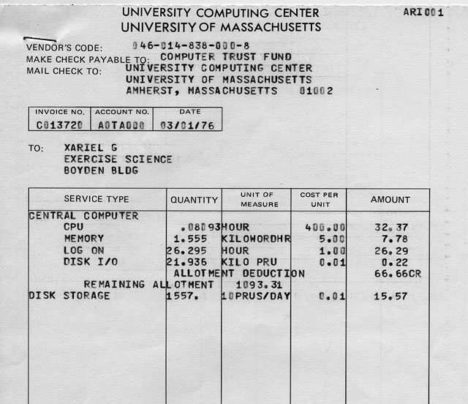
Typical Monthly Bill
One of the claims in Dr. Ricci lawsuit was that I used over 10 Millions of Dollars in Computer time that was belong to the University. Dr. Ricci knew at the time that all the use of the computer was given to me by Dr. Worgrin the head of the computer Sciences with the knowledge that I am using the computer for my own private research and company. When you using the computer, the use of the CPU does not affect any other users. Plus Dr. Wogrin was proud of my work.
Well, the day in court arrive and I was present with my attorney in the District Court of North Hampton. The Judge listen to the arguments of the attorney from the University representing Dr. Ricci and to my attorney and he concluded that: “If Dr. Ariel owe Royalties to the University, than, the University owe royalties to Isaac Newton; Case dismissed.”
People were clapping their hand and were very happy for me. However, what bother me is that Dr. Ricci and Dr. Plagenhoef did not come to court. They did not have the guts to see me beating them.
So, I confronted Dr. Ricci at the department and told him what I am thinking about him, which I will not repeat here. This immediately caused Dr. Ricci to file another lawsuit against me and the next statement by me to the court, which was handled again in North Hampton a year later.
STATEMENT BY Gideon Ariel
Three years ago, Dr. Ricci-initiated a law suit against ne. Since that time, he has been actively engaged in sending letters and memos, blocking my reappointment as a professor at the University of Massachusetts by not Abstaining when the Vote was taken despite his obvious negative involvement with me, and repeatedly was quoted in the press as having "new evidence" which would appear in the court case.
Finally, however, after 3 years of delays, the case was to be heard in court. Mr. Ricci insisted at the pre-trial conference that he was not interested in an out-of-court settlement. However, at 10 O'clock the night before the trial, while I was returning on the red-eye special from a presentation in Florida specifically to be in court the next morning, Mr. Ricci decided that now was the time to settle! The next morning, when the case- was presented to the judge, neither Mr. Ricci nor his attorney were present. Following the dismissal in the court, I went to Boyden Gymnasium at the University to tell all my friends that the whole affair had been dissolved. I was quite happy and wanted everyone to know that I. had been right all along.
Surprisingly, I saw Mr. Ricci in the⁻corridor of the building, and proceeded to ask him why he had not been in court. His response was "what court?".
then followed him down the hall and, in a voice loud enough for others to hear, told him that the judge had been embarrassed at his failure to appear and that he did not even respect his own constitution. At no time did I touch him, threaten him, or in any • way hinder. or block his way.
Signed under the penalties of perjury
Gideon B. Ariel, Ph.D.
Well, during all this time the newspapers of Amherst did not stop to print the scandals in the department. I am going to include only few of them here:
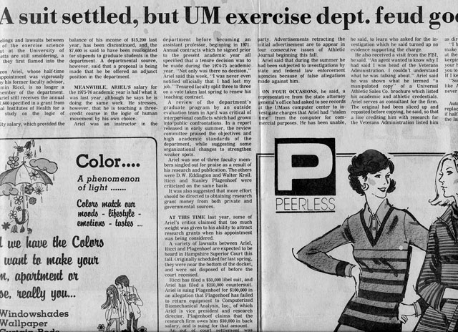

Some of the text:

Bitter feelings and lawsuits between members of the exercise science department at the University of Massachusetts are still smoldering, a year after they first flamed into the open Dr. Gideon Ariel, whose half-time teaching appointment was vigorously protested by his former faculty advisor, Dr. Benjamin Ricci.

Ariel was one of three faculty members singled out for praise as a result of is research and publication. The others ;ere D.W. Eddington and Walter Kroll. ticci and Stanley Plagenhoef were criticized on the same basis. It was also suggested that more effort should be directed to obtaining research rant money from both private and governmental sources.

This lawsuits caused the department to seek outside evaluation. And now the big scandal for the department started. Here came the headline:
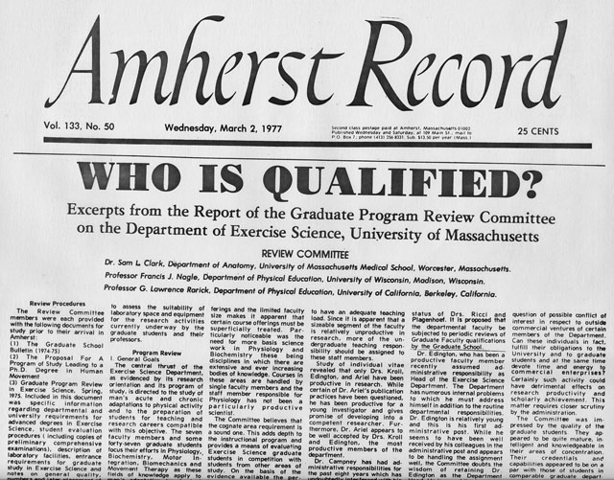

The department had to seek outside committee from other schools around the country to evaluate the department. And this what they came with:
___________________________________________________________________________
Particularly noticeable was the need for more basis science work in Physiology and Biochemistry these being disciplines in which there are extensive and
ever increasing bodies of knowledge. Courses in these areas are handled by
single faculty members and the staff member responsible for Physiology has not
_ .
been a particularly productive scientist.
The budget provided for laboratory equipment and supplies, while modest does constitute a clear asset and one not commonly provided. There is a need
for the Exercise Science staff to pursue more vigorously outside governmental
and private funds for research support. The evidence indicates that to date __—
only three faculty members have engaged in such efforts. A research oriented staff (graduate faculty) should be expected to seek outside funding to support their research.
Study of individual vitae revealed that only Drs. Kroll, Edington, and
Ariel have been productive in research. While certain of Dr. Ariel's pub,
lication practices have been questioned, he has been productive for a young investigator and gives promise of developing into a competent researcher. Furthermore, Dr. Ariel appears to be well accepted by Drs. Kroll and Edington, the most productive members of the department.
The publication record of neither Dr. Ricci nor Dr. Plagenholf is impressive. Their research output is not at a level expected of those holding graduate faculty status. According to the information provided to the Committee Dr. Ricci is currently directing no Ph.D. research. Dr. Plagenholf has directed one Ph.D. dissertation and is presently directing
a second dissertation. Judging from Dr. Plagenholf`s vita the Committee has some conc^{e}rn for the quality of his research since so little of his work has appeared in refereed journals.
In view of the above the Committee has some question regarding the graduate faculty status of Drs. Ricci and Plagenhoif. It is proposed that the departmental faculty he subjected to periodic reviews of Graduate Faculty qualifications by the Graduate School...
____________________________________________________________________________
I could not believe how good these evaluation was for me. God was on my side. These two professors that went against me got punished beyond belief. But, they did not give up. Now they joint forces with another crazy Man that tried to destroy me. This was Arthur Jones from Nautilus and I will get into this subject in the next Chapter.

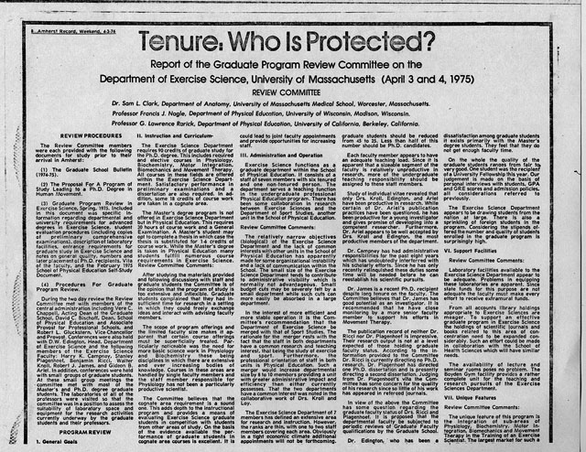
In 2006, the amazing thing happened. The Department of Exercise Sciences, which at that time their name change to the Department of Kinesiology selected me to be the selected Graduate Student Achievement Award.
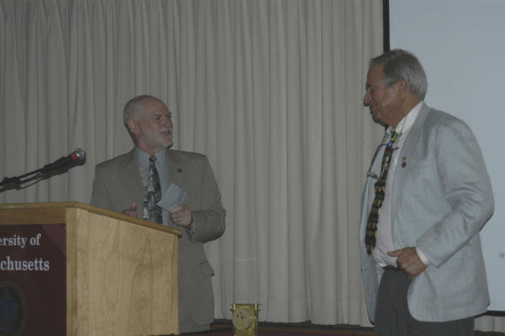
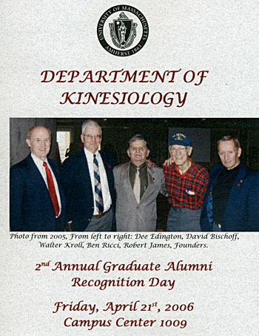
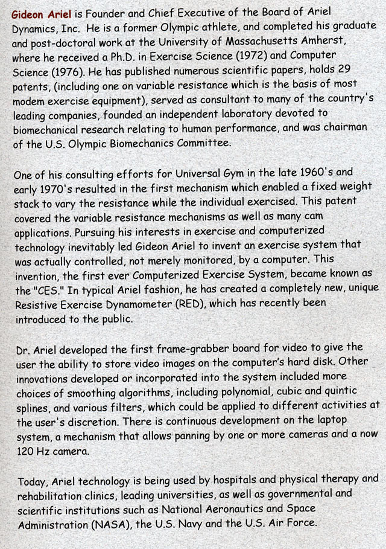
I started my presentation as follows:
“It is an honor for me to receive this award for my accomplishment and being a student in the Exercise Sciences Department. Unfortunately, you had to wait for two faculties to die before you invited me to this ceremony……But I am so please to have this phase of life complete. It is a really honor for me to present in this occasion.”

