Chapter 16: The NASA Connections

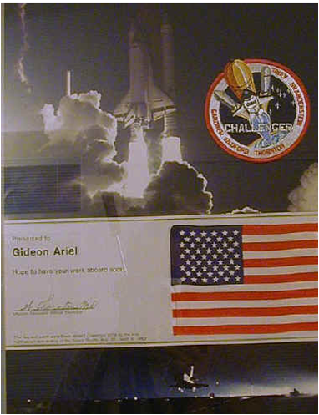 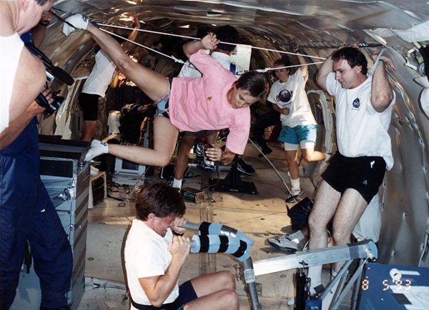
Present from Astronaut Thornton The Ariel Exercise Machine on the KC-135 0-Gravity flight
My first association with NASA was when I met Captain James Lovell. Captain Lovell was selected as an Astronaut by NASA in September 1962. He has since served as backup pilot for the Gemini 4 flight and backup Commander for the Gemini 9 flight, as well as backup Commander to Neil Armstrong for the Apollo 11 lunar landing mission.
On December 4, 1965, he and Frank Borman were launched into space on the history-making Gemini 7 mission. The flight lasted 330 hours and 35 minutes and included the first rendezvous of two manned maneuverable spacecraft.
The Gemini 12 mission, commanded by Lovell with Pilot Edwin Aldrin, began on November 11, 1966. This 4-day, 59-revolution flight brought the Gemini program to a successful close. Lovell served as Command Module Pilot and Navigator on the epic six-day journey of Apollo 8 - man's maiden voyage to the moon - December 21-27, 1968. Apollo 8 was the first manned spacecraft to be lifted into near-earth orbit by a 7-1/2 million pound thrust Saturn V launch vehicle; and Lovell and fellow crewmen, Frank Borman and William A. Anders, became the first humans to leave the Earth's gravitational influence.
He completed his fourth mission as Spacecraft Commander of the Apollo 13 flight, April 11-17, 1970, and became the first man to journey twice to the moon.
I have met Captain James Lovell while serving with him on the Scientific Committee of the Health and Tennis Corporation of America in 1973.
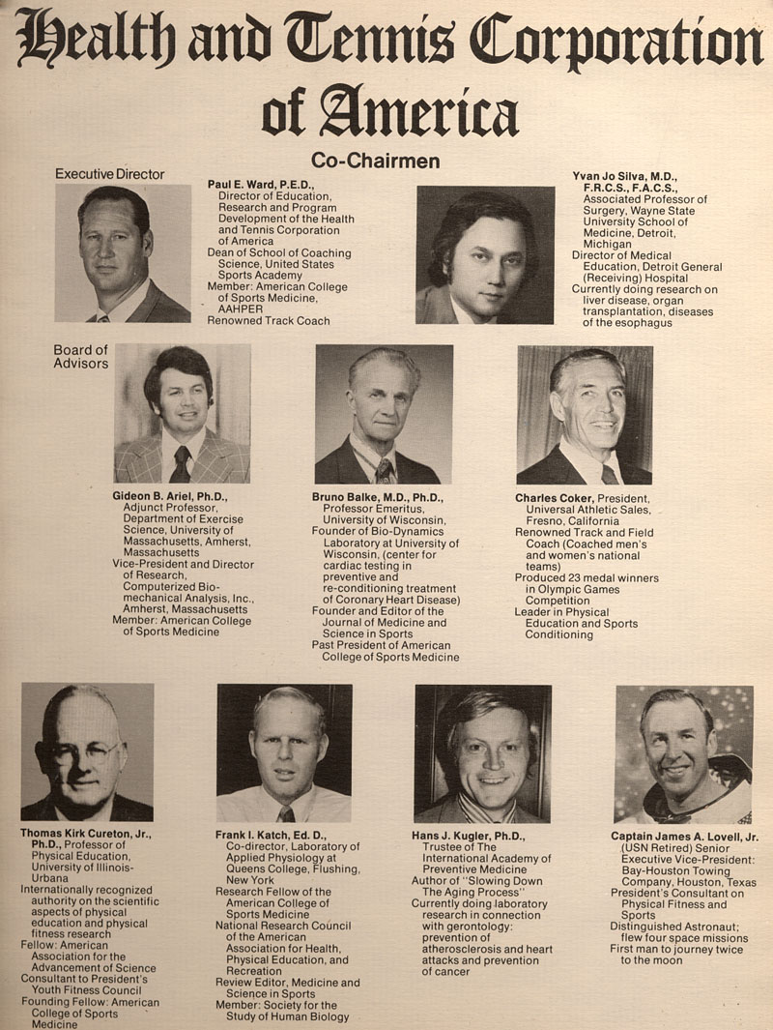
The Health and Tennis corporation of America was the largest Health Club chain center in the USA and probably in the World. Leading World scientists in the field of human performance such as Bruno Balke the pioneer in using lactic acid as an indicator of fitness level, Dr. Frank Katch, a leading Physiologist and nutritionist; Dr. Thomas Cureton one of the most known Exercise Physiologist, and others serve with me on this committee.
As a member of this committee I had numerous discussions with Captain Lovell about how to prepare astronauts fitness for the space mission. The lack of gravity and its effect of the bone structure was a main consideration at NASA. I have told Captain Lovell about my Computerized machine which I was developing in the University of Massachusetts and that it was gravity independent. Also, I showed him in one of our meeting, my Motion Analysis system and how it could be used to analyze Astronauts in Motion in space. He expressed to me how such a system could be used in NASA for many purposes. The First Astronaut to visit with me in my Laboratory in Coto De Caza was Gordon Cooper
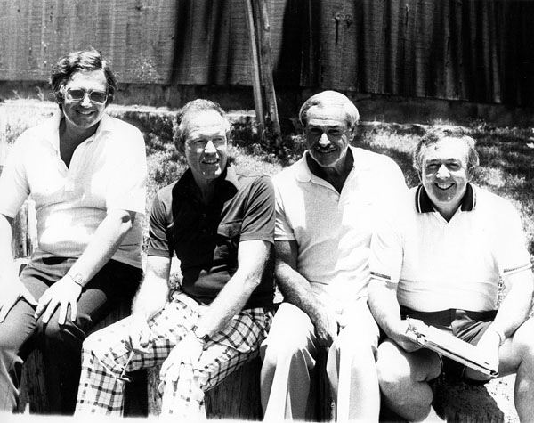
Seating beside the Astronaut Gordon Cooper with the Pilot Bo Friedman and Tennis Pro Vic Braden
Leroy Gordon Cooper, Jr., also known as Gordo Cooper, (March 6, 1927 – October 4, 2004) was an engineer and American astronaut. Cooper was one of the seven original astronauts in Project Mercury, the first manned space effort by the United States. He was the first American to sleep in orbit, had flown the longest spaceflight of the Mercury project, and was the last American to be launched alone into Earth orbit and conduct an entire solo orbital mission.
Apparently, he passed the word about my technology and not long after that I had a call from two other Famous Astronauts. Astrounaut Dave Walker and Dr. William Thornton.
Dr. Thornton was a member of the astronaut support crew for the Skylab 2, 3, and 4 missions, and principal investigator for Skylab experiments on mass measurement, anthropometric measurements, hemodynamics, and human fluid shifts and physical conditioning. He first documented the shift and loss of fluid changes in body posture size and shape, including increase in height and the rapid loss of muscle strength and mass in space flight.
As a member of the Astronaut Office Operations Missions Development group, Dr. Thornton was responsible for developing crew procedures and techniques for deployable payloads, and for maintenance of crew conditions in flight. He developed advanced techniques for, and made studies in, kinesiology and kinesimetry related to space operations.
During Space Shuttle operations he continued physiological investigations in the cardiovascular and musculoskeletal and neurological areas. He developed the Shuttle treadmill for in-flight exercise and several other on-board devices. His work concentrated on the space adaptation syndrome, with relevant investigations on STS-4, STS-5, STS-6, STS-7, and STS-8.
Dr. Thornton holds more than 35 issued patents that range from military weapons systems through the first real-time EKG computer analysis. Space-related items include the first in-flight mass measurement devices, shock and vibration isolation systems, an improved waste collection system, an improved lower body negative pressure (LBNP) apparatus, and others.
A veteran of two space flights, Dr. Thornton has logged over 313 hours in space. He served as a mission specialist on STS-8 in 1983, and STS-51B in 1985.
David Mathieson Walker (May 20, 1944 - April 23, 2001), was a United States Navy officer and a NASA astronaut. He flew aboard four Space Shuttle missions in the 1980s and 1990s.
Dave was extremely interested in our system and saw a tremendous resource research tool for NASA. Unfortunately, Dave our good friend died in 2001. He was only 56 Years old.

Both asked to arrange a meeting with me in my new laboratory at Coto De Caza. (I will discuss in detail this great laboratory in the next Chapter).
Dr. Thornton greeted me with a special pluck of his mission to space which was the first night mission to space.
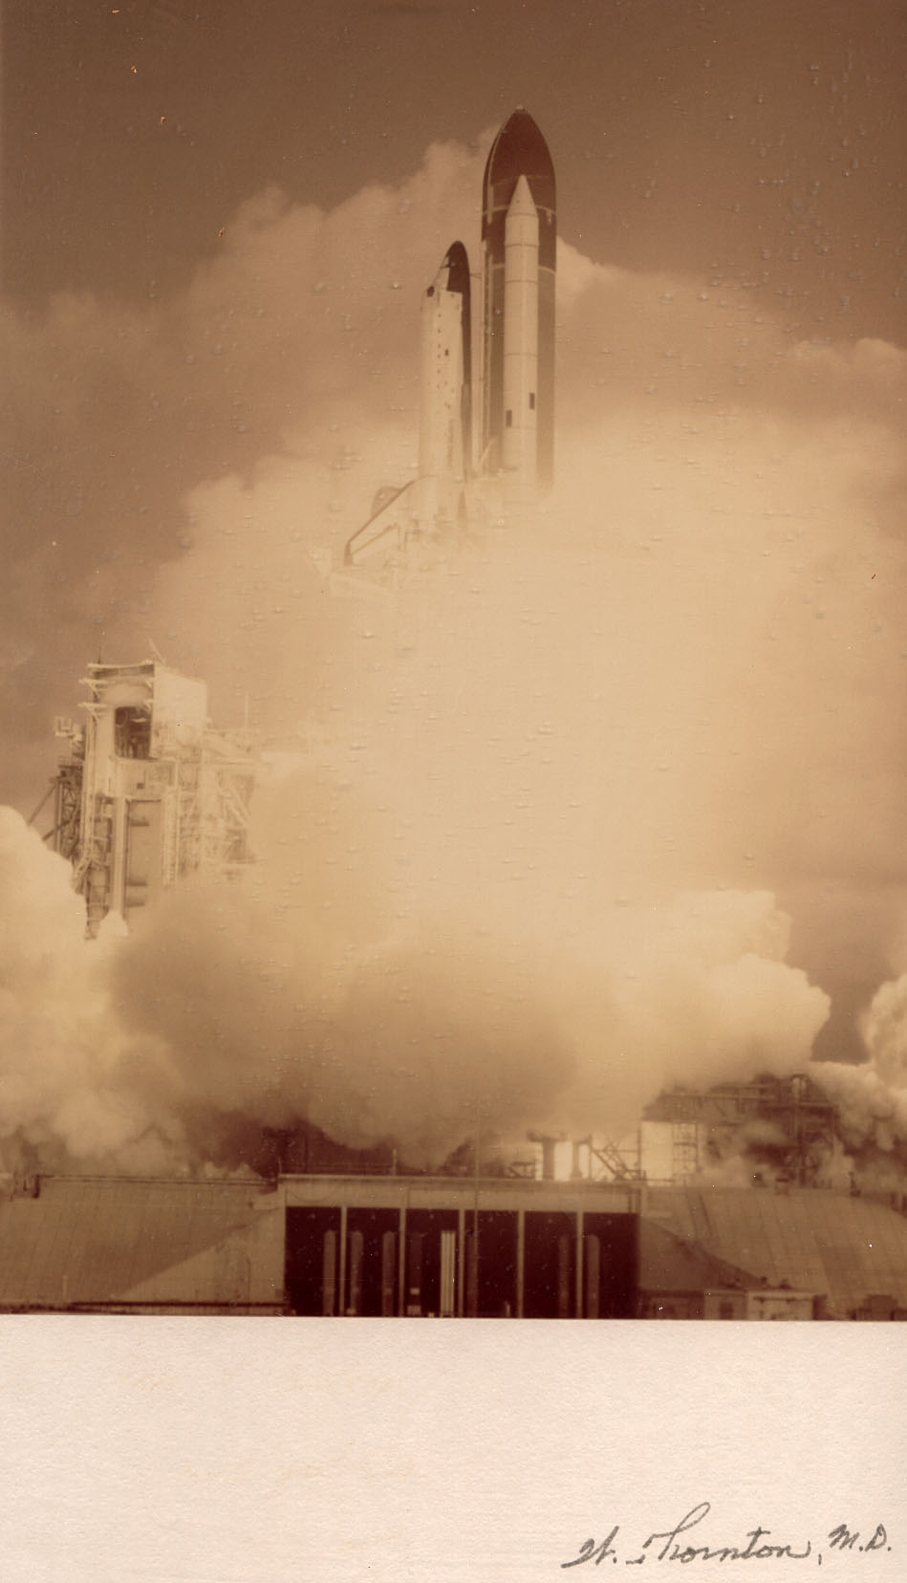
I sent him a thank you letter as follows:
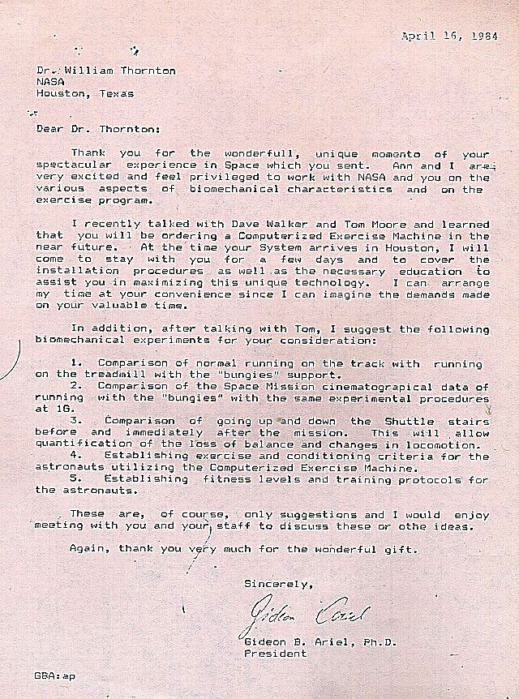
The text read:
April 16, 1984
Dr.: William Thornton
NASA
Houston, Texas
Dear Dr. Thornton:
Thank you for the wonderful, unique memento of your spectacular experience in Space which you sent. Ann and I are very excited and feel privileged to work with NASA and you on the various aspects of biomechanical characteristics and on the exercise program.
I recently talked with Dave Walker and Tom Moore and learned that you will be ordering a Computerized Exercise Machine in the near future. At the time your System arrives in Houston, I will come to stay with you for a few days and to cover the installation procedures as well as the necessary education to assist you in maximizing this unique technology. I can arrange my time at your convenience since I can imagine the demands made on your valuable time.
In addition, after talking with Tom, I suggest the following biomechanical experiments for your consideration:
- Comparison of normal running on the track with running on the treadmill with the "budgies" support.
- Comparison of the Space Mission cinematograpical data of running with the "bungies" with the same experimental procedures at 1.
- Comparison of going up-and down the Shuttle stairs before and immediately after the mission. This will allow quantification of the loss of balance and changes in locomotion.
- Establishing exorcise and conditioning criteria for the astronauts utilizing the Computerized Exercise Machine.
- Establishing fitness levels and training protocols for the astronauts. These are, of course, only suggestions and I would enjoy meeting with you and your staff to discuss these or other ideas.
Again, thank you very much for the wonderful gift.
Sincerely,
Gideon Ariel, Ph.D. President
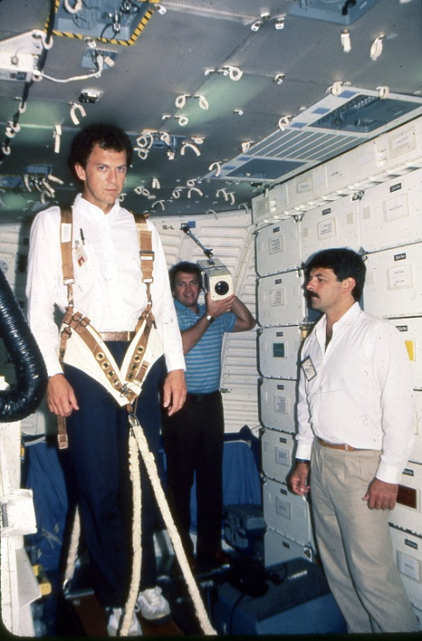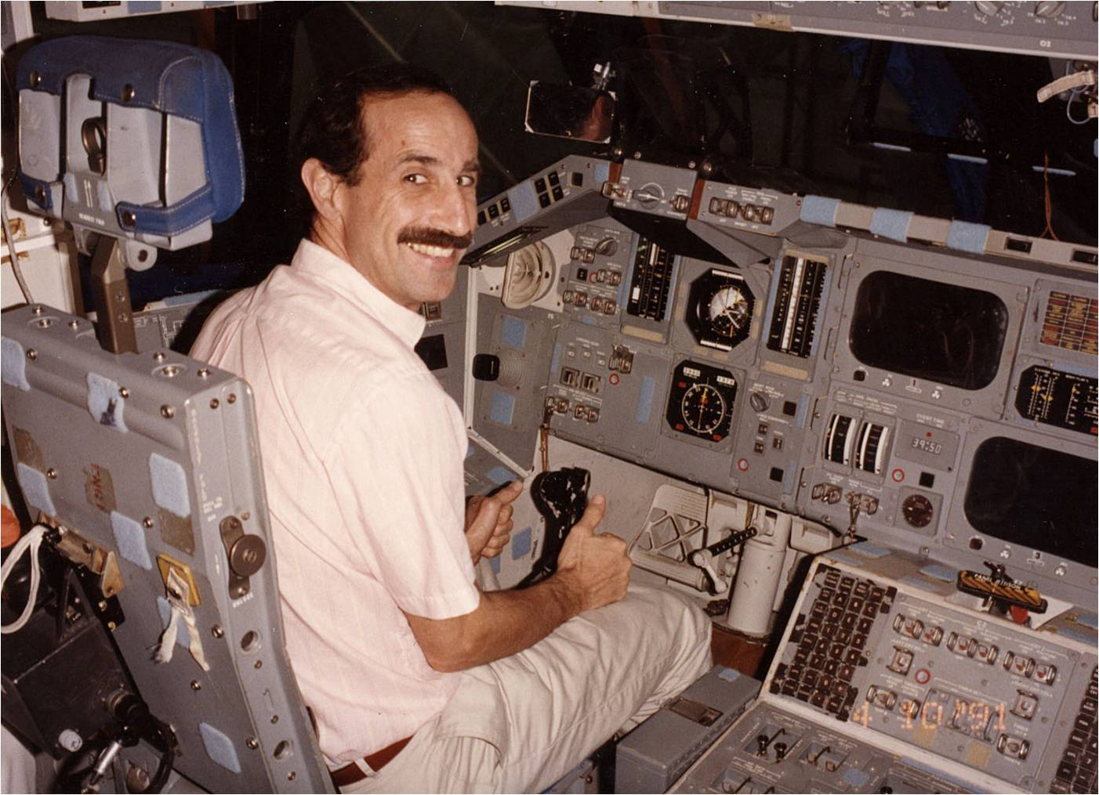
Dr. Moore and Bob Wainright at the Space Station Jeremy Wise at the Space Station

Dr. Thornton and Dave Walker met with me in my research Laboratory at Coto De Caza. They presented to me a very significant problem that they had in NASA. Apparently, NASA and the Russian Space Authority had an agreement of sharing research together. Both organization would record space missions and exchange 16mm film shown the various functions at the mission capsules.
In both cases, one of the activities was running on a treadmill as an exercise. The American NASA treadmill was designed and built by the Astronaut William Thornton which was meeting with me with the Astronaut Dave Walker.
One of the serious problem hat Dr. Thornton was facing was that the American Astronauts always had to use their hands to hold the handle bar in order to maintain upward position. Since the capsule was in space experience close to Zero Gravity, you had to connect yourself to the treadmill with bungees cords. If the American Astronauts did not support themselves with holding the front handle bar, they would rotate while running and losing balance. However, to all surprise, the Russians were able to run without holding the front handle bars. In fact they did not need handles at all.
The following figure shows the original pencil drawing of the schematic of the Astronauts running on the treadmill and a real photograph of one of the astronaut running on the Treadmill.
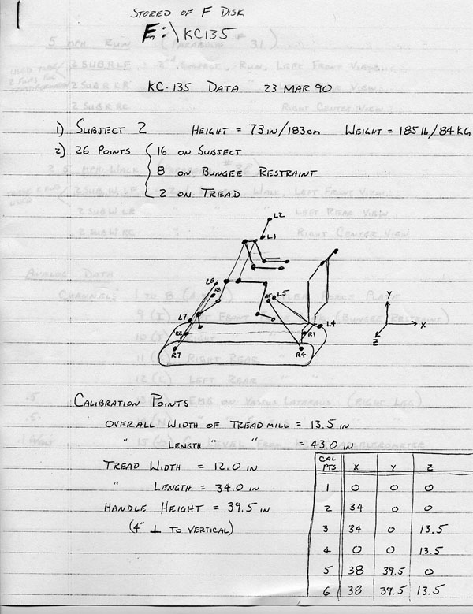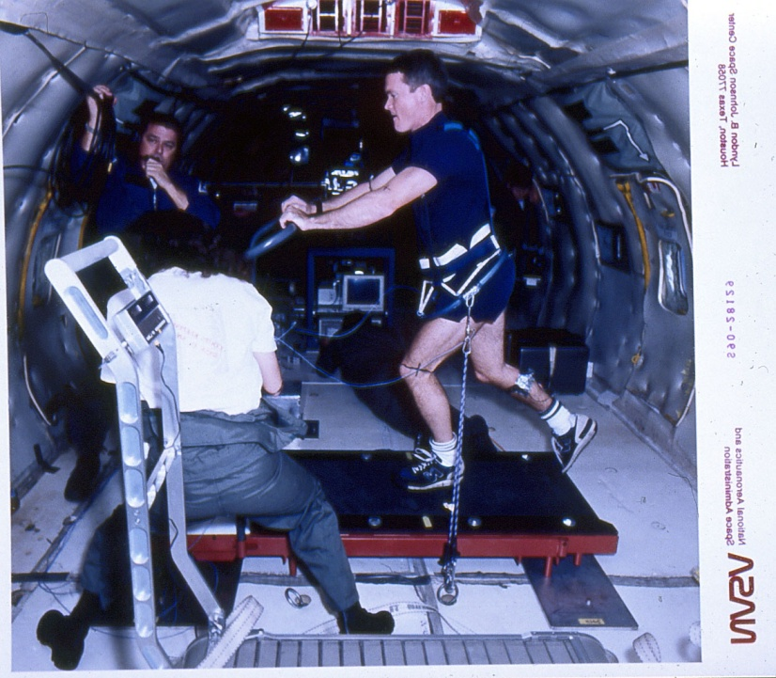
When we digitized the motion from the supplied film we got multiple of figures as in the following:
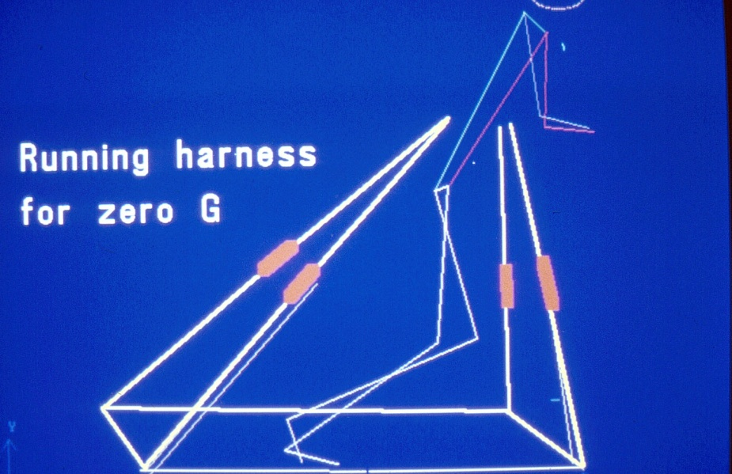
One digitized frame on the treadmill with bungee cords
With the Ariel Performance Analysis System (APAS) we could measure all the kinematics and Kinetics parameters. This resulted in the following first experiment for NASA by ADI Inc.
In Fact, this was the first biomechanical experiment in space. The idea was to compare running on the ground with running in space. This will show us what the mechanical differences and will throw light on the reason why the Russians Astronauts are so advance to the American Astounds and do not need to use their hands and arms to balance their run on the treadmill in space. We had the original data for the Americans and the Russian Astronauts supplied by NASA.
BIOMECHANICAL COMPARISON OF TREADMILL RUNNING IN SPACE TO NORMAL GRAVITY CONDITIONS
The present study is the first of its kind to compare the performance of four subjects (astronauts) running on a treadmill in a zero-gravity environment (Space) to the same subjects running in the normal gravitational environment of earth.
Phase I data collection was during the STS7 and STS-3 Space Shuttle missions using a special on-board camera at 24 frames per second. The treadmill running activity was recorded from two different perspectives - front and side. Each astronaut wore a specially designed harness connected to the treadmill with "bungee" (elastic cords) to provide vertical reaction forces and assist the subject in returning to the treadmill after each stride. A handrail attached to the treadmill contributed to stabilization and comfort. Phase II will duplicate the exercise tests and data collection on earth using the same four astronauts and the same treadmill with the bungies eliminated. In addition, running on normal ground surface will also be filmed. It is expected that the comparison will determine the similarities and differences in running performances in order to facilitate sufficient and appropriate exercise/aerobic training in Space.
A biomechanical analysis will subsequently performed on the Space film sequences with the same procedures to be applied to those obtained on earth. The technique begins with each frame being projected onto a digitizing screen and the location of each body joint (foot, ankle, knee, hip, shoulders, elbow, wrist and hand) accurately measured and saved under computer control. A proprietary transformation and kinematic analysis is performed on the digitized data to yield true image space joint displacement, velocity, and acceleration information. This information is then used to perform a kinetic analysis in order to determine the dynamic forces and moments acting on the subjects during the running activity. Bungie reaction forces were included in 'these calculations for the Space sequences.
WORK STATEMENT: Film sequences of the running motions of the four astronauts will be performed in Houston on the treadmill and on normal ground surface. Data collection will be made at the convenience of the subjects. Biomechanical analysis and data quantification will be performed at the Coto Research Center in California.
INVESTIGATORS: Gideon B. Ariel, Ph.D. M. Ann Penny, Ph.D.
Thomas P. Moore, M.D. William E. Thornton, M.D.
The parameters to be measured can be shown in the following figures. Of course, the detail of this study is beyond the scope of this book. However, I wanted to point out the first study among many others that we performed for NASA.
Our study was very successful and lead to amazing finding.
While Ann was digitizing the film for hundreds of hours we actually notice that the Russians astronauts did not use the Handle bars. It was very surprising since the bunggi cords looked very similar attached to the body.
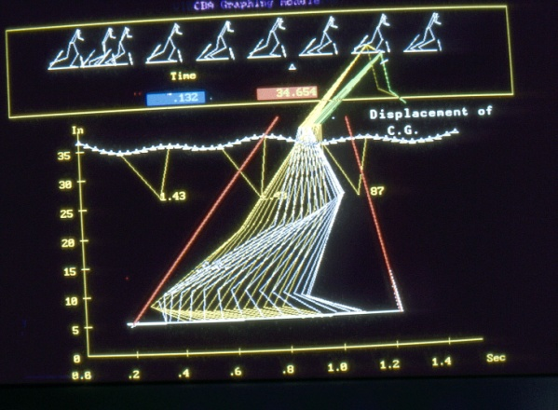 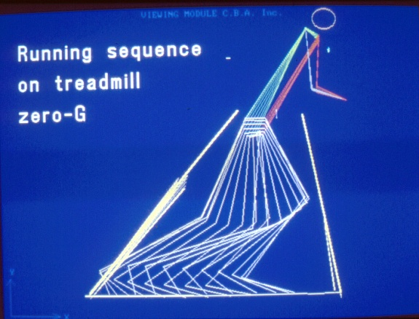
American Russian
Our Biomechanical Analysis could not reveal what the Russians doing different and from their body’s angle and movement of the legs, according to our calculations in Zero gravity the forces should tilt them backward. But it did not. Why?. We struggle with these questions for weeks.
One afternoon, while Ann digitizing the images on the digitizer screen I have noticed a little dot moving down. Looking on it more carfully it seems that it was a drop of sweat detached from the Russian Astronaut. Immediately, I asked Ann to digitize this sweat droplet. “Are you crazy, Gideon, to digitize a sweat?” Ann comment at me. “Yes, I want to see what the acceleration measured on this sweat drop”.
Well, amazing! The acceleration was measured 9.8 Meter per second per second. This means the sweat drop is dropping at gravitational acceleration! The Russians send us film as if they run in Zero gravity, but actually they run at 1G. On the ground, not in space!
This finding was amazing and in NASA they requested and made us sign a none disclosure document not to reveal this information. It was better to know that the Russians cheating us than to let them know that we know that they are cheating us.
After some time later on, this information become known. On the Biomechanics Society Net list the following message was published:

From: "Dr. Chris Kirtley" <kirtley@CUA.EDU>
To: <BIOMCH-L@NIC.SURFNET.NL>
Subject: Science Quiz: summary & solution
Date: Monday, May 14, 2001 8:54 AM
Dear all,
Thanks (?) to all the sour grapes who are still griping about the quiz
answer. At the risk of re-starting the Cold War, I hope our Russian
biomechanists will forgive this message from Gideon Ariel, which I think
provides an appropriate codicil...
Chris
Hi Chris:
Very nice. But I must tell you a story about the Tears in space.
In 1979 my company was hired by NASA to conduct a research analyzing
Running on a treadmill. This was the year where the USA and the USSR signed an agreement to collaborate in space research. At that time they both used
16 mm film, collecting film data in space on the Astronauts running on the
treadmill. This was the first biomechanical study in space !!!
The question to answer was, why the Russians using only bungee cords
around their hips and do not need to have hand support, and the
Americans using the bungee cords around the hips but must gain support with their hand on a handlebar built into the treadmill. From biomechanical point of view it did not make sense. If you have only have bungee cords around the
Center of mass, by propelling the legs on the treadmill it will created moment which will twist the body backward. Did the Russians calculated the CM
And attuched the cords just little higher or lower??? Well the Russians seems to do it with no problems. We digitized 25 sequences and the finding show that the Russians did not need to counter the backward moment. Why ??? Why??? We went crazy and the scientists in NASA went crazy.
On repeating the digitizing procedure, one of my scientist Dr. Ann
Penny noticed a tear or a sweat going off the body of one of the Russian
Astronauts. I told her to digitize this "tear" or "sweat" drop. And
Guess what??? It exhibit acceleration at 9.8 meters/second/second.
Obviously the experiment by the Russians was conducted on Earth......
They sent a misleading film.... This was kept in secrete until 1995.
In anyway, this is in reference to the tears that you mention in your
message.
And this was the first Biomechanical Study in space.

This American-Russian treadmill running study gave us significant notoriety in NASA and we were assigned number of projects.
The next study was similar but pertained only to vertical force on the treadmill:
COMPARISON OF VERTICAL FORCES APPLIED DURING
HUMAN LOCOMOTION IN A ONE-G AND ZERO-G
ENVIRONMENT ON THE SPACE SHUTTLE TREADMILL
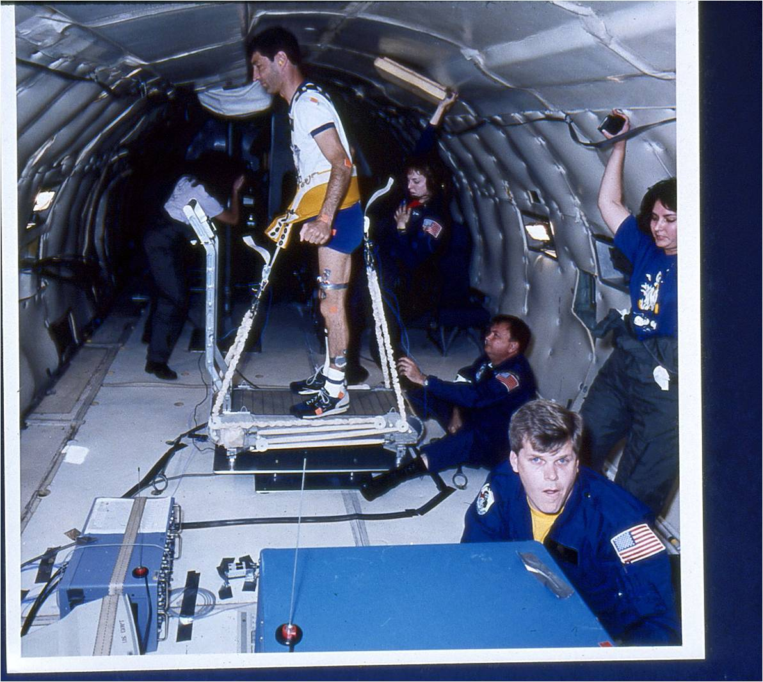
Abstract
The purpose of this study was the development and fabrication of the instruments and hardware necessary to quantify the vertical impact forces (Fz) imparted to the space shuttle passive treadmill during human locomotion in a three dimensional zero-gravity environment. The shuttle treadmill was instrumented using a forceplate (Kistler) to measure vertical impact forces. The current passive treadmill system employs a harness/bungee device as a means to restrain an astronaut in zeroG. Force links (Kistler) were employed to measure the bungee cord loading. The hardware was designed so that it would meet crash loading requirements as written in the JSC-22803 manual for experiments flying in the Reduced Gravity Aircraft (KC-135). The impact force and bungee cord data was collected and analyzed using a biomechanics performance analysis system (Adel Corporation).
To verify that the instruments and hardware were functional, they were tested in the Anthropometry and Biomechanics Laboratory (ABL) at the Johnson Space Center. The KC-135 reduced gravity aircraft was used to determine if the system could operate successfully in a three-dimensional zero-gravity environment. It was found that the vertical impact forces could be quantified in a one-G and zero-G environment using the forceplate, and through use of the forceplate and/or bungee instrumentation, a subject's one-G weight could be replicated in zero-G by adjusting the bungees to elicit the proper load. The magnitude of the impact loads generated in one-G on the shuttle treadmill for the given walking, jogging and running velocities (1.1 G, 1.7G, and 1.726 respectively) were not observed in the zero-G environment. However for the higher zero-G jogging and running velocities (3.5 mph and 5.0 mph) greater than 1 G loads were seen (1.2G and 1.5G). Thus the issue becomes "How much impact is enough?".
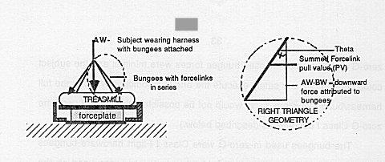
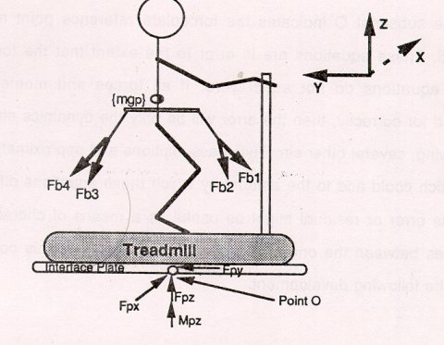
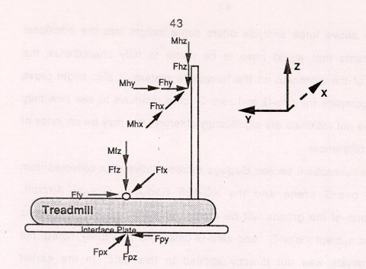
i
As a part of the system, it was necessary to incorporate a data collection instrument. A biomechanics analysis system (Ariel Performance Analysis System, ADI Inc. Corporation, 6 Alicante, Trabuco Canyon, CA 92679) served as the data collection device (Figure 12). Using this system, data was acquired from all data input channels at a rate of 250 samples/channel/second. A ruggedized hardware cabinet had to be obtained to encase this system and the other associated electronics equipment before they could fly on the KC-135 aircraft. A KC-135 floor-to cabinet interface plate, a backplate, and cabinet insertion plates had to be designed and created for mounting the equipment inside the hardware cabinet . The cabinet backplate and the hardware insertion plate are shown in Figure 13a. The assembled hardware cabinet system is depicted in Figure 13b

A STUDY OF BIOMECHANICAL COMPARISON OF TREADMILL
RUNNING IN SPACE TO NORMAL GRAVITY CONDITIONS
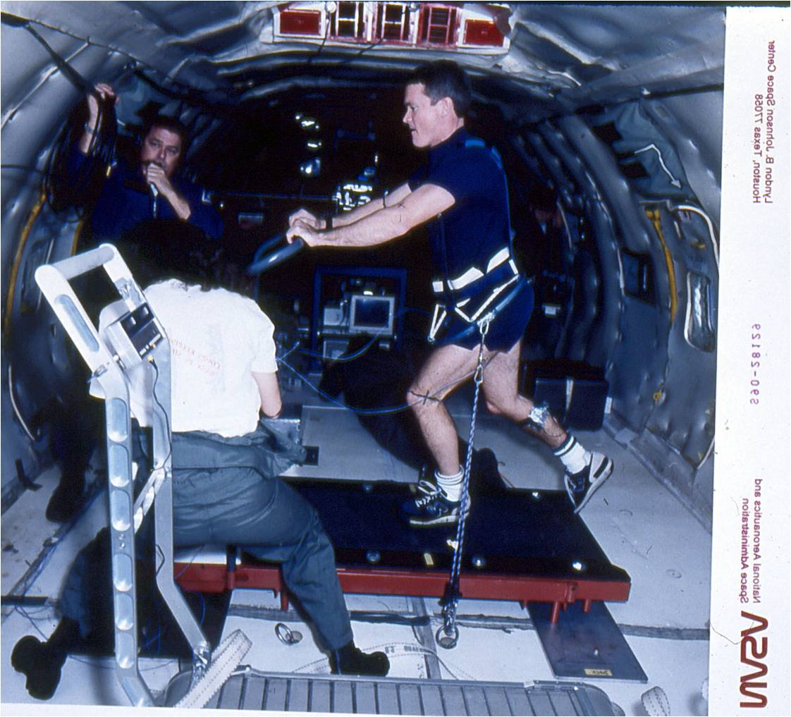
The present proposal is the first of its kind to compare the performance of four subjects (astronauts) running on a treadmill in a zero-gravity environment (Space) to the same subjects running in the normal gravitational environment of earth.
Phase I data collection was during the STS7 and STSB Space Shuttle missions using a special on-board camera at 24 frames per second. The treadmill running activity was recorded from two different perspectives - front and side. Each astronaut wore a specially designed harness connected to the treadmill with "bungies" (elastic cords) to provide vertical reaction forces and assist the subject in returning to the treadmill after each stride. A handrail attached to the treadmill contributed to stabilization and comfort. Phase II will duplicate the exercise tests and data collection on earth using the same four astronauts and the same treadmill with the bungies eliminated. In addition, running on normal ground surface will also be filmed. It is expected that the comparison will determine the similarities and differences in running performances in order to facilitate sufficient and appropriate exercise/aerobic training in Space.
A biomechanical analysis will subsequently performed on the Space film sequences with the same procedures to be applied to those obtained on earth. The technique begins with each frame being projected onto a digitizing screen and the location of each body joint (foot, ankle, knee, hip, shoulders, elbow, wrist and hand) accurately measured and saved under computer control. A proprietary transformation and kinematic analysis is performed on the digitized data to yield true image space joint displacement, velocity, and acceleration information. This information is then used to perform a kinetic analysis in order to determine the dynamic forces and moments acting on the subjects during the running activity. Bungie reaction forces were included in these calculations for the Space sequences.
WORK STATEMENT:
Film sequences of the running motions of the four astronauts will be performed in Houston on the treadmill and on normal ground surface. Data collection will be made at the convenience of the subjects. Biomechancial analysis and data quantification will be performed at the Coto Research Center in California.
INVESTIGATORS: Gideon B. Ariel, Ph.D. M. Ann Penny, Ph.D. Thomas P. Moore, M.D. William E. Thornton, M.D.

RIGID BODY ANALYSIS OF SYSTEM
As part of this study, a rigid body dynamics model of the astronaut and the treadmill system has been evaluated. Although the analysis has not been applied to the early experiments reported here, it is presented to give better insight into the measured forces. Hopefully it can be incorporated into later studies to better describe the differences in one-G and zero-G experiments.
The forces existing between the force plate and interface plate are considered to be applied at a known point on the forceplate (point 0) as shown in the free body diagram (Figure 15). The forceplate was initialized without the subject (i.e. the weight of the treadmill and interface plate in one-G was tared). The brackets depict those forces that would only be seen in the one-G environment.
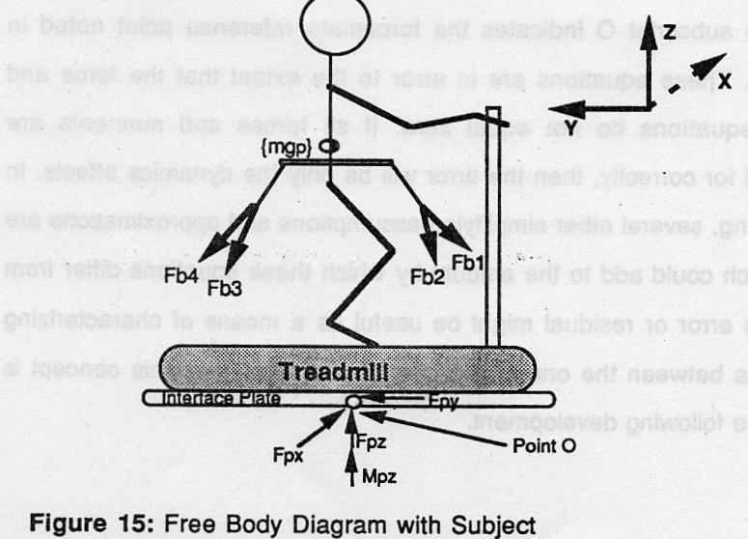

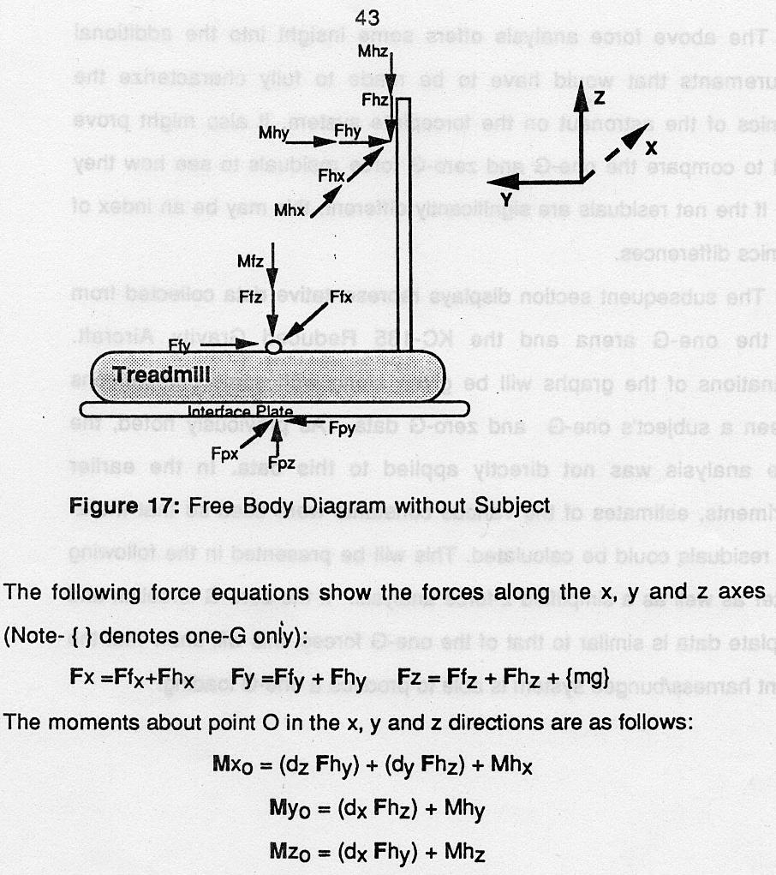
If no forces or moments were exerted by the hands, it would be possible to use these equations to calculate the reaction forces at the foot (or feet) of the subject. Since there are typically forces at the hands, it would be necessary to add instrumentation to fully resolve the actual foot contact forces. Such a measurement may be appropriate for future work.
The reason I shown some of the “free diagrams” is to show how complicated such a study can be. And for most to show that this was the first Biomechanical Study in Space.

After these studies, many studies were conducted with NASA. In fact NASA decided to hire my company as an integrated research company to work directly with NASA. Here is part of the contract which consisted of many “legalistic” pages and not fit to this book.
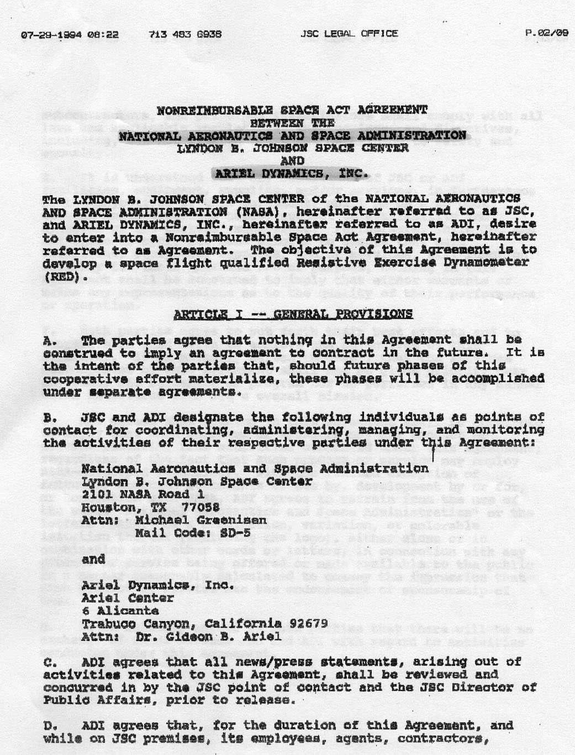
The text read as follows:
07-29-1994 08:22 713 483 e936 JSC LEGAL OFFICE P.02/09
NONREIMBURSALE SPACE ACT AGREEMENT
BETWEEN THE
NATIONAL AERONAUTICS AND SPACE ADMINISTRATION
LYNDON B. JOHNSON SPACE CENTER
AND
ARIEL DYNAMICS, IOC.
The LYNDON S. JOHNSON SPACE CENTER of the NATIONAL AERONAUTICS AND SPACE ADMINISTRATION (NASA), hereinafter referred to as JSC, and ARIEL DYNAMICS, INC., hereinafter referred to as ADI, desire to enter into 4 Nonrsimbursable Space Act Agreement, hereinafter referred to as Agreement. The objective ofthis Agreement is to develop a space flight qualified Resistive Exercise Dynamometer (RED).
ARTICLEL-- GENERAL
A. The parties agree that nothing in this Agreement shall be construed to Imply an agreement to contract in the future. It le the intent of the parties that, should future phases of this cooperative effort materialise, these phases will be accomplished under separate agreements.
R. an and ADI designate the following individuals as paints of contact for coordinating, administering, managing, and monitoring the activities of their respective parties under this Agreement:
National Aeronautics and Space Administration Lyndon B. Johnson Space Center
2101 NASA Road 1
Houston, TX 77058
Attn: Michael Greenisen
Mail Code: SD-5
and
Ariel Dynamics, Inc.
Ariel Center 6 Alicante
Trabuco Canyon, California 92679 Attn: Dr. Gideon B. Ariel
- ADZ agrees that all news/press statements, arising out of activities related to this Agreement, shall be reviewed and concurred in by the JSC point of contact and the JSC Director of Public Affairs, prior to release.
- ADI agrees that, for the duration of this Agreement, and while on JSC premises, its employed, agents, contractors,

(Many more pages to the agreement)

The person in charge of the research studies with ADI Inc. was Dr. Michael Greenisen. Dr. Greenisen was in charge of the Counter Measure research in NASA.
In one of the early meeting with Dr. Greenisen and others in NASA I was asked to write a paper on the potential research studies that we at ADI could perform for NASA.
The first paper I submitted was titled: Biomechanics Research in Space.
BIOMECHANICAL RESEARCH IN SPACE
By
Gideon Ariel, Ph.D.
ABSTRACT
Aerospace engineers are now calling for development of space as a new frontier. To accomplish safe flights and landing, we faced with great challenges. One of the biggest challenge is the human physiological machinery. The goal of the present project is to minimize the effects of deconditioning during spaceflight. Some of these effects are physiological and mechanical demands of microgravity is by deconditioning of the cardiovascular, musculoskeletal, and neuromuscular systems. Deconditioning produces a multitude of physical changes such as loss of muscle mass, decreases in bone density and body calcium; it is also responsible for decreased muscle performance, strength and endurance.
Extravehicular activity (EVA) in space require the most physically demanding task that astronaut perform on orbit. Therefore, it is necessary to develop exercise programs as well as exercise device to countermeasure these effects.
Biomechanics in space is fundamental to understanding the work performance capabilities of humans in space. Biomechanics as practiced by NASA has the primary goal to conducting operationally-oriented research focusing on maximizing astronaut on-orbit performance capabilities.
At the present time the following biomechanics prioritized research objectives are designed for immediate research projects:
- The design of flight dynamometer
- Task analysis and efficiency of IVA and EVA
- Biomechanical analysis of performance and modeling
- Biomechanical countermeasures of 0-G effects
- Biomechanics of space suit assembly
- Telescience, Automation, and Tool Design
All the biomechanical analysis integrate a high speed videography, EMG and force plates. In addition, a computer controlled dynamometer is programmed to provide specific exercise prescriptions to the astronauts in order to maximize their muscular strength and endurance to perform the require tasks which analyzed by the integrated movement analysis.
“A nation must believe in three things. It must believe in the past. It must believe in the future. It must, above all, believe in the capacity of its people so to learn from the past that they can gain in judgment for the creation of the future.”
Franklin D. Roosevelt INTRODUCTION
Aerospace engineers are now calling for development of space as a new frontier. They maintain that a high frontier in space can produce the same kind of boom conditions that existed for Europe after 1500 and for the United States during early days of its experience when an ever expanding West helped to produce a growing, spirited America. Specifically, space frontier can provide unlimited low-cost energy, available to everyone rather than just to those nations favored with large reserves of fossil or nuclear fuels. Provide unlimited new lands to provide living space of higher quality than that now possessed by most of the human race. And provide an unlimited materials source, available without stealing or killing or polluting.
When Americans reflect on the space program, there are two events that stand out more prominently than others. The first moon landing and the Challenger disaster.
On July 21, 1969, an Apollo spacecraft carried Neil A. Armstrong, Edwin E. Aldrin, and Michael Collins to the moon. Aldrin, became the first man on the moon. When Neil Armstrong touch his foot to the moon's surface he said:
"That's one small step for man, one giant leap for mankind."
The second event, the Challenger disaster, took the lives of seven astronauts, including the school teacher Christa McAuliffe, when the rocket boosters of the space shuttle exploded 73 seconds after lift-off on January 28, 1986.
Neil Armstrong fixed the ultimate significance of his deed by what he said; Christa McAuliffe did the same by who she was. Armstrong, in the midst of a historic event, had the vision to say the right thing. McAuliffe, although a nonprofessional astronaut, had the vision to become part of the quest.
We stand before a frontier of apparently infinite proportions. It constitutes perhaps the ultimate quest. As we proceed in this exploration, we are outfitted with the most sophisticated and rapidly expanding technologies the world has ever known. Authentic heroes have helped us to understand that "the right stuff" must be complemented with "the right reasons" when we undertake such a task.
To accomplish the "right stuff" we faced with great challenges. One of the biggest challenge is the human physiological machinery. Man, having evolved as an upright, bipedal animal, cannot consciously take the rapid onset of acceleration that would be required for long distance space travel. Additionally, the physiological adaptations of a microgravity environment are poorly understood, and it can arguable be said that long term weightlessness results in significant post--flight deleterious changes that may be permanently debilitating.
COUNTERMEASURES
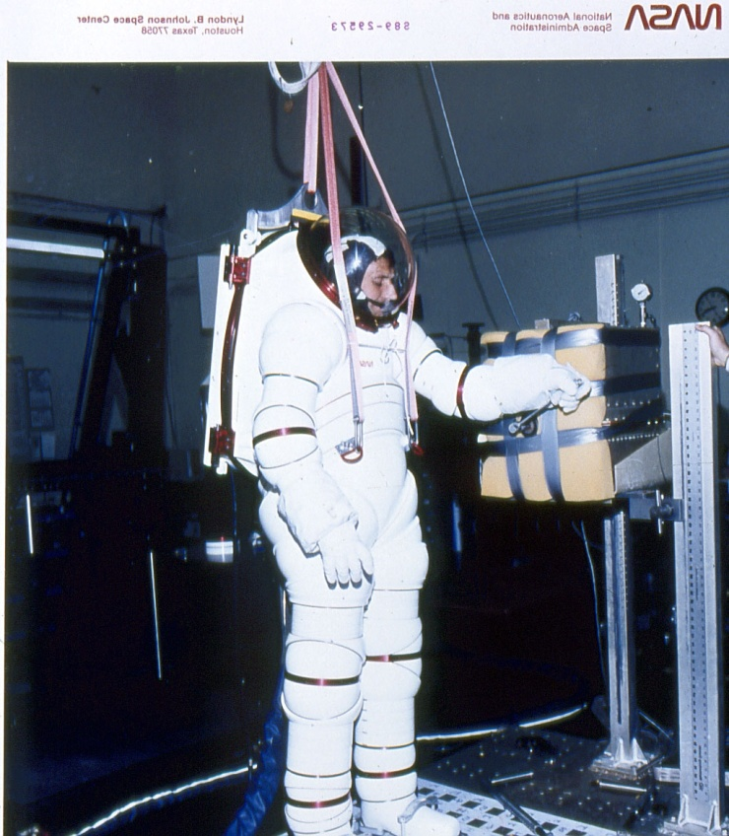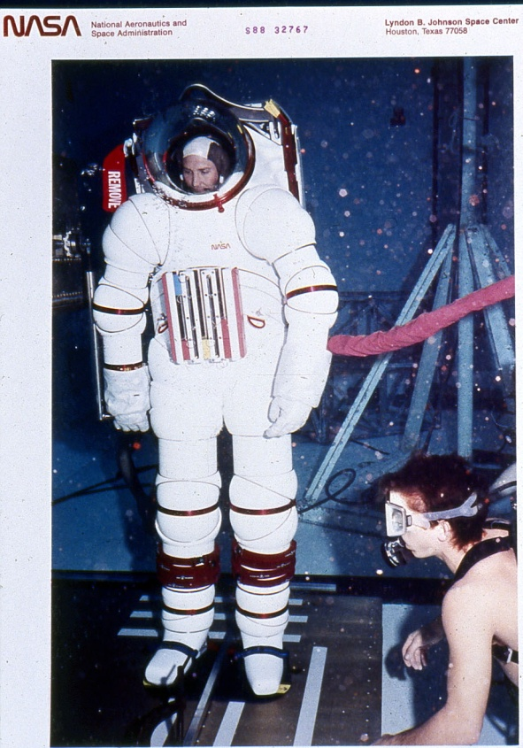
The goal of the present project is to minimize the effects of deconditioning during spaceflight using individualized exercise "prescriptions" and inflight exercise facilities combine with extensive biomechanical analysis of movement in microgravity.
Background:
One of the ways the human body reacts to the reduced physiological and mechanical demands of microgravity is by deconditioning of the cardiovascular, musculoskeletal, and neuromuscular systems. Deconditioning produces a multitude of physical changes such as loss of muscle mass, decreases in bone density and body calcium; it is also responsible for decreased muscle performance, strength and endurance, orthostatic intolerance, and overall decreases in aerobic and anaerobic fitness.
Deconditioning presents operational problems during spaceflight and upon return to 1-G. Muscular and cardiovascular deconditioning contribute to decreased work capacity during physically demanding extravehiculr activities (EVAs); neuromuscular and perceptual changes can precipitate alterations in magnitude estimation, or the so-called "input-offset" phenomenon; and finally, deceased vascular compliance can lead to syncopal episodes upon reentry and landing.
Extravehicular Activity (EVA) is the most physically demanding task that astronauts perform on-orbit. Space Station Freedom and manned Lunar and Mars missions will greatly increase the number, frequency, and complexity of EVA's within the next 10 to 20 years.
Countermeasures are efforts to counteract these problems by interrupting the body's adaptation process. Effective countrmeasures will assure mission safety, maximize mission success, and maintain crew health.
Results from experiments on the Gemini, Apollo, and Skylab missions suggest that regular exercise is helpful in minimizing several aspects of spaceflight deconditioning (7,9,10). In fact, exercise is the only countermeasure that can potentially counteract the combined cardiovascular, musculoskeletal and neuromuscular effects of adaptation.
Biomechanics in space is fundamental to understanding the work performance capabilities of humans in space. Biomechanics as practiced by NASA has the primary goal to conducting operationally-oriented research focusing on maximizing astronaut on-orbit performance capabilities.
The purpose of biomechanical analysis in space is to provide a program of exercise countermeasures that will minimize the operational consequences of nhicrogravity-induced deconditioning. Biomechanical analysis of movement in space will provide individualized exercise "prescriptions" for each crew member to optimize required tasks in microgravity environment. Through characterizing the tasks requirement in the musculoskeletal and neuromuscular systems induced by microgravity, develop training protocols to address deconditioning in these systems that will serve as the basis for training prescriptions.
To achieve these training protocols it is necessary to develop flight exercise hardware and associated software related to biomechanical measurement devices.
Critical Questions:
Some of the critical questions to be addressed the present goals are:
- What type of exercise devices such as weight training, bicycling, rowing, swimming, running, etc. are necessary to train all of the organ systems affected by deconditioning?
- Which indices are the most reliable indicators of changes in fitness?
- Which reliable indicators of changes in fitness best describe the changes caused by deconditioning?
- How does training in microgravity differ from training in 1-G ?
- What are the differences between training that includes impact forces and training that uses non-impact forces?
- Can an artificial intelligence expert system be developed to aid in monitoring, controlling, and adjusting prescriptions?
- How does inflight exercise training affect the adaptation process?
- Which muscle groups are critical in the performance of egress, landing, and EVAs?
- Which of the indicators of miinicrogravity-inducedhange in muscle function can be correlated with possible difficulty in performing egress, landing, and EVAs?
These are few of the questions to be answer to understand the possible countermeasures to be efficient.
On Wednesday, September 20, 1989, the following 23 topics were suggested by members of the Biomechanics group, of which I was one of the members:
Identify and analyze tasks by mission.
Focus studies to examine the functions of upper extremities during space flight.
Integration of Biomechanics and Physiology to fully understand "the complete picture."
Examine the use of power tools to enhance performance and reduce fatigue of the crew members.
Compare the use of a robotic hand to EVA crew interaction.
Investigate "tweaking" existing tools to a give a greater mechanical advantage.
Use of the prediction of work and tools required to perform a given task.
What jobs/tasks are needed on orbit?
What are the energy expenditures for on orbit activity.
Comparison of perceived target accuracy and spatial orientation to actual target accuracy and spatial orientation.
Comparison of gross tasks to fine motor control.
Quantify performance of metabolism, muscles, forces, etc.
Determination of the scope of biomechanics
operations vs. those of medical science.
Evaluation of muscle, EMG, etc. of crew members. Evaluation of hormones and metabolic information.
Investigation of hardware issues such as the development of a universal tool.
Integration of protocols including recovery, strength, power, endurance, and frequency.
Development of work related tests incorporating dynamometers, force plates, etc.
definition of specified joint axes.
Investigation into the use of a robot glove as an extension of the space suit.
Development and use of a flight qualified dynamometer and determination of what information should be measured (i.e. power, endurance, etc.).
Development of an immediate recovery dynamometer to measure post-flight crew strength.
At the present time the following biomechanics prioritized research objectives are designed for immediate research projects:
Flight Dynamometer
- on-orbit data collection
- EVA tools/work tasks
- single joint articulations
Task Analysis and Efficiency (IVA/EVA)
- upper body work tasks -mechanical efficiency
- metabolic efficiency
- psychomotor efficiency/accuracy
Biomechanical Performance and Modeling Predictions -prediction model vs actual performance -integrate biomechanics with physiology movement notes
Biomechanical Countermeasures
-short arm centrifuge
- skeletal system impact loading
-vertebral column/locomotion skeletal muscles
Biomechanics of Space Suit Assembly
- development of flexible, high performance space suit -glove design
Telescience, Automation, and Tool Design
-development of robotic tools to perform some tasks -power tools (smart tools)
- increase mechanical advantage of existing tools
- development of universal tool
Human Motor Control Strategy
- training
-subject feedback
One of the first biomechanical project underway at the present time is to investigate landing and normal egress.
Task Analysis of Landing and Normal Egress:
Objectives:
- Identify the normal biomechanical and kinematic requirements of landing and walk-out of shuttle egress using video motion analysis.
- Identify specific tasks associated with individual crewmembers during ELE.
- Quantify the forces of gait during normal walkout egress.
- Suggest physiological parameters that might be tested in a laboratory that may mimic tasks that are performed during landing and normal walk-out egress.
The following is one of the biomechanical studies to evaluate landing and normal egress.
ABSTRACT: This study requires using the astronauts preflight; during egress training, and postflight; during landing, (out of seat egress) and during normal exit from the shuttle to a ground level. A total of ten (N=10) manifested astronauts are requested, five Pilots and 5 Mission Specialists, to participate so that comparisons can be made on post mission walk-out performance.
Video cameras and force plate instrumentation will record simulated tasks associated to landing and egress during normal training in the high fidelity mockup. During training, crew will be video recorded as they perform the actual tasks that will be idiospecific to their flight tasks. Normal, walk-out of orbiter, egress will also be video recorded, however, specifying that the first 3-4 steps on level ground be done on the Force Plate for force patterning and gait analysis. At landing, video cameras in the orbiter will record landing procedures in upper and middecks and for out of seat egress. Additional video cameras will also record normal walk-out egress from the orbiter with the first 3-4 steps on level ground being done on the Force Plate. This study is the first of several studies to scientifically quantify the forces, movement patterns, center of gravity and force velocities of motion
during landing and egress tasks. This base investigation shall be further expanded to evaluate ground based emergency egress of volunteer subjects and counermeasure interaction and effectiveness on egress performance of astronaut crewmembers.
Another task :is to design an exercise dynamometer to be able to exercise and analyze muscle functions and efficiencies. The goal is to utilize biomechanical research to utilize the most efficient means to counteract the effect of deconditioning in space.
Fitness technology, in both theory and practice, exhibits two problems common to many modern, rapidly emerging disciplines. First, a lack of clearly defined and commonly accepted standards has resulted in a marketplace rife with conflicting claims and approaches to both attaining and maintaining fitness. In general, both vendors and consumers of fitness technology have been unable to provide a sound scientific answer to the simple question, "Are we doing the right thing?" Second, a lack of the proper tools and techniques for measuring fitness and the effectiveness of a given technology to the attainment of fitness has made it quite difficult to evaluate existing products in order to select the ones that really work.
Some of the requirements to in/flight 0-G exercise dynamometer are as follows:
The flexibility of performing exercises and diagnostics in isotonic, isokinetic, isometric, accommodating velocity at variable loads as well as accommodating resistance at variable speeds or any combination of these exercise controlled modes.
The ability to perform exercises and diagnostics from a pre-programmed sequence of tests and exercises stored on disk. The investigator can prescribe for object, testing and rehabilitation programs from a library of specialized programs or create specific protocol tailored for that subject.
To offer user-friendly, menu-driven software packages which can be easily learned and are simple to operate.
Allows for data transfer to other commercial or custom software packages for extraordinary graphing, data report formats, statistical analysis, etc.
Allow for external analog data acquisition that can be correlated with the acquired force curves such as E.M.G. data and load cells.
All dynamometer functions can be controlled or monitored either from the keyboard, hard disk storage, or a remote location, via telephone modem and satellites.
The ability to simulate real task activities for comparison of strength and endurance in 1 and 0 Gs.
All exercise program variables, such as intensity, frequency, duration, sets, work load, percent fatigue, can be controlled and changed from the control keyboard or by remote modem.
The software is an artificial intelligence expert system that monitors, controls and adjusts prescriptions according to the measured output of the exerciser.
Mechanism for the Required Dynamometer:
A standard hydraulic cylinder is attached to an exercise bar by a mechanical linkage. As the bar is moved, the piston in the hydraulic cylinder moves pushing non inflammable liquid out of one side of the cylinder, through a valve, and back into the other side of the cylinder. When the valve is fully open there is no resistance to the movement of the liquid and thus no resistance to the movement of the bar. As the valve is closed, it becomes harder to push the liquid from one side of the cylinder to the other and thus harder to move the bar. When the valve is fully closed, liquid cannot flow and the bar will not move. In addition to the cylinder, the resistance mechanism contains sensors to measure the applied resistance mechanism contains sensors to measure the applied force on the bar and the motion of the bar. Now assume the valve is at some intermediate position and the bar is being moved at some velocity with some level of resistance. If the computer senses that the bar velocity is too high or that bar resistance is too low, it will close the valve by a small amount and then check the velocity and resistance values again. If the values are not correct, it will continue to close the valve and check the values until the desired velocity or resistance is achieved. Similarly if the bar velocity is too low or the bar resistance is too high, the computer will open the valve by a small amount and then recheck the values. This feedback loop will continue with the valve being opened by small amounts until desired velocity or resistance is achieved. The feedback cycle occurs hundreds of times a second so that the user will not experience perceptible variations from the desired parameters of exercise.
There are a number of advantages in such a resistance mechanism. One significant advantage is safety. The passive
hydraulic mechanism provides resistance only when the user pushes or pulls against it. The user may stop exercising at any time, such as during rehabilitation if pain or discomfort is experienced, and the exercise bar will remain motionless. Another advantage is that of bidirectional exercise. the hydraulic mechanism can provide resistance with the bar moving in either direction.
This computer controlled exercise device has been designed to consider every movement or exercise performed by a user to be a pattern of continuously varying velocity or resistance. This pattern may be set using direct measurement of subject motion by the system, it may be copied from the results of performance analysis, or the pattern may be "designed" or created by the user or practitioner as a goal of training or rehabilitation. Exercise patterns are stored in computer memory and can be recalled and used each time a subject trains. During exercise, the computer uses the pattern to adjust bar velocity or bar resistance as the subject moves through the full range of motion. In this manner, the motion parameters of almost any activity can be really duplicated by the exercise system. Thus, assessment, training, or rehabilitation may be performed using the same pattern as the activity itself.
The value of applying the principles of biomechanics to the assessment of fitness in space has been clearly demonstrated. Performance analysis provides the means to quantify human activity and to provide insight into the mechanisms that contribute either to superior or inferior levels of performance. At the same time, it has been shown that fitness technology has been presented that permits exercise and countermeasure means patterns to biomechanically duplicate the target activity.
The integration of movement analysis with measurements such as E.M.G. activity with forces measured in load cells and force plates allow to analyze the astronauts in various gravitational conditions and allow the design of optimal technique and equipment to optimize space missions.

Another paper I submitted entitled: Biomechanics in Space.
BIOMECHANICS IN SPACE
Gideon B. Ariel
Ariel Life Systems, Inc.
1299 Prospect St., Suite 303, La Jolla, CA 92038 USA
Aerospace engineers and many biological scientists perceive Space as the new, and last, frontier. Although there are extensive technological considerations in hardware instrumentation, perhaps the greatest challenge is understanding and solving the complexities of the anatomical, physiological machinery of the human in Space. The goal of those involved with Exercise Countermeasures research is to minimize the effects of deconditioning during spaceflight. Microgravitional experiences have produced a multitude of physical changes including loss of muscle mass, decrease in bone density and bone calcium, and decreased muscular performance, strength, and endurance. Extravehicular activity (EVA) in Space requires physically demanding performance. Therefore, additional attention must be directed at develop exercise programs and devices to enable the astronaut to perform properly under those demanding conditions. Biomechanical consideration of task analysis and efficiency requirements, modeling, space suit assembly, zero-G effects, and other EVA needs are important operationally-oriented research goals.
BIOMECHANICS IN SPACE AND THE DESIGN OF EXERCISE
AND ANALYSIS DYNAMOMETER AND SOFTWARE SYSTEM
AS AN IN/FLIGHT, 0-G, EXERCISE DYNAMOMETER
SYSTEM
Fitness technology, in both theory and practice, exhibits two problems common to many modern, rapidly emerging disciplines. First, a lack of clearly defined and commonly accepted standards has resulted in a marketplace rife with conflicting claims and approaches to both attaining and maintaining fitness. In general, both vendors and consumers of fitness technology have been unable to provide a sound scientific answer to the simple question, "Are we doing the right thing?" Second, a lack of the proper tools and techniques for measuring fitness and the effectiveness of a given technology to the attainment of fitness has made it quite difficult to evaluate existing products in order to select the ones that really work.
Some of the requirements to in/flight 0-G exercise dynamometer are as follows:
The flexibility of performing exercises and diagnostics in isotonic, isokinetic, isometric, accommodating velocity at variable loads as well as accommodating resistance at variable speeds or any combination of these exercise controlled modes.
The ability to perform exercises and diagnostics from a pre-programmed sequence of tests and exercises stored on disk. The investigator can prescribe for object, testing and rehabilitation programs from a library of specialized programs or create specific protocol tailored for that subject.
To offer user-friendly, menu-driven software packages which can be easily learned and are simple to operate.
Allows for data transfer to other commercial or custom software packages for extraordinary graphing, data report formats, statistical analysis, etc.
Allow for external analog data acquisition that can be correlated with the acquired force curves such as E.M.G. data and load cells.
All dynamometer functions can be controlled or monitored either from the keyboard, hard disk storage, or a remote location, via telephone modem and satellites.
Biomechanics in space is fundamental to understanding the work performance capabilities of humans in space. Biomechanics as practiced by NASA has the primary goal to conducting operationally-oriented research focusing on maximizing astronaut on-orbit performance capabilities.
The purpose of biomechanical analysis in space is to provide a program of exercise countermeasures that will minimize the operational consequences of microgravityinduced deconditioning. Biomechanical analysis of movement in space will provide individualized exercise "prescriptions" for each crew member to optimize required tasks in microgravity environment. Through characterizing the tasks requirement in the musculoskeletal and neuromuscular systems induced by microgravity, develop training protocols to address deconditioning in these systems that will serve as the basis for training prescriptions.
To achieve these training protocols it is necessary to develop flight exercise hardware and associated software related to biomechanical measurement devices.
Critical Questions:
Some of the critical questions to be addressed the present goals are:
- What type of exercise devices such as weight training, bicycling, rowing, swimming, running, etc. are necessary to train all of the organ systems affected by deconditioning?
- Which indices are the most reliable indicators of changes in fitness?
- Which reliable indicators of changes in fitness best describe the changes caused by deconditioning?
- How does training in microgravity differ from training in 1-G ?
- What are the differences between training that includes impact forces and training that uses non-impact forces?
- Can an artificial intelligence expert system be developed to aid in monitoring, controlling, and adjusting prescriptions?
- How does inflight exercise training affect the adaptation process?
- Which muscle groups are critical in the performance of egress, landing, and EVAs?
- 9. Which of the indicators of microgravity-induced change in muscle function can be correlated with possible difficulty in performing egress, landing, and EVAs?
- These are few of the questions to be answer to understand the possible countermeasures to be efficient.
- On Wednesday, September 20, 1989, the following 23 topics were suggested by members of the Biomechanics group, of which I was one of the members:
- Identify and analyze tasks by mission.
- Focus studies to examine the functions of upper extremities during space flight.
- Integration of Biomechanics and Physiology to
- fully understand "the complete picture."
- Examine the use of power tools to enhance performance and reduce fatigue of the crew members.
- Compare the use of a robotic hand to EVA crew interaction.
- Investigate "tweaking" existing tools to a give a greater mechanical advantage.
- Use of the prediction of work and tools required to perform a given task.
- What jobs/tasks are needed on orbit?
- What are the energy expenditures for on orbit activity.
- Comparison of perceived target accuracy and spatial orientation to actual target accuracy and spatial orientation.
- Comparison of gross tasks to fine motor control.
- Quantify performance of metabolism, muscles, forces, etc.
- Determination of the scope of biomechanics
- operations vs. those of medical science.
- Evaluation of muscle, EMC, etc. of crew members. Evaluation of hormones and metabolic information.
Investigation of hardware issues such as the development of a universal tool.
Integration of protocols including recovery, strength, power, endurance, and frequency.
Development of work related tests incorporating dynamometers, force plates, etc.
definition of specified joint axes.
Investigation into the use of a robot glove as an extension of the space suit.
Development and use of a flight qualified dynamometer and determination of what information should be measured (i.e. power, endurance, etc.).
Development of an immediate recovery dynamometer to measure post-flight crew strength.
At the present time the following biomechanics prioritized research objectives are designed for immediate research projects:
Flight Dynamometer
- on-orbit data collection
- EVA tools/work tasks
-single joint articulations
Task Analysis and Efficiency (IVA/EVA)
- upper body work tasks
- mechanical efficiency
- metabolic efficiency -psychomotor efficiency/accuracy
Biomechanical Performance and Modeling Predictions
-prediction model vs actual performance
- integrate biomechanics with physiology -movement notes
Biomechanical Countermeasures
- short arm centrifuge
- skeletal system impact loading
- vertebral column/locomotion skeletal muscles
Biomechanics of Space Suit Assembly
- development of flexible, high performance space suit
- glove design
Telescience, Automation, and Tool Design
- development of robotic tools to perform some tasks -power tools (smart tools)
- increase mechanical advantage of existing tools
- development of universal tool
Human Motor Control Strategy -training
- subject feedback
TASK ANALYSIS OF LANDING AND NORMAL EGRESS
Objectives:
- Identify the normal biomechanical and kinematic requirements of landing and walk-out of shuttle egress using video motion analysis.
- Identify specific tasks associated with individual crewmembers during ELE.
- Quantify the forces of gait during normal walkout egress.
- Suggest physiological parameters that might be tested in a laboratory that may mimic tasks that are performed during landing and normal walk-out egress.
The following is one of the biomechanical studies to evaluate landing and normal egress.
ABSTRACT: This study requires using the astronauts preflight; during egress training, and postflight; during landing, (out of seat egress) and during normal exit from the shuttle to a ground level. A total of ten (N=10) manifested astronauts are requested, five Pilots and 5 Mission Specialists, to participate so that comparisons can be made on post mission walk-out performance.
Video cameras and force plate instrumentation will record simulated tasks associated to landing and egress during normal training in the high fidelity mockup. During training, crew will be video recorded as they perform the actual tasks that will be idiospecific to their flight tasks. Normal, walk-out of orbiter, egress will also be video recorded, however, specifying that the first 3-4 steps on level ground be done on the Force Plate for force patterning and gait analysis. At landing, video cameras in the orbiter will record landing procedures in upper and middecks and for out of seat egress. Additional video cameras will also record normal walk-out egress from the orbiter with the first 3-4 steps on level ground being done on the Force Plate. This study is the first of several studies to scientifically quantify the forces, movement patterns, center of gravity and force velocities of motion during landing and egress tasks. This base investigation shall be further expanded to evaluate ground based emergency egress of volunteer subjects and counermeasure interaction and effectiveness on egress performance of astronaut crewmembers.
The ability to simulate real task activities for comparison of strength and endurance in 1 and 0 Gs.
All exercise program variables, such as intensity, frequency, duration, sets, work load, percent fatigue, can be controlled and changed from the control keyboard or by remote modem.
The software is an artificial intelligence expert system that monitors, controls and adjusts prescriptions according to the measured output of the exerciser.
Mechanism for the Required Dynamometer:
A standard hydraulic cylinder is attached to an exercise bar by a mechanical linkage. As the bar is moved, the piston in the hydraulic cylinder moves pushing non inflammable liquid out of one side of the cylinder, through a valve, and back into the other side of the cylinder. When the valve is fully open there is no resistance to the movement of the liquid and thus no resistance to the movement of the bar. As the valve is closed, it becomes harder to push the liquid from one side of the cylinder to the other and thus harder to move the bar. When the valve is fully closed, liquid cannot flow and the bar will not move. In addition to the cylinder, the resistance mechanism contains sensors to measure the applied resistance mechanism contains sensors to measure the applied force on the bar and the motion of the bar. Now assume the valve is at some intermediate position and the bar is being moved at some velocity with some level of resistance. If the computer senses that the bar velocity is too high or that bar resistance is too low, it will close the valve by a small amount and then check the velocity and resistance values again. If the values are not correct, it will continue to close the valve and check the values until the desired velocity or resistance is achieved. Similarly if the bar velocity is too low or the bar resistance is too high, the computer will open the valve by a small amount and then recheck the values. This feedback loop will continue with the valve being opened by small amounts until desired velocity or resistance is achieved. The feedback cycle occurs hundreds of times a second so that the user will not experience perceptible variations from the desired parameters of exercise.
There are a number of advantages in such a resistance mechanism. One significant advantage is safety. The passive hydraulic mechanism provides resistance only when the user pushes or pulls against it. The user may stop exercising at any time, such as during rehabilitation if pain or discomfort is experienced, and the exercise bar will remain motionless. Another advantage is that of bidirectional
exercise. the hydraulic mechanism can provide resistance with the bar moving in either direction.
This computer controlled exercise device has been designed to consider every movement or exercise performed by a user to be a pattern of continuously varying velocity or resistance. This pattern may be set using direct measurement of subject motion by the system, it may be copied from the results of performance analysis, or the pattern may be "designed" or created by the user or practitioner as a goal of training or rehabilitation. Exercise patterns are stored in computer memory and can be recalled and used each time a subject trains. During exercise, the computer uses the pattern to adjust bar velocity or bar resistance as the subject moves through the full range of motion. In this manner, the motion parameters of almost any activity can be really duplicated by the exercise system. Thus, assessment, training, or rehabilitation may be performed using the same pattern as the activity itself.
INTEGRATION OF PERFORMANCE ANALYSIS AND COMPUTERIZED
EXERCISE IN ACHIEVING OPTIMUM FITNESS
The value of applying the principles of biomechanics to the assessment of fitness in space has been clearly demonstrated. Performance analysis provides the means to quantify human activity and to provide insight into the mechanisms that contribute either to superior or inferior levels of performance. At the same time, it has been shown that fitness technology has been presented that permits exercise and countermeasure means patterns to biomechanically duplicate the target activity.
The integration of movement analysis with measurements such as E.M.G. activity with forces measured in load cells and force plates allow to analyze the astronauts in various gravitational conditions and allow the design of optimal technique and equipment to optimize space missions.
These two papers resulted in number of studies in NASA utilizing the APAS System.
<>
Evaluation of Lens Distortion Errors
National Aeronautics and Space Administration
Lyndon B. Johnson Space Center
in Video-Based Motion Analysis

ABSTRACT

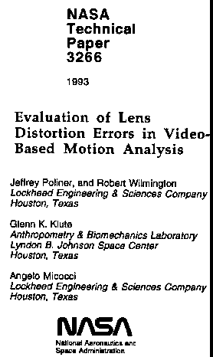
Video based motion analysis systems are widely used to study human movement. These systems use computers to aid in the capturing, storing, processing, and analyzing of video data. One of the errors inherent in such systems is that caused by distortions introduced by the camera and lens. Wide-angle lenses are often used in environments where there is little room to position cameras to record an activity of interest. Wide-angle lenses distort images in a somewhat predictable manner. Even "standard" lenses tend to have some degree of distortion associated with them. These lens distortions will introduce errors into any analysis performed with video-based motion analysis systems.
The purposes of this project were:
- 1. Develop the methodology to evaluate errors introduced by lens distortion.
______________________________________________________________________

Evaluation of Lens Distortion Errors Using
An Underwater Camera System
For Video-Based Motion Analysis
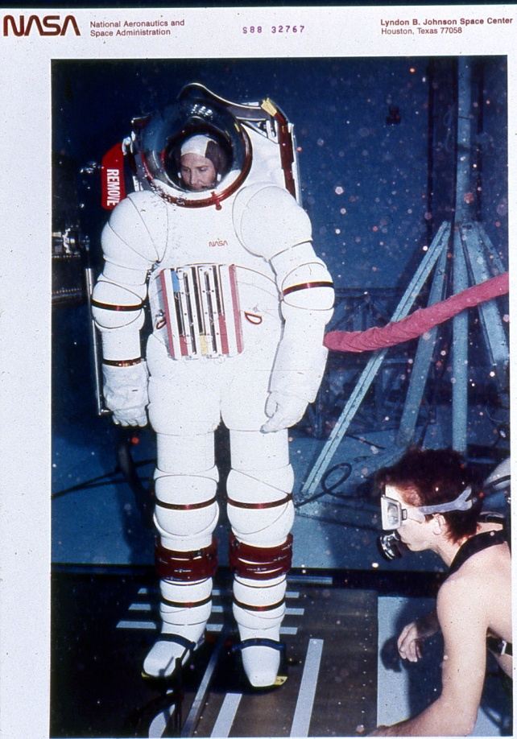

Jeffrey Poliner
Lockheed Engineering & Sciences Company
Houston, Texas
Lauren Fletcher & Glenn K. Klute
Lyndon B. Johnson Space Center
Houston, Texas

INTRODUCTION
Video-based motion analysis systems are widely employed to study human movement, using computers to capture, process, and analyze video data. This video data can be collected in any environment where cameras can be located.
<>
NASA Technical Memorandum 104795

THE INTERACTION OF THE SPACE SHUTTLE LAUNCH AND ENTRY SUIT AND SUSTAINED WEIGHTLESSNESS ON EGRESS LOCOMOTION

Principal Investigator
Michael C. Greenisen, Ph.D.
SD5/Space Biomedical Research Institute
NASA Johnson Space Center
Houston, TX 77058

Co-Investigators:
Gideon B. Ariel, Ph.D.
Visiting Scientist
Universities Space Research Association
John D. Probe, M.E.
Visiting Research Engineer
Universities Space Research Association
Suzanne M. Fortney, Ph.D.
SD5/Space Biomedical Research Institute
NASA Johnson Space Center
Houston, Texas 77058
Mark S. Sothmann, Ph.D.
Department of Human Kinetics
School of Allied Health Professions
University of Wisconsin
Milwaukee, WI 53201

Many more studies were performed utilizing the APAS system and some of the parameters that were discussed in my papers. Some of the studies had to be performed on the KC-135 plan that simulate Zero Gravity. For that, I had to go through space flight training that consists of “De Compression”; Performance under low oxygen environment. Awareness test in Zero Gravity environment, and some more tests. This was 3 days tests performance and written. There were 8 potential Astronauts in the group and some other research scientists that train to fly in the KC-135.
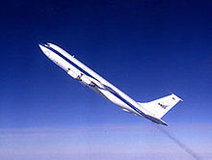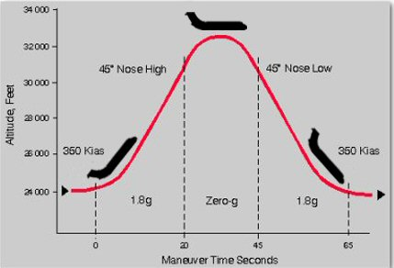
The KC-135 Plan and its path
The KC-135 also called the Vomit Comet….. Vomit Comet is a nickname for any fixed-wing aircraft that briefly provides a nearly weightless environment in which to train astronauts, conduct research and film motion pictures. Versions of such airplanes have in the past been operated by NASA Reduced Gravity Research Program where the unofficial nickname originated. NASA has adopted the official nickname Weightless Wonder for publication.
The aircraft gives its occupants the sensation of weightlessness by following an (approximately parabolic) elliptic flight path relative to the center of the Earth. While following this path, the aircraft and its payload are in free fall at certain points of its flight path. The aircraft is used in this way to demonstrate to astronauts what it is like to orbit the Earth. During this time the aircraft does not exert any ground reaction force on its contents, causing the sensation of weightlessness.
Initially the aircraft climbs with a pitch angle of 45 degrees. The sensation of weightlessness is achieved by reducing thrust and lowering the nose to maintain a zero-lift angle of attack. Weightlessness begins while ascending and lasts all the way "up-and-over the hump", until the craft reaches a declined angle of 30 degrees. At this point, the craft is pointed downward at high speed, and must begin to pull back into the nose-up attitude to repeat the maneuver. The forces are then roughly twice that of gravity on the way down, at the bottom, and up again. This lasts all the way until the aircraft is again halfway up its upward trajectory, and the pilot again initiates the zero-g flight path.
This aircraft is used to train astronauts in zero-g maneuvers, giving them about 25 seconds of weightlessness out of 65 seconds of flight in each parabola. In about two thirds of cases, this motion produces nausea due to airsickness, especially in novices, giving the plane its nickname.
In order to conduct some of the next series of experiments I had to pass the tests to fly the KC-135 and I did passed the tests and NASA issued me a certificate to this effect which made me qualified for the initial testing of being an Astronaut. Here is the certificate:
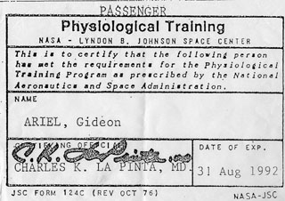
To date I am very proud of this achievement. And now I was qualified to run additional tests for NASA aboard the KC-135.
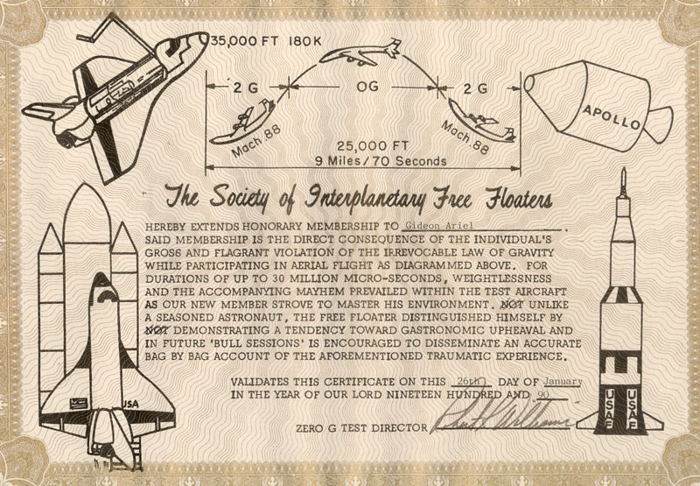
My Certificate of completing the flight on the KC-135
One of the studies was the effect of the astronaut suit on his mobility. We had to simulate number of flights on the KC-135 and than measure kinematic parameters demonstrated by the Astronauts.
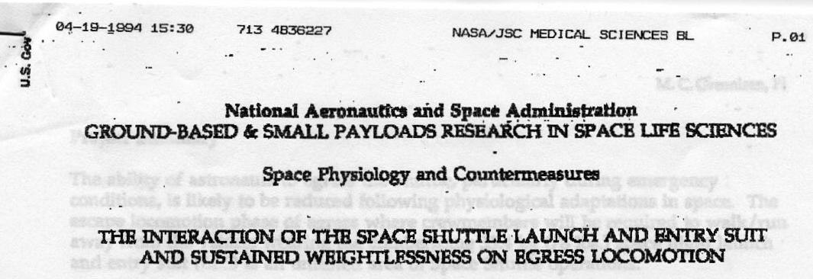
Principal Investigator: Michael C. Greenisen, Ph.D.
SD5/Space Biomedical Research Institute NASA Johnson Space Center
Houston, TX 77058
Telephone 713-483-3874, FAX 713-483-6227
Co-Investigators: Gideon B. Ariel, Ph.D.
Visiting Scientist
Universities Space Research Association Houston, TX
714-483-3874
Suzanne M. Fortney, Ph.D.
SD5/Space Biomedical Research Institute NASA Johnson Space Center
Houston, Texas 77058
Telephone 713-483-7213, FAX 713-483-6227
John D. Probe, M.E. Visiting Research Engineer
Universities Space Research Association
Houston, TX 77058
714-483-3874
Mark S. Sothmann, Ph.D.
Department of Human Kinetics School of Allied Health Professions University of Wisconsin
Milwaukee, WI 53201
414-229-5676
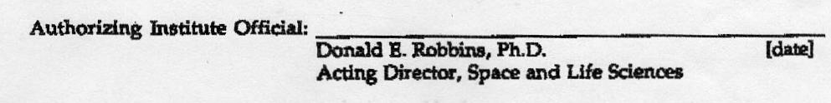
BIOMECHANICS IN SPACE AND THE DESIGN OF EXERCISE
AND ANALYSIS DYNAMOMETER AND SOFTWARE SYSTEM
AS AN IN/FLIGHT, 0-G, EXERCISE DYNAMOMETER
SYSTEM
Fitness technology, in both theory and practice, exhibits two problems common to many modern, rapidly emerging disciplines. First, a lack of clearly defined and commonly accepted standards has resulted in a marketplace rife with conflicting claims and approaches to both attaining and maintaining fitness. In general, both vendors and consumers of fitness technology have been unable to provide a sound scientific answer to the simple question, "Are we doing the right thing?" Second, a lack of the proper tools and techniques for measuring fitness and the effectiveness of a given technology to the attainment of fitness has made it quite difficult to evaluate existing products in order to select the ones that really work.
Some of the requirements to in/flight 0-G exercise dynamometer are as follows:
The flexibility of performing exercises and diagnostics in isotonic, isokinetic, isometric, accommodating velocity at variable loads as well as accommodating resistance at variable speeds or any combination of these exercise controlled modes.
The ability to perform exercises and diagnostics from a pre-programmed sequence of tests and exercises stored on disk. The investigator can prescribe for object, testing and rehabilitation programs from a library of specialized programs or create specific protocol tailored for that subject.
To offer user-friendly, menu-driven software packages which can be easily learned and are simple to operate.
Allows for data transfer to other commercial or custom software packages for extraordinary graphing, data report formats, statistical analysis, etc.
Allow for external analog data acquisition that can be correlated with the acquired force curves such as E.M.G. data and load cells.
All dynamometer functions can be controlled or monitored either from the keyboard, hard disk storage, or a remote location, via telephone modem and satellites.
Biomechanics in space is fundamental to understanding the work performance capabilities of humans in space. Biomechanics as practiced by NASA has the primary goal to conducting operationally-oriented research focusing on maximizing astronaut on-orbit performance capabilities.
The purpose of biomechanical analysis in space is to provide a program of exercise countermeasures that will minimize the operational consequences of microgravityinduced deconditioning. Biomechanical analysis of movement in space will provide individualized exercise "prescriptions" for each crew member to optimize required tasks in microgravity environment. Through characterizing the tasks requirement in the musculoskeletal and neuromuscular systems induced by microgravity, develop training protocols to address deconditioning in these systems that will serve as the basis for training prescriptions.
To achieve these training protocols it is necessary to develop flight exercise hardware and associated software related to biomechanical measurement devices.
Critical Questions:
Some of the critical questions to be addressed the present goals are:
- What type of exercise devices such as weight training, bicycling, rowing, swimming, running, etc. are necessary to train all of the organ systems affected by deconditioning?
- Which indices are the most reliable indicators of changes in fitness?
- Which reliable indicators of changes in fitness best describe the changes caused by deconditioning?
- How does training in microgravity differ from training in 1-G ?
- What are the differences between training that includes impact forces and training that uses non-impact forces?
- Can an artificial intelligence expert system be developed to aid in monitoring, controlling, and adjusting prescriptions?
- How does inflight exercise training affect the adaptation process?
- Which muscle groups are critical in the performance of egress, landing, and EVAs?
- 9. Which of the indicators of microgravity-induced change in muscle function can be correlated with possible difficulty in performing egress, landing, and EVAs?
- These are few of the questions to be answer to understand the possible countermeasures to be efficient.
- On Wednesday, September 20, 1989, the following 23 topics were suggested by members of the Biomechanics group, of which I was one of the members:
- Identify and analyze tasks by mission.
- Focus studies to examine the functions of upper extremities during space flight.
- Integration of Biomechanics and Physiology to
- fully understand "the complete picture."
- Examine the use of power tools to enhance performance and reduce fatigue of the crew members.
- Compare the use of a robotic hand to EVA crew interaction.
- Investigate "tweaking" existing tools to a give a greater mechanical advantage.
- Use of the prediction of work and tools required to perform a given task.
- What jobs/tasks are needed on orbit?
- What are the energy expenditures for on orbit activity.
- Comparison of perceived target accuracy and spatial orientation to actual target accuracy and spatial orientation.
- Comparison of gross tasks to fine motor control.
- Quantify performance of metabolism, muscles, forces, etc.
- Determination of the scope of biomechanics
- operations vs. those of medical science.
- Evaluation of muscle, EMC, etc. of crew members. Evaluation of hormones and metabolic information.
Investigation of hardware issues such as the development of a universal tool.
Integration of protocols including recovery, strength, power, endurance, and frequency.
Development of work related tests incorporating dynamometers, force plates, etc.
definition of specified joint axes.
Investigation into the use of a robot glove as an extension of the space suit.
Development and use of a flight qualified dynamometer and determination of what information should be measured (i.e. power, endurance, etc.).
Development of an immediate recovery dynamometer to measure post-flight crew strength.
At the present time the following biomechanics prioritized research objectives are designed for immediate research projects:
Flight Dynamometer
- on-orbit data collection
- EVA tools/work tasks
-single joint articulations
Task Analysis and Efficiency (IVA/EVA)
- upper body work tasks
- mechanical efficiency
- metabolic efficiency -psychomotor efficiency/accuracy
Biomechanical Performance and Modeling Predictions
-prediction model vs actual performance
- integrate biomechanics with physiology -movement notes
Biomechanical Countermeasures
- short arm centrifuge
- skeletal system impact loading
- vertebral column/locomotion skeletal muscles
Biomechanics of Space Suit Assembly
- development of flexible, high performance space suit
- glove design
Telescience, Automation, and Tool Design
- development of robotic tools to perform some tasks -power tools (smart tools)
- increase mechanical advantage of existing tools
- development of universal tool
Human Motor Control Strategy -training
- subject feedback
TASK ANALYSIS OF LANDING AND NORMAL EGRESS
Objectives:
- Identify the normal biomechanical and kinematic requirements of landing and walk-out of shuttle egress using video motion analysis.
- Identify specific tasks associated with individual crewmembers during ELE.
- Quantify the forces of gait during normal walkout egress.
- Suggest physiological parameters that might be tested in a laboratory that may mimic tasks that are performed during landing and normal walk-out egress.
The following is one of the biomechanical studies to evaluate landing and normal egress.
ABSTRACT: This study requires using the astronauts preflight; during egress training, and postflight; during landing, (out of seat egress) and during normal exit from the shuttle to a ground level. A total of ten (N=10) manifested astronauts are requested, five Pilots and 5 Mission Specialists, to participate so that comparisons can be made on post mission walk-out performance.
Video cameras and force plate instrumentation will record simulated tasks associated to landing and egress during normal training in the high fidelity mockup. During training, crew will be video recorded as they perform the actual tasks that will be idiospecific to their flight tasks. Normal, walk-out of orbiter, egress will also be video recorded, however, specifying that the first 3-4 steps on level ground be done on the Force Plate for force patterning and gait analysis. At landing, video cameras in the orbiter will record landing procedures in upper and middecks and for out of seat egress. Additional video cameras will also record normal walk-out egress from the orbiter with the first 3-4 steps on level ground being done on the Force Plate. This study is the first of several studies to scientifically quantify the forces, movement patterns, center of gravity and force velocities of motion during landing and egress tasks. This base investigation shall be further expanded to evaluate ground based emergency egress of volunteer subjects and counermeasure interaction and effectiveness on egress performance of astronaut crewmembers.
The ability to simulate real task activities for comparison of strength and endurance in 1 and 0 Gs.
All exercise program variables, such as intensity, frequency, duration, sets, work load, percent fatigue, can be controlled and changed from the control keyboard or by remote modem.
The software is an artificial intelligence expert system that monitors, controls and adjusts prescriptions according to the measured output of the exerciser.
Mechanism for the Required Dynamometer:
A standard hydraulic cylinder is attached to an exercise bar by a mechanical linkage. As the bar is moved, the piston in the hydraulic cylinder moves pushing non inflammable liquid out of one side of the cylinder, through a valve, and back into the other side of the cylinder. When the valve is fully open there is no resistance to the movement of the liquid and thus no resistance to the movement of the bar. As the valve is closed, it becomes harder to push the liquid from one side of the cylinder to the other and thus harder to move the bar. When the valve is fully closed, liquid cannot flow and the bar will not move. In addition to the cylinder, the resistance mechanism contains sensors to measure the applied resistance mechanism contains sensors to measure the applied force on the bar and the motion of the bar. Now assume the valve is at some intermediate position and the bar is being moved at some velocity with some level of resistance. If the computer senses that the bar velocity is too high or that bar resistance is too low, it will close the valve by a small amount and then check the velocity and resistance values again. If the values are not correct, it will continue to close the valve and check the values until the desired velocity or resistance is achieved. Similarly if the bar velocity is too low or the bar resistance is too high, the computer will open the valve by a small amount and then recheck the values. This feedback loop will continue with the valve being opened by small amounts until desired velocity or resistance is achieved. The feedback cycle occurs hundreds of times a second so that the user will not experience perceptible variations from the desired parameters of exercise.
There are a number of advantages in such a resistance mechanism. One significant advantage is safety. The passive hydraulic mechanism provides resistance only when the user pushes or pulls against it. The user may stop exercising at any time, such as during rehabilitation if pain or discomfort is experienced, and the exercise bar will remain motionless. Another advantage is that of bidirectional
exercise. the hydraulic mechanism can provide resistance with the bar moving in either direction.
This computer controlled exercise device has been designed to consider every movement or exercise performed by a user to be a pattern of continuously varying velocity or resistance. This pattern may be set using direct measurement of subject motion by the system, it may be copied from the results of performance analysis, or the pattern may be "designed" or created by the user or practitioner as a goal of training or rehabilitation. Exercise patterns are stored in computer memory and can be recalled and used each time a subject trains. During exercise, the computer uses the pattern to adjust bar velocity or bar resistance as the subject moves through the full range of motion. In this manner, the motion parameters of almost any activity can be really duplicated by the exercise system. Thus, assessment, training, or rehabilitation may be performed using the same pattern as the activity itself.
INTEGRATION OF PERFORMANCE ANALYSIS AND COMPUTERIZED
EXERCISE IN ACHIEVING OPTIMUM FITNESS
The value of applying the principles of biomechanics to the assessment of fitness in space has been clearly demonstrated. Performance analysis provides the means to quantify human activity and to provide insight into the mechanisms that contribute either to superior or inferior levels of performance. At the same time, it has been shown that fitness technology has been presented that permits exercise and countermeasure means patterns to biomechanically duplicate the target activity.
The integration of movement analysis with measurements such as E.M.G. activity with forces measured in load cells and force plates allow to analyze the astronauts in various gravitational conditions and allow the design of optimal technique and equipment to optimize space missions.
Another study was conducted to find out the accuracy of the APAS System:
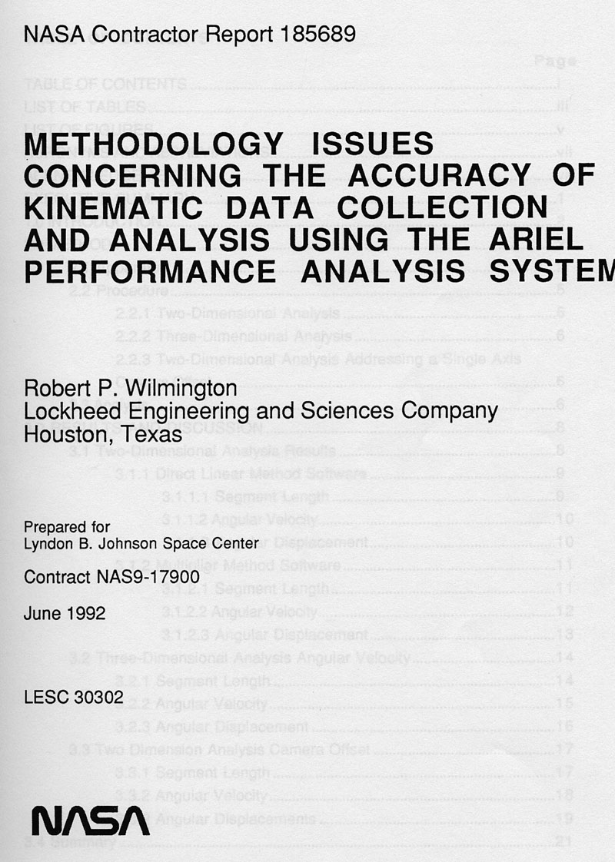
EXECUTIVE SUMMARY
Kinematics, the study of motion exclusive of the influences of mass and force, is one of the primary methods used for the analysis of human biomechanical systems as well as other types of mechanical systems. The Anthropometry and Biomechanics Laboratory (ABL) in the Crew Interface Analysis section of the Man-Systems Division performs both human body kinematics as well as mechanical system kinematics using the Ariel Performance Analysis System (APAS). The APAS supports both analysis of analog signals (e.g. force plate data collection) as well as digitization and analysis of video data.
The current evaluations address several methodology issues concerning the accuracy of the kinematic data collection and analysis used in the ABL.
This document describes a series of evaluations performed to gain quantitative data pertaining to position and constant angular velocity movements under several operating conditions. Two-dimensional as well as three-dimensional data collection and analyses were completed in a controlled laboratory environment using typical hardware setups. In addition, an evaluation was performed to evaluate the accuracy impact due to a single axis camera offset.
The specific results from this series of evaluations and their impacts on the methodology issues of kinematic data collection and analyses are presented in detail. The accuracy levels observed in these evaluations are also presented.
A very important study was performed by us related to Entry to Earth functions:
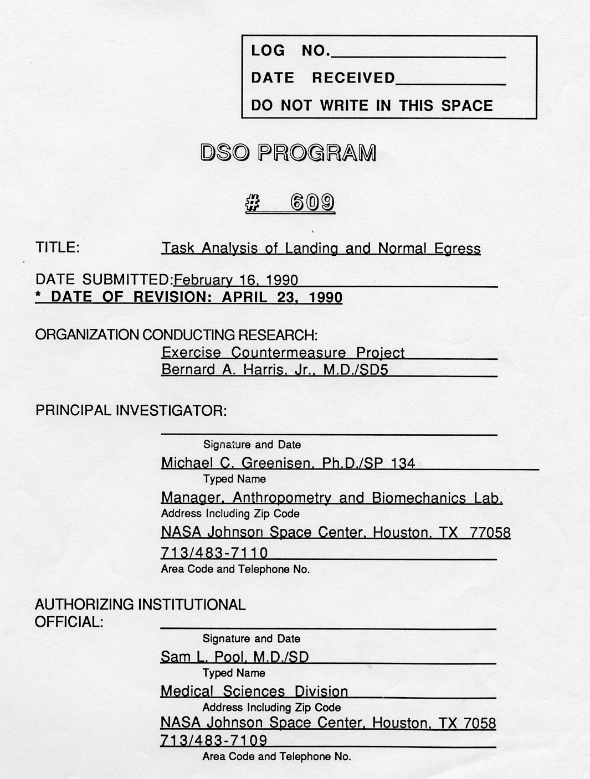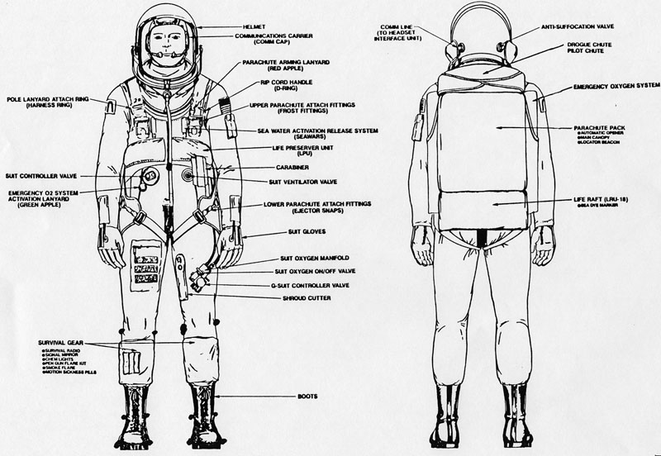
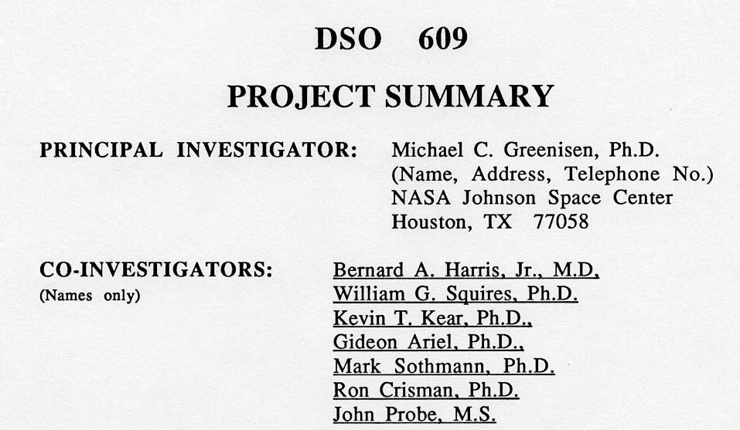
TITLE: Task Analysis of Landing and Normal Egress
ABSTRACT: Single-spaced, typed within the box below. Paragraphs (a)-(b) should include: (a) brief statement of the overall objective and relevance of the work and, (b) brief listing of what will be done during the award period and the approach to be used. (One additional continuation page may be used.)
This study requires using the astronauts preflight during
egress training, and postflight during landing, (out of seat egress), and during normal exit from the shuttle to ground level. A total of
ten (n=10) assigned astronauts are requested, five pilots and five mission specialists or Payload Specialists to participate so that comparisons can be made on post mission out of seat and walk-out egress performance. Video cameras and force place instrumentation will record simulated tasks associated to landing and egress during normal training in the Full Fuselage Training (FFT) or the Crew Compartment Trainer (CCT). After egress training and during practice of simulated egress, crewmembers will be video recorded as they perform the actual tasks that will be idiospecific to their flight tasks. Normal, walk-out of orbiter, egress will also be video recorded to a distance of 10 meters from the orbiter; however, specifying that the first three to four steps on level ground be done on the force plate for force patterning and gait analysis. During landing, video cameras in the orbiter will record task procedures in upper and mid decks and for out of seat egress. Additional video cameras will also record normal walk-out egress from the orbiter (down the stairs) to a distance of 10 meters with the first three to four steps placed on the force plate. at ground level. It is imperative during the walk-out phase that the 10 meter area be cleared so as to provide
unobstructed camera views of the crewmembers from both side of the stairs along with a front view, with cameras pointed directly at the stairs. (Refer to appendix for illustration)
This study is the first of several studies to scientifically quantify the forces, movement patterns, center of gravity, limb acceleration and force velocities of motion during landing and egress tasks. This base investigation of normal egress shall be further expanded to evaluate ground-based emergency egress of volunteer subjects. Other investigations will be added to include the effect of countermeasure interaction and effectiveness on volunteers egress performance time and that of astronaut crewmembers.

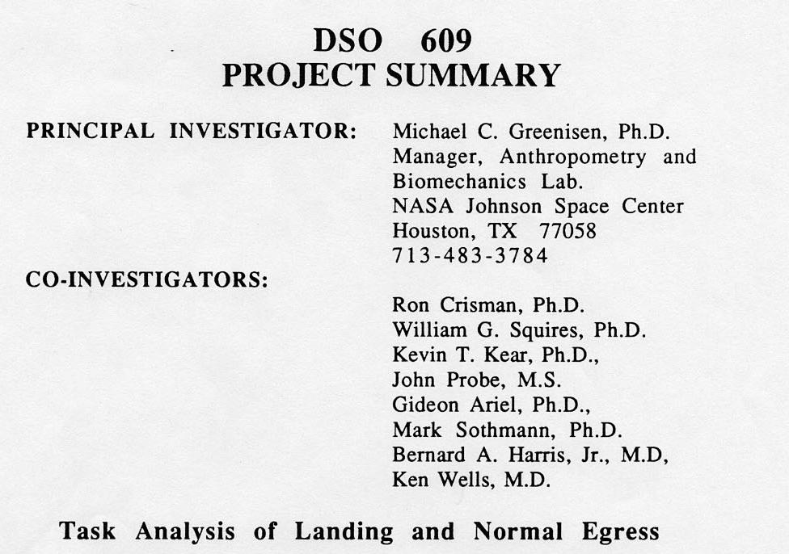
SUMMARY: The ability of astronauts to egress the Shuttle,
particularly during emergency conditions. is likely to be reduced following physiological adaptations in space. The tasks and Wye? 7
conditions of egress must be analyzed to provide standards for evaluation and optimum performance. These requirements have immediate application to crewmember safety and mission
completion.
It is well established that effective application of exercise counter measures requires the exercise be applied specifically. The problem is that objective scientific evidence is not available to validate which specific counter measures are most effective in support of egress.
The purpose of this study is to analyze the tasks (document the logical sequence of events from video recordings) for astronauts to accomplish Shuttle landing and normal egress. This task analysis will then be used to build a computer network model. Forces required to accomplish events and the timing of event sequences for the computer model will be performed by biomechanical analyses. Astronaut performance on tasks for Shuttle landing and normal egress, video recorded before and after missions, will be compared.
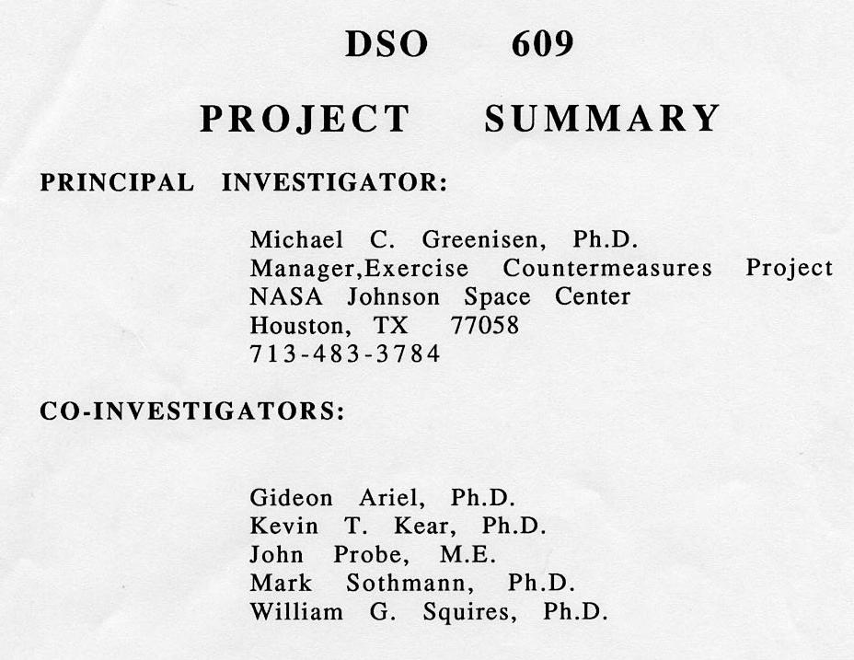
Biomechanical Analysis of Task Requirements Associated With Entry, Landing and Normal Egress
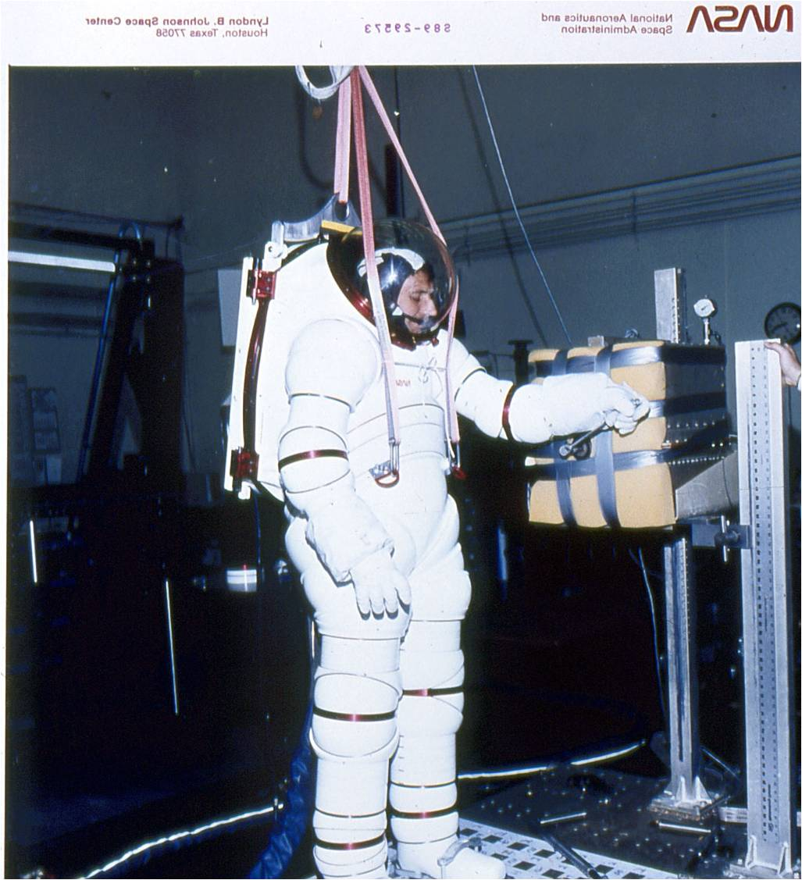
S UM M A R Y: The ability of astronauts to egress the Shuttle, particularly during emergency conditions, may be reduced following physiological adaptations in space. This
concern is based on anecdotal information. The tasks
inherent to egress must be systematically documented to
identify the critical issues for subsequent study. This
investigation has immediate application to crewmember
safety for mission success and completion. The results will
also provide information discerning critical issues facing the Exercise Countermeasures Project for the development of appropriate countermeasure protocols and hardware.
The specific purpose of this initial investigation is to document the performance of physical tasks (logical sequence of events from video recordings) for astronauts to
accomplish Shuttle landing and normal egress. The activities required to accomplish events and the timing of event sequences will be documented by kinematic analyses.
Data pertaining to Astronaut performance on tasks for Shuttle entry, landing and normal egress, will be video recorded before and after missions. Subsequent
investigations will focus on emergency egress and on exercise countermeasure development. Two EDO missions are
requested with four subjects per STS flight. Furthermore, one commander and the three crewmembers at seats MS1, MS2, and MS3 are requested to participate.
This study requires video recording astronaut performance during entry landing and normal walk-out egress of the Shuttle in two phases:
- Preflight during simulated entry, landing and normal egress in a simulator.
- Postflight during actual entry, landing and normal walk-out egress.
A total of eight assigned astronauts (n=8) are requested to participate in this investigation.
Phase I. (SIMULATED )
After training in the Shuttle simulator to asymptotic performance, crewmembers will be video recorded while performing simulated tasks specific to their flight requirements. These recordings will be during flight tasks
associated with entry, landing and normal egress. Shuttle
egress will be video recorded during seat exit, orbiter exit, and walking exit to a distance of 10 meters from the
orbiter. The first four steps at ground level will be on force
plates to determine force patterning for gait analysis.
Phase 2. (ACTUAL)
After Shuttle missions, crewmembers will be video recorded while performing actual flight tasks associated with entry, landing and normal egress, identical to Phase 1.

From all the studies it was apparent that we need to construct an exercise machine for the Astronauts to train in space. We at Ariel Dynamics were working on this device for years. The construction of the device was based on the following requirements:

The Computerized Resistive Exercise Dynamometer
By
Gideon B. Ariel, Ph.D. and M. Ann Penny, Ph.D.
March, 1991
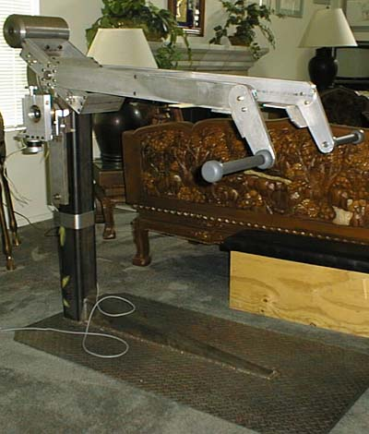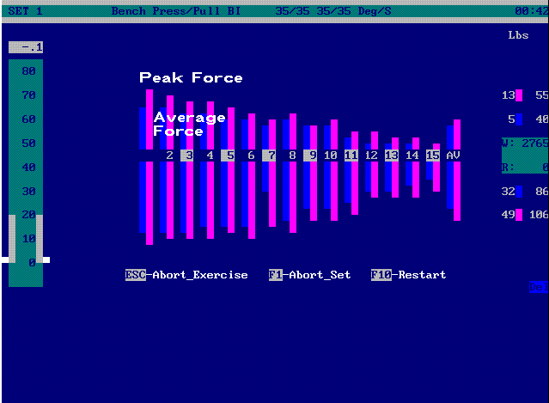
Original Prototype for the RED presented to NASA in 1989
1. IDENTIFICATION AND SIGNIFICANCE OF THE INNOVATION
The goal of this proposal is to develop a computerized, feedback-controlled, portable, battery-powered, hydraulic dynamometer which can be used in normal, reduced-g, and zero-g environments. The proposed device will provide a closed-loop feedback system to measure and control various muscular strength parameters. The innovativeness of this device includes (1) the ability to measure muscular strength without the limitations imposed by traditional weight-related devices; (2) computerization of both the feedback control feature, allowing adjustment of the device to the individual rather than the individual accommodating the device, and customization of the diagnostic and exercise protocols with data storage capabilities; (3) low-voltage, (4) portability, and (5) compactness. The relevance of the proposed equipment for NASA lies in its ability to evaluate astronaut strength and endurance levels as well as to design and follow appropriate exercise protocols in all gravitational environments. Data can be stored for later evaluation and for use in conjunction with other medical or physiological assessments in the continual effort to identify and counter the deconditioning caused by microgravitational conditions.
Physical fitness and good health have become increasingly more important to the American public, yet there exists no compact, affordable, accurate device either for measurement or conditioning human strength or performance. This deficit hinders America's ability to explore the frontiers of space as well. Without appropriate means to measure physical force requirements under zero-g conditions and without appropriate equipment for training for these task-related activities as well as against the deleterious physiological effects of microgravitational deconditioning, America's permanent manned presence in space will be severely restricted.
One of the ways the human body reacts to the reduced physiological and mechanical demands of microgravity is by deconditioning of the cardiovascular, musculoskeletal, and neuromuscular systems. This deconditioning produces a multitude of physical changes such as loss of muscle mass, decreases in body density and body calcium, decreased muscle performance in strength and endurance, orthostatic intolerance, and overall decreases in aerobic and anaerobic fitness [1]. The biomedical reports from the Gemini, Apollo, and Skylab missions and the work of Thornton and Rummell [2] have revealed a severe problem of reduced muscle mass and strength loss of the lower extremities following prolonged periods in microgravity. Since mission operations normally require relatively greater load demands for the arms and upper body than for the lower extremities, these findings were considered reasonable and not unexpected. However, the use of a bicycle ergometer on Skylab 2 was unable to provide sufficient aerobic exercise to maintain leg strength at earth-based, or 1-g, levels since it could develop neither the type nor the level of forces necessary. Devices which provided isokinetic resistance were employed on Skylabs 3 and 4 which resulted in higher leg force results than those generated in Skylab 2, but were limited to an inadequate level [3].
A review of the effects of strength training on human skeletal muscle suggests that the benefits of appropriate training would favorably counteract the negative effects of weightlessness. In general, strength training that uses large muscle groups in high-resistance, low-repetition efforts increases the maximum work output of the muscle group stressed [4]. Since resistance training does not change the capacity of the specific types of skeletal muscle fibers to develop different tensions, strength is generally seen to increase with the cross-sectional area of the fiber [5]. This may suggest an important finding in the effort to reduce or prevent the loss of muscle strength associated with reduced-g exposures. It may be that resistance training with the resultant hypertrophy would be an effective countermeasure for strength loss.
Since the cause of space deconditioning is usually attributed to the absence of gravity, the development of countermeasures is essential to interrupt these adverse adaptational effects and to develop activities which will sustain normal, robust fitness, conditioning, and good health. While experiments on the Gemini, Apollo, and Skylab missions suggest that regular exercise was helpful in minimizing several aspects of spaceflight deconditioning [6,7,8] there is a lack of quantifiable measures of specificity and amount of physical exercise performed by crew members during flight. Quantification of optimal intensity, frequency, and duration of exercise during spaceflight is of utmost importance for manned missions, yet "no data exists that provides even the slightest clue as to what the forces and impact load of locomotion are in microgravity" [3].
Countermeasures are efforts to counteract the physiological problems caused by exposure to zero-g by interrupting the body's adaptation process. Effective countermeasures will promote mission safety, maximize mission successes, and maintain optimum crew health [1]. Specific recommendations required by space missions were identified by participants at "The Manned System - A Human Factors Symposium and Workshop" sponsored by the American Astronautical Society. The need for appropriate fitness and recreation facilities, methods, and long-duration micro-gravity effects on EVA performance were identified as important topics by such diverse areas as habitat engineers, operation managers, EVA researchers, and the members of the Biomechanics group. The need for appropriate performance protocols as well as the development of a flight qualified dynamometer was emphasized.
The proposed equipment is intended for use as an effective countermeasure tool as well as addressing several of the operational restrictions imposed by spaceflight. Utilization of a hydraulic mechanism will provide a means for adequately creating resistance thus overcoming the ineffectiveness of weight-based equipment in zero-g. The apparatus will be compact, portable, and powered by low-voltage DC batteries which eliminates the need for shuttle power. These attributes are deemed necessary for easy and safe use in the restricted confines of the shuttle or on the space station. Computerization will provide several important innovations: (1) Activities performed will be programmable for "individualized" diagnostic routines and/or exercise protocols with results stored for subsequent evaluations. (2) The feedback control afforded by rapid computerized assessment and adjustment will ensure that the equipment will adjust to the performance levels of the astronaut rather than the reverse. Individualized adjustment assures that size and/or gender are irrelevant for successful operation. (3) Activities can be designed bi-directionally since resistance will be provided in both directions of bar movement. (4) Graphic displays and audio cues will provide information to the individual with such items as current strength level, repetition number, and bar location. The sound cues will be modulated in proportion to the exerted force in order to inform the individual about his or her performance response without the need to see the computer monitor. This will simplify operation as well as providing biofeedback. One of the most important features of the proposed device will be its functionality under all gravitational fields. Thus, medical and physiological researchers can design and test models on earth with the ability to recreate and evaluate the same models under reduced-g conditions.
The proposed device is specifically envisioned for application in musculoskeletal activities such as strength and endurance. However, its use as a criterion measure in quantification and/or verification of task performances in research strategies concerning bone demineralization, leg compliance, muscle size, and leg volume, may be appropriate. For example, the NASA Exercise Countermeasure Project Task Force, chaired by William G. Squires, Ph.D., determined that the validity and effectiveness of exercise countermeasures will be determined from the results of inflight studies and that the elucidation of the basic mechanisms from space- and earth-based research would develop specific acute and chronic exercise regimens to counteract physiological dysfunctions. The proposed Computerized Portable Dynamometer would appear to be an appropriate measurement device for such research.
2. PHASE I TECHNICAL OBJECTIVES
The goal of Phase I is to develop an operational computerized, feedback-controlled, portable, battery-powered, hydraulic dynamometer for use in 1-g conditions. The specific objectives required to accomplish this task are as follows:
(1) Objective 1. To select a portable, battery-powered computer which has the capability of interfacing with a Controller board used for analog to digital signal processing and dynamometer control. Additional attention will focus on disk storage capacity, secondary storage mediums, such as floppy drives, and visual display characteristics.
(2) Objective 2. To develop software on the computer identified in Objective 1 to operate the dynamometer.
(3) Objective 3. To test both the developed software and the portable computer on an existing device that utilizes a hydraulic valve, pack, and cylinder unit with an attached bar. Force and position transducers will provide the analog input signals.
(4) Objective 4. To test the calibration of the proposed dynamometer device using known weights.
(5) Objective 5. To conduct a simple experimental test using a squat exercise (a standing knee extension/flexion motion) to demonstrate both the feasibility and the functional capacities of the proposed device.
The two major feasibility questions to be answered in Phase I are: (1) Is there a portable, battery-powered computer commercially available with sufficient speed, memory, and storage capabilities, and which has the capacity to interface with a customized analog-to-digital (Controller) board, to support the proposed dynamometer? (2) Can appropriate software be written for the proposed dynamometer to control, assess, and store data required for evaluation and testing the human muscular strength and endurance functions previously discussed? The software considerations are not trivial. For example, several problems to be overcome include (a) the power requirements of the computer, the Controller board, and the transducers must be satisfied more efficiently than with the greater capacities afforded with external power supplies of larger computers, (b) rapid computer processing requires innovative programming code to afford smooth response for real-time feedback control, and (3) the flat panel monochrome display characteristics associated with portable, built-in single monitor computers present a unique challenge concerning the speed and esthetic qualities for the interactive visual medium.
During Phase I, the proposed dynamometer will be developed for earth-fixed environments. All information generated and developed in Phase I will be utilized in Phase II expansions. In Phase II, the proposed dynamometer will be developed on a portable, battery-powered computer with the capability of connecting the Controller board through an expansion bus. A specialized Controller board will be designed to fit within the designated computer and will be enhanced to allow additional analog input devices such as electromyography (EMG) and/or force plate data. During Phase II, attention will be given to developing a variety of options for force measurements by simple and creative orientations of the hydraulic cylinder with the bar, or handle, or other human/machine interaction points. Particular emphasis will be placed on mechanical designs appropriate for tests conducted in the restricted dimensions of reduced-g and zero-g workspaces. More extensive software attributes will be developed during Phase II as well. The developed product will be directed for use on shuttle flights, for a future space station, for lunar or Mars colonization, and for use as a measurement tool in the NASA research testing programs, such as examining neuromuscular forces, muscular strength, conditioning and deconditioning, habitat facilities, EVA studies, and others. Subsequent commercial use seems particularly applicable in instances where physical space is limited.
3. PHASE I WORK PLAN
The most important goal of the Phase I efforts is the production of adequate software on an appropriate portable, battery-powered computer to demonstrate the operational capabilities of the proposed dynamometer project successfully and sufficiently. An acceptable portable computer will be attached to an existing hydraulic pack and cylinder unit with an attached bar. The position and force transducers will provide the input signals through the Controller board. A simple experimental study will be conducted to compare force results registered by the dynamometer with those simultaneously secured on a force plate. The following presentation more fully describes the details for each of the essential components.

a. Computer.
The physical characteristics of the computer are of paramount importance in the microgravitional workspaces where the proposed dynamometer project is targeted for ultimate use. The dynamometer must be able to obtain force measurements, throughout a range of movement, as well as to provide a means of controlling the velocity or the resistance generated by the user. The performance criteria of the proposed dynamometer necessitate rapid computer processing speed, adequate memory, and rapid analog to digital conversions. The computer must be portable, as light-weight as possible, possess graphics display capability, and it must function on its own battery power which will eliminate any need for shuttle power. To insure sufficient speed, the computer must have an 80386SX or higher processor which has an Industry Standard Architecture (ISA) bus. It is anticipated that four (4) megabytes of memory will be sufficient for Phase I. Both a hard disk and at least one other storage medium, such as a floppy disk, are essential to ensure preservation of data, particularly that secured during zero-g missions. Compatibility with an external signal processing board is required. In Phase I only, the use of an expansion chassis to house this external board may be necessary but is not anticipated. A currently available customized Controller board will be used during the Phase I feasibility study. Any modification of this board for Phase I uses will be minor.
Because of the compactness of design and the ability to operate with a single monitor, either with or without a "Windows" environment, it is anticipated that one of the "laptop" computers will be selected for the proposed project. Because of the rapidly changing technologies in the commercially available computer hardware, selection of the specific computer to be used in Phase II will be postponed until that time. The computer selected for Phase II will be required to have provisions for an internal expansion slot for inclusion of a specially designed Controller board.
b. Controller Board.
The Controller board consists of specialized electronics which will perform analog-to-digital (A/D) conversions of the input signals received from both the position and the force transducers. Analog input signals are the standard characteristic of these sensory devices. The Controller board also has the appropriate electronics for controlling and powering the resistive mechanism of the dynamometer. Processing of the two analog input devices as well as transmission of the subsequent software generated digital signal to regulate the stepper motor attached to the hydraulic valve and cylinder unit must be rapid and precisely regulated for accurate and smooth performance results.
The Controller board utilized for the Phase I dynamometer will be an existing customized board and any modifications will be minor. However, a specialized board will be developed for the Phase II dynamometer product. The Controller board connects to the ISA bus of the computer, which powers both the controller board and the dynamometer. This is a very ambitious plan which requires that the Controller board be designed to require an absolute minimum of power so that the computer's batteries are not overly taxed. A worse case scenario would require that an additional, separate battery supply be incorporated into the design in Phase II. However, the additional battery would not appreciably increase the weight nor necessiate shuttle power. Further enhancements under consideration for Phase II include providing additional optional channels for securing EMG, heart rate, EKG, blood pressure, and/or other analog signal data.
c. Dynamometer Frame Mechanism.
In Phase I, an existing frame will be utilized for testing the proposed computer and software developed. In Phase II, a dynamometer frame will be developed which is compact and light-weight with a target weight of less than 10 kilograms. This is an ambitious design goal which will require frame materials to have maximum strength-to-weight ratios and the structure must be engineered with attention directed towards compactness, storage size, and both ease and versatility of operation. An additional consideration during Phase II development is to have the entire system readily adaptable to flight specifications.

d. Force and Position Transducers.
Existing transducers available commercially will be utilized for the proposed Phase I dynamometer project. The function of these input devices is to supply information to the computer relative to the location of the bar or handle against which the individual is exerting force as well as the amount of that force. This information must be provided rapidly enough for the computer to process the input signal and respond with an adjustment, if needed, to the hydraulic valve assembly so that the internal response adjustments are undetectable by the individual using the device. A characteristic essential to the proposed dynamometer is that the individual exerting force perceives only smooth operation and is insulated from any detection of hardware and/or functional adjustments. The continual exchange of data between input sensors and the regulation of the hydraulic system is one of the most crucial segments of the software programs to be prepared during the Phase I portion of the product development.
e. Hydraulic Valve, Pack, and Cylinder Unit and Stepper Motor.
An existing hydraulic valve, pack, and cylinder assembly which is currently integrated with an existing, commercially available stepper motor will be modified for use in the Phase I project. A stepper motor is attached to a hydraulic valve assembly which opens and closes an orifice regulating the flow of hydraulic fluid, thus controlling the amount of force needed to push or pull the piston within the cylinder. Since the main thrust of Phase I is to develop sufficient software capabilities on a portable, battery-powered computer to demonstrate the ability to measure and store forces, the development of a specialized hydraulic device with its related valve controls will be postponed until Phase II.
During Phase II, the design of a smaller and lighter hydraulic valve, pack, and cylinder assembly is envisioned. A further consideration is to use a flight-qualified fluid which would be more appropriate for microgravitational locations, such as in the shuttle or space station. Consideration of alternative resistive mechanisms have been abandoned because of the limitations imposed in zero-g conditions. Weight-based devices would have no value under reduced-g or zero-g conditions. Pneumatic resistance was rejected because of the pressure requirements, the problems associated with compressibility of gases, the difficulties associated with accuracy and calibration of measurements, and the need for pressurized cylinders. Hydraulic mechanisms are less affected by gravitational forces, can be regulated by low voltage, battery powered devices, can operate in both up and down stroke directions, and can function passively. Consideration of an "active" hydraulic system, which would provide conditions in which the individual would have to resist forces generated by the dynamometer, were rejected for the following reasons: (1) user safety, (2) decision against employing any motorized devices within zero-g workspaces for environmental safety considerations, and (3) more than sufficient and adequate results are obtainable with "passive" mechanisms.
f. Software.
Since one of the primary objectives in Phase I of the proposed dynamometer project is both to assess force levels throughout a range of motion and to provide a mechanism for conditioning, the initial software efforts will concentrate on this task. The software for the proposed dynamometer project must be capable of performing a variety of measurements as well as controlling repetitive movements and storing the generated data. Control of the hardware must be rapid and accurate to ensure smoothness of response. There must be appropriate means to interact with the individual and to access the resulting data. The proposed software developments should be considered on two levels. One level of software will be invisible to the individual using the dynamometer device since it will control the various hardware components. The second level of software will allow user/computer interaction. The computer programs necessary to provide the real-time feedback control, the data program and storage, and the additional performance manipulations will be extensive. A large portion of the software for the proposed project currently exists but operates on a larger and faster computer system. Although the proposed project constrains the software to provide smooth, feedback-controlled operation with a smaller, less powerful computer, new or revised programming code will be completed by the appropriate personnel within the time frame allocated in Phase I.
The software which provides computer interaction with the individual operator should automatically present a menu of options when the dynamometer system is activated. The menu will include at least four options: (1) diagnostics, (2) controlled velocity, (3) controlled resistance, (4) controlled work. In all cases, motion will be regulated in both directions, that is, when the bar moves up and down. Each of these four options will be briefly described in the following sections. In Phase I, the exercise selected for use will be restricted to a standing vertical leg extension task and the descriptive sections are oriented from this frame of reference.
Selection of the diagnostics option will allow several parameters about that person to be evaluated and stored if desired. The diagnostic parameters will be the range of motion, the maximum force, and the maximum speed that the individual can move the bar for the specific Phase I test activity selected. The maximum force and maximum speed data will be determined at each discrete point in the range of movement as well as the average across the entire range. The diagnostic data could be used solely as isolated pre- and post-test measurements. However, the data can also be stored within the person's profile so that subsequent actions and tests performed on the dynamometer can be customized to adjust to that specific individual's characteristics.
The controlled velocity option will permit the individual to control the speed of bar movement. The pattern of the velocity will be determined by the person using the equipment and these choices of velocity patterns will include: (1) isokinetic, which will provide a constant speed throughout the range of motion; (2) variable speed, in which the speed at the beginning of the motion and the speed at the end of the stroke are different with the computer regulating a smooth transition between the two values; and (3) programmed speed, which will allow the user to specify a unique velocity pattern throughout the range of movement. For each of the choices, determination of the initial and final velocities will be at the discretion of the individual through an interactive menu. The number of repetitions to be performed will also be indicated by the person. It will be possible to designate different patterns of velocity for each direction of bar movement.
The controlled resistance option will enable the person to control the resistance or amount of force required to move the bar. The alternatives will include: (1) isotonic, which will provide a constant amount of force for the individual to overcome in order to move the bar; (2) variable resistance, in which the force at the beginning of the motion and the force at the end of the movement are different with the computer regulating a smooth transition between the two values; (3) programmed resistance, which will permit the individual to specify a unique force pattern throughout the range of movement. An interactive menu will enable the person to indicate the precise initial and final values, the number of repetitions to be used, and each direction of bar motion will be independently programmed for each of the three choices.
The controlled work option will allow the individual to determine the amount of work, in Newton/meters or joules, to be performed rather than the number of repetitions. In addition, the person will be able to choose either velocity or resistance as the method for controlling the bar movement. As with the previous options, bi-directional control will be possible.
The data storage capability will be useful in the design of research protocols. The software will be designed to allow an investigator to "program" a specific series of exercises and the precise manner in which they are to be performed, e.g. number of repetitions, amount of work, etc., so that the astronaut need only select his or her name from the graphic menu and the computer will then guide the procedures. Data gathered can be stored for subsequent analysis. The proposed dynamometer will have the capacity to "program" a sequence of events, such as a series of different exercises; determination of that sequence will be solely at the discretion of the research investigator or other user. Data storage will be presented as an option; it will not be a required mode of operation. The proposed dynamometer will be fully operational for all options irrespective of whether the data storage option is activated.
In Phase I, control of the dynamometer will be through graphic menu displays and keyboard input by the individual for option selection and determination of information, such as velocity, resistance, work, and other necessary values. While the person pushes up and pulls down on the bar, both graphic and audio cues will be provided to indicate the current amount of force generated, the repetition number, and the location of the bar. In Phase II, computer/human interface via a mouse, trackball, or any acceptable pointing device rather than through the keyboard, more extensive graphics, and additional options are anticipated.
More extensive software enhancements will be developed in Phase II. For example, the ability to challenge the individual by placing a target on the graphic display. The person will then try to "hit" the target through greater effort. A "Fatigue" mode will be developed. This will allow the person to specify a decrement level so that when the performance deteriorates to that level, the computer will terminate the exercise. This may be a particularly important feature for use on rigorous missions. For those crew members involved in exhaustive work, such as extended EVA activities, computer intervention at a prescribed fatigue level may prevent undesirable overexertion yet allow sufficient exercise performance.
g. Calibration.
Accuracy of measurement is essential and it is deemed as one of the most important considerations in the software development. Calibration of the proposed dynamometer will be possible under dynamic conditions and is a unique feature that the computerization and the feedback system will allow. Calibration will be performed using weights with known values. The actual calibration procedure will allow the individual to place known weights at the starting position and, when released, force data will be sampled until the ending position is reached. The calibration procedure will be performed in both up and down directions. This type of calibration is unique in that the accuracy of the device can be ascertained throughout the range of motion. Restrictions of size and locations in the shuttle and space stations as well as the difficulties associated with weightlessness will necessitate an additional type of calibration for consideration in Phase II.

h. The Experimental Study.
An experimental study will be conducted to determine the functionality of the proposed device. As the Phase I goals are to select a portable, battery-powered computer and develop appropriate software on it, the study will be restricted to determining whether the Subjects can perform each of the four options previously described for one specific activity. The activity will be a squat exercise which is a standing knee extension/flexion motion.
i. The apparatus.
The equipment will consist of the computer and its operational software to be attached to an existing device suitable for performance of the squat exercise. The existing device has a hydraulic valve and cylinder attached to a bar which is both long enough and devised in a manner to accommodate this activity. The analog sensors and the digital control of the hydraulic stepper motor will be electronically interfaced with the computer through the previously discussed Controller board.
ii. The population.
Eight normal male subjects will be selected. The subjects will range in age from 25 to 45 and be of average height and weight. Subjects will be healthy and free of any physical disability.
iii. The protocol.
Each Subject will be tested on one day for approximately one hour with a ten minute break between each of the four menu options. A brief familiarization process will precede the test. A test will consist of performing the squat exercise for each of the four options; that is, diagnostics, controlled velocity, controlled resistance, and controlled work. All tests will begin with the diagnostic option. The order of the remaining three options will be varied to reduce any effects of learning but the Subjects will be randomly assigned to each of the specific procedures.
The diagnostic option will consist of one trial of each of the following (1) maximum range of motion, (2) maximum velocity, and (3) maximum force for each Subject. The controlled velocity option will use an isokinetic type of exercise beginning at 20 degrees per second and ending at 35 degrees per second. This speed and type will be used only in the up directions. For the down direction, the speed will be set at 100 degrees per second for the entire range. The controlled resistance option will be an isotonic type of exercise. Using the diagnostic results, the assigned resistance will be 75% of each person's maximum throughout the entire exercise movement in the upward direction. The resistance setting for the down direction will be set at 10 percent of the individual's maximum as determined in the diagnostic phase. The controlled work option will specify the amount of work as 7500 Newton/meters and will use the controlled velocity mode as the type of exercise.

i. Evaluation and Results.
The ability to perform the specified tests by the Subjects while interacting with the proposed computer and its software will determine the success or failure of the proposed project. A questionaire will be completed by each Subject concerning the tasks, the success of operation, and other pertinent information. Data gleaned from the questionaire will be valuable in determining the operational success of the proposed project.

j. Work Site.
All of the developmental and test work previously described will be conducted at Computerized Biomechanical Analysis, Inc., the applicant site. This includes the software development on the selected computer and the experimental study. All necessary equipment is currently available on site.
k. Timetable and Personnel.
Dr. Gideon B. Ariel, the principal investigator; Dr. M. Ann Penny, an exercise scientist with expertise in neuromuscular integration; Dr. Jeremy Wise, a software engineer; a TBA programmer; Mr. John D. Probe, a mechanical engineer; Dr. Ruth A. Maulucci, an information scientist with expertise in human performance and rehabilitation; and Dr. Richard Eckhouse, Jr., an electrical and computer engineer are the personnel who will perform the work. The specific tasks to be accomplished, the key person responsible, and the time for completion are outlined below:
Task 1. Choose the computer; Ariel, Wise, and Eckhouse; month 1.
Task 2. Software development; Wise, TBA, supervised by Wise, and
Eckhouse; months 1, 2, and 3.
Task 3. Arrange experimental apparatus; Penny, Probe, and Maulucci;
month 3.
Task 4. Recruit subjects; Penny; month 3.
Task 5. Modify and/or debug software; Wise and Ariel; month 4.
Task 6. Perform experimental study; Penny, Probe, and Maulucci;
month 5.
Task 7. Prepare final report; Ariel and Penny; month 6.

4. RELATED RESEARCH OR R&D

a. Recent Developments by Others.
The ability to assess strength and/or to exercise has occupied centuries of thought and effort. Since Milo the Greek lifted a calf each day until the baby grew into a bull, humans have attempted to provide suitable means to determine strength levels and ways to develop and maintain conditioning. However, most exercise equipment is gravity dependent and, therefore, would be ineffective in a weightless environment. Space flight exercise devices have been similar in design and function with many earth-bound devices but have been adapted for reduced-g applications. These devices include treadmills, bicycle ergometers, rowing machines, and other equipment. For purposes of this proposal, attention will be restricted to equipment utilized or proposed for use on shuttle missions and those most recent developments commercially available.
Treadmills have been used on all Russian Salyut space stations, Skylab 4, and Shuttle orbitors [3]. The treadmill currently used as standard exercise equipment on shuttle missions was designed in 1974 [9]. The rolling tread is coupled to a flywheel, brake, and tachometer using pulleys and belts. Speed may be varied at different levels by a rapid onset centrifugal brake. The astronaut provides earth equivalent body weight loading by adjusting a harness and rubber bungee cord arrangement. The treadmill is a passive device so that movement is produced by the astronaut leaning forward and pushing with the legs in a manner similar to running uphill on Earth. The treadmill models used on Skylabs 3 and 4 provided leg forces higher than those produced on a bicycle ergometer, but were below an adequate level demanded for return to 1-g [3]. There are no provisions for regulation nor recording of strength performance data with any of the treadmill units.
Bicycle ergometers have been utilized on shuttle, Skylab, and Russian spacecraft. The U.S. models employ a seat for support in 1-g environments with the head and arms providing counterforces in zero-g settings [9]. On Skylab, the bicycle ergometer was used to provide a quantitative stress level for studies of physiological response as well as the primary off-duty crew exercise apparatus [10,11]. Results from Skylab 2 indicated that while aerobic exercise and cardiorespiratory conditioning could be met through bicycle ergometer in-flight use, sufficient leg strength could not be maintained for 1-g needs [3]. Although the bicycle ergometer models previously used could be controlled by the astronaut's heart rate, manually, or by computer, strength and/or exercise data were not regulated nor was such data preserved.
Other types of exercise devices for space flight use have been considered. A flight qualified rowing machine is awaiting flight opportunity. This equipment provides foot restraints, since seats are unnecessary in weightlessness, and a cable with handles replaces the oars. Six discrete loads are provided. An internal NASA study found that the rower provided moderately heavy arm and back, but relatively small leg force loads [9]. A "body weight load for isotonic exercise" device employs spring tension to replace the force of the human body in 1-g environments [9]. Using a harness and pulleys, various isotonic exercises such as dips, squats, and chin ups can be performed on this apparatus. Another flight certified device is an isometric dynamometer [9]. The dynamometer utilizes a stain gauge torque element to measure maximal bidirectional isometric shoulder, elbow, knee and hip strength. A stationary locomotion apparatus makes use of a body harness and elastic bungee cords allowing walking, jogging, or jumping in place under a constant load [9]. None of the equipment mentioned above provides either for the regulation of exercise protocols nor the ability to record those parameters.
A plethora of exercise devices exist for earth-bound use ranging from simple cables, pulleys, and springs through more complex apparatus employing motors, air, hydraulics, etc. For example, various Cybex models provide hydraulic resistance and enjoy widespread use particularly in rehabilitation. However, the equipment provides non-varying isokinetic motion, cannot be calibrated dynamically, uses A/C power, requires high current, and is large. A Cybex model has been used on NASA's KC-135 aircraft and in the Weightless Environmental Training Facility (WETF) but would seem to be inappropriate for microgravitational sites for many of the reasons mentioned. The Ariel Computerized Exercise equipment provides feedback controlled variable speed functions, but requires A/C power and is too large for spacecraft applications.
In summary, all earth-based equipment are inappropriate for microgravitational use for one or more of the following reasons: (1) function only in normal gravitational environments, (2) use motors, need A/C power, require high current, and/or generate excessive heat, and (3) have excessive weight and/or are prohibitively large in size for use in the confined areas found on spacecraft or Space Stations.

b. Significant Research Conducted by the Principal Investigator.
Dr. Gideon B. Ariel, the principal investigator for this proposed device, has designed equipment for testing and exercising humans, has developed computerized software products, and has designed, developed, and manufactured computerized exercise equipment. The unique amalgamation of academic and professional expertise in human performance, mechanics, and computers are evident in the research and products developed by Dr. Ariel. The hallmarks of his research and the products he has developed are accuracy, quantification, and practicality.
Dr. Ariel had extensive experience in physical fitness and conditioning as an athlete, while participating in two Olympic Games, and in his early academic preparation. In the early 1970s, Dr. Ariel conducted studies assessing human performance criteria and, in addition, produced the first studies on anabolic steroids using trained athletes as Subjects . His findings revealed that statistically significant strength gains resulted from ingestion of an anabolic steroid, and these increases were not merely a placebo effect. Other publications presented results on exercise, training, and athletic performances.
While studying biomechanics in graduate school, Dr. Ariel recognized the lack of and the need for a system to quantify human motion. After receiving his doctoral degree, he combined his biomechanical training with his knowledge of computer programming guiding his small staff in the development of a computerized analysis system. This biomechanical analysis system was based upon Newtonian equations and produced the three-dimensional coordinates of the joints centers of a body. The computerized hardware/software system provided a means to objectively quantify the dynamic components of athletic events replacing mere observation and supposition. For approximately ten years, Dr. Ariel worked with numerous corporations, primarily in product assessment and their subsequent modifications. In addition, he worked closely with the United States Olympic Committee in the quantification of various athletic events and established the biomechanics laboratory at the U.S. Olympic Training facility in Colorado Springs, Colorado. Based upon this foundation of business experiences, programming skills, and awareness of the computer industry's rapid evolution from large main frames to mini and micro computers, Dr. Ariel has guided the development of his computerized motion analysis system into a product available commercially.
The invention of an computerized exercise machine was a natural evolution of Dr. Ariel's personal and academic investigations into physical conditioning, motion analysis, computers, and electronic as well as his knowledge of available, non-computerized exercise equipment. Currently three of Dr. Ariel's patented computerized exercise devices are marketed commercially.
c. Bibliographic References In Support of the Proposal.
[1] Squires, W.G., Tate, C.A., Raven, P.B., Vailas, A.C., Morgan, W.P. and Bishop, P.A. "Final report - exercise countermeasures project." Prepared by the Discipline Implementation Team, Johnson Space Center, Submitted October, 1990.
[2] Thornton, W. and Rummel, J. "Muscular deconditioning and its prevention in space flight." In: Biomedical Results from Skylab, Chapter 21. Ed. R. Johnston and R. Dietlein. Washington, D.C. NASA, 1977.
[3] Greenisen, Michael C. "Mechanics, impact loads, and EMG analyses of locomotion on the shuttle treadmill." NASA DSO Program document. Submitted, Feb. 2, 1990.
[4] Dudley, G. and Fleck, S. "Strength and endurance training: Are they mutually exclusive?" Sports Medicine, Vol. 4: pp. 79-85, 1987.
[5] McDonaugh, M. and Davies, C. "Adaptive response of mammalian skeletal muscle to exercise with high loads." European Journal of Applied Physiology, Vol. 52: pp. 139-155, 1984.
[6] Michel, E.L., Rummel, J.A., Sawin, C.F., Buderer, M.C., and Lem, J.D. "Results of Skylab medical experiment M171: Metabolic activity." In: Biomedical Results from Skylab. Chapter 36. Ed. R. Johnston and R. Dietlein. Washington, D.C. NASA, 1977.
[7] Walker, J., Greenisen, M., Cowell, L.L., and Squires, W.G. "Astronaut adaption to 1 G following long duration space flight." Presentation at the 21st International Conference on Environmental Systems sponsored by the Engineering Society for Advancing Mobility Land Sea Air and Space, San Francisco, CA, July, 1991.
[8] Rummel, J.A., Michel, E.L., Sawin, C.F., and Buderer, M.C. "Metabolic studies during exercise: the second manned mission." Aviation, Space, and Environmental Medicine, Vol. 47: pp. 1056-1060, 1976.
[9] Thornton, W. "Status review of flight exercise hardware, Johnson Space Center 1990". NASA document. October 15, 1990.
[10] Johnson, R.S. "Skylab medical program overview." In: Biomedical Results from Skylab. Chapter 1. Ed. R. Johnston and R. Dietlein. Washington, D.C. NASA, 1977.
[11] Moore, T.P. "The history of in-flight exercise in the U.S. Manned Space Program." Proceedings of NASA sponsored Workshop on Exercise Prescription for Long-Duration Space Flight, Houston, Texas, 1989.
5. RELATIONSHIP WITH PHASE II OR OTHER FUTURE R/R&D

The ultimate result envisioned from the proposed project is a computerized, feedback-controlled, portable, battery-powered, hydraulic dynamometer which can be used in earth- and microgravitational environments. Phase I addresses only one of the essential components, namely the feasibility of using a portable, battery-powered computer and implementing operational software for earth-fixed use. During Phase II, attention will be extended to several areas including: (1) developing a specialized Controller board which will fit within the designated computer and will be enhanced to allow additional analog input devices; (2) designing a frame which will be light-weight and compact. Special attention will focus on versatility in order to maximize the number and variety of exercises; (3) selection of a portable computer with provisions for an internal expansion slot for inclusion of the Controller board; (4) design of a smaller and lighter hydraulic valve, pack, and cylinder assembly with consideration for use of flight qualified materials; (5) extensive software development will include more extensive graphics, data storage and evaluation features, different exercise options, such as a "performance target" and "fatigue" modes, and optional computer/operator interface devices, such as a mouse, trackball, or other pointing device; and, (6) consideration of calibration procedures in zero-g conditions.
6. POTENTIAL COMMERCIAL APPLICATIONS

The proposed equipment has commercial potential for use in any restricted-space area, such as submarines, homes, offices, and many medical and rehabilitative facilities. Another important feature of commercial value is the portability of the device which could expand the service opportunities for therapists in the areas of physical and occupational rehabilitation. The ability to transport a compact, portable exercise device to a patient's location within a hospital or convalescent facility would enhance on-site therapeutic procedures. This could be particularly important for those individuals whose immobility would prohibit receipt of such services.
Commercialization of products emerging from research conducted at Computerized Biomechanical Analysis, Inc. is of interest to the company. Currently, the corporation derives royalties from previous research efforts and will aggressively pursue the marketing of the device proposed for this grant. Spin-off products based on the proposed equipment may be appropriate for children as well as for the elderly. During Phase I, contacts will be initiated to determine interest in Phase III commercialization of the proposed Computerized Portable Dynamometer.
7. COMPANY INFORMATION
Computerized Biomechanical Analysis, Inc. was established in 1971 to quantify human (the "Bio") movement using the Newtonian equations of motion (the "mechanical"). Many of the early research investigations involved product assessment and design improvements for sporting goods companies, including golf balls and clubs, tennis rackets and balls, skis and ski boots, basketballs, softballs, as well as the shoes and apparel of various sports. Primary consideration was given to task analysis and performance expectations developed from quantification of empirically secured activity data. Subsequent product developments, improvements, and/or modifications were derived from actual human performance characteristics rather than estimated needs or current fads. Additional biomechanical studies include studies of violin performances, ballet, feminine hygiene products, feline and equine locomotion, hand writing, and numerous forensic investigations posed both by defense and prosecution. In addition, a major software project was sponsored by IBM.
The company and its staff have demonstrated their expertise in devising and conducting research inquires under vendor contract dictates as well as in independent, in-house initiatives. Project management begins with problem identification, proceeds through experimental formulation, data collection and reductions, interpretation of results, and formulation of prototypes, where needed, or of product alteration recommendations. The researchers at Computerized Biomechanical Analysis, Inc. possess the academic credentials and creative imaginations as illustrated in their individual and collective abilities at performing innovative tasks. In addition, understanding and enhancing human performance is a special interest of the company and each of its employees.
Extensive computer and peripheral hardware are available to the research scientists at Computerized Biomechanical Analysis, Inc. Computer systems currently in use include IBM models XT's and AT's, AST models 286, 386, and 486, Toshiba models T1600/40, T5100, and 1000SE. Monochrome and color, both EGA and VGA, monitors are utilized for different applications. Color, near-letter quality, and laser printers are available. A variety of languages are available to program developers so that each project can be executed in the most efficient and appropriate language for the specific need. Commercial application software programs including word processors, spreadsheets, data base managers, CAD/CAM, AutoCad, and graphic designs are frequently used for data reductions, for enhanced report presentations, and specialized board and product design and layout.
Ancillary hardware includes Kistler, AMTI, and Bertec force platforms, preamped electrodes for EMG data acquisition, and video cameras for motion analysis. Special customized software was developed at Computerized Biomechanical Analysis, Inc. for data collection, storage, and processing.
8. KEY COMPANY PERSONNEL

CURRICULUM VITAE
GIDEON B. ARIEL, Ph.D.

EDUCATION
Ph.D. Exercise Science University of Massachusetts 1969-72
M.S. Exercise Science University of Massachusetts 1966-68
B.S. Physical Education University of Wyoming 1963-66
D.P.E. Physical Education Wingate College (Israel) 1958-60
AFFILIATIONS
United States Olympic Committee; Chairman and founder of Biomechanics Committee for Sports Medicine, 1976-84
Adjunct Professor - Hahnemann Univ., 1977-present
Adjunct Professor - University of California-Irvine, Department of Neurology, 1979-present
Adjunct Professor - University of Massachusetts, 1974-76
Assistant Professor - University of Massachusetts, 1972-75
Post Doctorate Research Associate-University of Massachusetts, 1974-76
Instructor - University of Massachusetts, 1968-70
Research and Teaching Assistant - University of Massachusetts, 1967-72
BUSINESS EXPERIENCES
Computerized Biomechanical Analysis, Inc. - Founder and Vice President, 1971-present. A corporation dedicated to innovative research and product development.
Ariel Dynamics, Inc. - Founder and President, 1981-present. A corporation to manufacture and market exercise equipment. Minimal activity currently due to licensing agreement with Ariel Life Systems, Inc.
Ariel Performance Analysis, Inc. - Founder and President, 1986-present. A corporation to manufacture and market motion analysis equipment. Minimal activity currently due to licensing agreement with Ariel Life Systems, Inc.
Ariel Life System, Inc. - Founder and President, 1990-present. A corporation to manufacture and market exercise equipment and motion analysis system.
PATENTS
1. Variable resistance exercising device. No. 665,459, March 17, 1981.
2. Programmable variable resistance exercise. No. 4,354,676, October 19, 1982.
3. Passive programmable resistance device. No. 4,544,154, October 1, 1985.
SELECTED PUBLICATIONS
Ariel, G.B. "The effect of knee joint angle on Harvard Step Test performance." Ergonomics, Vol. 12: pp. 33-37, 1969.
Ariel, G.B. "Effect of anabolic steroids on reflex components." Journal of Applied Physiology, Vol. 32: pp. 795-797, 1972.
Ariel, G.B. and Saville, W. "Anabolic steroids: physiological effects of placebos." Medicine and Science in Sports, Vol. 4: pp. 124-126, 1972.
Ariel, G.B. "The effect of anabolic steroid upon skeletal muscle contractile force." Journal of Sports Medicine and Physical Fitness, Vol. 13: pp. 187-190, 1973.
Ariel, G.B. "Computerized biomechanical analysis of human performance." In: Mechanics and Sport, The American Society of Mechanical Engineers, Vol. 4: pp. 267-275, 1973.
Ariel, G.B. "Computerized biomechanical analysis of the knee joint during deep knee bend with heavy load." In Biomechanics IV. Edited by R.C. Nelson and C.A. Morehouse, Fourth International Seminar on Biomechanics, Pennsylvania State University, 1973.
Ariel, G.B. "Prolonged effects of anabolic steroid upon muscular contractile force." Medicine and Science in Sports, Vol. 6: pp.62-64, 1974.
Ariel, G.B. "Shear and compression forces in the knee joint during deep knee bend." In: XXth World Congress in Sports Medicine Handbook, Melbourne, Australia, 1974.
Ariel, G.B. "Method for biomechanical analysis of human performance." Research Quarterly, Vol. 45: pp. 72-79, 1974.
Ariel, G.B. "Computerized biomechanical analysis of athletic shoe." Vth International Congress of Biomechanics Abstracts, Jyvaskyla, Finland, pp. 5, 1975.
Ariel, G.B. "Computerized biomechanical analysis of human performance." In: Biomechanics of Sport. Ed. Thomas P. Martin, State University of New York at Brockport, pp. 228-229, 1975.
Ariel, G.B. and Maulucci, R.A. "Neural control of locomotion - a kinetic analysis of the trot in cats." In: Neural Control of Locomotion. Ed. R.M. Herman, et.al., Plenum Publishing Corp., pp. 759-762, 1976.
Ariel, G.B. "Elementary biomechanics." In: Therapeutics Through Exercise. Ed. D.L. Lowenthal, et.al., Grune and Stratton, pp. 99-102, 1979.
Ariel, G.B. "Human movement analysis." Applied Ergonomics, Vol. 11: pp. 61-62, 1980.
Ariel, G.B. "Resistive Training." Clinics in Sports Medicine, Vol. 2 (1): pp. 55-69, 1983.
Ariel, G.B. "Biofeedback and biomechanics in athletic training." In: Biofeedback and Sports Science. Ed. J.H. Sandweiss and S.L. Wolf, Plenum Publishing Corp., pp. 107-145, 1985.
Ariel, G.B. "Body Mechanics." In: Injuries to the Throwing Arm. Ed. B. Zarins, J.R. Andrews, and W.G. Carson, W.B. Saunders, Co., pp. 3-21, 1985.
Ariel, G.B. "Biomechanics of exercise fitness." In: Encyclopedia of Medical Devices and Instrumentation. Ed. J.G. Webster, John Wiley & Sons, pp. 387-392, 1988.
Ariel, G.B. "Biomechanics." In: Scientific Foundations of Sports Medicine. Ed. Carol C. Teitz, B.C. Decker, Inc. Chapter 12, pp. 271-297, 1989.
Dr. Gideon B. Ariel, the principal investigator for the proposed project, is the Vice President and founder of Computerized Biomechanical Analysis, Inc. Dr. Ariel is employed full time at Computerized Biomechanical Analysis, Inc. and will continue in this capacity during the Phase I and Phase II periods encompassed by the proposed project. Currently, he has allocated no time commitments for other projects in which he would function as the principal investigator during the Phase I and II portions of the proposed project.
CURRICULUM VITAE
M. Ann Penny, Ph.D.

EDUCATION
Ph.D. Exercise Science University of Massachusetts 1973-77
M.S. Exercise Science University of Massachusetts 1968-73
B.S. Health and Phys- University of North Carolina 1962-66
ical Education
BUSINESS EXPERIENCES
President-Computerized Biomechanical Analysis, Inc. 1974-present
Vice President and Treasurer-Ariel Dynamics, Inc. 1981-present
Vice President and Treasurer-Ariel Performance
Analysis System, Inc. 1986-present
RESEARCH EXPERIENCES
Confidential and/or proprietary research was the primary corporate involvement and, thus publications based on studies conducted by Dr. Penny were severely restricted. In the role of primary or co-investigator, the following representative sample of research investigations conducted by Dr. Penny includes: (1) feminine hygiene products, (2) feline and equine locomotion, (3) specialized forensic projects related to product liability, (4) quantification of numerous Olympic athletic events, and (5) extensive product evaluation and subsequent design specification. Her participation and involvement began at project inception, continued through data collection, and culminated with the preparation of the final report. Her insight, academic preparation, and efforts were, and continue to be, invaluable and irreplaceable.
PUBLICATIONS AND PRESENTATIONS
Wolf, S. L., Ariel, G. B., Saar, D., Penny, M.A., and Railey, P.A. "The effects of muscle stimulation during resistive training on performance parameters." American Journal of Sports Medicine, Vol. 14(1): pp. 18-23, 1986.
Ariel, G.B., Saar, D., and Penny, M.A. "A computerized formation analysis of the women volleyball world cup championship in Japan, 1981." presented at American College of Sports Medicine conference, Montreal, Canada, May, 1983.
Saar, D., Ariel, G.B., Penny, M.A., and Saar, I. "Aerobic adaptation to work and fatigue training modes on the computerized exercise system." In: New Horizons of Human Movement, Vol. 3: pp. 171, Seoul Olympic Scientific Congress, Korea, 1988.
Ariel, G.B., Penny, M.A., Saar, D., and Railey, P.A. "Cardiovascular and muscular adaptation to training utilizing a computerized feedback-controlled modality." In: New Horizons of Human Movement, Vol. 3: pp. 167, Seoul Olympic Scientific Congress, Korea, 1988.
Ariel, G.B., Penny, M.A., Saar, D., and Selinger, A. "Computer-controlled strength training program for the U.S. national women's volleyball team." In: New Horizons of Human Movement, Vol. 3: pp. 171, Seoul Olympic Scientific Congress, Korea, 1988.
Ariel, G.B., Saar, D., Wolf, S., Penny, M.A., and Railey, P.A. "The effects of muscle stimulation during dynamic resistive training on performance parameters." In: New Horizons of Human Movement, Vol. 3: pp. 162, Seoul Olympic Scientific Congress, Korea, 1988.

CURRICULUM VITAE
JEREMY WISE, Ph.D.

EDUCATION
Ph.D. Physics University of Massachusetts 1972-78
B.S. Physics Cornell University 1964-69
PUBLICATIONS
Jensen, D. Kreisler, M., Lomanno, F., Poster, R., Rabin, M., Smart, P. Wise, J, and Dakin, J. "A Computer Controlled Pulser System." Nuclear Instruments and Methods, 1980.
Wise, J., Jensen, D., Kreisler, M., Lomanno, F., Poster, R., Rabin, M., Way, M., and Humphrey, J. "A High Statistics Study of Lambda Beta-Decay." Bulletin of the American Physical Society, Vol. 23, No. 4: pp. 546, 1978.
Lomanno, F., Jensen, D., Kreisler, M., Poster, R., Rabin, M., Way, M., Wise, J., and Humphrey, J. "Measurement of Polarization in Inclusive Lambda Production at 28.5 Gev/c." Bulletin of the American Physical Society, Vol. 23, No. 4: pp. 600, 1978.
Wise, Jeremy "Holography on a Low Budget." American Journal of Physics, Vol 40: pp. 1866, 1972.
RESEARCH EXPERIENCES
Dr. Wise has worked for Computerized Biomechanical Analysis, Inc. since 1978 and is currently the Director of Software Development. In addition to his exceptional computer programming skills, Dr. Wise has academic knowledge and laboratory experience in physics, high energy physics, mathematics, and electronics. During his tenure with the applicant corporation, he has been significantly involved in the development of extensive proprietary software. His services and his direction of the TBA graduate student programmer for the proposed project are essential.
9. SUBCONTRACTS AND CONSULTANTS

MOCO, inc., a small business biomedical research firm in Massachusetts, will be a subcontractor to this proposal (see attached letter of agreement). The company was established for the purpose of conducting research in human performance using the principles of mathematics, control theory, and computer and information science. The scientists at MOCO have performed extensive and diverse investigations aimed at understanding normal human functioning and at identifying and explaining abnormal behavior. MOCO, inc. will contribute seven days of consulting to this project at $300.00 per day. Ruth A. Maulucci, Ph.D. and Richard H. Eckhouse, Jr., Ph.D., the two principal employees at MOCO, inc. will serve as the named consultants. No logistic problems are anticipated, since MOCO, inc. has other projects involving performance sites in Arizona requiring several visitations during the period covered by this proposal.
Ruth A. Maulucci holds both a Masters and a Ph.D. degree in Computer and Information Science as well as a Masters degree in Mathematics. Dr. Maulucci is an information scientist with expertise in human performance and rehabilitation who has worked and published in the areas of biological signal processing, feedback and adaptation in the central nervous system, biomechanics and applications of optimal control theory, and mathematical modeling of biosystems. Her role in this project will be to advise on the design of the experimental paradigm and on the methods of feedback training. Her specific qualifications for this role are as follows. She has developed and is marketing a computerized workstation consisting of integrated feedback training programs for upper extremity control and balance. This workstation was developed under a Phase I and II SBIR grant from the Department of Health and Human Services. She has conducted a longitudinal experiment to study the maturational kinematic characteristics of upper extremity movement. In another study, she investigated the relationships between biomechanical and EMG parameters in normal adult males. Currently Dr. Maulucci is conducting an empirical study of reaching and locomotion under a Phase II NASA SBIR grant to determine the characteristics of the upper and lower extremities pertinent to the design of optimal workspaces for astronauts.
Richard H. Eckhouse, Jr. holds a Ph.D. degree in Computer Science and a Masters in Electrical Engineering. With more than 25 years of experience, Dr. Eckhouse is a nationally recognized authority, particularly in the areas of computer architecture, operating systems, and physiological instrumentation. He has worked in academia and industry, and is on the editorial board of several professional journals. He has published more than 30 articles in refereed journals as well as written several graduate textbooks which are used internationally. Dr. Eckhouse will assist in the hardware and software design decisions of this project.
John D. Probe holds a Masters degree in Engineering in Bioengineering and will serve as a consultant for the experimental portion of the proposed project. Until recently, Mr. Probe was employed by Lockheed Engineering and Sciences Company where he was assigned as an Engineer in the Anthropometry and Biomechanics Laboratory at the NASA Johnson Space Center in Houston, Texas. His work at NASA included data collection and analysis for validating NASA's KC-135 research aircraft for "hyper-gravity" flights utilizing aircraft accelerometers and a portable data acquisition system; designed, implemented, and supervised testing in the Weightless Environment Training Facility (WETF) to determine IVA foot restraint reaction forces for a specified upper extremity workload; and served as the lead engineer for structural modifications of the Underwater Dynamometry System to prevent loosening of the dynamometer inside the waterproofed enclosure following extended use. Mr. Probe will work with Drs. Penny and Maulucci in preparing the experimental apparatus for the proposed project as well as assisting Dr. Penny in the experimental data collection. He will expend ten days effort on the project at $300.00 per day. No logistic problems are anticipated, since Mr. Probe spends approximately one day a week at the applicant site. Mr. Probe's employer, Ariel Life Systems, Inc., has agreed to his participation in the project (see attached letter). There is a close business relationship between the two corporations since Ariel Life Systems currently manufactures and markets a product for which Computerized Biomechanical Analysis holds the patent and, it is anticipated that this company would be receptive to pursuing the proposed device during Phase III.

This extensive proposal was accepted by NASA and we constructed the Resistance Exercise Dynamometer as approved by Dr. Greenisen the director of the Counter Measure Project.

Based on our proposal, NASA decided to include us on their research team:
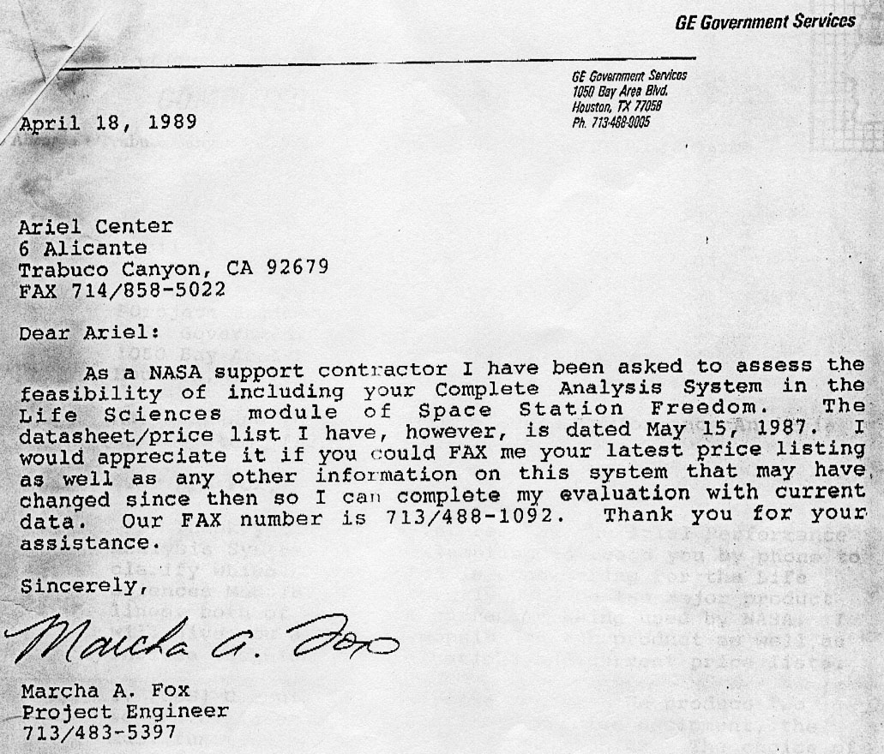
Ariel Center
6 Alicante
Trabuco Canyon, CA 92679 FAX 714/858-5022
Dear Ariel:
As a NASA support contractor I have been asked to assess the feasibility of including your Complete Analysis System in the Life Sciences module of Space Station Freedom. The datasheet/price list I have, however, is dated May 15, 1987. I would appreciate it if you could FAX me your latest price listing as well as any other information on this system that may have, changed since then so I can complete my evaluation with current data. Our FAX number is 713/488-1092. Thank you for your assistance.
Cincerely,
Gideon Ariel, Ph.D.
Universities Space Research Association
Visiting Scientist to NASA's Exercise Countermeasures Project 6 Alicante
Trabuco Canyon, CA 92679
Dear Gideon:
This letter is to recognize your and John Probe's involvement in the development of NASA's "Resistive Exercise Device" for Space flight. This engineering effort would not have been possible without your combined expertise in both hardware and software design and fabrication. In particular the opportunity to use the Ariel designed hydraulic actuator and associated software was the fundamental element which brought this
first generation prototype to fruition.
The tentative schedule for the First Generation Resistive Exercise Device is as follows:
1) Assemble and check out equipment in NASA-JSC Laboratories. a) As soon as posible
2) Fly equipment o.. board NASA's KC-135 Aircraft, for engineering analysis, during actual three dimensional zero gravity achieved by flying parabolic maneuvers.
- Late May 1993
- Using space flight experienced Astronauts as subjects
3) Write Detail3d Technical Objective (DTO) for space flight engineering perfrmance evaluation.
- June 1993
- Investigators: Ariel, Probe, Bufkin, Greenisen
4) Target fight date for Resistive Exercise DTO on STS-66, Launch Date 06 October 1994.
This schedule, however, does require several "Investigators Working Group Meetings" Jere in Houston. At a minimum and at your convenience these meetings should occur if possible at the following scheduled points:
1. Equipment Assembly and Lab Checkout
a) April 1993
2) During KC-135 "Zero-G" Flights
- Late May 1993
- Please have updated U.S. Air Force Class II! Flight Physicals and Physiological Training Certifications
3) Participate in writing of DTO for space flight
a) Late June-Early July.
Sincerely,
Michael C. Greenisen, Ph.D.
cc:
John Probe
Universities Space Research Association
Visiting Research Engineer to NASA's Exercise Countermeasures Project 4778 Valdina Way
San Diego, CA 92124
SD5/MCGreenisen:ar/4/1/93/33874

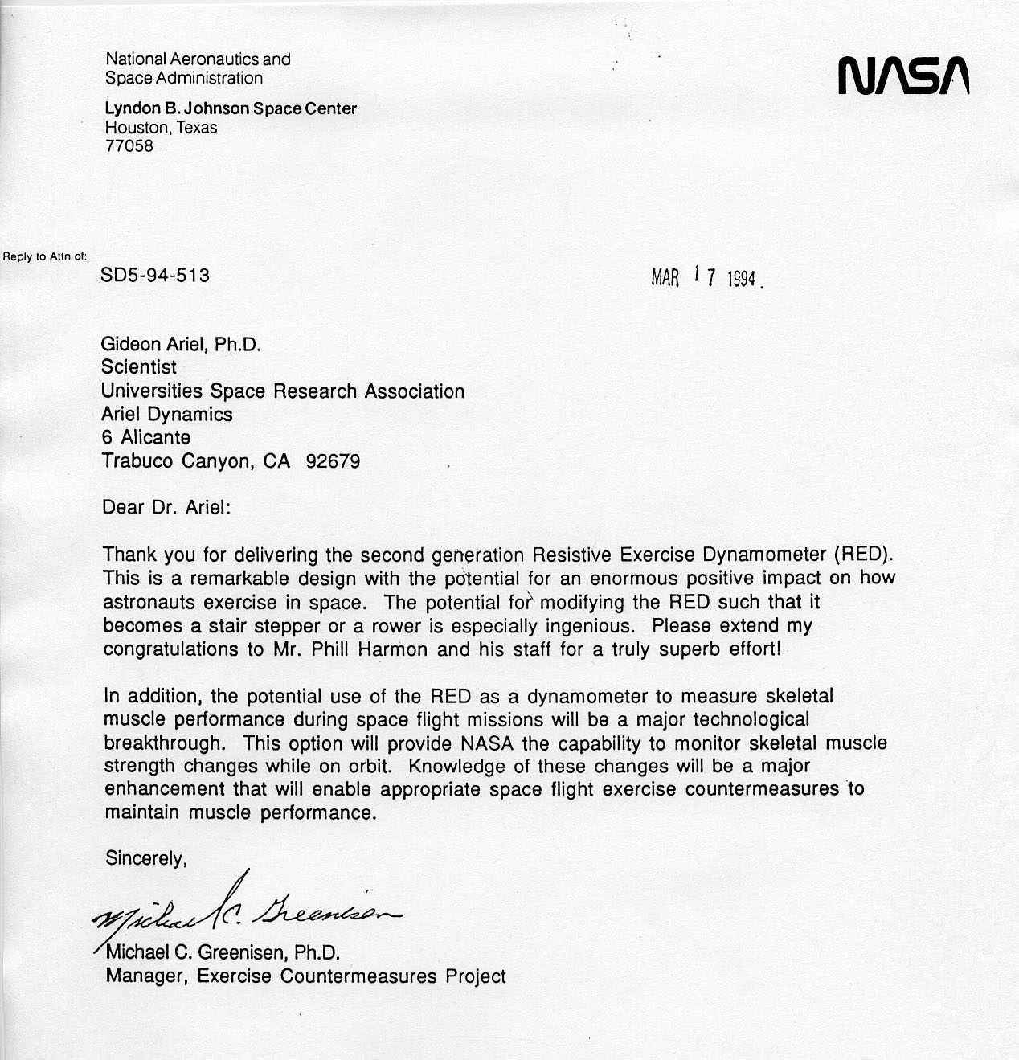
Gideon Ariel, Ph.D.
Scientist
Universities Space Research Association Ariel Dynamics
6 Alicante
Trabuco Canyon, CA 92679
Dear Dr. Ariel:
Thank you for delivering the second generation Resistive Exercise Dynamometer (RED). This is a remarkable design with the potential for an enormous positive impact on how astronauts exercise in space. The potential for modifying the RED such that it becomes a stair stepper or a rower is especially ingenious. Please extend my congratulations to Mr. Phill Harmon and his staff for a truly superb effort!
In addition, the potential use of the RED as a dynamometer to measure skeletal muscle performance during space flight missions will be a major technological breakthrough. This option will provide NASA the capability to monitor skeletal muscle strength changes while on orbit. Knowledge of these changes will be a major enhancement that will enable appropriate space flight exercise countermeasures to maintain muscle performance.
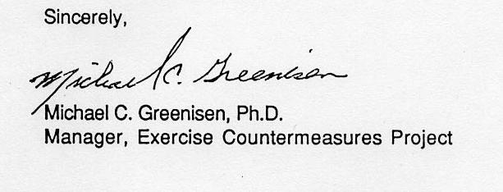
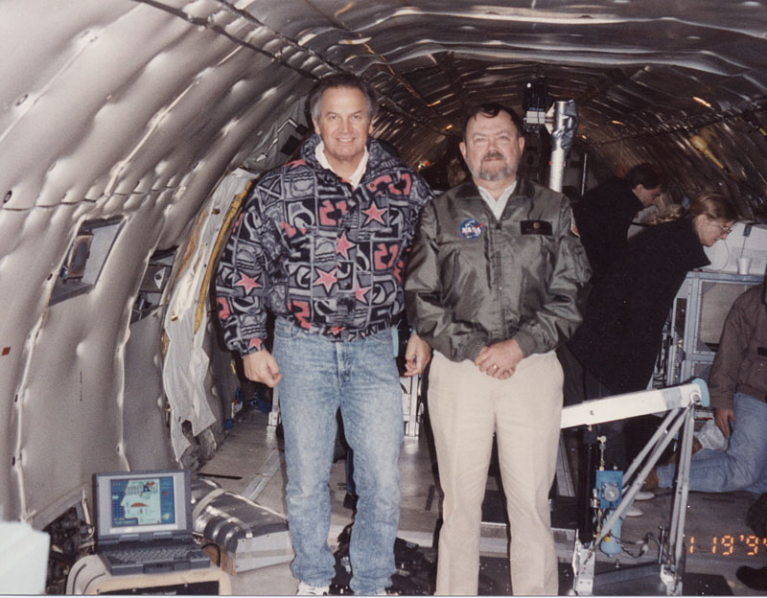
Dr. Greenisen and me setting the machine on the KC-135
We at ADI were working very hard to build the Computerized Exercise Machine for NASA. In NASA they called this machine the RED stands fro Resistance Exercise Dynamometer. There was a date for demonstration of the device.
The following Workshop was scheduled to discuss the advantages and disadvantages of the new device that we invented and modified for NASA use.
NASA Conference Publication 3252

Workshop on Countering Space Adaptation with Exercise:
Current Issues
Proceedings of a workshop sponsored by the National Aeronautics and Space Administration Washington, DC, and held at Lyndon B. Johnson Space Center Houston, Texas 1989
Contents
1 MUSCULAR TRAINING
- Muscular activity and its relationship to biomechanics and human performance .

Gideon Ariel, Ph.D., Ariel Dynamics
Eccentric exercise testing and training .
Priscilla M. Clarkson, Ph.D., University of Massachusetts
Exercise detraining: Applicability to microgravity
Edward F. Coyle, Ph.D., University of Texas at Austin
2. CARDIOVASCULAR FITNESS
Aerobic fitness and orthostatic tolerance: Evidence against an association . 121
Thomas J. Ebert, M.D., Ph.D., Medical College of Wisconsin
Does training-induced orthostatic hypotension result from reduced carotid
baroreflex responsiveness? 129
James A. Pawelczyk, Ph.D. and Peter B. Raven, Ph.D.
Texas College of Osteopathic Medicine
Cardiac output and cardiac contractility by impedance cardiography
during exercise of runners . 141
W. G. Kubicek, Ph.D. and R. A. Tracy, Ph.D.
University of Minnesota Medical School
3 SKELETAL COUNTERMEASURES
Weightlessness and the human skeleton: A new perspective .
Michael F. Holick, Ph.D., M.D., Boston University School of Medicine
Irreversibility of advanced osteoporosis - limited role for pharmacologic. intervention. 169 A. M. Parfitt, M.D., Henry Ford Hospital
Exercise and osteoporosis: Methodological and practical considerations .
Jon E. Block, Ph.D., A. L. Friedlander, P. Steiger, Ph.D., and
H. K. Genant, M.D., University of California at San Francisco
4 ELECTRICAL STIMULATION IN EXERCISE TRAINING
Electrical stimulation in exercise training.
Walter Kroll, Ph.D., University of Massachusetts at Amherst
Preface
The National Aeronautics and Space Administration's continuing goal is to explore the far reaches of the galaxy and universe. With the success of the Space Transportation System and advanced astrological observations, mankind's desire to explore is limitless. However, at the very core of this journey the question is raised, "Can man survive in space?" This certainly not new and has been asked since the onset of the manned space-flight program. Numerous biomedical investigations from the United States and Russian space programs make up the foundation for our knowledge of space-flight physiology. These studies support the hypothesis that the human body can adapt to any environment, even microgravity.
Even though the process of space adaptation is a natural phenomenon, it presents special problems to human performance and long-term survival. If humans were to adapt to a particular microgravity environment and remain in space, the problems in physiological performance would be predictable. Unfortunately, this is not the case. Astronauts and cosmonauts will be required to adapt to many different environments on their travels into space. One example of this would be a trip to Mars. Crewmembers will begin on Earth in a one-g environment, launch into space and stay for a time in a microgravity environment, and then land on Mars that has one third of the gravitational force of the Earth. During the entire mission, crewmembers will be required to maintain an adequate level of proficiency for contingency and/or emergency procedures.
The challenge to life sciences is clear-maintain crew health, performance, and safety in all environments. The tasks are many: (1) understanding how various gravitational fields effect the human body; (2) identifying those changes that will significantly affect crew health and retard crew performance; (3) developing measures to those adverse alterations; and (4) ensuring the appropriate response of the countermeasures, i.e., efficacy.
For many years now, both the United States and Russian programs have extensively used a number of countermeasures to maintain the crew's health and fitness, the premise that maintaining crew fitness results significantly in reducing the adverse effects of prolonged exposure to a microgravity environment. These effects vary from the onset of orthostatic intolerance following short-term space flight to the development of bone demineralization following long-term space flight. One thing is clear and that is the variable gravitational fields and the numerous translations found during space travel underscore the need to be prepared for all contingencies. Only the most trained and fit crewmembers will be prepared for these types of environments.
The countermeasure used most effectively in flight is exercise. Data from numerous ground-based and in-flight studies have shown the benefits of using exercise to mitigate the effects of a microgravity environment on the adaptation of the major human physiological systems.
These studies have led to the development of exercise countermeasures for space flight. However, much more knowledge needs to be gained before exercise can be used effectively and efficiently. For example, recent studies on aerobic conditioning of astronauts in flight have shown a dramatic decrease in heart rate while running on a treadmill in flight when compared to the same activity performed in one g. The study suggests that the basic characteristics of exercise to near maximum effort, particularly in-flight running, may be quite different. Extrapolating from this, other exercise modalities may be different when carried out in a rnicrogravity environment and, perhaps, other variant gravitational fields.
In the fall of 1989, the NASA Johnson Space Center's Exercise Countermeasures Project hosted a workshop to examine the use of exercise as a countermeasure for specific responses. Some of the leading scientists participated in free communication and open debates regarding the use of exercise as a tool to influence physiological systems. This workshop entitled, "Countering
v
Space Adaptation with Exercise: Current Issues," included topics on: bone demineralization, aerobic fitness and orthostatic tolerance, cardiovascular deconditioning, concentric versus eccentric exercise training, electrical stimulation, biomechanics of movement in a microgravity environment, detraining, the effects of exercise response and rehabilitation, and psychophysiology of exercise and training.
The goal of this workshop was to explore those issued related to the application of countermeasures to increase overall understanding and gain insight into the use of these countermeasures in our nation's space program.

Exercise Countermeasures Project

Science Plan
Bernard A. Harris, 'jr MD.
Project Manager

Prepared by Christine Wogan and the ECP Team
7ohnson Space Center
7une 1989
Science
Operations Technology
EXERCISE COUNTERMEASURES PROJECT

SCIENCE PLAN
INTRODUCTION
PURPOSE: This document describes the overall science plan for the Exercise Countermeasures Project. The goal of the Project is to minimize the effects of deconditioning during spaceflight using individualized exercise "prescriptions" and inflight exercise facilities. This document sets the direction for the exercise countermeasures program at National Aeronautics and Space Administration's Johnson Space Center.
SCOPE: This document describes the scientific, operational, and
technological goals of the Exercise Countermeasures Project, and
gives a broad overview of the approach that will be used to achieve
these goals. The Science Plan includes critical questions,
investigational outlines, and timelines. Administrative and
managerial information can be found in the Exercise Countermeasures
Project Plan.
BACKGROUND: One of the ways the human body reacts to the reduced physiological and mechanical demands of microgravity is by deconditioning of the cardiovascular, musculoskeletal, and neuromuscular systems. Deconditioning produces a multitude of physical changes such as loss of muscle mass, decreases in bone density and body calcium: it is also responsible for decreased muscle performance (strength and endurance), orthostatic intolerance, and overall decreases in aerobic and anaerobic fitness.
Deconditioning presents operational problems during spaceflight and upon return to 1-g. Changes in the sensory system during adaptation to microgravity can cause motion sickness during the first few days in flight; muscular and cardiovascular deconditioning contribute to decreased work capacity during physically demanding extravehicular activities (EVAs); neuromuscular and perceptual changes can precipitate alterations in magnitude estimation, or the so-called "input-offset" phenomenon; and finally, decreased vascular compliance can lead to syncopal episodes upon reentry and landing. Countermeasures are efforts to counteract these problems by interrupting the body's adaptation process. Effective countermeasures will assure mission safety, maximize mission success, and maintain crew health.
Other countermeasure programs have included evaluating lower body negative pressure (LBNP) devices and saline loading to counteract cardiovascular deconditioning (1,2,4,8), and fluoride and calcium supplementation to counteract bone demineralization (3,5,6). These measures have proven effective, but narrow in scope. In contrast, results from experiments on the Gemini, Apollo, and Skylab missions
1
suggest that regular exercise is helpful in minimizing several aspects of spaceflight deconditioning (7,9,10). In fact, exercise is the only countermeasure that can potentially counteract the combined cardiovascular, musculoskeletal and neuromuscular effects of adaptation.
The Exercise Countermeasures Project will systematically examine the effectiveness of exercise in retarding or preventing the deleterious effects of space adaptation. It will define the specific effects of exercise on the cardiovascular, musculoskeletal, and neuromuscular systems, and characterize the body's responses to exercise in 1-g and in microgravity. Specifically, the ECP will provide individualized exercise prescriptions that will improve (pre-flight), maintain (inflight) and regain (post-flight) aerobic and anaerobic fitness, orthostatic tolerance, muscular performance (including ligament and tendon strength and elasticity), bone demineralization, and body composition. The ECP will also design and build interactive inflight exercise facilities consisting of exercise devices and physiological monitors that will provide feedback to the exercising subject.
OVERALL GOALS AND OBJECTIVES: The overall goal of the Exercise Countermeasures Project is to provide a program of exercise countermeasures that will minimize the operational consequences of microgravity-induced deconditioning. This program will include individualized exercise "prescriptions" for each crew member, and interactive exercise facilities for preflight, inflight, and postflight training.
The primary objectives of the Exercise Countermeasures Project are:
Science: Through characterizing physiological changes in the musculoskeletal, cardiovascular, and neuromuscular systems induced by microgravity, develop training protocols to address deconditioning in these systems that will serve as the basis for exercise prescriptions

operations: To build upon these training protocols and develop individualized exercise prescriptions designed to minimize or prevent the operational consequences of deconditioning during extended spaceflight

Technology: To develop prototype flight exercise hardware and associated software, including physiological & biomechanical measurement devices
2
SCIENCE PLAN
APPROACH: Countermeasures developed by this Project will address the established priorities of assuring mission safety, maximising mission success, and maintaining crew health before, during, and after missions. Assuring mission safety is defined as (1) preserving piloting proficiency, from deorbit through landing, including nominal and manual override operations; (2) preserving the entire crew's ability to perform atmospheric emergency operations, (3) nominal egress, and (4) post-landing emergency egress. Mission success is defined as proficiency at extravehicular and intravehicular activities (EVAs and IVAs). The former addresses prolonging EVA operational effectiveness; the latter focuses on maintaining operational proficiency for orbital piloting, payload, and critical maintenance activities. Maintaining health, applicable to all crewmembers, includes (1) using exercise to maintain preflight baselines during and after progressively longer spaceflights, and (2) using exercise to return to baseline after after multiple flights.
Meeting these priorities forms the basis of the ECP's approach to developing a countermeasure program. Our approach is summarized in the following general questions:
* What physical functions are critical to performing the required
tasks (egress, landing, EVA/IVA, return to flight status)?
* How do these functions change, in terms of both biomechanics and
physiology, in microgravity?
* How do these changes affect crew performance?
* How can exercise be used to interrupt deconditioning and thereby
maintain effective levels of performance?
The next section, "Critical Questions," asks more detailed questions within this framework. These critical questions will drive the development of ground-based and inflight investigations. These investigations have been divided into 3 broad categories: Science (includes limited basic research): Operations (includes development of countermeasures that address specific needs in flight: and Technology (designing and building necessary hardware and software).
Science, operational, and Technological Investigations are closely interrelated, and heavily interdependent. Science Investigations lay the groundwork for assuring the effectiveness of countermeasures: These investigations will clarify the specific physiological effects of deconditioning on the human body: they will establish the differences between the body's responses to exercise in 1-g and its responses in microgravity: and they will establish biomechanical requirements for performing critical mission tasks. Operational investigations will apply results from the Science Investigations to developing exercise prescriptions that will address operational concerns. Technological Investigations comprise development of prototype exercise hardware and software, and exploration of new techniques of measuring and monitoring physiological parameters.
The key to employing exercise as a countermeasure lies in defining the specificity of its effects on the cardiovascular, musculoskeletal
and neurosensory systems. To date, there have been few studies that relate rigorously controlled forms of exercise (see Table 1) to specific parameters of physical fitness (see Table 2). All of the investigations in this program involve the evaluation of many measures of physical fitness. Physical fitness (and in turn the effectiveness of training programs, exercise equipment, monitors, and computerdriven control devices) will be assessed in the areas of muscle performance (both biomechanical and physiological); energy metabolism; anthropometry (body composition, biomechanical anthropometry); bone structure and metabolism; and aardiovascularrespiratory function. Table 2 provides a tentative list of indices measurable in each of these 5 areas; this list will be trimmed or supplemented as studies progress.
The ECP brings rich multidisciplinary resources to these investigations. Project members include researchers in physiology, biomechanics, bioengineering, and artificial intelligence (see Laboratories of the ECP). Each discipline contributes to science, operational, and technological investigations: and each plays a role in achieving project goals.
The next section begins with the critical questions that will drive the Project's investigations. Next follow outlines of the approaches to be used in Science, Operational, and Technological Investigations, with accompanying timelines. Finally, after these outlines, an organizational chart and capsule laboratory descriptions describe the structure of the ECP.
CRITICAL QUESTIONS TO BE ADDRESSED BY THIS PROJECT
science Investigations
1-1 How many types of exercise (e.g., weight training, bicycling,
rowing, swimming, running) are necessary to train all of the

organ systems affected by deconditioning?
2A-1 Which indices are the most reliable indicators of changes in fitness (e.g., muscle fiber typing, lung volumes, muscle performance characteristics; see Table 2)? Are they equally reliable in 1-g and in microgravity?
2A-2 How do indices of fitness differ in microgravity with respect to 1-g norms? Are these differences significant?
2A,2C-1 How can microgravity-induced changes in specific muscle groups best be quantified?
2A-4 Which reliable indicators of changes in fitness best describe the changes caused by deconditioning?

2B-6 Can classic analogues of microgravity (bedrest, neutral buoyancy, parabolic flight) be used to simulate physiological changes in fitness in true 0-g?
Are there differences in physiological adaptation to microgravity over time (i.e., with increasing flight duration)?
2C-3 How do changes in muscle functioning interact with changes in orthostasis and perception?

2D-7 Does the rate or type of deconditioning change with repeated exposure to microgravity?
3B-1 How does training in microgravity differ from training in 1-g?
3A,B,C-3What effect does changing variables in a training protocol (such as duration, intensity, frequency, etc.) have on longterm fitness?

3A-1(KSC)What are the differences between training muscle groups using eccentric contractions vs using concentric contractions?

3B-4 What are the differences between training that includes impact forces and training that uses nonimpact (torsional) forces?

3D-1 What are the physiological and psychological changes that accompany overtraining?

3D-2 Is overtraining expressed differently in microgravity than in 1-g?

6

3D-3 Which physiological or psychological variables might be predictive of overtraining?
4-1 Can an artificial intelligence expert system be developed to
aid in monitoring, controlling, and adjusting prescriptions?
5-1 What effects will wearing space suits have on astronauts'
work performance?
Operational Investigations
2-2 How does initial fitness level (with or without preflight
training) affect the rate and type of deconditioning?
2-3 How does preflight exercise training affect the adaptation
process?
2-4 How does inflight exercise training affect the adaptation
process?
2-5 What combinations of countermeasures (exercise, LBNP, PAT,
etc.) optimize crew performance of critical mission tasks
(egress, landing, EVA)?
3-1 How can exercise be used to enhance rapid reconditioning?
5-1 Which muscle groups are critical in the performance of
egress, landing, and EVAs?
5-2 Which of the indicators of microgravity-induced change in
muscle function can be correlated with possible difficulty in
performing egress, landing, and EVAs?
5B-1 Does the rate or type of deconditioning change with length of
mission?
5C-x. Can the expert system detect physiological changes and readjust the prescription as training (or detraining) progresses?

5c-x. How does the inflight expert system compare to the groundbased expert system and to the human examiner?

Technological Investigations

1-1 Which commercially available exercise devices can be modified for use in flight?

1.2-1 Are such devices physiologically, biomechanically, and mechanically effective in microgravity?

2-1 Which commercially available monitoring and measurement devices can be modified for use in flight?

At that conference I was asked to demonstrate the RED in action. I was expecting the first question in the critique periods to be: “What are the solution to be taken if the mechanism of the machine is leaking?”
Therefore, for this meeting I used Maple Syrup for the medium which provide the resistance.
When the question came, and it was the first question, I answered it:
“You drink it.”
“What???” most of the people in the conference jumped from their chair to hear such a crazy idea. This was the time where I have told them that you can use any liquid to have as a medium, and I chose to use Maple Syrup. They all were laughing and the few persons who just came to critique were quiet for the rest of the conference time.
The following are some photos from working on the designed machine at the KC-135 Zero Gravity Plan.
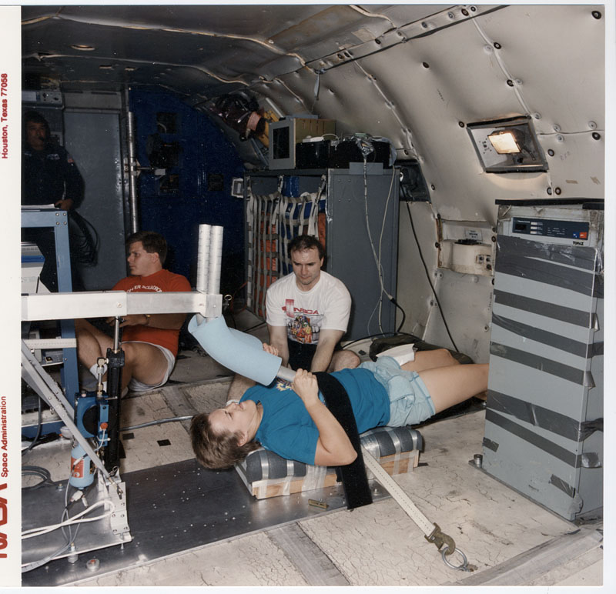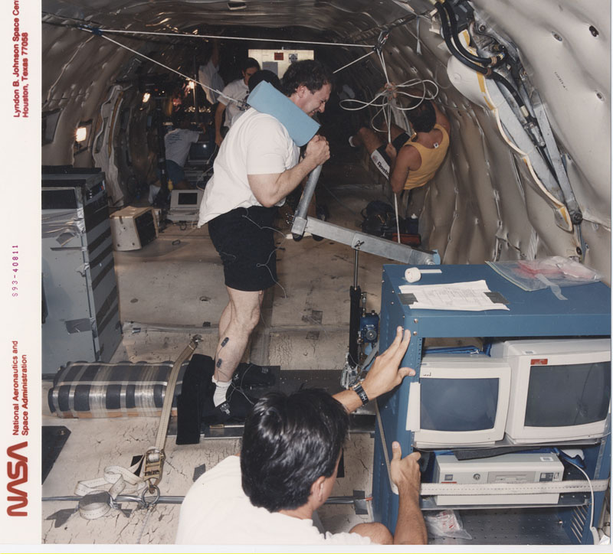
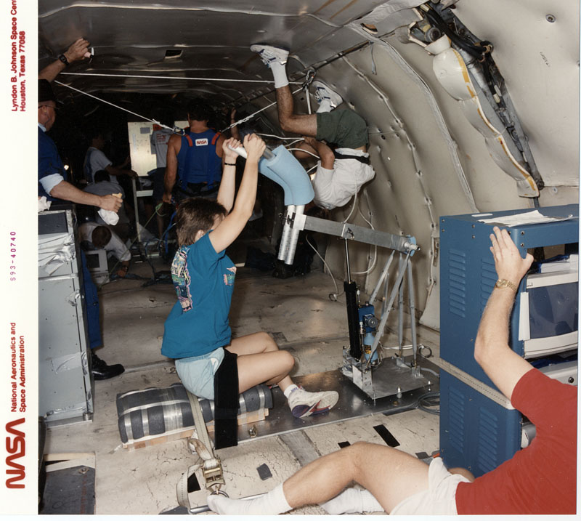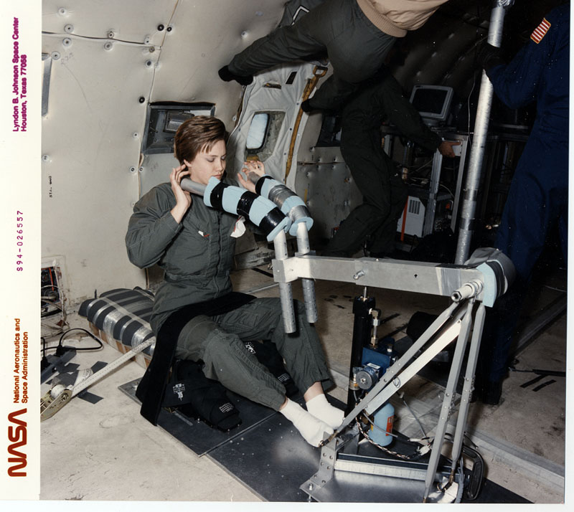
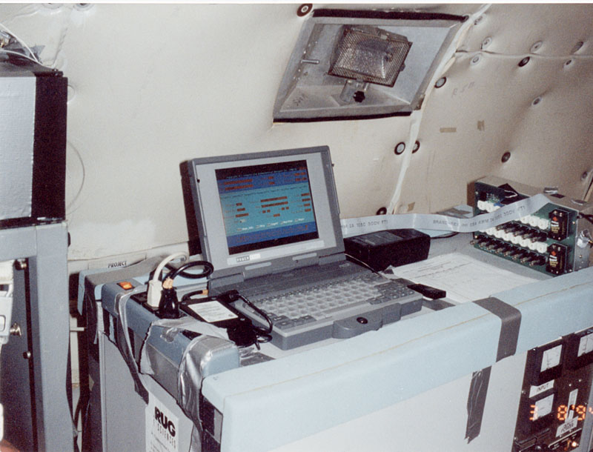
The APAS System on the KC-135

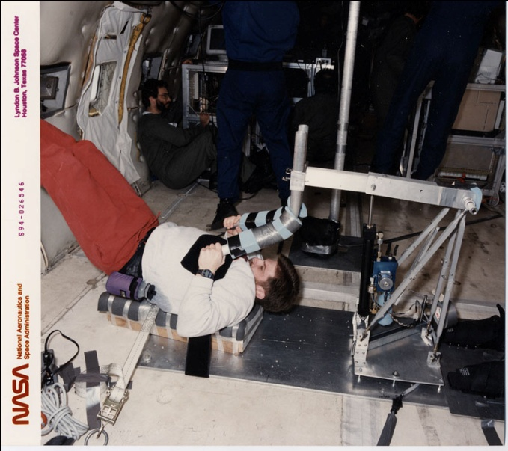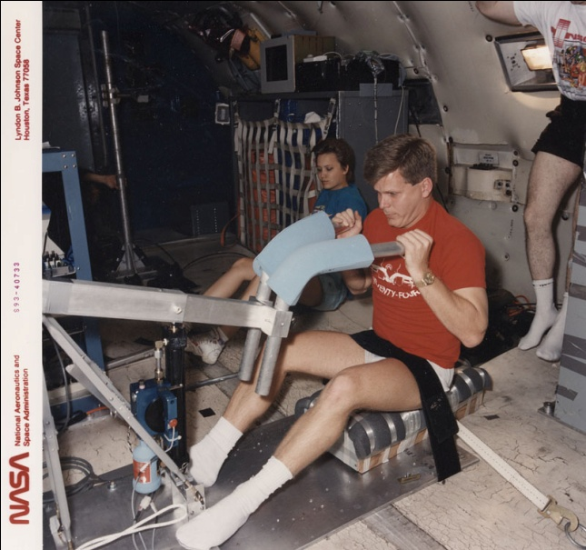

After number of flights and testing the following report was published on the effectiveness of the RED machine designed by ADI, Inc.
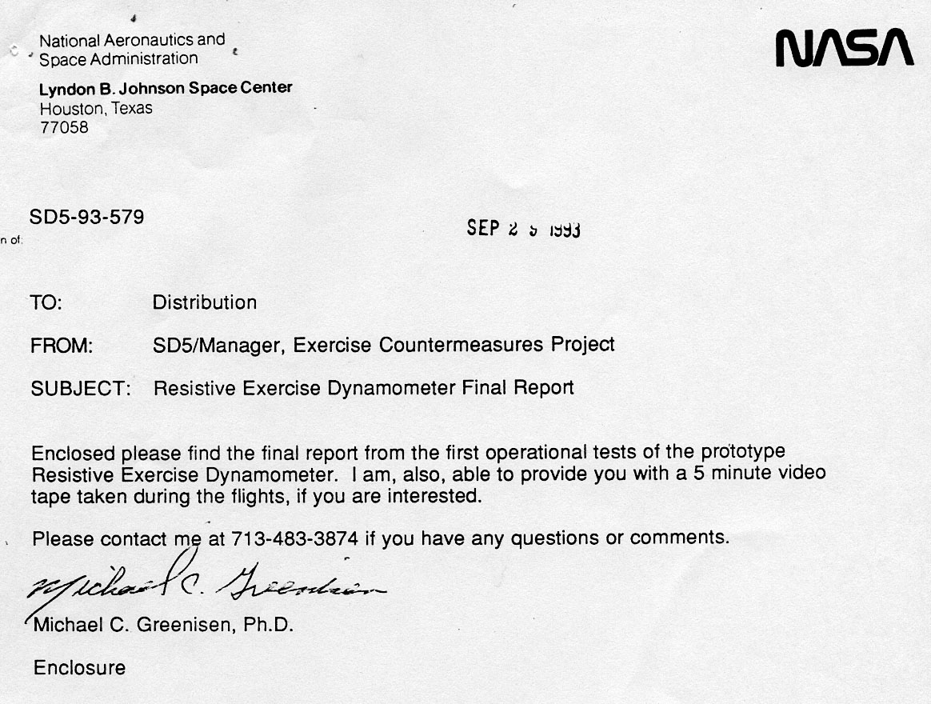
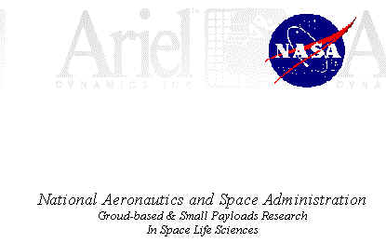
Re: Unsolicited Proposal For Using The Ariel Dynamics Inc.. Exercise and Analysis Dynamometer and Software System As An In/Flight, 0-6, Exercise Dynamometer System.
Ariel Dynamics Team for This Project:
Gideon Ariel, Ph.D- Company Chief Executive Officer, Inventor and Founder.
Jeremy Wise, Ph.D.- Chief Programmer and Executive Officer of Software Systems Development.

INTRODUCTION
This document is an unsolicited proposal to present the case for the use of the Ariel Computerized Exercise System hereafter, for the purpose of this document, referred to as CES dynamometer for consideration as an in-flight dynamometer system, for future O-G orbitor and space station missions.
The order of discussion shall include:
- HISTORY OF DEVELOPMENT
- SYSTEM OVERVIEW
- CONSIDERATIONS FOR THE ARIEL CES AS A FLIGHT QUALIFIED DYNAMOMETER
- RATIONAL FOR USING THE CES AS AN INTEGRAL PART OF ASTRONAUT SELECTION, TRAINING AND FLIGHT ACTIVITIES
- OPERATING SYSTEM [ a comparison of the CES to the NASA document, "Request For Quotation For A Prototype Dynamometer."
- DISCUSSION OF ESTIMATED COST
I. HISTORY OF DEVELOPMENT
Ariel Dynamics Inc. was incorporated on in 1969 as CBA Inc., for the purpose of developing and marketing the Ariel Dynamics Computerized Exercise Systems [CES]. Product development was begun in 1968, at the University of Mass., Amherst, using the University mainframe computer as an interface to a universal type Hydraulic (Isonetic) machine. The first commercial version was completed in 1974. The first machines were based on Data General mini computers. The instrument was used for individual evaluation of elite Olympic and professional athletes, many associated with the United States Olympic Committee, of which Dr. Ariel was chairman of the Biomechanics Committee.
With the advent of the low cost microprocessors, in the late 1970's, the product was redesigned and introduced to the marketplace at a much lower cost, in 1980. Since that time, the Ariel CES is being utilized by physicians, physical therapists, hospitals, researchers, government agencies, product development companies, military organizations, universities, cardiac rehabilitation centers, medical schools and olympic organizations throughout the world. The information collected and reported by the Ariel [CES] is widely accepted by insurance companies, the medical community and the legal community when disability analysis is an issue in legal cases.
The company is entering its 20th year of business with the current patented software and hardware design. Although the evolution of the software and hardware has undergone many improvements and revisions, the patented design concept of the internal resistive mechanism remains basically unchanged. The system hardware has proven to be field rugged and durable under a wide range of end user applications. The beauty of the resistive pack design is in its simplicity, with a total of six moving parts. The brain of the system, allowing for complex real time data acquisition and reporting and a wide range of end user exercise parameters, lies in the electronics package and software.
II. SYSTEM OVERVIEW
The basic commercial model CES includes the following Hardware Specifications
Computer- AST 386 with the following included:
- 2MB RAM
* 100 MB Ruggerized Hard Disk *3.5" 1.44 MB Disk Drive *5.25" 1.2 MB Disk Drive
- 40 MB Backup Tape Drive
- Monochrome Display Monitor
- Multisynch High Resolution Color Display Monitor
- Math Co- processor
*Mouse
16 Channel Analog board, Extended to 32 Channel
Software Features
The Ariel [CES] software represents the state-of-the-art in medical technology and research dynamometry. The Ariel system is the only system commercially available that automatically monitors, controls, and modifies resistance and velocity while the subject is exercising. It does this safely and efficiently by constantly adjusting itself to accomodate each person's unique capabilities or limitations. Ariel [CES] also provides extensive and accurate measurements of movement [Range of Motion], strength, and endurance with the capability for automatic storage and subsequent retrieval for comparison and analysis of the individual's performance.

One of the persons on my staff was Moshe Lahave. Moshe was an Israeli pilot who was involved with the bombing of the Iraqi nuclear plant in 1981. He was considered as one of the best pilots in the World at the time. In fact, in one of his mission a missile knocked out one of the Wing on his F-4 fighter jet. Moshe was the only fighter pilot in the World that was able to land the plan with one wing.
Moshe at the 1988 Korean Olympics
Moshe was begging me for years to take him to NASA to see the technologies there. However, there was a policy in NASA not to let Israeli pilots in. I discussed the matter with my friend Mike Greenisen who I worked with. He told me to bring Moshe, but at the entrance when questions for identification will come, for him to keep his mouth shut.
And this how Moshe got into NASA and in fact was visit with us on the Space Shuttle model. Moshe was supposed to be quiet and just follow us. But as an typical Israeli, he got to the wrong secure area and the horns start screaming all over the place. Thanks to Mike Greenisen he got us out of this mess.
The reason that I am telling you about Moshe is that he was working on his Master Degree, investigating the multiple G-forces that effecting the fighter jet pilots in combat flight.
So, Moshe was using the same machines that were used in NASA to conduct his study as described here:
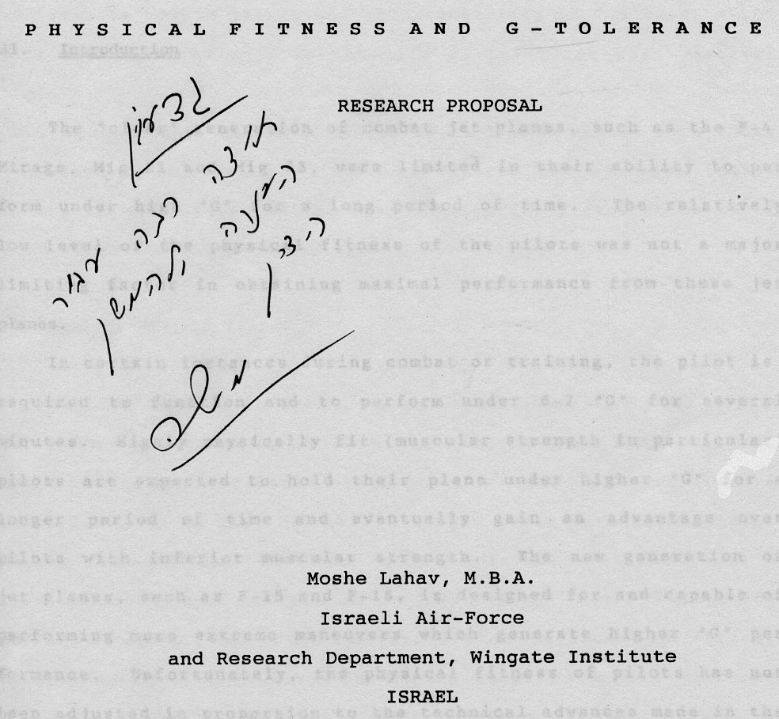
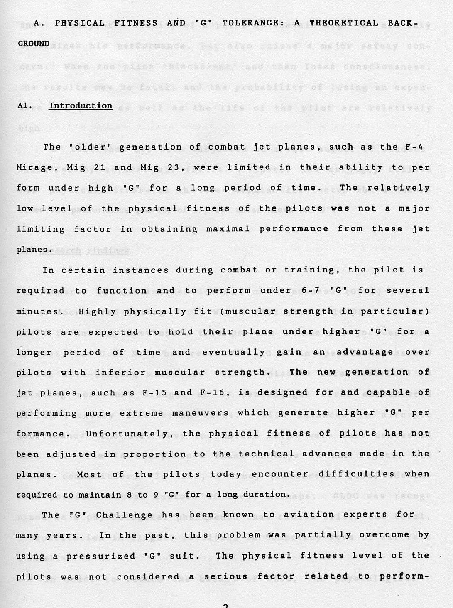

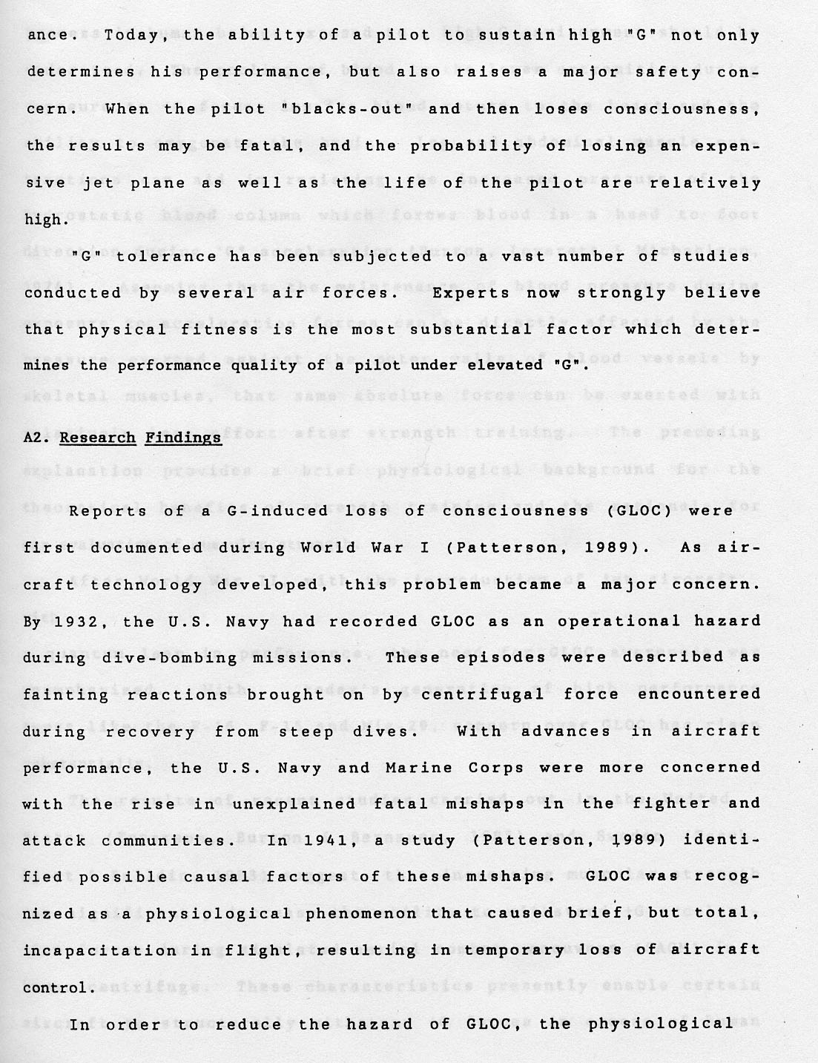
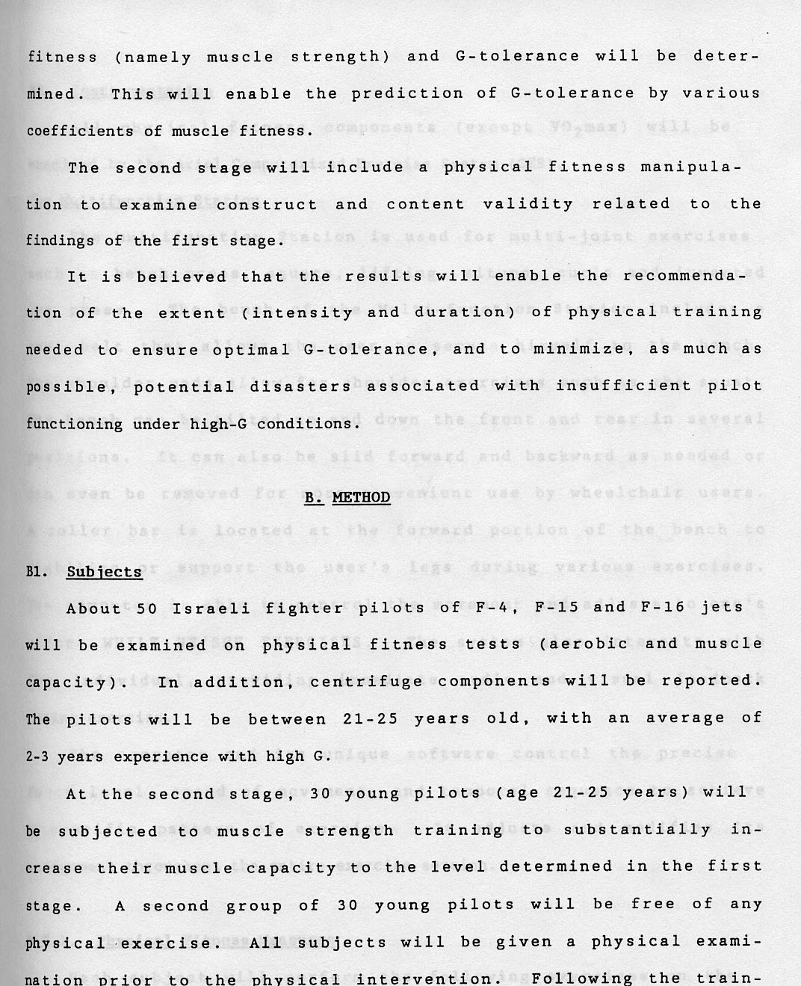

From his study, the Israeli Air force purchased 30 of the Ariel Machines and trained the pilot to be able to sustain high G-Tolerance.
So what was great for the Astronauts in 0-G gravitational environment was a great tool to increase the tolerance in high G environment.
So, we accomplished both tasks and enjoy the associations with NASA and the Israeli Air Force.

