Chapter 18: Life in Coto de Caza

In 1987 after 10 years contract with the Coto De Caza corporation, we realized that our business model had changed. Companies no longer were interested in contract outside service but wanted to own the technology to conduct their research in house. The investment in computers and programmers became easier and easier and cheaper. Before we would charge for a project an average of $100,000 or more. Now a company such as Wilson, Spalding or AMF could buy powerful computer and hire good programmer for the same price and conduct number of projects in house which allow them to keep information more secure.
So, we decided to make a big move. We are going to be in business to sell our software and hardware on IBM PC and close the Coto Research Center. We would give back our share in the Research Center to Coto De Caza corporation and settle the financial ownership so everyone will be happy.
It was a heart breaking to see so many equipment going to trash. We just could not use them anymore. The Data General computers that cost us Millions were not up to date with the current computers. It is amazing what different was between 1977 and 1987. These 10 years created total industrial revolution in our business of Biomechanics. Like a day and night. We had to hire a corporation to move our computers to the dump no one could use them anymore. We had to pay to dump our multi-Millions equipment. We used to have a special room with special floor and special air condition to maintain the Data General computers. Now for few thousand Dollars we had the PCs as many as we wanted with no special environment. When a computer went bad, it was cheaper to replace it with a newer model then fixing it.
By that time the Coto De Caza corporation already sold most of the land to owners for multi Millions Dollars and as a real state corporation were not interested anymore in great athletes to come to the premises, since there were no advantages from a business point of view. All they care was to sell land and houses. We were used as part of the selling and advertisement. I am sure, that for me to bring the Olympic to Coto De Caza sold for them thousands of home and real states properties. In fact, because of the Olympics in Coto De Caza the US Government finance a new road to Coto which made accessibility very comfortable. This fact by itself sold allot of real estate. The administrator at the Real-Estate company of Coto De Caza only care to sell land. They did not care what so ever for the Olympic Ideals or for the fact that the Olympic is held in Coto De Caza. To my amazement to date, the Coto De Caza owners never use the Olympic Rigs symbol on their restaurant or the arriving gate. Being an Olympic Site, they have the right to use the rings for their marketing. Sequa Valley doing it for year since the Winter Olympics was running there.
The Women Volleyball team left Coto after the 1984 Olympics. And after the Los Angeles Olympics we had less number of athletes coming to our research center. It is normal that immediately after the Olympics, athletes taking their rest period for few months.
The Coto Research Center also presented with large overhead. It was a good time to move to smaller location with an efficient laboratory to perform small projects but expend on our marketing to sell the Ariel Performance Analysis System (APAS) software and our Computerized Exercise Machines which were selling very well.
So, it was a time to find a location. Ann and I lived in the same condominiums from 1976.
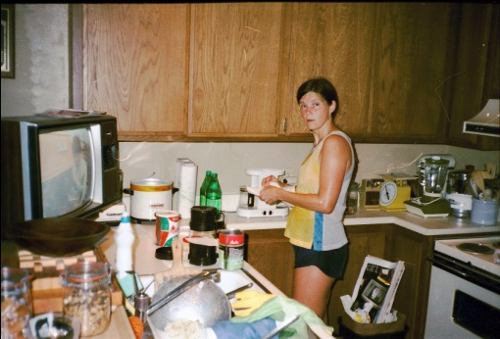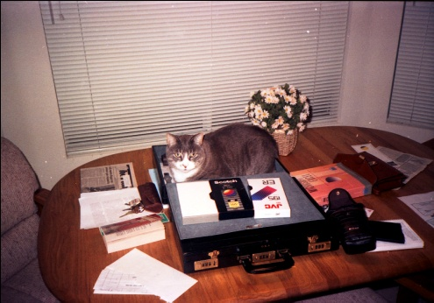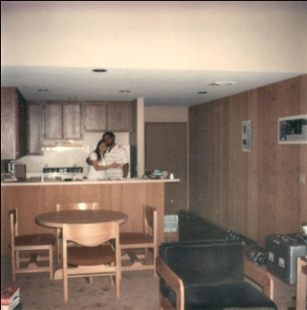
In our Condo
It is a time to move up to a nicer place and maybe find a location where there are two houses beside each other. One for us to live in, and the other for our new Laboratory and business.
It was somehow a problem since Coto De Caza is a gated community and you do not allow to have any running business in the community. In fact, there are no stores or schools or other urban facilities in Coto De Caza.
I took my Honda small motorcycle and start driving around Coto to new development locations. After a while I found two demonstration houses one beside the others designated to show the new models to be built in the new areas of Coto.
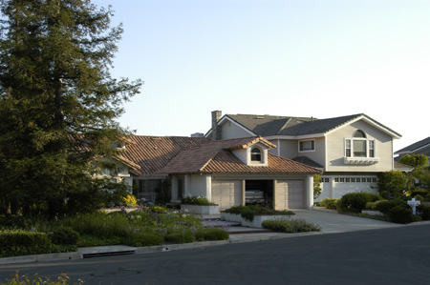
Two houses I found one beside the other
I stopped by the real state office which was close by and asked them if these two new houses are for sale. They told me that in fact just that week they were released for sale since they were used for the last few months as “demo houses” to show potential home buyers these two models. I asked if I can buy the two homes immediately. The two ladies realtors looked at each other and then at me with my short and flip laps which just parked his little motorcycle Honda beside their office. “Well you will have to put the down payment which amount to $50,000 on each house. “No problems.” I answered. “Do you want to check the houses and see them inside?” One of the realtors asked. “No, I want to buy them like that as they are.” They thought I am totally crazy which probably I was but, how could I go wrong with houses in Coto De Caza which cost more than twice of any house outside this gate community with bunch of Millionaires that occupied this settlement. If you recently watch the program called “house wives of Orange County” you basically see the production that was taking place here in Coto De Caza. They even interviewed me at this terrible program on show number 7. I was running a Baseball analysis on one of the sons of a baseball pro that live in Coto. Needless to say that after I have watched the first episode I tried to get out of it, but could not. The director of the shows Mr. Scott Dunlap used to work for me and his brother was the attorney for the US Olympic Committee when I was working with them.
“Well could you fill the form, and we need the down payment.” The realtor said. “Can I use your phone to call my Girlfriend? “ So, I called Ann: “Hay Ann could you bring a check for $100,000, we are buying here two houses one beside the other.” “What?!”
Well, Ann came to see us with my Chevy-71 with $100,000 check. By the way, the cleaner lady that came to clean our condo each week drove Chevy-85.
For me a car that has 4 wheels is the best car I can drive. I really do not care for the new neighbor that I have driving his Rolls Royse and his 17 years old daughter that drive the newest BMW. Even today at 2011 I still drive my Chevy-89. They are great cars and made in the USA.
So, Ann, totally in shock, asks to see the inside of the houses. The realtor ladies also in total shock took us to see the houses. They were perfect. One house, one story building perfectly for living in at 4000 square feet and the other house two stories perfect for office space at 5000 square feet.
After examination of the houses and the potential new life style, Ann did not mind to pay the balance due on the houses 1.4 Million Dollars. We paid it in one check full amount. 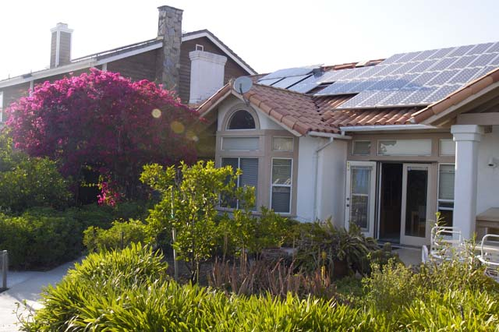
Our two new houses at Coto De Caza. The living house and the office house
We had allot of moving to do from the Coto Research Center to the new office building. By the way, you are not supposed to have business building in this “very special” community. However, our business from now on will be software and internet sale. We are not going to have any manufacturing or need for big tracks to come to pick up merchandise. No one in the community to date knows what this big two story house is for. For our machines manufacturing we always had other company making it. And in the future we had to find marketing company to sell them.
I set all the communication technologies in the houses. There were no important technologies that we did not have. Especially communication. I knew that the Internet will be the way to go in the early 70’s and always kept up on it. I converted both houses to Solar Power. We were the first in the whole Orange County to be totally independent of electric power using solar panels on our roofs. Our electric meter is rotating backward which amazed the inspector for long time. In fact, in the early 90’s the electric company was required to buy our access electricity that we produced on the roof of our two houses.
Our Solar Panels supplied us all the necessary energy
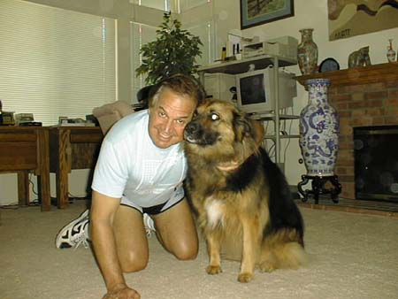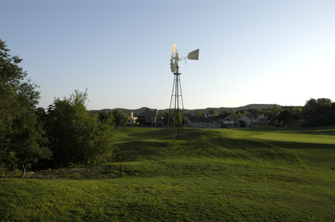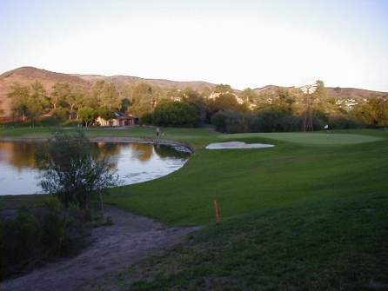
Inside our house Outside our house
Adapting to our new life we were blessed with many more hours. No athletes in our place. No number of projects at the same time to complete. Less overhead and less expenses. Its as we moved from New York City to some small town in the middle of nowhere.
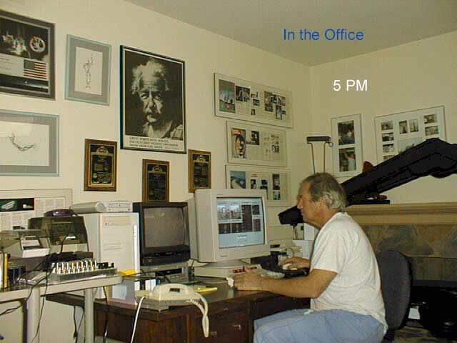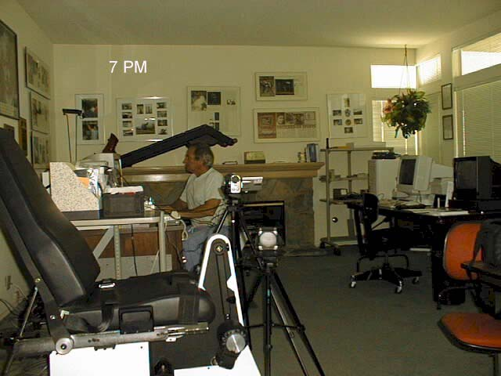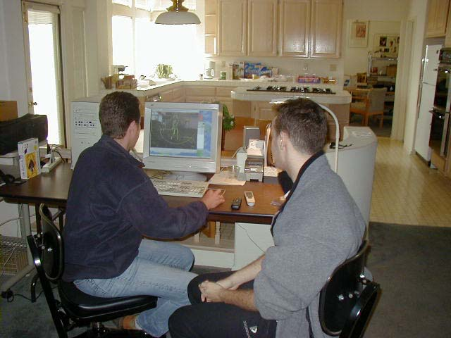
Inside our new office and laboratory
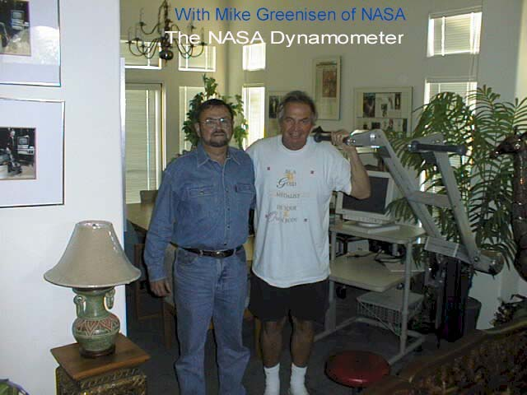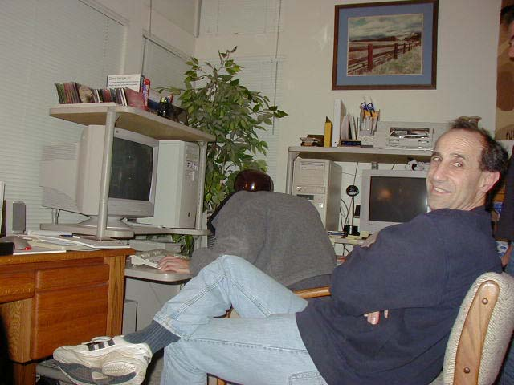
Developing the Exercise Machine (RED) for NASA-Mike Greenisen and Jeremy Wise – In our new Office/Lab
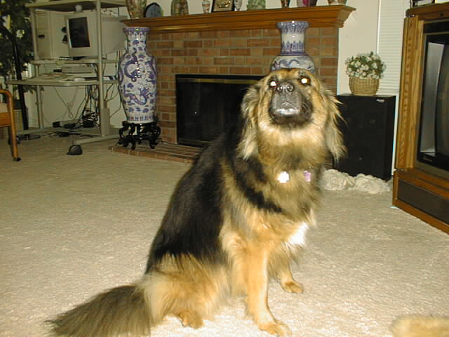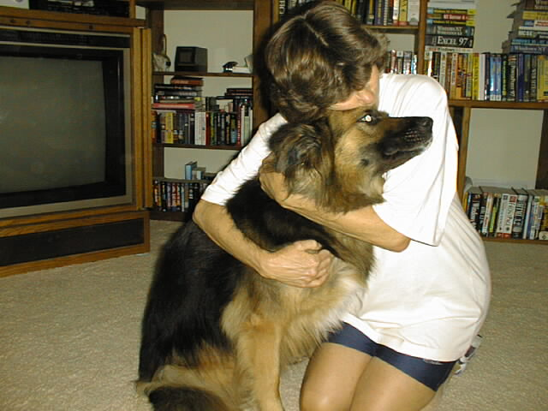
Our dog Malka
For long time I had professionals invite me to conferences and speeches. Plus, I was interested in attending some of these conferences in Biomechanics and Sports Sciences. So, I start traveling around the World giving presentations about Sports Biomechanics and about our systems.
I presented hundreds of presentations from Israel to China, to the UK to Spain, India, all over the World. Here are some of my presentations:
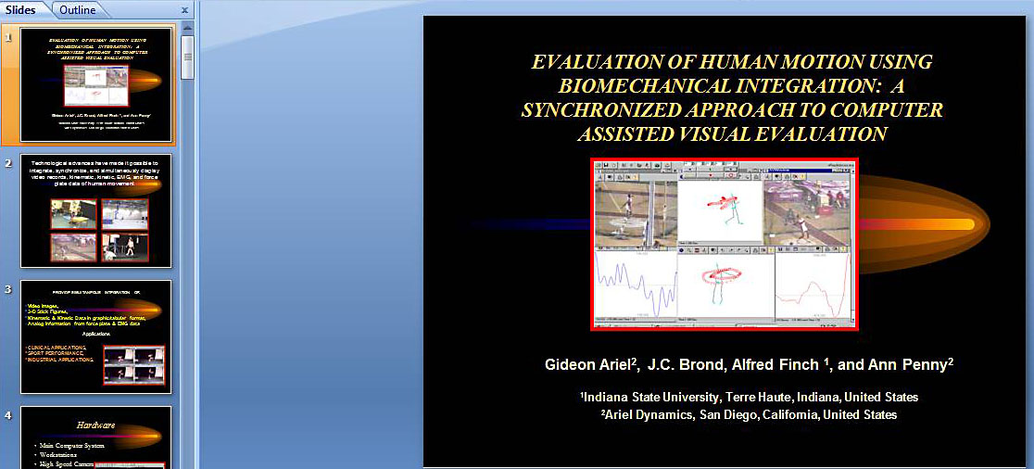
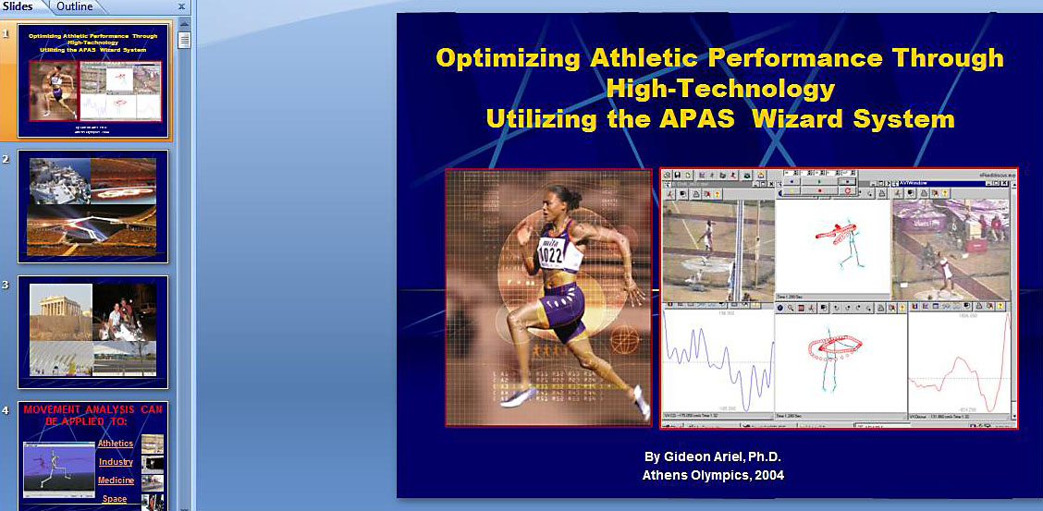
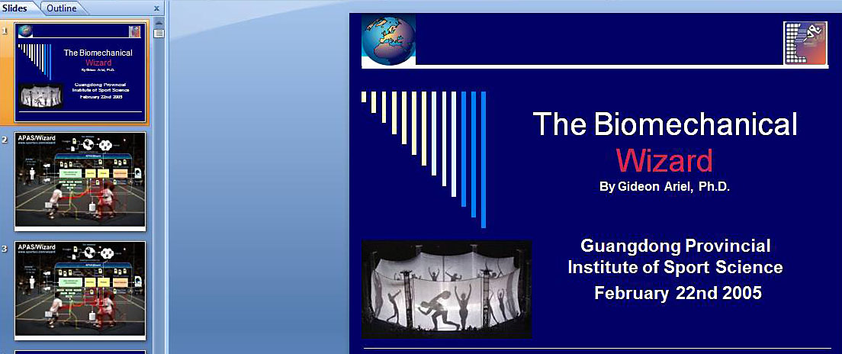
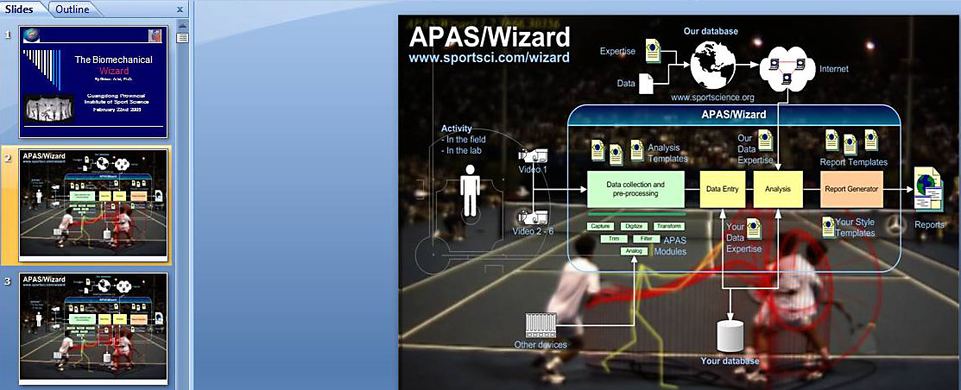
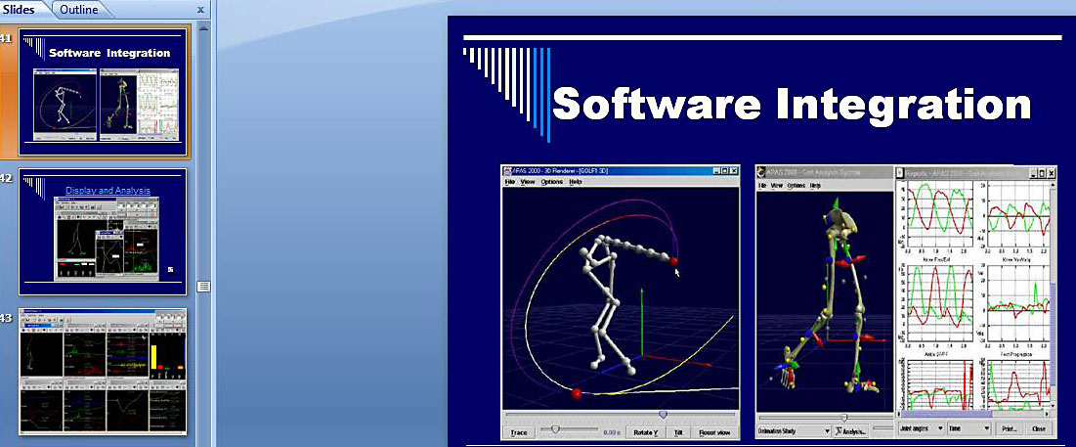
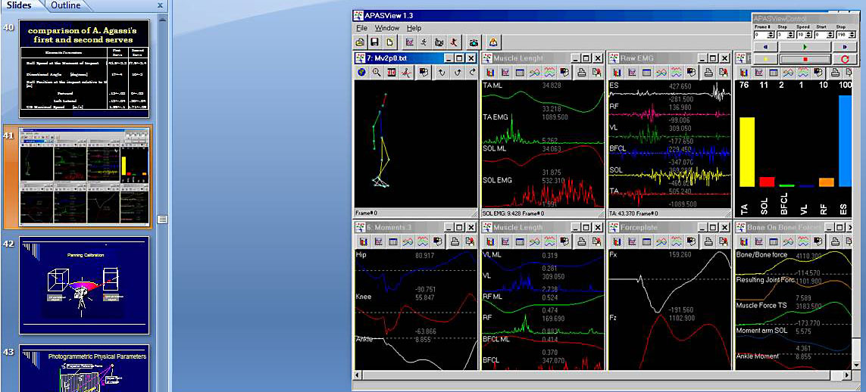
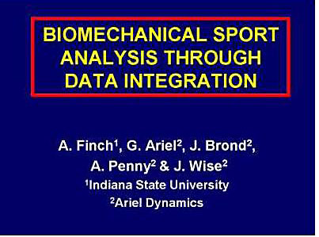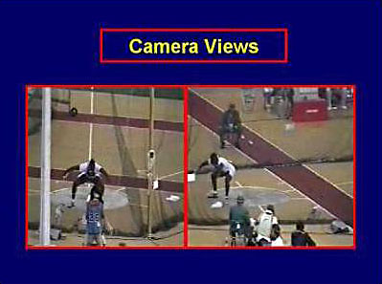
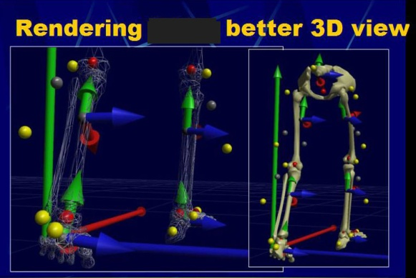
These are only few of the presentations. These presentations gave us World recognition for our system and it increase our business significantly, even better then the days in the research center with the projects we had with the big corporations.
But, those presentations made me travel all around the World. I would be at least 6 months out of the year away from home.
The media were all over us with new articles and TV clips as you can see below:
Articles
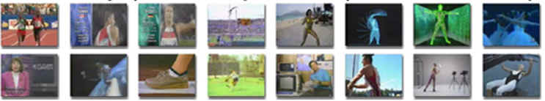
TV-Productions
In one of my presentation I have met a person by the name Herbert Lightstone. He was very impressed with my technology and asked me to meet with him. As it happened before with Larry Graham, I invited him to Coto to see my facility. At that point, of course, we were much more advance as in the old days in Belchertown in my kitchen laboratory.
Mr. Lightstone visit us, and as one can expected was very impressed. He already saw few televisions reports on my system. He saw the office, met Ann and my dog and my staff and suggested that I will meet with his friend Dr. Don Broker in San Diego. Dr. Broker was an entomologist. He was one of the inventor of the Hard Contract Lenses. This fact impressed me from the start. Here is another “crazy” scientist, inventor like me. Mr. Lightstone told me that Dr. Brocker just sold his patent to Bush and Lomb for 120 Millions Dollars and has allot of money to invest in new venture.
We all, Ann, Mr. Lightstone and Dr. Brocker met again in Coto and Dr. Broker offer to be an exclusive distributor to my systems. He mention that his experience in business and his financial resource will allow to build a large company very profitable to all. Originally, I agreed only to the Computerized Exercise Machine distribution but eventually he included the motion analysis system also. That means the APAS System and the ACES Exercise System. My attorney Mr. Norman Zaftman drew a protective contract which allowed me to sell my systems but give an exclusive to one distributor to sell my systems. We called the new company Ariel Life System. Eeach sale of our systems would pay us good amount of Royalties so in addition to my own sell of my systems it would be an additional income to the company. It sound and seems as win win situation for us.
Dr. Broker resided in La Jolla, California. Upon signing the contract in 1990, he created amazing office with staff at the most expensive building in La Jolla. In fact, he owned this building and a restaurant on the second floor. We at ALS (Ariel Life System) had 3 floors. Dr. Broker hired at least 50 staff people from professional’s manufacturers to high paid secretaries. I understood that the overhead reached around $300,000 per month. But the organizations were perfect. We went to shows and sell start climbing. We would sell at least 20 machines each month for average price of $25,000 each and at least 10 APAS systems for an average price of around $35,000 each. Profit was great and everyone was happy.
Here is the statement of Ariel Life System to the community:
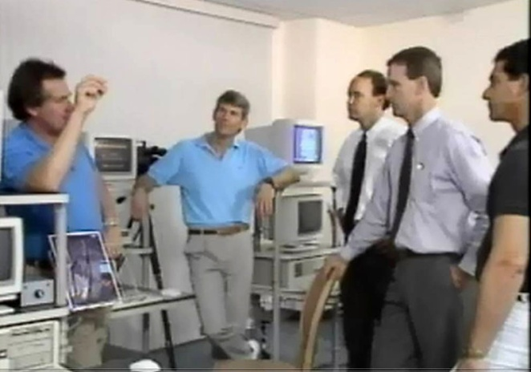
I. INTRODUCTION
ARIEL LIFE SYSTEMS, INC. ( "Ariel " ) was incorporated as a California Corporation in December 1989, with preliminary operation commencing in mid 1990, for the purpose of commercializing the Ariel Computerized Exercise System and Ariel Performance Analysis System. Both systems were developed by Dr.Gideon Ariel, an acknowledged world leader in human biomechanical performance and evaluation.
The Ariel Computerized Exercise System ( "CES" ) represents the state-of-the-art in technology for medical diagnostics, physical therapy and rehabilitation, sports medicine evaluation and treatment, fitness training and research. The CES is a computerized exercise system that automatically monitors, controls and modifies resistance and velocity while being used. It does so safely and efficiently, constantly adjusting itself to each person's individual capabilities and limitations, and may be used isotonically, isokinetically, and isometrically, or any combination of the three. It is the only exercise system available with so many capabilities.
The CES employs true, interactive bio-feedback control of both effort and movement during exercise, which allows the machine to dynamically adapt to the activity being performed, rather than using the traditional approach of modifying the activity to conform to the limitations of the machine.
The CES training/rehabilitation units utilize a passive hydraulic resistance mechanism under the direction of the system's fully programmable computer. The CES functional resistance mechanism offers numerous advantages :
The positive bi-directional resistance allows opposing muscles to be trained in a single exercise, while avoiding the dangers of negative resistance. It provides resistance only when the user pushes or pulls against it, so that the user may stop at any time, if pain or discomfort is experienced.
The bio-feedback allows variable speeds, normally used throughout a range of motion, to occur unhampered by inertia.
Specific patterns of motion and resistance can be individually programmed in advance to create a complete training/rehabilitation routine with the results recorded for future comparison. The variable hydraulic motion is completely smooth in both directions.
Originally there were two models of the CES, the Arm/Leg Machine designed for single joint movements and the Multi-Function Machine designed for multi-joint movements. Many centers used both machines, which can be run off a single computer. Recently the newly-developed CES Back Machine has also been made available.
The Ariel Performance Analysis System ( "the APAS" ), is the latest enhancement to the proprietary biomechanical analysis systems, developed through more that two decades of research by Dr. Ariel. This movement analysis system measures speed, acceleration and energy transfer by use of video cameras in combination with a computer. It is the most advanced and flexible system of its kind, yet is still user friendly.
Marketing Enhancements:
Over the past two years, Ariel has done some professional journal advertising, given many
demonstrations and exhibited at approximately 60 national or regional conventions. The effect
of this has been to make the Ariel technology known to a larger percentage of potential users.
In addition, several seminars have been held on the Americans with Disability Act (ADA) of 1990, to explain how Ariel technology will allow industry to conform to the sweeping changes in employment screening, hiring and job task analysis that this Act requires.
Internationally, in addition to a distributor in Japan who was "inherited" from Gideon Ariel, the Company has added distributors in France, Belgium, Germany, Scandinavia and Australia.
IV. MARKETS
In this era of aging population, baby boomers bent on staying young, spiraling health care costs, bankrupting workers' compensation claims, and laws such as the Americans with Disabilities Act ( ADA ), the technology of Ariel Life Systems, Inc., addresses the buzz words of the decade " functionality ", " risk assessment ", " fitness ", " prevention ", and " rehabilitation " more than any other technology or combination of technologies.
Unlike other types of equipment which may add to the cost of health care, Ariel Technology has been shown to minimize malingering, speed diagnosis, and reduce rehabilitation treatment time.
The largest markets for Ariel Life Systems' products are Medical, followed by Sports, Research & Education, Fitness & Health, Aerospace & Military, and Industrial Engineering.
Established Medical Markets
Ariel Technology has been introduced, in a limited fashion, into several medical markets through conventions, direct contact, and journal advertising.
Physical Therapy Clinics
There are approximately 10,000 Physical Therapy Clinics in the United States, all of which have the potential to utilize the APAS for diagnosis and the CES for both diagnosis/testing of strength and range of motion and for rehabilitation training. In addition, Physical Therapy Clinics are also becoming increasingly involved in Industrial Medicine.
Hospitals
There are approximately 3,500 hospitals with over 100 beds in the United States. About 50% of these facilities have rehabilitation departments, all of which are potential users of the entire Ariel product line. The applications involved would include both rehabilitation and Industrial Medicine.
Orthopedic Surgeons
Orthopedic Surgeons number in excess of 15,000 in the United States. It is estimated that approximately 50% of this number have the potential to utilize Ariel products for pre- and post-operative evaluations as well as rehabilitation, independent of hospitals and physical therapy clinics.
Physiatrist ( Rehabilitation Physicians)
The Physiatry community numbers approximately 20,000 physicians. While most are affiliated with a hospital, approximately 10% direct Sports and Industrial Medicine Clinics and have the potential to use Ariel products independently.
Chiropractors
The total number of Chiropractors in the U.S. is in excess of 70,000. The potential use of Ariel Life Systems' products in this market is estimated at 30% of the total population, as the profession is broadening its scope of practice to include injury assessment and rehabilitation.
Podiatrists
There is growing use of Ariel technology for gait analysis by Podiatrists (approximately 12,000 in the U.S.) to aid in orthotic prescriptions and to study other anomalies.
Prosthetics
Ariel technology is being used to analyze prosthetic devices to insure their maximum efficiency.
Industrial Medicine, Safety and Ergonomic Market
While a large percentage of the industrial medicine market will be handled by clinical facilities, there is significant interest by industry itself in the area of OSHA, Americans with Disabilities Act (ADA) and Workers' Compensation, and certain larger companies (e.g.Boeing,Levis, Ford) are examining the possibility of using Ariel systems internally. The U.S. Bureau of Mines is using APAS to develop safety standards.
New Medical Markets
The value of Ariel Technology has been recognized in several areas, into which it has not yet been introduced to any significant extent.
Neurology
Neurologists in the United States number about 10,000. Approximately 50% of Neurological
community could potentially utilize Ariel products for the diagnosis and treatment of conditions such as Parkinsons Disease and MS and for neuro rehabilitation (a growing sub-
specialty) independent of hospitals and clinics. Cardiac Rehabilitation
Resistance exercise has recently become accepted as being beneficial in cardiac rehabilitation cases, and preliminary research indicates that bio-feedback capability, and bi-directionality of the Ariel CES (which avoids the dangers of negative resistance) are especially suited for cardiac rehabilitation.
Rheumatology
The APAS is ideal for determining functionality which is critical in evaluating the extent of a disability.
Exercise has recently been recognized as significant in the treatment of arthritic conditions and degenerative changes, and the biofeedback, double concentric motion (of special significance because it eliminates the " squeezing out " of synovial fluid which occurs during negative motion) and safety features of the CES distinguish the system in this area.
Geriatric
Ariel is designing CES equipment specifically tailored to the geriatric market. The ability of the Ariel CES to modify its resistance according to the reaction of the patient, as opposed to all other systems of resistant exercise which require the patient to modify their reaction to accommodate the machine, is especially suited for use in geriatric facilities.
Pediatric
Ariel has designed smaller versions of its CES equipment for the pediatric market, where safety is very important. There is no competition in this market.
Research & Education Market
There are over 400 educational facilities in the United States which currently have biomechanical departments or laboratories. All of these facilities are potential users of both the APAS and the CES.
Ariel Technology is currently being used in over fifty leading Universities throughout the world. Aerospace & Military
Though military and aerospace budgets are diminishing, Ariel technology is critical for advancement in the areas related to human performance.
Both the APAS and the CES have been used for several years by NASA in research to design space suits and to develop methods of exercise to overcome the effects of zero gravity. A lighter version of the CES is being designed to test aboard the NASA shuttle.
The APAS is scheduled to be used in 1993 on the space station MIR in a joint French/Russian flight.
The Israeli Air Force has pioneered the development of exercises using the CES to overcome the effects of gravity during high performance flights.
The APAS is being used by the U.S. Navy, Army, and the Air Force Academies. Navy Seals use the CES in their training regime.
Sports Market
Golf
Over 25 million individuals played at least one round of golf in the United States last year. We feel the potential market for golf analysis using the APAS to produce video cassettes of an individual is approximately 10% of this population, many of whom would purchase repeated analysis as they progress through a teaching program. Several hundred APAS units would be needed (several facilities could share a system, as only cameras are required to gather data) to meet the demand for golf analysis.
Tennis
With 5 million tennis players in the United States, we feel there is an opportunity for a potential 250 facilities to provide tennis analysis through the use of the APAS.
Health Clubs
An excess of 25,000 gym/health clubs exist in the United States today. With the growth of rehabilitation services in these facilities, and the expanded use of personal trainers, the potential for CES use is large. We estimate that in excess of 2,000 of the higher-end facilities could use the CES today. Many facilities would require multiple purchases. Recently, former users of the CES have caused their gyms to purchase the technologies.
Elite Athletes
The technology of both the APAS and the CES have been used by Olympic and other elite athletes, many of them world champions and/or record holders, from Al Orter to the crew of America³. Presently the Australian, Czechoslovakian, Finish, French, German and Spanish Olympic facilities have Ariel technology, and there are plans to equip the new U.S. Olympic training facility scheduled to be built in San Diego with Ariel equipment.
College/Professional Sports
The major college and professional sports community number is approximately 1,200, of which approximately 250 are potential users of both the APAS and the CES 5000. Several professional teams are using APAS and/or CES either directly or through affiliated medical groups. They include the Philadelphia Eagles, Houston Oilers, Cleveland Indians, and Toronto Blue Jays.
Industrial Engineering Market
Recently Ariel has been demonstrating the APAS equipment in conjunction with high speed cameras for use in the analysis of car crashes, air bags, and related subjects. Initial orders are pending from several large corporations. It is too early to estimate the size of this market, but the initial reaction is positive and significant.
Insurance and Forensic Markets
At the present time, in regard to health insurance, Workers' Compensation, and alike, Ariel technology is used exclusively by industrial and health care professionals. However, interest has been expressed by insurance companies and the legal community in becoming directly involved in using and owning the equipment.
New Developments
Ariel Life Systems is continually introducing improvements and upgrades to its technology. The latest are :
A six pound notebook computer capable of operation and/or demonstrating the entire system
Panning cameras, hardware and software, which allow an unlimited number of cameras to follow a subject's movements.
CES machines designed for specific three dimensional movements.
Potential Domestic Revenue
If there are 30,000 potential purchasers of Ariel technology domestically, and assuming an average conservative sales price of $75,000, (including various combinations of APAS and CES, and ignoring the fact that many facilities would require multiple purchases) the initial U.S. market for Ariel technology could be as large as $2 billion, with a continued follow up market of software and hardware upgrades.
Foreign Markets
Reliable figures are not available for the non-United States markets. However, there is considerable and growing interest and sales in Europe, Australia and the Far East for Ariel technology, especially in the area of industrial medicine, research and sports.
Far East - The Japanese Market represents approximately 75% of the U.S. Market and Ariel equipment has been used in Japan for some time. Ariel equipment is also in place in China, Korea, Australia, Singapore and Hong Kong.
Europe - Although the European market has been largely untapped, approximately 30 systems have been sold over the years in Belgium, Germany, Finland, England, France, Poland, and Czechoslovakia. Ariel has recently added distributors in France and Belgium, which are beginning to make significant progress. They predict that the European market for Ariel equipment will rival that of the United States within a few years.
Israel - Several CES machines and APAS systems have been sold to the Israeli Air Force in previous years.
In time, it is believed, the potential of foreign markets should approach that of the United States.
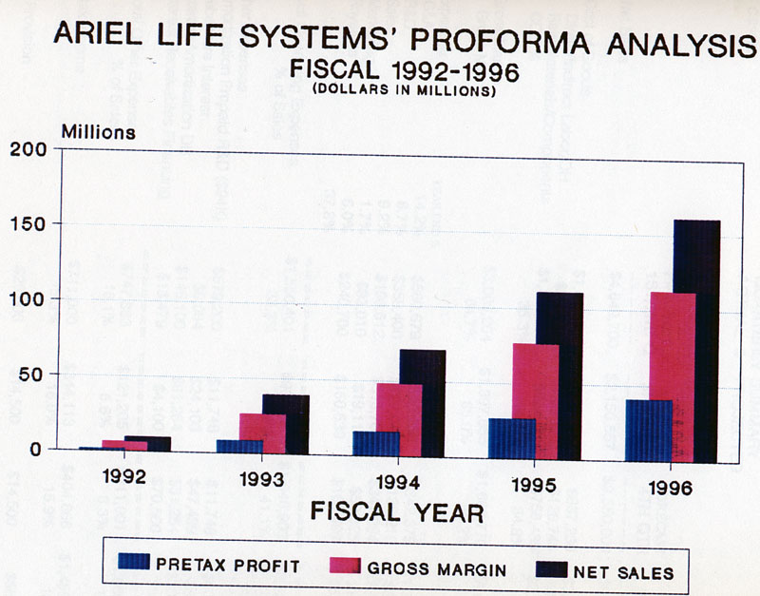
To put it in numerical values to potential investors, here it is:
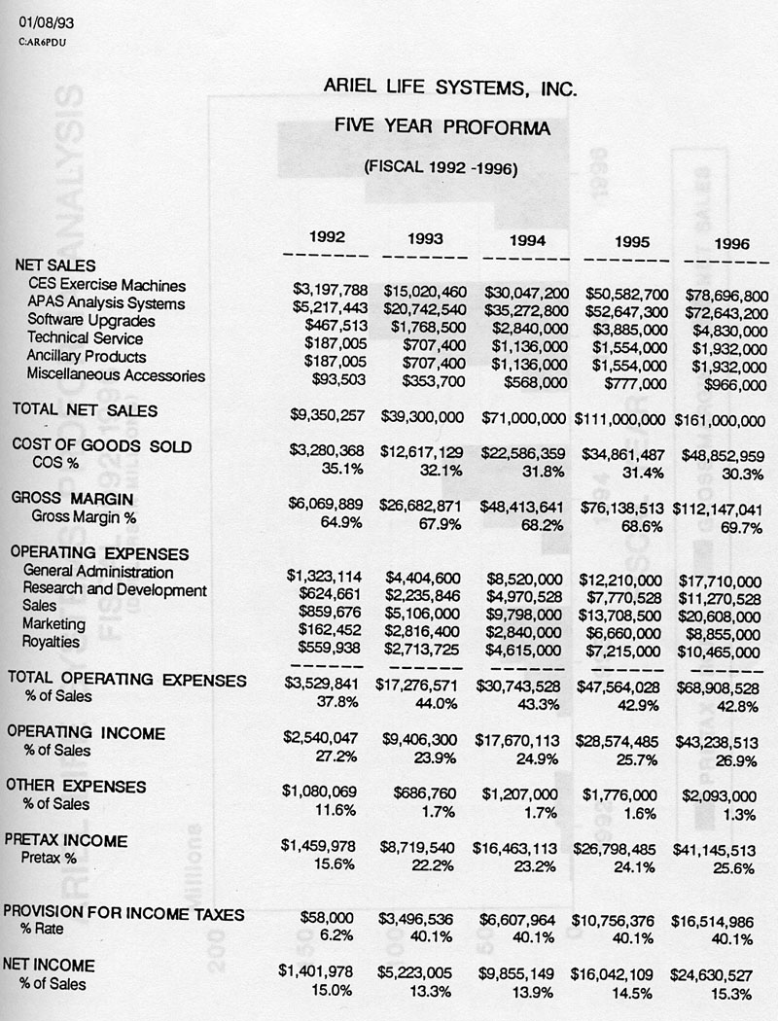
What a fantastic projections. Who would not want to invest in such a company that looks right “of the box” better then Microsoft was at that stage.

One of the salesman name was John D'Aquisto. John was a professional baseball player with the Padres in San Diego. Don hires him as one of the directors of sales. In fact, I appeared with him on TV analyzing famous baseball players:
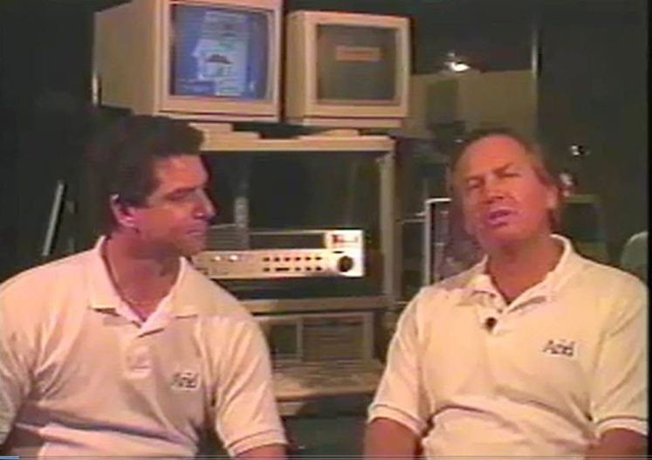
John D'Aquisto and Me in Interview for the TV
Here is one of many articles appeared in the San Diego area telling about the new corporation and about John D'Aquisto:
Ariel's Systems Take Guesswork Out For Athletes
By KATHY DAY
San Diego Daily Transcript Staff Writer
Gideon Ariel's stubbornness with his coaches proved profitable for is future.
When the former Israeli Olympian coaches tried to tell him what to do to improve, he suggested that he could help them develop a system to show athletes how to maximize their performance.
They ignored him, so he went off and created a biomechanical analysis system that gives graphic illustrations to professional and Olympic athletes — as well as weekend and aspiring jocks at this weekend's All-Star FanFest —about what's right and wrong with their movements.
The Ariel Performance Analysis System all starts with a video of the player's swing or throwing motion, taken from the side and back. The two separate angles are digitized, then turned into a stick figure on a computer screen, explained John D'Aquisto, former Padres pitcher who is now sports marketing director for La Jolla-based Ariel Life Systems. The figure can be rotated to analyze various elements of the motion such as speed, acceleration, velocity and torque.
Besides video, it can be used with electromyography or force platforms to achieve its goal of modeling "the human body as a mechanical system of moving segments upon which muscular, gravitational, inertial and reaction forces are applied."
In his competitive days Ariel was a shotputter and discus thrower. Now a recognized authority on biomechanics who holds a Ph.D. from the University of Massachusetts, he says of his system, "Human beings are creative, but we have terrible memories.
"Computers are ignorant, but their memories are infinite. You have to guide them step-by-step and channel your creativity through the computer software — which is the program created by human ingenuity."
"We can look at how the kinetic chain is formed and where it goes awry," he said, noting that the system has been used to analyze what made Babe Ruth such a powerful hitter.
They took an old newsreel and looked at where the force came from. They found that the Babe had a "perfect swing and didn't use that big stomach of his. It came more from his legs," D'Aquisto said. "Once he started, it was hard to stop. That's why he struck out so much."
Besides using it to find out what made the greats great, the system has been used by greats to make them even greater, or to help notso-greats get better.
Edwin Moses, Olympic hurdles gold medalist, improved upon his already-stylish techniques, and L.A. Dodgers rookie Eric Karros —a San Diego native — has improved upon last season, when he was "hitting his weight (235) to gain a starting position."
Blue Jays pitcher Dave Steib is a personal project of Ariel, who is trying to help him recover from a
career-threatening back injury.
D'Aquisto, who moved from a career in bank marketing back to the world of sports via the company, spent 16
Years in baseball — 10 in the major leagues. He thinks he might still be pitching professionally today if he'd had the system to keep him in form.
Today he pitches in an over-30s league, and can still go nine innings and throw a 90 mph fastball. "I learned to throw from my feet up and make my hips and legs work for me — even with a torn-up elbow."
Besides baseball, the system is used by professional golfers and tennis players as well as a wide range of Olympic athletes, including skaters and track athletes. It also has applications in general medicine, to help identify when patients are at risk of injury or to improve body mechanics following back surgery.
It can be used for gait analysis, job task analysis, injury quantification and rehabilitation, and with the added product of a computerized exercise machine has gained notice in the field of industrial medicine.
The company employs 52 at its Prospect Street offices and Sorrento Valley manufacturing facility, and another 60 or so in the field around the world and at its East Coast office in New Jersey. Ariel, who has been a consultant to the U.S. Olympic Committee, maintains an extremely sophisticated research lab in Orange County's Coto de Caza community.
Another article out of many talking about John and the new company is here:
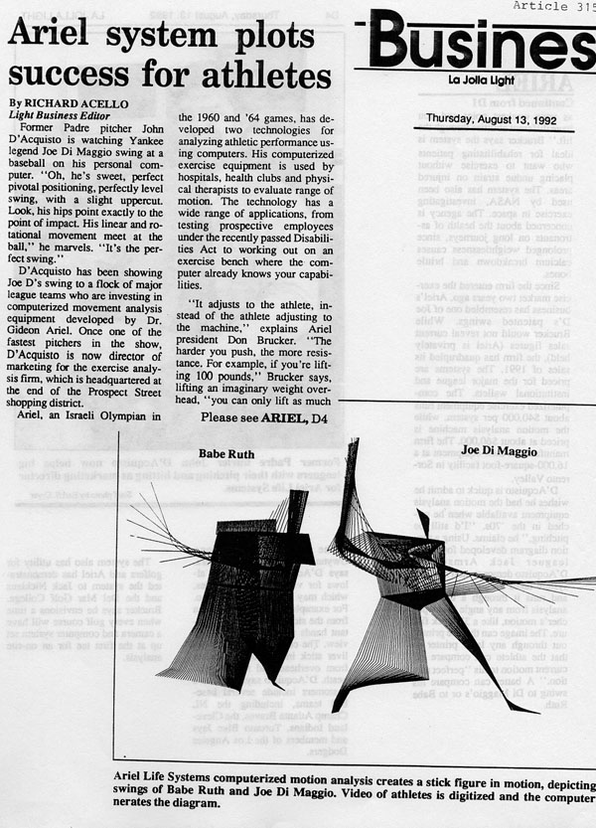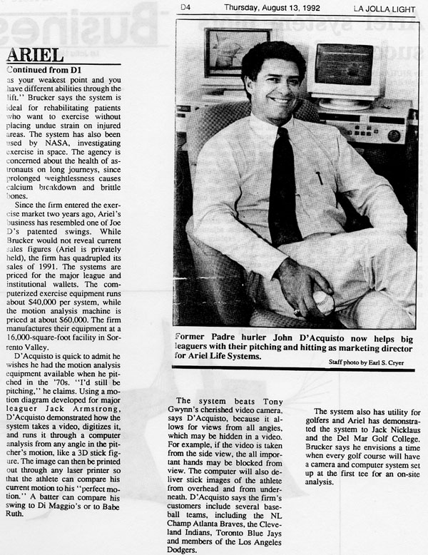
These are only two articles out of many that appeared in the San Diego vicinity.
Based on more then 25 such articles in the San Diego area and various magazine the community were aware of the new company reside in a very affluent location and doing business successful right from the start.
Because we were so successful in sale and in general organization, John suggested to Dr. Broker that we should try to go public and raise allot of money this way. I did not like this idea, however the others believed it was a good idea. Well, Don had to buy me a nice suit and a nice tie which I did not have and we were flying first class to New York City to meet with J.P. Morgan on Wall Street.
I gave my presentation, and things start going into action. Price Waterhouse did the due diligent which we came very well and they value the company at 40 Million Dollars. Even though we were selling maybe close to 7 Millions Dollars worth of software and hardware, they value us like 7 times the sale income. I guess this is normal upward evaluation. Here are only two pages of many of the evaluation by Price Waterhouse:
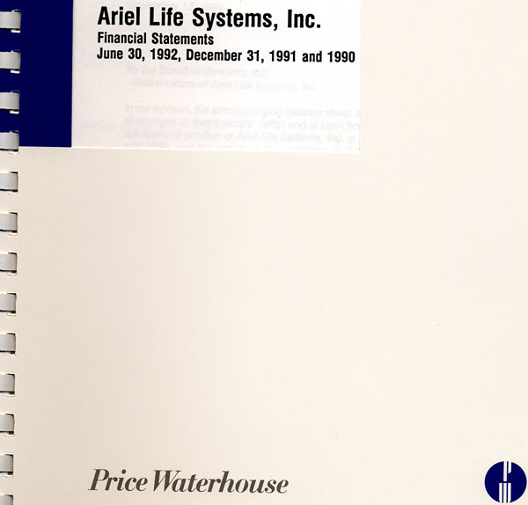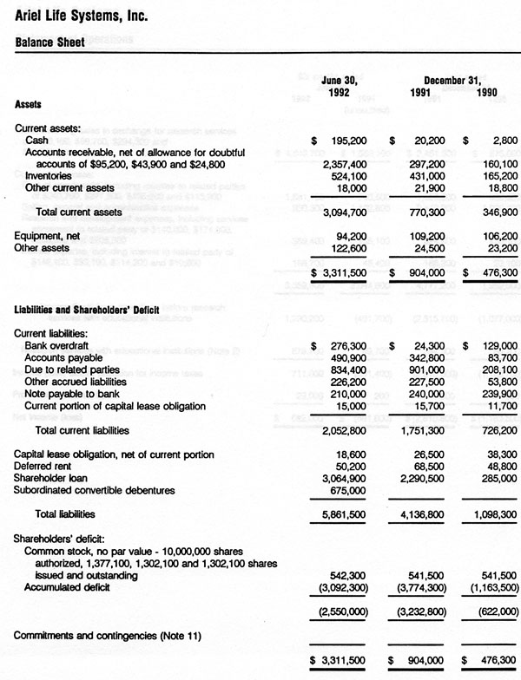
The due diligent by Price Waterhouse was great. We were profitable with no debt and great potential future. In addition, the President and CEO, Dr. Brocker, the inventor of hard contact lenses and a Multi Millionaire is running the company.
At that point I felt very comfortable. I had less administration work to do and could concentrate on interesting research projects and travel around the World with Ann.

At that evaluation, Don and John start getting investors which put Millions of Dollars into the company. This money was used for shows, travel, salaries, and manufacturing as well as sell expenses. The company did great at that point.
Here are some of the “placement offers” by the company to investors:
PRIVATE PLACEMENT MEMORANDUM
(CONFIDENTIAL)
200,000 SHARES OF COMMON STOCK
$3.75 PER SHARE
ARIEL LIFE SYSTEMS, INC.
(a California Corporation)
THESE SECURITIES INVOLVE A HIGH DEGREE OF RISK
THESE SECURITIES HAVE NOT BEEN REGISTERED UNDER THE SECURITIES ACT OF 1933, AS AMENDED, AND ARE BEING OFFERED TO PROSPECTIVE PURCHASERS IN RELIANCE UPON AN EXEMPTION UNDER THE ACT. NO REGISTRATION STATEMENT OR SIMILAR FILING HAS BEEN MADE WITH THE UNITED STATES SECURITIES AND EXCHANGE COMMISSION. LIKEWISE NO REGISTRATION STATEMENT HAS BEEN FILED AND REVIEWED BY ANY STATE SECURITIES REGULATORY AGENCY IN ANY STATE IN WHICH THIS OFFERING MAY BE MADE IN RELIANCE UPON EXEMPTIONS FROM REGISTRATION OR QUALIFICATION. ANY BENEFITS NORMALLY ACCRUING TO INVESTORS BY A REVIEW OF AN OFFERING BY THE SECURITIES AND EXCHANGE COMMISSION OR BY SUCH A STATE AGENCY WILL NOT BE AVAILABLE TO INVESTORS.
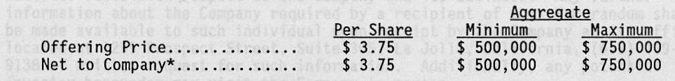
Exclusive of certain unaffiliated individuals or entities who offer Shares on behalf of the Company and who may be paid a commission of up to 10% on Shares sold by them. No commissions will be paid to officers
or directors of the Company. This Net to Company is before other offering expenses, including legal costs.
Offered by Officers and Directors
of
ARIEL LIFE SYSTEMS, INC.
P.O. Box 1169
1299 Prospect Street, Suite 305
La Jolla, California 92038
(619) 459-6659
Attention: Donald Brucker
INTRODUCTION
Ariel Life Systems, Inc. (the "Company") is a company engaged in the business of manufacturing, marketing and distributing sophisticated computerized exercise equipment that combines advanced theories of biomechanics, the science linking physics of motion to the human body, and computer science. The Company proposes to offer a minimum of 133,333 shares for a total consideration of $500,000 and up to a maximum of 200,000 shares for a total consideration of $750,000 of the Company's Common Stock. The proceeds of this Offering will be used by the Company primarily to purchase capital equipment and to cover any cash shortfall between the Company's sales and its receivables.
This Offering is being made, and shares will be sold, only to accredited investors, the criteria for which are set forth under "Suitability Standards and Subscription Documents" on p. 7 of this Private Placement Memorandum.
This Memorandum should be read in conjunction with the Business Plan attached hereto as Exhibit A. This Memorandum is being provided for the purpose of acquainting the potential investors with the general business and structure of the Company and highlighting the risks involved in investing in the Company. However, the information provided in this Memorandum and the Business Plan is in no way intended to be a complete disclosure of all material facts with respect to the Company and its business. Any further information about the Company required by a recipient of this Memorandum shall be made available to such individual upon receipt by the Company at its office located at 1299 Prospect Street, Suite 305, La Jolla, California, (619) 4599138 of written request for such information. Additionally, any potential investor hereunder may visit the Company in person.
The Company specifically reserves the right to reject, in whole or in part, for any reason whatsoever, any prospective investor's subscription for Common Stock hereunder.
There were many meeting in our La Jolla office to demonstrate the great company to potential investors. I was asked to present the scientific side of the technology. Don was presenting the business side of the company and Herb Lightstone was comfort the potential investors with his experience in business.
John D'Aquisto was running around and show the plucks on the wall and all the articles about the company. Two of the plucks on the wall very impressive to the potential customer. One was my induction to the Jewish Hall of Fame for sports sciences as it is shown below:
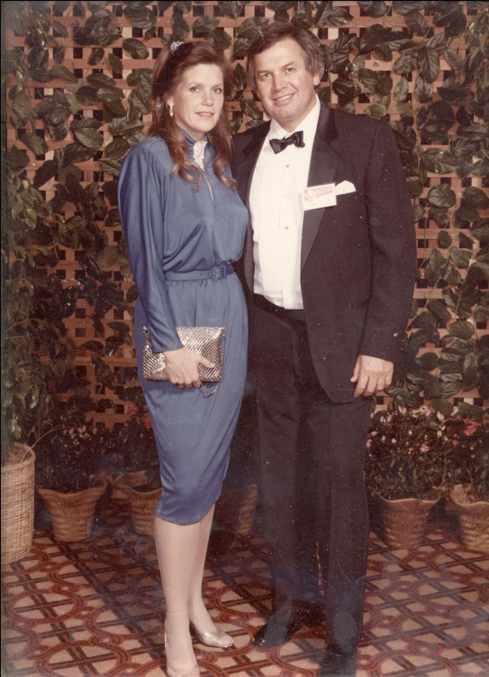
Ann and I preparing for the induction
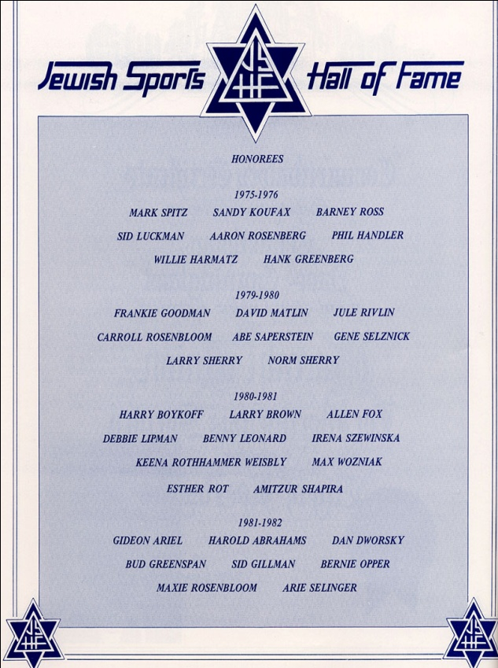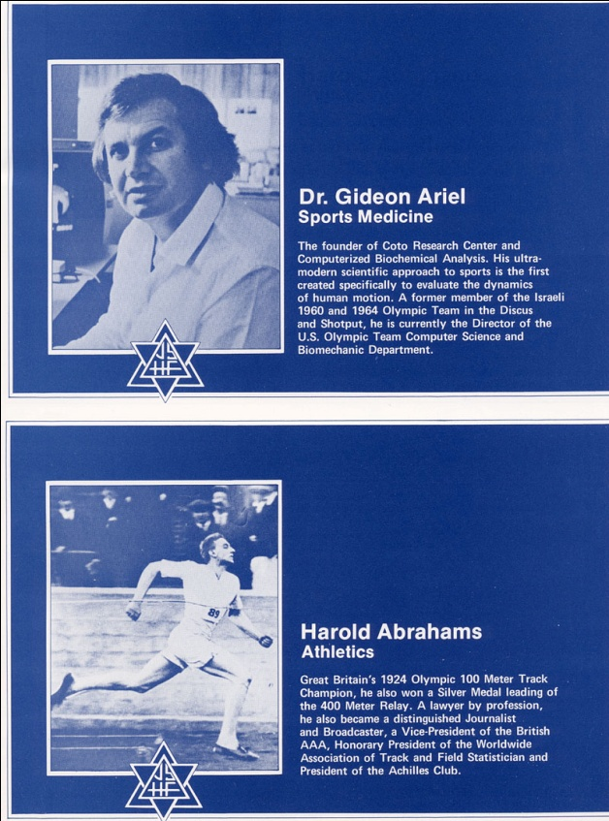
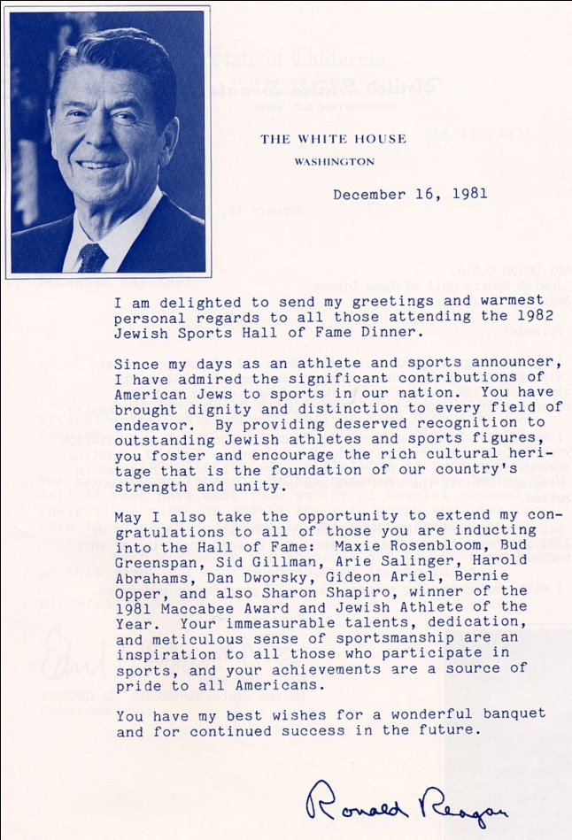
Here is the text from President Regan:
I am delighted to send my greetings and warmest personal regards to all those attending the 1982 Jewish Sports Hall of Fame Dinner.
Since my days as an athlete and sports announcer, I have admired the significant contributions of American Jews to sports in our nation. You have brought dignity and distinction to every field of endeavor. By providing deserved recognition to outstanding Jewish athletes and sports figures, you foster and encourage the rich cultural heritage that is the foundation of our country's strength and unity.
May I also take the opportunity to extend my congratulations to all of those you are inducting into the Hall of Fame: Maxie Rosenbloom, Bud Greenspan, Sid Gillman, Arie Salinger, Harold Abrahams, Dan Dworsky, Gideon Ariel, Bernie Opper, and also Sharon Shapiro, winner of the 1981 Maccabee Award and Jewish Athlete of the Year. Your immeasurable talents, dedication,
and meticulous sense of sportsmanship are an inspiration to all those who participate in sports, and your achievements are a source of pride to all Americans.
You have my best wishes for a wonderful banquet and for continued success in the future.
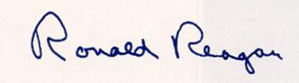

Another impressive document was from the American-3, the American Cap that wan the race in 1992. They used our technology for few years before to be able to win the World Championship in the yacht race. Here is the document:

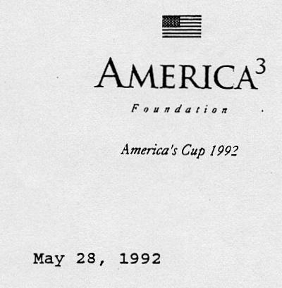
Dr. Don Brucker
President
Ariel Life Systems, Inc. P. 0. Box 1169
La Jolla, CA 92038
Dear Dr. Brucker:
This letter comes to thank you and all the Ariel staff for your tremendous support throughout the America's Cup competition. We really believe that the fitness of our grinders aided by the use of the Ariel CES equipment helped to give America³ an edge over the competition.
We appreciate the time taken by Ariel personnel to train our coaching staff and to upgrade our equipment to state of the art.
Thank you Ariel Life Systems, for all your help and support - we
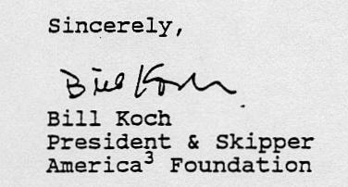

Our technology also was used with the Navy Seals in San Diego. They used the Computerized Exercise Machines for years. (I could not find the letter from them. But, it was on the wall as well.)
The investor were what was called a mezzanine investors. They are investing money before the company going IPO. These investors would make a bundle after the company would go IPO in one year or so.
The Price Waterhouse corporation did the due diligent on us. The report came great. Very few start up companies would have such a good financial spreadsheet.
So, all Dr. Brocker had to do is to collect the money from the investors. It was a clean and honest operation. Everything followed the law with the Price Waterhouse shown to investors how good their investment would be.
There were approximately 60 investors, most of them from San Diego and some from New York and other locations. I personally was not involve in this process. I found latter on what a mistake I was making by getting personally involved by presenting my technology to investors.
Dr. Brocker raised Millions of Dollars from the investors that came to visit with us. The money was used for shows, salaries, manufacturing and all the other expenses necessary for a company with over 50 emplyees.
Well, as we know from the stock market, it is going up and down unpredicted. In 1992 was a sort of a crash of the stock market and some of the investors lost allot of money in the market. They had to capitalize on the money they gave Dr. Don Broker and asked ALS to return the money to them.
By that time Don spend allot of the money on marketing and manufacturing plus had to pay me for the Royalties on the software that I provided. The company ran out of money and two investors force the company into bankruptcy. This lead to bankruptcy legal procedures which are very time consuming and annoying. In addition, some of the inventors were suing everyone in Ariel Life System including suing me and my company even though we had nothing to do with the ownership in ALS.
The lawsuits continued for six years and I would not budge or settle out of court. I insisted to go to trial. The trial came in 1995 and a Jury decision was as Not Liable against me. I was free of lawsuit but spent over a Million Dollars on legal fees.
The following is the letter Ann I prepared to the investors in ALS.
The Ariel Life System Inc. (ALS) Story
By Gideon Ariel and M. Ann Penny
August 1st, 1993
The purpose of this document is to describe the important events concerning ALS prior to its existence, during its brief life, and to illuminate some of the reasons for its demise.
In 1989 Mr. Herb Lightstone (Herb) was introduced to Ariel Dynamics Inc. (ADI) in Coto De Caza, California by Mr. Norman Zafman, (Norman), the ADI patent attorney. According to Herb, ADI could do much better if they would allow a group with the appropriate marketing and sales expertise to handle the Computerized Exercise Machine (CES). Until this point in its history, ADI had sold the CES throughout the world with normal sales terms of one-third down at the time the customer placed the order and the remaining balance paid prior to shipping the equipment. ADI was a profitable company utilizing a few consultants and without employees. For example, three consultants were involved with programming on the East Coast, the sales people worked as independents for commissions only. Dr. M. Ann Penny was the president of Computerized Biomechanical Analysis Inc. (CBA), which provided the software and the know how to ADI CBA also performed services contracts to various companies such as Wilson Sporting Goods, I.B.M., Kimberly Clark, AMF, Spalding, NASA and many more. The contracts supported the development of many products including the CES. Dr. Penny also functioned in financial and business involvements with Gideon in each corporation. Gideon was the leader and decision maker for each corporation. Neither Dr. Penny nor Dr. Ariel drew salaries from their companies.
Dr. Penny (Ann) discussed with Dr. Gideon Ariel (Gideon) the concept of having a marketing group to sell the CES. After months of persuasions, Gideon reluctantly agreed to meet with Dr. Don Brucker (Don) of La Jolla and, in late 1989, Gideon demonstrated the CES to Don and Herb at Coto. Don was very impressed but could not believe that such a small company could make such a profit without marketing and advertising. Also, he was intelligent enough to realize that there was a potential gold mine in the CES due to
patented, sophistication, technological superiority, and uniqueness that were inherent in the CES. Clearly it was and continues to be the most advanced Computerized Exercise System in the world. In fact, he asked "Where is the catch?" I gave him the answer which was true then as it is now. I explained that the market is very limited, the customers are normally highly trained and specialized within their own academic or professional areas, and there are limited available monies.
Following additional meetings with Don, Gideon, Ann, and Norman Zafman (Norman), as well as conference calls and meetings between Herb and Mr. John Soja (John), who is Gideon's attorney, a new company was formed called Ariel Life System Inc. This company received only the license from Gideon's various companies to manufacture and market the CES. It was decided at the beginning that Gideon would own the same number of stocks in the company that Don owned. The intention underlying this decision was to prevent Don from unilaterally executing the sale of the company to other parties, entering into ventures which Gideon and his advisors believed were detrimental to the success of the product, or any other action or decision of an adverse nature relative to Gideon or the CES. Don requested that Gideon hold the title of Chairman of the Board. This was for marketing purpose only since Don believed that the public would more favorable receive the CES with Gideon's perceived involvement. However, Gideon was told that this position was symbolic only, the Chairman does not make any decisions, and Don's position and function was to operate all of the business, including but not limited to sales, marketing, manufacturing, and financial. Gideon's
function was to concentrate on the Research and Development in order that the CES would always be on the leading edge of hardware and software technology; this is Gideon's great asset. For special events, such as a very important conference or a significantly large potential client, which necessitated Gideon's presence, these involvements were included among the various contractual agreements. Don's involvement was to operate all of the business relating to ALS with no restraints or constraints imposed by contract or via the Board of Directors. I was not interested in the business aspects of ALS; since I could sell the APAS under the contracts, I perceived ALS primarily as potential source of CES sales which would keep the product viable in markets which I had not pursued as well as generating monies to support aggressive R&D efforts to maintain technological superiority.
A contract was prepared by Norman and signed granting ALS licensing rights to manufacture and market the CES in return was to pay a seven percent royalty (7%). (Contract is available upon request). It seemed like the appropriate time and business relationship for the CES to reach its international potential; Don was going to build a large company to sell the CES, I would get royalties on each sale, and, at the same time, I could sell the APAS as usual. How could I go wrong? It was sounded very attractive.
During the CES negotiations, Don expressed interest in another of Gideon's computerized products, namely, APAS or Ariel Performance Analysis System. This motion analysis quantification system was developed by Gideon and was sold world wide. Both Gideon and Ann adamently refused to allow ALS to have anything to do with the APAS. However, following numerous negotiations, Gideon agree that ALS, as a distributor, could sell the APAS system. Essentially ALS would be able to purchase the APAS system at a reasonable price and Gideon's company would profit from sales in markets which they were not addressing. The commission which ALS was to pay for each sale of the APAS system was 33 1/3 percent of the selling price. A distributor contract was prepared and signed up. (Available upon request). Since Gideon's company normally paid sales people a 25 percent commission, it was consistent with acceptable business practice to pay ALS a distributor commission of 33 1/3 percent for larger quantities of sales.
In order to make the CES available to ALS the following situations had to be resolved:
- Buy back the Ariel patents from Wilson Sporting Goods Inc.
- Terminate the relationship with the existing CES manufacturer.
- Terminate existing CES liabilities with CES manufacturer.
Gideon need cash to eliminate these liabilities and was large enough to prevent the entire ALS concept from commencing. However, Don explained to Gideon, Ann, Norman, and Herb that just the inventory alone, which Gideon already owned, would more then pay for these outstanding obligations. At that time, ADI had 57 fully assembled CES machines. These had already been fully paid for at a cost to ADI of approximately $10,000.00 each. The price and the fact that they were already paid for was ADI's normal method of business -- No paper work, No hassles, No problems regarding credit, and No time demands!!! These 57 fully assembled and ready to go machines were worth $2,280,000.00 retail income (57 at the list price of $40,000.00). In the presence of Norman Zafman, Ann Penny, and Herb Lightstone, Don agreed to pay Gideon all these expenses from the initial sale of the equipment which were to be contributed to ALS by Gideon. In addition to the 57 CES machines, there were 62 computers to run them, and 200 valves to be used on future machines. These various items had cost Gideon approximately $600,000.00 which did not include the money previously paid for the 57 CES machines. Gideon had raised the money through various loans and commitments. The interest bearing on this money sometimes exceeded 30 percent per year. During the negotiations involving Norman, Herb, Ann, and Gideon, Don stated that any loans which I secured should be for short terms with none more than a maximum of one month. (The cost for one month was $25,000.00!) Based upon the recommendation of all parties
involved, I arranged the financing and paid all the obligations to free the patents and to buy the additional inventory from the company which had been manufacturing the CES machines.
At that point, I did not realize that I had created a liability for myself in access of $600,000.00 and, since ALS had all of my inventory, I had nothing to sell from ADI. However, since ALS was to pay me everything within a month and was to pay 7% on sales, there seemed no reason for concern. With the new cash from ALS, I could continue my small scale operation of APAS sales and focus on R&D efforts.
After receiving the CES machines, ALS began selling the equipment, however, no payments were made to Gideon. Don always had some reason why the payment would be delayed until the following month. In the mean time, payments towards the loans were having to be made by Gideon from the R&D monies paid by ALS to ADI. It became increasing more apparent to Gideon that he had been taken and was in deep financial commitments. Don was selling the CES machines but would not pay the monies due to Gideon for either the original equipment or the royalties. Also, according to the contract, ADI was suppose to receive a minimum monthly license fee to help both companies in the event that there were slow months relative to CES sales. These fees were not made during the first 8 months which placed ADI in difficult financial problems.
Don complained that ALS was unable to pay ADI because of the low commission fees associated with APAS sales and he demanded a more advantageous arrangement, namely, a 50 percent commission instead of the current of 33 1/3 percent. With this amendment, he insisted that ALS would be able to meet the financial obligation to ADI. By this time, the funds had been due for more than a year. The Amendment was made (available upon request) but payments to meet the ADI commitments continued to be unpaid.
During this time, Don had full control over the CES since he manufactured it but now he demanded that all sales of APAS should be made from ALS so he could pay the money he owed to ADI. Despite the facts that the ONLY item which ALS had the license to manufacture and market and strong insistence that APAS should be kept completely separate from ALS, Don was relentless in demands for APAS. He insisted on more ALS sales opportunities and better financial terms (smaller and smaller commissions) with ADI.
Gideon had called Herb several times to obtain his help but with no success. In fact, Herb was busy with a new venture created within ALS which was called Ariel Financial Corporation. Gideon was not told about this financial entity and information sought was not provided. Meanwhile, Don continued to stonewall on payments to ADI so that the royalty, expense, and R&D commitments increased continually. Norman was informed about the problem but he was unsuccessful in obtaining any financial information nor could ADI's accountant, Collin Hatch, obtain the necessary information to determine the actual and accurate facts about ALS. There seemed to be many systems leaving ALS, but any and all financial information was sealed from Gideon by Don, Laura, Peter and Neville. Since no system could leave ALS without ADI/CBA software implementation, Gideon had some limited knowledge about the number of systems being shipped, the customers, and the information provided on the invoice. Whether any system was ever delivered to a customer, the accuracy of the invoice, or payments made or not, was never available to Gideon, his professional assistant staff, or from ANYONE at ALS. Little or no monies which were legitimately due to Gideon and which were associated with each sale were paid or accounted for except for partial information which Gideon had to obtain surreptitiously from some employees. There were very few employees who would give Gideon any information; the majority of people, when he asked for facts, told him that they worked for Don and were expressively forbidden from telling Gideon anything.
Although Gideon was an owner equal in shares to Don and ALS had financial obligations to Gideon for royalties, expenses, and monthly R&D commitments, he was
unable to secure this financial information. I demanded this information from Laura and Peter, but they said that they reported only to Don and had been expressly directed not to provide me with any details. In fact Laura told me: " I work for Don not for you and, unless Don tells me to give you information, I cannot help you". I responded very angrily and told Laura that she is working for me as much as for Don. However, Don intervened and persuaded me to calm down. He told me that" The money's coming next week ..." However, time passed and Don exerted greater and authority in all areas including the R&D areas by insisting on a new Back machine, new software such as DELTA and GAIT programs, yet he continued to hide the financial activities from me and any of my associates as well as refusing to pay the obligations. Each time that I reached a point of complete frustration and was ready to terminate the relationship which I was basically having to subsidize, Don promised that when ALS went public there would be millions of dollars available to pay all of ALS's obligations to ADI and Gideon. According to Don, this time was very soon.
From that point, the Public Offering was the reason for the delay in payment and became the new scenario in Don's ALS arsenal of arguments to be used on Gideon that he must change the agreement for the APAS to only 7 percent. (Available upon request). Norman insisted on a condition in this agreement which included a protection for Gideon in view of the consistent failure of ALS and Don to pay the monies due to ADI. Gideon and ADI were granted a UCC1 to protect the overdue investment which Gideon and ADI were unwillingly providing. Don accepted this condition and I owned the UCC1 which protected me as first creditor.
At that point ALS owed ADI in excess of one Million Dollars but Don decided that the company would look more favorable to potential investors with different payment structures and, based on this opinion, he modified the financial books. With the help of the accounting department, which consisted of Laura, Peter, and Neville, the books were made to reflect a lower level of royalties and commission owed to ADI. Without having access to the books, Gideon discovered that the amount of money due to ADI was now $640,000.00. At this point, Gideon knew that something was terribly wrong within the especially when he found that other people had invested substantial amounts of money in ALS. It was this source of money along with Don's continuous financial contributions which was the substance of ALS rather than product sales. In other words, Gideon thought that Don's contributions were to cover recurring cash flow difficulties and the few outside investors which he was aware of were important people who would be useful in the future or were past friends of Don's; clearly, Gideon was nowhere near the true story. As Gideon became increasingly more concerned about things he was discovering at ALS, he Immediately called Herb for help. Herb came to ALS and, after only one week of digging into the business, stated to Gideon that many things were bad and the books might actually be fraudulent. Also, Herb made it known to Gideon that a promise had been made to an investment bankers from New York in which the Ariel Patents were available for sale.
At that point, Gideon faxed Michael Gardner and Steve Sanders in New York indicating that he did not now and had never had any intention of selling the patents at any price. This event caused the people from New York to carefully examine the situation.
It was clear that ALS had spent too much money on various marketing scenarios. It was soon learned that systems had been sent to customers to reflect greater numbers of sales than actually existed to indicate to Wall Street that sales were booming. Only Don and the accounting staff really knew, until recently, that these sales were bogus and, in some cases, did not even exist! Price Warehouse's auditing report led the Wall Street people to believe that sales were fantastic. Don had borrowed more money to support his effort to reflect high sales. Whenever I asked Peter or Laura if these sale were realistic , they assured me that the "Money is in the bank".
Since the accounts receivable which were shown to individual like me reflected over 5 Million in sales, Don obtained another loan from the bank to cover the time during the "cash flow pinch". The bank for this transaction was Riviera. They demanded a UCC1 before they would advance ALS one million dollars against the accounts receivable. Don approached me to relinquish my UCC1 so that ALS could grant a UCC1 to Reviera. I called Norman and we demanded a payment of $300,000.00 to credited against my royalties . At that point ALS officially owed me in excess of $600,000.00 and unofficially, if the "real" sales were audited, more than one million dollars. Don had no choice. If I relinquished the UCC1, he must pay me $300,000.00 which would allow him to keep $700,000.00. This agreement was reached in the present of Norman, Herb, and Peter. Norman demanded a new contract be prepared and signed reflecting the agreed upon terms. Don became very angry and said change muse be executed immediately since Reviera was on the line. "Don't you trust me to give you the money tomorrow?" he asked. I could not conceive that Don would take a chance to lie in front of Herb and Norman; therefore, I gave up the UCC1 in favor or Riviera. The next day, Reviera advanced the million dollars to Don but he did not paid the $300,000.00. Amazingly, he spent the money on other expenses and did not meet the obligation to me. When I called Norman, he could not believe it!
At this point I knew that ALS was doomed as a company. I would not continue to work under this conditions. I resigned as Chairman and from the Board and wanted no further involvement in any way with Don. I warned Herb to immediately investigate what was going on. This is where we are today.
So what happened???
Don had been successful in the past selling contact lenses and made quite allot of money when his company was bought by Revlon for more than a 100 million dollars. When he learned about the CES, he thought he had discovered a "hot" product. The CES and the APAS were the top of the line in both concept and technical sophistication. In addition, they had been virtually nothing done as far as marketing and sales techniques to produce larger quantities of sales. than ADI had generated. Don believe that, with a small investment, he could make ALS large, successful, and be of great financial benefit to himself. After all, he believed that since he had done it once, he could obviously do it again. However, impatience and a high level of greed, stimulated him to accelerate normal business criteria in an effort to achieve that success. In order to reach his predetermined maximum, he needed to be able to open the company to the public via Wall Street . What he failed to realize or perhaps to accept was that the CES and the APAS were not ready to go public since the markets did not exist. ADI had the best product on the market but that market was very small. The market Don fantasized about did not and still does not exist. Don thought that such a market could be created and he spent millions of dollars to create it. In fact he spent all his money and, at that point, he needed other people money so he switched from legitimate business practices to illegitimate ones. Books were changed and sales were exaggerated. These activities were legitimized by Price Warehouse, a reputable accounting firm . Don was able to fake the best in the field. For me, unfortunately, it was like watching a movie since I never knew what to believe it or who not to believe. Even the people I met who worked in and around Wall Street assured me how great the company was going to be. I remember asking Michael Gardener how it is possible to invest in something that had not happen yet. He assured me that this is the way the American business is made.
And what Happens now?
ALS has filed for bankruptcy protection under Chapter 11. I have fired most of the salaried staff. The only remaining personnel are John Probe, my chief executive in charge of quality control, new sales, and customer support. Stan, who assembles new systems and services equipment previously sold. Dany Saar functions as an
independent sale person on a straight commission basis. Andre, Don Sir, and Daniel work on contract by contract bases as needed. The payroll can support only one person and this is John Probe at $4500.00 per month. I have not nor do I intend to draw salary.
On the other hand, we have 3 accountants on staff: Laura, Robin, and Ken. I am personally opposed to this and have expressed this opinion to Herb. It sound ridiculous to have 3 accountants on staff with few sales and with only two people needed for technical support for new and old systems. We should have accountants only as consultants at some reasonable rate such as $50 per hour.
According to the information which I have been given, since the filing date we were able to collect more than $500,000.00. I am not sure about the exact amount since I still do not receive accounting information. (This seems to be a consistent pattern with ALS regardless as to who is running it! I never received information when I was the Chairman of the Board, as a major stock holder, nor as one of the owners of the
company. I didn't get financial information at the beginning of ALS or now after the filing. I do not know why despite demanding this accounting information repeated then and now.
Also, I hold all of those within the business, financial and accounting areas responsible for the demise of ALS. This includes primarily Don, but as his "agents or workers" were Peter, Laura, and Neville. These people should be held responsible and should not continue to be employees of ALS.
The approximately $500,000.00 of income from accounts receivable should be allocated to generating new sales by supporting a minimal staff, purchasing the barest numbers of inventory needs, and settling historical problems. There should be enough money to allow ALS to survive for at least one year and with normal growth. With a barebones existence, ALS should be able to over come the Chapter 11 shock and to gain sales and emerge from this bankruptcy in the future. This is not guarantee but it is possible. It will not be possible by spending money on nonproductive staff or ineffective actions.
I was very successful with these products in the past and I suggest that my decisions be the ones to follow in the future. I can run this company but anybody on the payroll must be responsible to me one hundred percent. Anyone that does not agree or chooses otherwise should resign (without sick days and holiday pay!!) I welcome volunteers to help and advise me. But, if you are on the payroll, you will have to follow my orders exactly and report only to me.
I realize that there are other creditors besides me but these products are mine and their future is in my hands. I have lost a tremendous amount of money as is reflected on the ALS books but I have also lost substantial monies from my other companies. I devoted myself exclusively to ALS and have diverted sales which were legitimately mine to take to ADI which was revenue lost twice!! In addition, it is my name, my reputation, and my future that has been and will continue to suffer until the ALS mess is resolved. I believe no one can argue that they have lost more than I have nor been more fair and generous in trying to make ALS successful. I hope that the other creditors truly understand the situation as it was and is and will be supportive and contribute to the future recovery and success of ALS. If anyone involved does not agree, we all need to know about it in this meeting.
Also, Jeremy, wrote a message to the Biomechanics list responding to the Bankruptcy:
Contrary to John Blackwell's statement, the demise of Ariel Life
Systems is quite irrelevant to those who have an Ariel system or
are thinking of purchasing one.
Ariel Life System was merely a distributor for Ariel products, and
a non-exclusive one at that. Ariel Life did not develop the
products or own the products, it merely sold them. Ariel Life was
the dealer not the car maker. The inventor of the products and the
owner of the intellectual properties involved, Dr. Gideon Ariel,
was only a minor player in Ariel Life.
For many years before Ariel Life Systems came into existence, we
at Dr. Ariel's own company, Ariel Dynamics Inc., developed the
systems, marketed the systems, and supported the customer base. We
will continue to do so into the future to the best of our
abilities.
If one reads the article mentioned you will see that the Ariel
products are spoken of very highly as being on the cutting edge of
the technologies involved. Also, there is absolutely no reference
to losses by customers. Quite to the contrary, even with the demise
of Ariel Life the customers were treated very well. The only
persons to have suffered a loss were investors. Although one can
have sympathy for these people, investing in Ariel Life was not
like investing in IBM or DEC which turned out to be very poor
investments, or even a risky IPO. Investing in Ariel Life was
investing in a complete startup, which is as risky a business as
one can get, and the nature of the risk was clearly presented.
People who invested accepted the risk for the potential of high
gain. It comes with the territory.
Those persons who have or are thinking of purchasing Ariel products
should be unaffected by the demise of Ariel Life. We may not be
able wine & dine as well as Ariel Life but as for development and
support for the Ariel products it has never been better.
Dr. Jeremy Wise
Dir R&D Ariel Dynamics Inc.

ALS went bankrupt. We got out of this mess after 6 years of legal battle. But we have never stopped selling our technologies and making progress. One thing that I changed is that I did not want to meet with the media anymore. We were working in our houses and use the Internet to generate business for us. I was going around the World and still presenting scientific presentation on my technologies.
Now, Ann and I were back at our houses, the living house and the company house and we decided never to have any business with anyone. We became alone with ourselves. And we did great. We start traveling around the World and taking educational courses at Oxford and Stanford Universities. We start having marvelous time. Still have very limited staff working with us, only 5. But we made big business since we had the best system in the World to offer in the field of Biomechanics and Exercise Machines systems.
To any other country that we traveled we would bring back home some memory from these countries. Our home start to look more and more like a Museum.
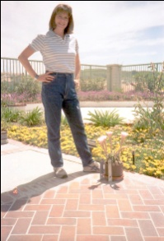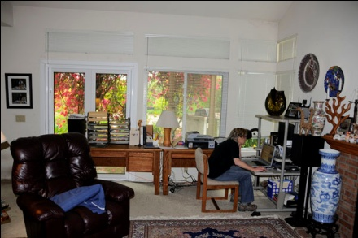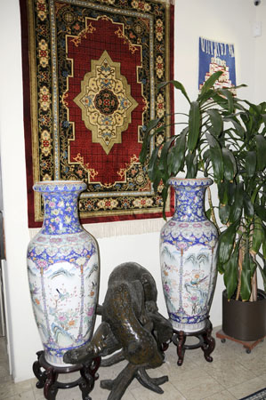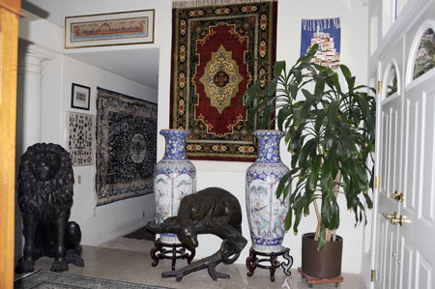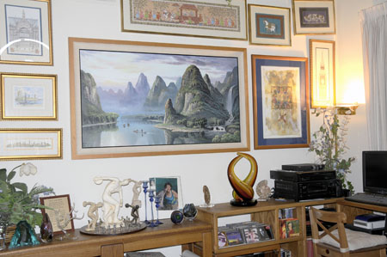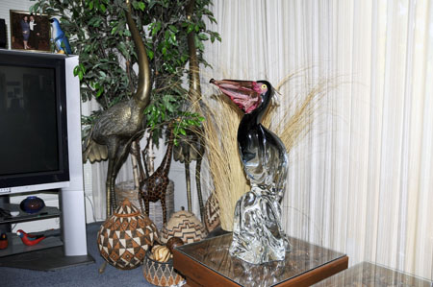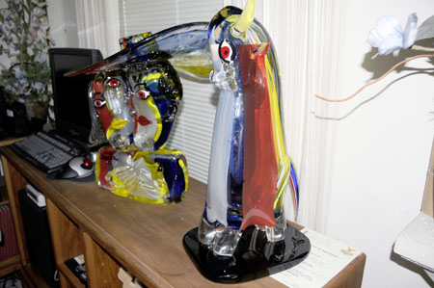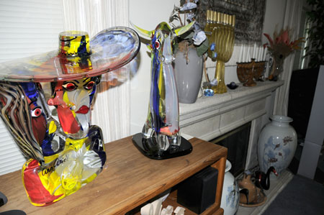
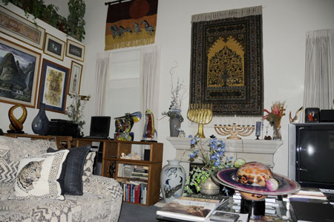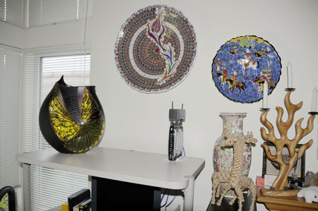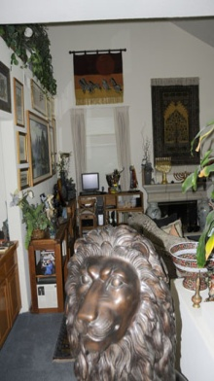
Our Dogs Hertzel and Shaloma
Ann and I converted our business to a virtual one. In fact, we always had a virtual office where our staff were working from their home. Only when we needed to meet with customers or give presentation we would meet in our office in Coto De Caza. We were operating from any place in the World with our Notebook and global internet connection. People really did not know where we are. We could be in England, China, Singapore, Hong Kong, France, Israel etc. etc. and we ran our business as if we were working from our office. Even our staff at Amherst and San Diego did not know where are we at the time.
I was invited to be a keynote speakers in many conferences. The ones that I loved the most were the ones in the Olympic Games. I have never missed any Olympics from 1960. I did participated in the Rome Olympics and in the Tokyo Olympics. In 1968 I was assigned to be on the field collecting biomechanical data which latter I presented. In 1972 I was given a keynote address at the Munich Olympic Games. In 1976 I was a keynote speaker at the Montreal Olympic Games and were assigned on the field to collect data. The USA boycott the Olympic Games in Moscow, so I was not there.
In 1984 at the Los Angeles Scientific Congress I presented a research paper related to the throwing events. In 1988 in Seoul Korea I presented a research paper related to the results in the 1984 Games. In the Barcelona in 1992 I was a Keynote speaker at the scientific congress presenting the APAS system.
In the Olympics at Atlanta in 1996, I was assigned to collect data and I presented few papers in the Scientific Congress. Below are some of the documentation:
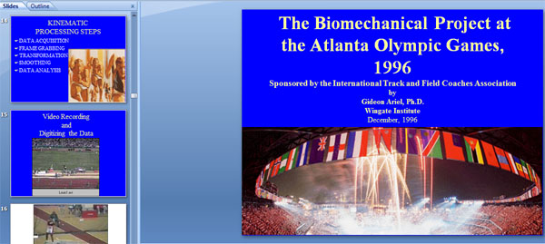
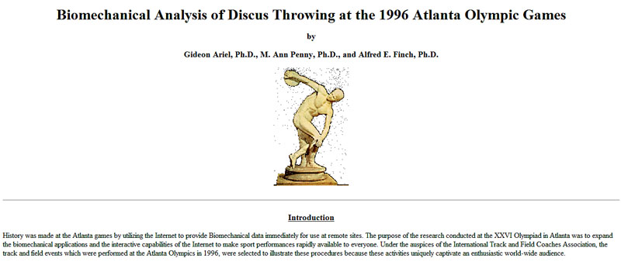
In the year 2000 we collected data at the Sydney Olympics in Australia and I was a Keynote speaker at the scientific congress as shown below:
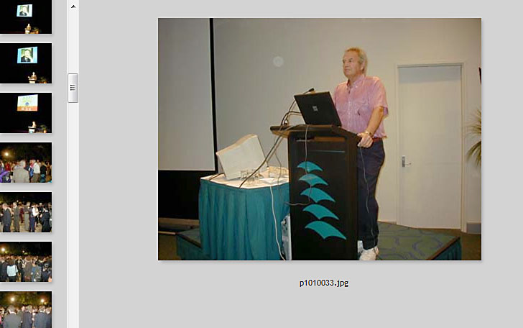
Next Olympics was in Athens Greece. I was assigned to collect data on the field and did present results in the Scientific Congress as shown below:
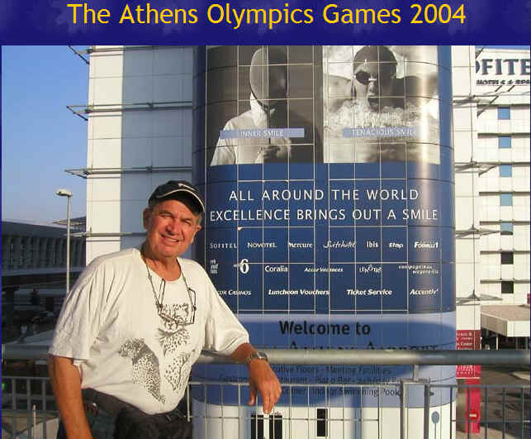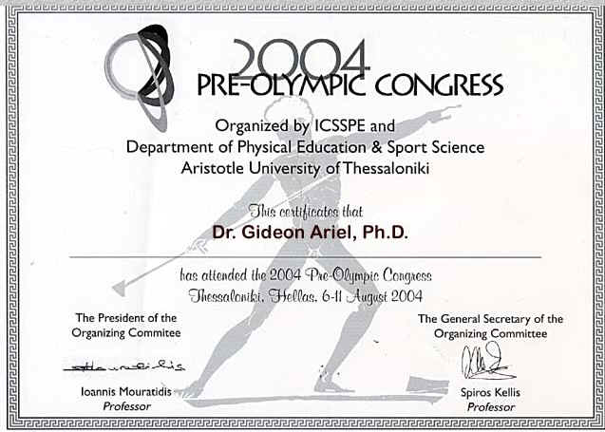
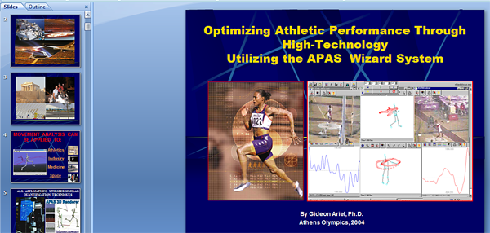
And here an abstract of one of our studies from the Games:

Biomechanical Analysis of the Shot-Put Event at the 2004 Athens Olympic Games
Gideon Ariel, Ph.D.
Institute for Biomechanical Research, Coto Research Center, Coto De Caza California
The stadium was Ancient Olympia. The site of the ancient Games of the Olympiad, 2,800 years ago. The site of the modern Games of the Olympiad; the shot put competition was held there.
The Purpose of this study was to analyze the best Shot-put performances in the Athens Olympic Games, 2004. The Shot-Put event at the 2004 Olympics was conducted at the sacred Olympia location. The Biomechanical Analysis of the Shot Put event was sponsored by the International Track and Field Coaches Association. Multiple high speed digital video cameras were placed in specific location on the field at proper angles in order to capture the performance of the athletes in the preliminaries and finals. This was the only biomechanical analysis performed at the Athens Olympic Games where cameras were placed on the performance field.
Two stationary cameras were placed at 45 degrees to each other. In addition 3 more cameras used by the NBC broadcasting were used to assist the other 2 cameras. Temporal and kinematics variables were calculated from the videos records and were analyzed yielding three-dimensional biomechanical results. Pattern of the segments movement were used rather then absolute values, to assist the athletes and the coaches.
Because of limited space, Kinematics parameters presented in this study are for the best 3 final performers. However, analysis was perform for all participants and will be presented in the oral presentation.

In 2008, in Beijing China Olympics I presented a paper in the Scientific Congress:
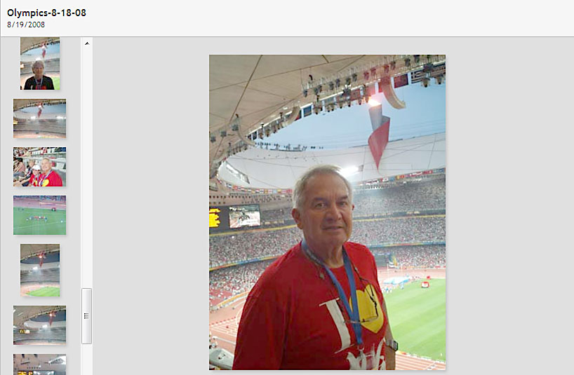
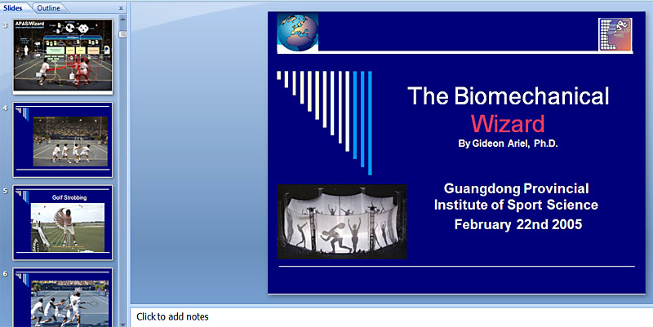
The scope of this book does not allowed to show all the hundreds of interesting presentation which I made. However, what I tried to show is that the business problems we had with the ALS Company did not affect our efficiency. The World loved us and loved our technology. We installed more than 10,000 APAS systems around the World and more than 1000 computerized Exercise Machines around the World.
Our life in Coto continue to be great. This is our Paradise. How many places in the World you can ski in the morning and surf the waves afternoon. Here are some of the photos:
