# Chapter 20: The Reunion

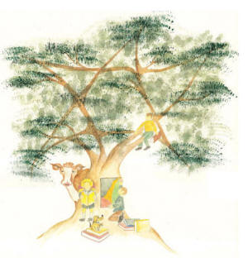

It was the 5th Discus Throw at the 1960 Olympic Trials in Israel that made everything happened. Without this record throw I would not write this book. However, it was the eight years in Hadassim, that made me throw the discus so far. These were my close friends that I have grown with that allow that to happen.

After 55 years I was looking back and remember all my friends. However I did not know much about them. In Hadassim we were not talking with each other on the past. We were one family but no one knew about the life history of the others. We had present and future, but not past.

The holocaust survivors would not talk about how they had to see their parents killed. They did not tell about the survival time in horrible conditions.

The children with family problems did not want to discuss their problems at home and discuss their parents.

The children that put in Hadassim because their parents were in the government or belong to leaders that could not make them grow normal life at their home, did not want and understand why they were let out of their family to live in Hadassim.

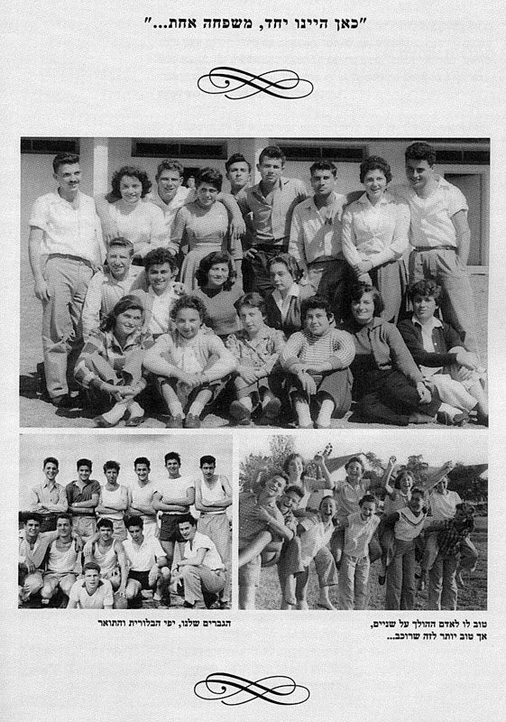  
The Hadassim Family for years live and grow together

One thing we knew: Who are we:

Our story is the story of the Generation of the State, the generation forged during

the founding of the State of Israel. Two generations of Zionist life in the land of

Palestine had preceded ours: the Founding Generation, led by Ben-Gurion, and the

Palmach Generation, led by Moshe Dayan and Yigal Allon. The iconic generals Yitzhak

Rabin and Ariel Sharon were also groomed in the Palmach days.

We are the Third Generation, born in the thirties and forties. One after another,

the pieces of our adolescent landscape unfolded with WWII and the Holocaust, the influx

of illegal refugees from occupied Europe, the struggle against the British, the War of

Independence, a still more earth-shaking wave of Mizrachi and Ashkenzi immigrants and

still further Arab attacks on the newborn state. After the Suez War, in the fifties, our

leaders claimed that the era of war had given way to the era of peace. We, of course,

took these claims seriously, though they had no basis in reality, so we never considered

the army our highest calling – as the Palmach generation had. We pursued other

interests, namely: science, business, sports and art. Beyond the communal life of the

nation, each of us delved into our own personal experience, and these individual

narratives will be presented in full, unvarnished and whole, as without them none of us

can truly be known. While the Hadassim tale deals in a miracle, the tales of its students

are sometimes quite difficult to bear. Some of our parents were murdered in the

Holocaust, while still others fell in the War of Independence. The remainder survived to

build the state, handing their flag down to us at the twilight of their days.

Part Two tells the story of that youthful lot, hailing from all over the world, which

first gathered together in Hadassim under one banner, and then charged toward their

futures with an energy that no other place could have given them.

In order to create the conditions for true dialogue among Hadassim students, in

order to stir in them a life of creativity, Jeremiah and Rachel Shapirah determined that

students would be selected in equal numbers from three groups: Holocaust survivors,

children of broken or troubled homes, and lastly those children of a comparatively

privileged status – heirs of comfortable hearths and homes whose parents were simply

too busy to tend to them, for a variety of reasons. The three groups integrated well: the

rich kids grappled with new realities; the troubled kids were introduced to better realities,

and learned in their guts that they could succeed if they would only make the effort; and

the holocaust survivors encountered the new, versatile world of a versatile Israeli identity.

In the end, these children of the Holocaust became Israelis, while the troubled kids

ascended to the elite and the elite learned to live uncorrupted by their privileges.

Many of the kids in Hadassim who’d lived through the Holocaust were, in fact, the moral

and intellectual elite of our generation. Not only had they been better cultivated in the European

Diaspora, but their hard-won battles for survival had endowed them with moral and psychological virtues of far greater reach. In order to harness their latent strength, however, they first needed a warm and understanding home; they needed friends who would keep close to them rather than labeling them “soaps” -- a cruel jibe at their near-immolation at the concentration camps – as was so

much the custom in the cities and Kibbutzim. They needed teachers who would also be friends.

The children of the Holocaust were given all of these things in Hadassim. The

following are some of their stories, starting with Ephraim Shtinkler-Gat and ending with

Avigdor Shachan. The majority of their age group hadn’t survived, and those who did carried scars in their souls that compromised their full development. But in Hadassim,

Ephraim, Avigdor and their friends did the seemingly impossible.

After 60 years we did not know the story of the past of our Hadassim Family. Ann and I were now Married and one day she asked me about the history of some of the kids in Hadsassim who she met in some of our trips to Israel. I did not know the answer. However, as usual the “Kid with the dreams” was dreaming another event. How about to organize a big Reunion? Invite all the “kids” that I grew with to the best event I can offer. Would they come? I did not know. I called my friend Hillel (known as Chile) and asked him. He thought it is a good idea but was doubt that anyone of us will tell their stories.

I was thinking about my friends. I remembered one of my classmates his name is Uri Milstein. In the 10th grade we had to prepare in the literature class a composition each weekend on selected subject. On Sunday class the teacher would at random ask two of the pupils to read their composition in front of the whole class. I would usually calculate the probability of the teacher calling me, and few weeks I would take the chance of not writing the composition but having more time to throw the discus. Luckily I was never caught and when I was called I had the composition prepare.

However with Uri it is another story. One week we were assigned to write a composition regarding the independent War of Israel in 1948. I decided to take a chance and not write anything. But was happy to hear others. Uri was selected at that Sunday to read his composition. It was a fabulous presentation. Detail and dates and amazing stories from the War which we learned throughout the course. Uri’s composition was so good that the teacher asked him to give him the notebook so we will published it to everyone in Hadassim to have a copy. The teacher insist and actually approached Uri and extend his hand to receive the notebook. Uri, handed the notebook. The teacher Shalom Dotan, thank him and open the notebook. It was empty. Needless to say that Uri got in trouble and had require to write the whole speech again or to suffer F grade in the class.

I have never forgot this event. It fascinated me for years. I had in mind that we must find the information about the “kids” and no one could be better to write it than Uri Milstein. I did not have any connection with Uri for 50 years. I did not know anything about him all these years. But I have remembered the event in Class.

I called Hillel on day and asked him if he knows where I can get hold of Uri. He did not know but told me that Uri is a very famous writer by then and infect wrote over 20 books very popular in Israel. I told Hillel that he must find him. And, he did.

I called Uri from the US: “Hello Uri, how are you?” “who is that?” He answer. “This is Gideon”.

Uri got very excited and we had long conversation about the past and present where suddenly I told him: “Uri, we must write a book about the kids in Hadassim. No one know the past. We only knew the present and we now know the future, but we do not know the past, we must write it and give to each of the “kids” the book in the Reunion that I am planning.”

At first, Uri thought it is impossible task but told me that he will try. We agreed on the price and I told him that I want a hard copy first class book with photos. He told me that this will cost allot. I told him that I do not care and just to let me know where to send the checks.

After a week of research, Uri told me that it will take 8 months to do the job and he will have to interview each one of the “Kids” that were with us in class and some that were above us and below us since it was significant for the content. I agreed and the job started. We called the book: “Oasis of Dreams”. Of course the scope of this book does not allow to include allot of material from this research that we did and published but I will include only some especially for the kids of the Holocaust We found their past from them after we lived with them for 10 years, and they told us the events after 60 years. They never told these events to anyone since. These are few Interviews that my friend and classmate in Elementary School and High School conducted with the “kids”.

**A Child in the Closet**

**  
Ephraim Shtinkler**

As his parents were being murdered in Auschwitz, the five year old Ephraim Shtinkler-

Gatwould end up spending two years imprisoned inside a coat-closet in a Polish family’s apartment.

It was in that closet that he ate, drank, grappled with lice and breathed naphthalene – all without

so much as coughing or sneezing or uttering a single word. He slept with his knees curled up in

a sitting position. Whole days and nights he would spend in the dark, motionless, taking in the

conversations outside his little sanctuary, listening to the family exchange words with SS agents who

would exterminate him within the span of seconds if they but discovered him. These weren’t healthy

conditions for a five year old’s development, to say the least. Our estimate is that most children

could not survive in such circumstances, and that those who could would remain forever tortured.

Not Ephraim.

Most families who risked their lives hiding Jewish children lived in crowded

conditions, often sharing a single room with friends, relatives and neighbors. The child, a

fugitive from Nazi justice, would usually be kept a secret even from most of these coinhabitants,

as most of them would otherwise have run straight to the Gestapo for sheer bigotry and material gain. Today, there’s hardly a father or a grandfather who would believe that Ephraim sat still and silent over the course of those two years.

I could hardly believe my own ears when Ephraim recounted his story. As we sat together in my kitchen in 2005, on a tempestuous winter night, I searched for any sign of a wounded and tortured soul, the kind I would have expected from the war veterans I’d written about all these years. But I found nothing of the kind. Instead, his casual smile evoked something entirely different –

He learned the precise date when his mother was sent to the gas chambers when he visited the camp in later years.

As if Hadassim had reduced his childhood trauma to an amusing memory. If this is what

happened, I thought to myself, our school’s success had indeed been unparalleled.

Ephraim came with the first eight Holocaust children in August, 1947. It was for

them that WIZO celebrated the founding of Hadassim on Normandy. “It was worth the effort just for him,” Helena Glazer, president of World WIZO told us after reading this chapter in her Tel Aviv office. As she turned page after page, she kept whispering “Unbelievable, unbelievable…” as she wiped tears off her face. And there were many like him to arrive at Hadassim. He was a pale, blond child with brown eyes and Slavic features – handsome, in short – who seemed to have emotionally

distanced himself from his past, who seemed ready to embrace life (“we have everything to look forward to!”). It might have been his DNA, it might have been the closet that been his abode, and it was probably also the immediate influence of Rachel and Jeremiah’s educational ideology, which encouraged us to embrace the future. He was alive by dint of his hair color and facial features, by dint of a Polish family’s superstition -- that Jesus had commanded them to save a Jewish boy at their doorstep from certain death. He remained alive by sheer discipline and plenty of luck.

It occurred to me that luck – or fate, more precisely – was the name of the game

that God had played with us in the years 1939-1945. Though Einstein could never accept

notion that “God plays dice with the universe,” it became clear in the middle of the 20th

century that our maker was doing just that – with a vengeance. The Holocaust finally ended for Ephraim when he was seven years old, parentless, illiterate, his childhood so far eviscerated. Yet he had gained incomparable survival insights. He’d conversed with spiders, learning the lessons of endurance from them, learning to depend on his own mind, to ignore open wounds and not to scratch the scarred-over ones. Hadassim taught him to let the scars go.

Avinoam Kaplan was his first instructor. The first time Kaplan met with the eight

children he showed them a bunch of small animals, pulling them out of his pockets one

by one, including spiders. “These are my best friends,” Ephraim yelled out, and Kaplan

chuckled because he thought the boy was making some kind of a joke. Kaplan would

later tell us that he loved Ephraim as a son, and this is also one of Hadassim’s miracles:

teachers were to their students as parents.

While we were serving in a paratrooper unit together, I once asked Ephraim how

he survived the Holocaust.

“That’s a long story,” he answered.

“Well, I have time.”

“Then use it for more constructive things.”

“Like what, for instance?”

“To make plans for your vacation.”

While we were growing up together, Ephraim thought it better not to tell his story,

that there were more “productive” things to be getting on with. Now, at the age of 68, his

edge softened a bit, he was more willing to explore his earliest trials. I was so grateful

that I wanted to hug him, but I was afraid that even that would cut the conversation off

very quickly.

Who would have believed that this Holocaust orphan could serve in one of the

finest battalions, that he could spill blood with his brothers in ‘67 and ‘73, that he would

go on to take a bachelor’s in chemistry and biology and master’s in botany (in Kaplan’s

footsteps), that he would then study computer science and attain a senior position within

the sophisticated Israeli aviation industry? It was men like Ephraim, born of the

Holocaust but bred in Hadassim, that allowed the Israeli state to endure the multiple

threats against her.

After our first interview with him, we called him to go over certain details

regarding his childhood survival. “How are you doing?” We asked.

“Couldn’t be better!”

Was he exaggerating? Was it possible he was merely hiding behind psychological fortifications? To our eyes, Ephraim had always embodied the “nice Israeli” archetype. We asked him how Hadassim had helped him, how he made the transition to the “normal” Israeli persona. “We came into an atmosphere where the past was dead, where we were now reborn in our true homeland. Almost nothing was said in Hadassim about the “thing” that happened. During the Holocaust, everything was forbidden (except some very limited things) but in Hadassim everything was permitted (except that which was forbidden). So almost overnight we found ourselves in unadulterated freedom, something that even normal children rarely experience. That freedom neutralized the otherwise inevitable compulsions and fears -- of the unknown, of trying new things – that children of our

backgrounds would have. Unfortunately not many other survivors were so lucky. The

nurturing and encouragement we received at the get-go from our first counselor, Malka

Kashtan, helped us a great deal.”

It is astounding, and telling of Hadassim’s magic, that a Tel-Avivian bourgeoisie

accustomed to thrice-weekly hair-treatments from her mother became a mother in her

own right to these eight Polish children. Her care taught them that it was possible to

bond with fellow human beings, something they’d never learned in all their constant

dislocations before and after the war. Malka also looked after us, the native Israelis, for a

whole year, and was able to give many of those with troubled family backgrounds –

Gideon Ariel, Asher Barnea, Shula Druker, Esther Korkidi and others – the same level of

care and psychological security. The dialogic educational concept was given a personal

dimension through her. Sadly, at the age of eighty-four, her daily routine is now sealed

inside her house; having survived her husband and even her two daughters, she only

waits for her own death. We sense, with heavy hearts, that her kindnesses have gone

unrewarded.

Ephraim was born in 1938, in the city of Bielsko-Biala in West Galicia – the birth-place of Arthur Schnabel, the same Jewish pianist whose performance of the “Phoenix” Beethoven sonata so enraptured us on that magical Tikun Leil Shavuot night.

Dr. Michael Berkowtiz, an assistant of Theodor Herzl and the Hebrew translator of his

book Der Judenstaat (“The Jewish State”), was a high-school religion instructor in

Bielsko-Biala in the years 1911-1934. He was one of the main transmitters for the Herzl

Effect on Judaism, and his influence in the city is crucial to understanding the story of

Ephraim Shtinkler-Gat.

The city of Bielsko-Biala was a fusion of two elements divided by the Biala River. Jews had settled there from the 17th century; their population had exceeded 4000 by WWII, and Zionism had flourished there since the end of the 19th century. Besides Arthur Schnabel, other well-known Jews native to the city included Zelma Kurtz, one of the more renowned European Divas tutored under Gustav Mahler’s baton in the Vienna State Opera; Herman Freishler, director of the Vienna Volksoper; and Jan Smeterlin, another accomplished pianist and Chopin interpreter. Thus, before the war Bielsko-Biala was a city of great culture, its high cosmopolitan threshold touching on the life of Jews and Poles equally, rich and poor. The baby Ephraim breathed it all in despite his modest

roots (his father was a blacksmith) and working-class heritage – a heritage that proved

potent indeed when it came time for him to survive in that wretched closet.

The Germans conquered the region encompassing Bielsko-Biala on the third day

of the war, and two weeks later they had already burned the synagogues and looted the

Jewish shops. Ephraim was the only child of Yaakov and Sara. He has only one genuine memory of the town: his father walking along with him as he showed him how to ride a bike. In 1941, his family

moved to Zawiercie to live with his grandfather. Ephraim remembers the train-ride – the depressed

passengers, their terror-stricken eyes longing to be both invisible and blind. The Shtinklers resided in the Jewish quarter of Zawiercie. In 1942 the Jewish quarter was converted into a ghetto, a kind of prelude to extermination, whose inhabitants needed permission to exit. Luckily Yaakov, a resourceful

and self-sufficient man who by now owned his own smithy in the Polish worker’s quarter, had such

permission. He’d also befriended the Novak’s, a family that lived above his workshop, and did many of their house repairs for free. He told them all about his sharp-witted and lively young son.

Ephraim’s father dedicated all his energy to save him. The Novak’s had fallen in love with the boy before they even met him. Ephraim would soon learn that life and death can hinge on the power of the tongue at these moments. Ephraim told us his first memory of the Ghetto:

“My father and I were directed to one group, my mother to another, with a road separating the two. My mother was chosen for the group that was to be exterminated. But she found the strength to approach one of the officers and ask to be allowed to join us and live, and he agreed, though it was probably a one in a million chance that he did. Mother got an extension on her life, while the others were sent away to be swallowed up by the earth. Not everything in life is black or white; there are hues of grey and dark brown, and in hell the grey stands for light and brown can mean salvation.”

His second memory: “We lived on the ground floor in the Ghetto. I remember lying on the bed, surrounded by chairs to prevent me from falling or bother my mom while she was doing house cleaning. I heard her washing the floors and singing in Polish, ‘All the fish are sleeping in the lake, though you are still awake…’ To this day I hum that song, always picturing her luminous face. As she kept cleaning I imagined to myself that she was a queen and that we would soon fly off back to King Boris’ palace.” “Why didn’t your parents try to rebel?” We asked. “I can’t really answer for my parents, but the kids were mesmerized by the soldiers’ obvious power, their imposing and always neatly-ironed uniforms, their organization and efficiency. They commanded, and everyone obeyed instinctively.” “So the German were allowed to murder and people did nothing? How could you

let that happen?” “All of us, the ‘good’ kids, we all believed that if we could do what was demanded of us they would keep us alive. We felt guilty, like we had all done something wrong; we never thought of hurling stones at them the way the Palestinians do today – we lacked that sense of justice, the kind that motivates you for action. Guilt only allows for resignation. We felt guilty, so we were powerless – and they were strong.”

I’ve always asked myself: Who is to blame for the inherent weakness that allowed

for the Jews to be eaten alive? What could bring on a sense of guilt that would let the Nazis destroy with impunity? And the answer: Jewish leaders, ever busy poring over the Torah and raising capital, had deserted their communities and come to Israel to build and be built up into a nation-state. In that dire moment of history, European Jewry needed the right leadership to fight guiltlessly and ferociously. Thus, what was tantamount to mass suicide was both the price of Judaism and of Zionism. The occupation zones were unlikely sources of rebellion in any case, given the general anti-Semitism of the native residents, who were at the very least going to be unwitting participants in the slaughter. They would neither assist any uprising nor lift a finger to deter the Germans from brutal

retaliation, nor admit too many Jews into their partisan (resistance) fold in the surrounding forests.

On the other hand, there were many individual acts of rebellion, many of them life-saving. Ephraim’s life was preserved by such a rebellion, by his father’s. Shevach Weiss, Metuka and Alex Orlander, Eliza Bar-Shwartzwald and Moshe Fromin were all promised a new life in Israel by such rebellions.

In August 1943, there were six thousand Jews in the Zawiercie Ghetto. The Germans eventually sent everyone they could get their hands on to Auschwitz, among them Rabbi Shlomo Rabinovitch, the last great rabbi of the town. Rumors of the liquidation began to spread the day before, specifically that the Germans were going to be killing a certain number of the children.

Yaakov acted quickly to save his son. His own, quiet rebellion called for him to enlist his new Polish friends. Franchise Novak agreed to send his two daughters Rosalia and Wislava out to the Ghetto’s border at a pre-arranged time, where they would pretend to busy themselves in games and wait for Ephraim. Once they recognized him, in his prearranged clothes, it was

simply a matter of letting him into the game as casually as possible. Then they slowly moved back toward the workshop, careful not to alert any of the policemen – just two little girls and an even younger boy, strolling and giggling innocently together. It was a simple plan, and it worked brilliantly.

While the girls climbed back up to their apartment, Ephraim locked himself inside the smithy, where the darkness was complete. He sat on a lathe and softly hummed his mother’s song about the little fish sleeping in the lake, thinking of his parents as knight and queen. The Novak felt so much pity for the five year old, immersed in machinery and dust, that they risked their own lives sneaking him up the serpentine stairway up to their apartment. “There are Christians who want the Jews to suffer for the murder of Jesus, and then there are those who wish them salvation. The Novak’s belonged to the second group,” Ephraim told us. The day after, when Yaakov confirmed that his son was alright, he decided to find somewhere even safer for him and asked the Novak’s to keep him for another 24 hours. Unfortunately, Yaakov didn’t know at that point that he didn’t have 24 hours: the Germans chose the same day for their “liquidation,” and Yaakov and Sara Shtinkler were both sent to Auschwitz. Only eight Jews remained in the Zawiercie Ghetto, two of them children. Ephraim was one of them.

[Ephraim]:

The entrance to the Novak’s house was through the kitchen, which led to the sparsest living room. The only bathrooms were in the courtyard, and since there weren’t any showers everyone was obliged to wash themselves in a large bucket. The living room had enough room for one bed (and a closet), for the parents, Franchisek and Genovepa, and two of the girls, while Genovepa’s mother

and her dwarf sister slept in the kitchen. So besides me, kindly relegated to the eighty centimeters in the closet, there were six people altogether. I knew very well that the Germans would kill me in an instant, that I had to keep quiet even to the point of repressing the dimmest sneeze or cough, that the neighbors who strolled in day and night could just as easily turn everyone over to the authorities.

That sustained condition dictated the next two years for me and my tiny capsule, disconnected from day and night. Still, I began to experience something akin to meditation, without either boredom or anxiety; I stopped asking when all of this would end, when evening or the next meal would come. Regardless, I was very attentive to all the goings-on in the apartment. I tensed up whenever I heard a strange voice, or whenever a neighbor came by, and I kept as silent as mouse. None of that had to be explained to me. I was only allowed to relieve myself at night, when I would be rushed out of the closet to get cleaned up and then pushed back inside just as quickly. On one occasion, they’d taken me out to treat me for lice, when there was a sudden knock on the door that

sent me back into the closet trembling and naked. Wislava threw herself into the bucket in my place, tearing her clothes off just in time for the neighbor to stroll in complaining about being made to wait in the hallway.

As far as I was concerned, this situation could have gone on forever.

Franchisek took seriously ill after a short while, and no amount of cupping his chest with hot glasses could help him without any other available level of care. He lay dying on the bed surrounded by candlelight for four days, and I kept breathlessly still in my little closet space as all manner of friends and neighbors came in to say their goodbyes. Without a breadwinner, it was left to Rosalia and

Wislava to support the family, including me. So everyday they marched to the nearby village, where they could get milk and eggs for cheap and then sell them back for a profit in town. As young as they were, they still kept quiet about me –even with their closest friends.

Two months before the Russian occupation, the Nazis appropriated the living room for two of its officers, and the family was moved into the kitchen, where I soon joined them -- covered by the sliver of cloth that hung around the dinner table. I sat there day and night on a low bench, where I could gaze at the officers’ feet as they took their meals. As Russian soldiers replaced Germans, Ephraim was finally allowed out of the closet. He was every bit as illiterate as the mythical boys

raised by Roman wolves, yet he still had the gleam in his eye of his native city’s culture, one that remained with him always. Genovepa, now a widow, smuggled him to her sisterin-law’s in a nearby town for two weeks. The Novak’s were afraid they had taken too great a risk even with their

neighbors’ lives, though Ephraim was now well-versed in the proper Christian prayers and rituals and could probably pass for a common Polish boy.



The Closet

He was now seven years old. After another several months, Genovepa met another Jewish survivor, a factory owner, and told him about the boy she had hidden for two years. When he came to visit, the man suggested that they send Ephraim to a Jewish orphanage, and the boy was soon traveling the escape routes, stopping in one of the refugee camps (where he briefly met Shevach Weiss) on the way to the children’s camp in Furten, Germany. There, one of the instructors, Masha Zarivetch, promised him that he would soon “reach Eretz Israel and be reborn in a new paradise.”

Masha and Eizik Zarivetch eventually came to live in Hadassim. On our first Holocaust Memorial Day, Eizik told us all about life at the Furten camp, and one of the other sabras (native Israelis) remarked, “So the Holocaust wasn’t so bad, then.” To which Eizik replied, “Furten was heaven compared to what this boy had to endure,” nodding toward Ephraim. He turned to him and asked if hemight tell his story. Ephraim looked up at him and went deathly silent.

  
Elisa Shwartzwald-Bar

Elisa Shwartzwald-Bar was one of the orphans to arrive with the first eight children to Hadassim. She was born in 1938 in Lvov, the capital of Galicia,**4** known as a “Paragon of Beauty” in Jewish parlance. Jews had been in Lvov since the 13th century; there were 150,000 of them there – a full third of the city’s population – up until the Holocaust. When the war erupted, the Soviet Union annexed the city to the Soviet Republic of Ukraine and took freely of its possessions, while the Germans would end up taking the rest when they came in July of 1941.

Elisa was the single daughter of a wealthy and established merchant family; she was two years old when the Germans occupied the city. As she recounts her first memory of it, “the Germans burst into the house and tore all the pictures out of their frames, tossing everything into chaotic

piles and marking a bold X on every item worth looting.” The family was thrown into the Ghetto in November, 1941, and from that day her father, Randolph, did everything he could to save her. For anyone who would doubt that a two year old girl could remember these things, we answer that no

one was left to recount them to her: her parents and remaining close family were exterminated to the last man. Elisa would go on to spend twelve years in Hadassim. “Hadassim’s strength owed itself to people’s immense energies, far more than the usual, in every field.” As she put it to us, remembering back fifty years, “They invested everything they had in us –they didn’t hold back, they were absolutely reckless about it –and asked nothing in return. They poured all their strength into

us. Life in a boarding school can be like that, it can serve as a social laboratory for collective action. The combination of that commitment with that environment had an indelible effect on us.”

After graduating from a teachers’ seminary in Hadassim, Elisa went on to do a bachelors in Bible Studies and Literature and then a master’s in education at the Hebrew University. Today she works at the Council for the Sheltered Child in Israel, helping to rehabilitate some 550 children of broken homes, ages K-3, 92% of whom passed exams in reading and math with better scores than the current 8th grade national averages. “The Current capital of Eastern Ukraine only relative I have left, a very distant one, used to tell me I’d end up as a seamstress. But for Hadassim, he could easily have been proven right.”

Elisa remembers: “Part of our family was smuggled out of the Ghetto to live with a Polish family. They’d received a handsome sum from my father in exchange for housing us, but the

neighborhood Ukrainians, even more than the Germans, were always spying after families that sheltered Jews, were always suspicious that someone buying extra groceries could be a Jew-lover. So eventually the Poles threw us out, and we scattered about the town at night, my aunt Berta and I, knocking on doors and looking for shelter. For a while no one would let us in, and with fear ruling the streets, my aunt, in an act of desperation, left me behind in one of the back rooms of the house we’d been thrown out of. Fortunately, our Polish hosts discovered me in the morning and decided to keep me anyway. They were too devout to get rid of me. Father would send them more money

from time to time, and eventually they saw that they could keep me openly – I was blond,

had blue eyes and spoke Polish well enough, so it was easy for them to pretend I was

their granddaughter.” “Father made a few rare, nightly visits, always bringing more money and

occasionally leaving me brief notes. One of them read: ‘Remember that your name is

Elisa Shwartzwald, a Jew. Tell no one, but always remember.’ We lost contact toward the end of the war, and I assume he was probably caught and murdered. “During that period of shelter, I learned all the Christian practices and accompanied my hosts to church. They even gave me their surname, though I can’t remember it today. The only friends I had were the few mice who would eagerly await

my daily portion of yellow bread. I used to hide the leftovers underneath the sofa in the bedroom, then lie in the dark and listen to them twitter about underneath as they ate it up.

I can hardly remember it ever being cold, really – I remember only the bountiful summer

gardens, the wonderful pea pods and poppies. The Germans came to the house from time to time, but never suspected I could be a Jew. I was still very afraid, of the planes and bombs, of the secret I had to carry with me that I hardly even understood.” Only eight thousand remained of the original 150,000 Jews of Lvov after the German occupation. The rest were dispensed with in the Janovsky and Belzec death camps. Belzec was one of the three extermination camps that were part of the

framework for the Reinhardt Operation (together with Treblinka and Sobibor), where at

least half a million of Jews were murdered. When the occupation had ended, Elisa’s caretakers kept expecting someone to come for her, but they waited in vain. Despite everything, they’d never really bonded with her; it was clear they had tended to her from religious and material motives. Now they were desperate to escape west, away from the Soviet occupied zones, so they sent Elisa to the Jewish community center where most of the effort to reunite families was concentrated.

So there she was, a six year old girl sitting alone, listening to reams of Yiddish gibberish passing wildly from one pathetic face to another, waiting politely for someone in the crowd to recognize her. Finally, a woman came to her and asked, “Can you give me any names of relatives? Any name you can think of.” Elisa gave her one name that was familiar, ‘Mandel,’ and the lady sent a note on her behalf to the family listed under that name. Elisa’s Polish caretaker took her to their address in the city, and as luck would have it they identified her immediately. That was the last Elisa saw of her Polish hosts.

The Mandels were distant relatives, and they gladly adopted her. Curiously, she

continued to attend church in secret. When they asked where she was spending that time,

she told them she’d gone out to play. They had their own suspicions after a while, though, and one day when she gave the same alibi they laughed and said, “Nah, you were seen in church, kneeling at Mary’s feet and praying to the icons! Don’t you know you’re Jewish? You don’t have to go there anymore.” Soon enough, the Mandels were off wandering through Poland themselves to escape from the Soviets. They finally stopped at Lignitz, where Elisa met Metuka. Sixty years later, the little blond Jewish girl who knelt at Mary’s feet in a Polish church is a senior officer of Israel’s ducational system -- another Hadassim miracle.

  
**Alex Orlander and is sister, Metuka**

Alex Orlander was born in 1935, near Lvov in the town of Zolkiewin Eastern Galicia. His sister, Metuka, was born four and half years later. Their mother, Rachel, came from one of the richest families in the area, the Reitzfeld’s, who owned a nearby oil and barley factory. Their father, Hirsh Leib, orphaned at a tender age, was a successful fur manufacturer – and Zolkiew was the center for Poland’s fur industry, center of fur manufacturing for the whole world. Hirsh’s aunt had adopted him and he had learned the fur business from his cousin. Currently Nesterov The big guns of the industry were all mostly Jews, in fact. Prior to the war, many of them had taken their commerce to Paris, London and Brussels, quickly flourishing there and maintaining their network throughout Europe. But Zolkiew remained the nexus of activity in this line; its furs could be found in the most elegant shops in every capital of the world. Metuka would certainly have enjoyed this facet of life herself – and Alex would certainly have risen up in the business – were it not for the war. Zolkiew was originally built as a fortress in the sixteenth century. There were Jews there from the beginning, and by the 19th century the Jewish community had built its central synagogue there with contributions

from rich Spanish Jews. True to the city’s origin, the synagogue was actually planned as a

citadel for Jews in times of invasion or war – a prescient notion, no doubt, but one that fell

short of the right conclusion: a national homeland in Israel. A “Soldier’s home” based

on a model of the Zolkiew synagogue was built in Beer Sheva by David Tuvyahu, a former

resident of the Polish city, to keep the tradition alive. The composer of the Israeli national anthem, Naphtali Herz Imber, was born in Zolkiew in 1856. The famous Yiddish poet Moshe Leib Halpern was born there thirty years later. Zolkiew saw the birth of the Jewish-American poet, playwright and

chemistry Nobel laureate for 1981, Ronald Hoffmann in 1937. The city was home to 5000 Jews at the outset of the war. Nobody then believed – certainly not the Reitzfelds or the Orlanders – that there was a safer or more pleasant place to live. Nevertheless, the city was full of Zionist activity; Alex and his uncle Manek (Rachel’s brother) both tried incessantly to persuade their rich

grandfather of buying land in Eretz Israel and directing some of his assets there. A conservative businessman par excellence, he rejected the idea with a charitable smile. Sometimes it is the naïve, not the canny, who are in the right. The Orlanders lived comfortably in the countryside. Their estate at the city’s periphery was ensconced in orchards and gardens. It was the ideal life that Rachel and

Hirsh Leib had wished for their children, one that Alex nostalgically pines for seventy

years later – the explosion of happy summers, the excitement of picking fruit off

neighbors’ trees. He was rather hyperactive as a child in Zolkiew, but the overspill of

energy became initiative as he became a man in Hadassim and an officer in the IDF.

After the army he became a businessman, and he has remained a successful one –

affirming the tenacity of his grandfather’s genes. The Reitzfelds had always lived in prosperity, and Rachel herself was a benevolent and loving hostess and homemaker, always providing a joyful atmosphere. Both she and Hirsh had believed that God would take care of them and theirs. It was an

infectious, steady loyalty to happiness, and even after sixty years, in spite of what they

endured in the Holocaust, Alex and Metuka, along with their children and grandchildren,

are still as optimistic and open-hearted, and just as generous with their guests. We

interviewed both of them several times for long hours, and we feel that their story is a

microcosm of Hadassim’s success. We felt that their story is Hadassim’s Success story.

Both of them have affirmed this last, and encouraged us to make clear that very little

would have been left of them without Hadassim. Several days into the war, the Orlander’s welcomed

several relatives who were escaping from Krakow into their home. Despite the nature of the visit, the atmosphere in the house was stubbornly happy and even light. With the din of war in the background, they actually played cards. No one saw the writing on the wall; no one even spoke

of trying to escape, of finding real shelter from what history had promised all these years. They’d all thought of Uncle Manek, always harping about moving to Israel, as adorably neurotic. Sure, the Soviet border wasn’t far, but the Russians were easily dismissed as philistines, but the implications of the combined German and Ukrainian attacks against the Jews of Zolkiew, in September 1939, seems to have been utterly lost on this family. It should have been clear what was waiting for

them if German and Ukrainian anti-Semitism would join forces.

The Germans turned the city over to the Soviets after only five days. “It was then

that the population really began to feel the war,” Alex remembers. Members of the

communist party, some of them Jews, readily handed the Russians the names of all

wealthy citizens; relatives denounced relatives, each hoping to bring about utopia.

Everyone of substantial wealth was arrested, and by June of 1940 most of them were

exiled in Uzbekistan. These included many members of the Reitzfeld family – the

grandfather, the aging pater familias, included.

This prefatory exile seemed catastrophic, of course. But in the end, many of the

exiled survived while most of those left behind in the city did not. With the Germans

pressing against the Soviet Union in June 1941, many Jews fled east alongside the

Russians. But the Reitzfelds and Orlanders stayed in the city.

On June 28, the Germans occupied Zolkiew, and by the next day they had already

burned down its ancient synagogue. The mass abduction of Jews for forced labor began

after a month, once they were properly sealed and helpless – and still they didn’t realize

what was going on, not fully. “It was common to hear that the ‘barbarians’ who had

come in initially and exiled the rich were gone, that our German captors, the ‘civilized

Germans’ had taken their place, and once Romanian allies entered the city some people

thought we were saved. They [the Romanians] brought lemons with them, and we even

bought lemons from them in exchange for food! Then the Gestapo arrived, and slowly

rumors descended that they were going to kill Jews. As it turned out, there were no

murders in the city, and people continued their lives, but trains were passing through,

transporting Jews to the Belzec camp which wasn’t far. Some of them had been able to

jump from the trains, and they started telling stories of horrible cruelty and random

murder in the outlying villages. My cousin Clara and some of her friends knew first aid,

so they treated some of these people. Mother had just then bought a cow for the family,

so we’d have more milk for the kids.

“When the Germans began fighting Russia, Father was recruited into a Soviet

Polish unit, and we eventually heard that he’d died near Ternopol, eastward toward the

Soviet border.”

As German actions became frequent in the city, with Jews butchered in plain sight

and others sent to the extermination camps, sixteen people from the Patrontch, Melman

and Reitzfeld families holed up together under the Melman residence. But they refused

to have Rachel, Alex and Metuka with them for fear that the two year old Metuka

wouldn’t hold still and silent and that they would all be exposed. The three of them were

therefore forced to leave and move in with Aunt Cohen in the Ghetto at the end of 1941.

Overpopulation in the Ghetto eventually spread plague – typhoid fever – and the

rate was atrocious, with one tenth of the population succumbing every day. Cousin

Akiva lay dying right before our eyes, and then their mother’s condition began to

deteriorate as well. Aunt Sara snuck out of the Melmans’ hole and came into the Ghetto

temporarily to help her. Thankfully, Rachel soon recovered and the three of them moved

into the Ghetto center to avoid the epidemic.

Metuka: “On my fourth birthday, April 3, mother went out with uncle Joseph

searching for food, so that we would at least have something to eat on my birthday. My

eyes followed her from behind the shutters. Most of the Jews had already been murdered

at that point, or sent to the camps. Mother probably also intended to go and consult with

her family on how to rescue us from this inferno, but along the way suddenly German

cars burst through the streets and started shooting in all directions. It was one of their

tricks: baiting with an announcement of food supplies, then switching once the Jews had

crawled out from their hiding places. They drew them in and then shot them wholesale.

This is what it meant, their ‘Judenrein’ – Jew cleansing. Some were killed right there in

the streets, while others, some 3000 of them, were taken to the Borek Forest to be shot to

death. The Germans left about sixty of them alive, my mother and uncle among them, to

‘clean’ the streets.

“Two days later, in the evening, mother and Joseph finally tried to come back to

our hiding place, but they were captured and executed almost immediately. I didn’t see

them hurt, but the sound of the bullets still pierce and echo in my ears to this day. Alex

and I were left alone in the attic. He was seven years old, and I four.”

David Maneck was still busy along with fifty or so others in cleaning the Ghetto

and carrying out corpses. After two days, he managed to sneak up the attic and tell the

two children that “Mama will be back in a few days,” and leave them some food. Several

days later, on a Sunday morning, he led them out to the Ghetto gates. He instructed Alex

to walk hand in hand with Metuka to his friend Igor Melman’s house, where they would

meet Valenti Back7 and ask for Aunt Sara.

So on they walked on the main road, and as it was indeed Sunday most of the

Poles and Ukrainians, who were quite religious, were busy praying inside their churches,

allowing for them to cross the city safely back to the Melman house. Metuka remembers

every little detail of this trip:

“People in all manner of austere clothes were walking past us in the other

direction; various higher-class Poles could be seen riding their carriages. I asked David

Maneck, years later, if any of this had really happened or I’d dreamt it all. He told me,

‘No, you weren’t dreaming at all. Your only chance of getting past the Gestapo was that

Sunday, when everyone was at church.’”

Valenti recognized Alex and Metuka as soon as he opened the door, and he was

genuinely shocked. It was only a year since he’d refused to have Rachel and her children

under his house, and her death was now clearly on his conscience. “What are you doing

here?” he asked tentatively.

“We know that Aunt Sara is here. Can we see her?”

The Germans turned the Melman house over to the Back family during the occupation.

Valenti pulled the children inside quickly, before any of the neighbors could

notice, and he repeated his warning to Alex that Metuka would not be allowed to stay –

that she couldn’t be trusted to stay silent. Alex already seemed to know what he would

say. “I’m almost a man now. I’ll leave and join the resistance in the forest, so she can

take my place. Please – just let her stay in the house.”

Valenti was expectedly moved by this. It was an astounding gesture, an unheard

of thing for a boy of seven. So he took them both into the attic, handed them toys

belonging to the Melman children, and then left them to talk to the family in the burrow.

“Are you willing to have these children?” The families then held a long discussion, culminating in a disgraceful majority vote to the effect that it would be too dangerous to take Alex and Metuka in – that they should be sent away. It was left to a Pole of German ancestry – an unimaginable reversal of fate – to persuade them: “These children found their way here from all the way back in the center of town; no one saw them, no one harmed them. I tell you, it is God’s hand in this. Only God could decide to allow them here, it is his command. Therefore, as the owner of the house I veto your

decision. They stay.” Then he brought Clara and Sara up to the attic, where they washed

the two children, cut their hair off and led them back down where they joined the other

dwellers. Their number had now grown to eighteen.

It was very soon afterwards that major catastrophe took place: a fire had spread

through some twenty houses, and whole blocks were incinerated, including the nearby oil

refinery. The Melman’s roof started burning, and as more and more smoke seeped into

the house the residents began to suffocate. While their lives were in danger inside, their

fates were equally vulnerable outside, where neighbors could easily spot them and report

them to the Gestapo. Luckily the house had extra underground sanctuary built at the start

of the war, and only a wall separated them from this additional space. As the smoke

grew denser everyone clawed harder at the wall, looking for a loose opening they could

pry through. One of the girls, a fourteen year old girl by the name of Manya, couldn’t

take the panic, and she decided to leave the house altogether. She ran upstairs and out to

the courtyard, where she cried back, “Father, I won’t be buried alive – I want to live!”

The fire was extinguished shortly thereafter, but for Manya it was too late. She had

already run out to the street from the courtyard, where some of her old peers from school

identified her. When the Gestapo got wind of it, she was arrested and taken to their

headquarters, where she was interrogated and tortured – but she revealed nothing about

the location of the burrow or its inhabitants. She died, of course, but her loyalty inspired

fierce rebellion in the other prisoners. “These soldiers are nothing but dogs – you can

talk, but they’ll murder you anyway…”On July 10, 1942, two months after Alex and Metuka were accepted into the burrow underneath the Melman house, the Germans ended their liquidation of the

Zolkiew labor camp and finished off the remaining forty prisoners in the nearby forest.

The hunt continued for the last scattered remains of Zolkiew’s Jews, with the last victims

executed on the grounds of ancient Jewish cemetery. It was with this ultimate

desecration that the Nazis declared the city “Judenrein”. The burrow and its dwellers, however, were still intact. There were four young children there now, including Alex and Metuka. Clara entertained them by drawing comical stick figures on newspapers, which they clipped out and goofed around with. She taught Alex how to read Polish, and eventually began reading all the books the

families had brought down with them, along with those that Valenti occasionally

smuggled in.

As for Valenti, his incessant drinking became worrisome. He worked at a local

police station, so there was ample reason to suspect he could let something slip if he

wasn’t careful with his Vodka. He even had his colleagues over at the house for weekly

card games, in order to buy their trust. Local policemen and Gestapo men played gin and

drank to their hearts’ content while Alex and Metuka listened silently, inches below their

feet. Some of them would occasionally stay the night, and towards the end of the war the

authorities even appropriated part of the house for two of its soldiers. One of the latter

was in charge of the nearby train station that saw the transport of Jews to the Belzec

camp.

One of the things Valenti smuggled into the burrow was a globe, which the

children could use to follow the course of the war while listening to BBC broadcasts

through their ceiling. “Eretz Isreal was a frequent topic of discussion for us at the time,”

Metuka remembers. “Many of the adults argued bitterly about what the Jews might have

been able to do if they’d only had a state of their own prior to the war.”

On July 27, after days of constant bombardment, the Soviets finally entered the

city. Some of the bombs and shells had exploded very close to the Melman house.

Metuka describes it:

“Shells were blasting heavily outside, and many were dying. I remember thinking

how unbelievable it was that we could die now from some random explosion, after

having made it this far. The only thing I wanted and looked forward to was a big slice of

bread covered in butter and jam; it’s all I could picture to myself now.

“Suddenly, there was dead silence. Valenti knocked on the burrow entrance and

we let him in. ‘The Russian are here. You’re free…’

“We were stunned. It just didn’t seem possible, it couldn’t be happening – and

we were hesitant to move at first. We waited another half-day to make sure it was really

safe enough. The adults could hardly even move, as their muscles had atrophied after all

this time. The light outside was piercing white. My eyes went straight to the Katopiski

flower – big and yellow, smooth as silk on the inside and shaped like a duck’s beak. I’d

hardly remembered that there could be something so beautiful out there in the world.”

Metuka, born and plucked away from her mother in springtime, had only

discovered the real wonders of spring at the age of five. And yet, she would go on to live

through eleven years of uninterrupted spring in the paradise of Hadassim. There she

blossomed like the flower she was destined to become, and took flight as the prima

ballerina of the dancing troupe. That was the nature of Hadassim: a school in the mold of

a rising Phoenix.

Only five thousand were left of what had originally been seventy-thousand Jews.

Ukrainian gangs now took to wandering the streets at night and fell upon the survivors,

while Russian soldiers could be seen taking freely and cruelly of defenseless women. It

was an expression of the new regime’s hostility, a regime that felt every bit as

comfortable dealing in violence. Mass expropriation of homes and possession, along

with implacable intolerance toward any criticism, was the order of the day.

Valenti couldn’t hold back his reams of obscenity at the soldiers who had come to

strip bare the Melman house. He was immediately arrested and sentenced to death, and

he fell to the ground pleading for his life. When his claims to have saved Jews during the

war fell on deaf ears, Metuka and Alex came running to help him. The commander’s

heart softened at such a display from the children, and Valenti was released. He

subsequently took his family west away from Soviet territory.

In 1945, when the whole region was formally annexed to the Soviet Union, Alex

and Metuka, along with the rest of the families, found their way to the city of Lignitz in

western Poland. There the families rehabilitated an oil factory, and their economic

situation improved quickly: Jews had once again proved their tenacity – their unbreakable

will to survive. They had an accountant by the name of Moshe Altshuler-Eshel who

eventually became treasurer of Hadassim.

Metuka: “We lived in a big apartment, and as more money came in we started

eating like crazy. Meanwhile, I kept hearing that mother was still in Russia and kept

expecting her to come back. It was really two years later that I realized she would never

return to me, and I actually started calling Aunt Sara ‘mother’.

“Our building was solely occupied by Jews, and as I was the youngest I had no

one to play with. One day Elisa Bar and her relatives moved in. She was as thin as a

matchstick, with little blue eyes. She looked pallid green with malnutrition.

But it was great to have her with me, and we bonded immediately. We ended up

taking the escape routes through Europe together on the way to Eretz Israel, where we

grew up together in Hadassim.”

These were on three events of 3 out of 100 Children that I grew up with. We have never heard about this stories. We have all the detail of all the “kids” story at our book “Oasis of Dreams”.

  
Our book about Hadassim

Now I was supposed to organize the Reunion. Uri and I finished the book and published 250 of them to be able to give each of the participant in the Reunion a book. They did not know about it until they received the book. It was a secrete between me and Uri Milstein. I made sure that the book was published on a first class hard copy with the best grade papers.

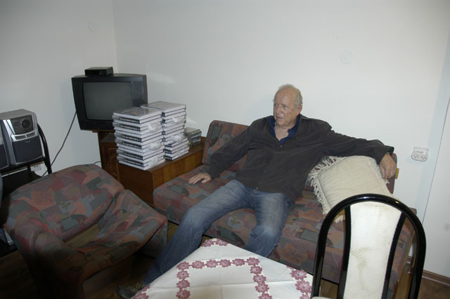  
Uri Milstein and some of the books in the Acadia Hotel

To organize the reunion I needed a professional. I met few of them in Israel but was the most impressed with Dalia. Dalia organized unions before and some meeting to government officials among them Arik Sharon. She knew her business. In our meeting before signing the contract I told her:

“Dalia, I have two request for you to organize this reunion: First one is that it is going to be the best meeting you have ever organized. The second request is: You will never be able to organize in the future a better on”. She laughed with me and we start working on the Reunion.

I start gathering photographs from over the years. We design the invitation to the 250 “kids”. We hired the Master of Ceremony, Haiem Kinan which was one of the students in Hadassim also. One of the “Kids” was Gila Almagor the famous Movie star that played the Mother in the Munich movie.

Of course, Dani Dasa my Physical Education teacher was invited from Los Angeles.

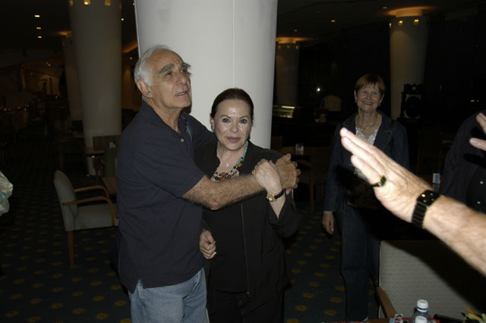  
Dani Dassa and Gila Almagor day before the Reunion

The hotel I chose was one of the best in Israel on the Mediterranean sea by the name Acadia.

I made sure that the food will be as should be in a five stars hotel and everything should provide in first class to all participants.

We started with the reception outside on the Sea:

  
Acadia on the Sea

The emotion ran high. Some of the “kids” were hard to recognize. They are all around 65 years old. Last time we saw each other latest was when we were around 18 years old. Even though some of us used to meet all these years, but only few of us.

The emotion ran high. There were no dry eyes for the next few hours:

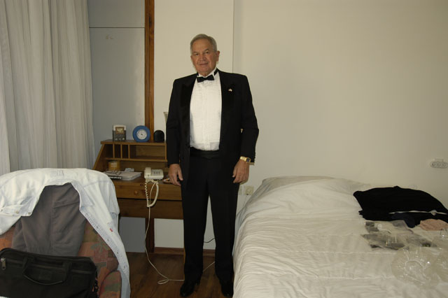  
Preparing for the Reunion in one hour

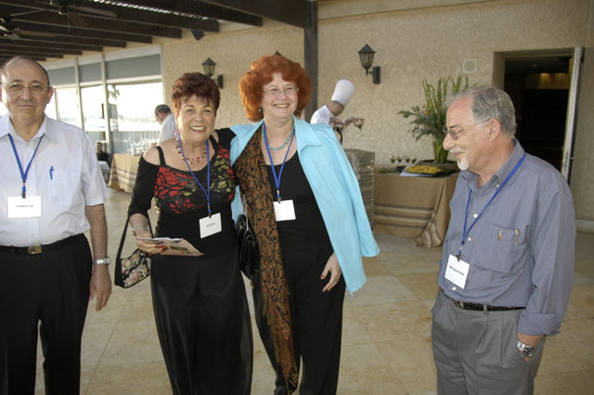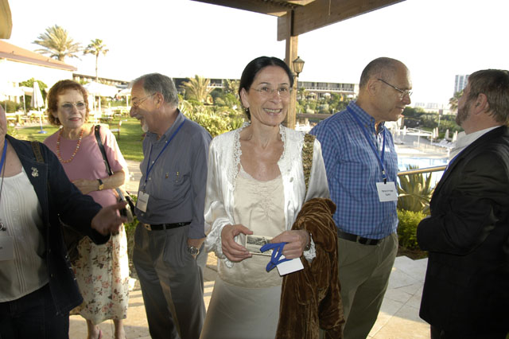

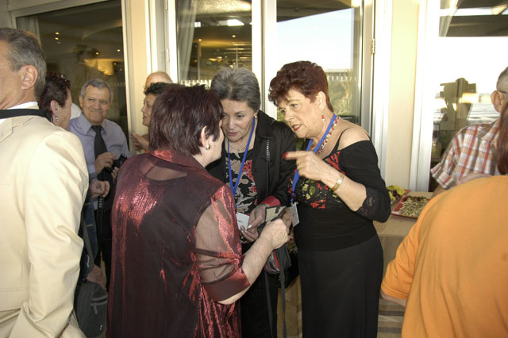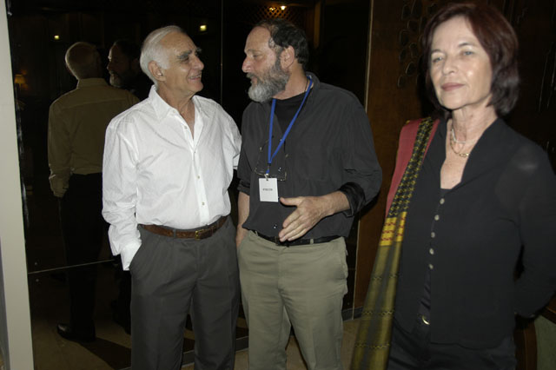

And now we are going to the meeting hall for the presentations:

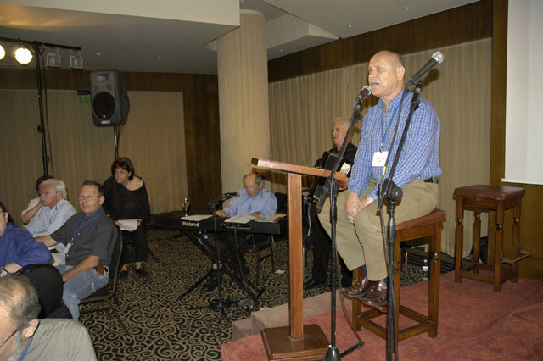

Haiem Kinan conduct the Ceremony

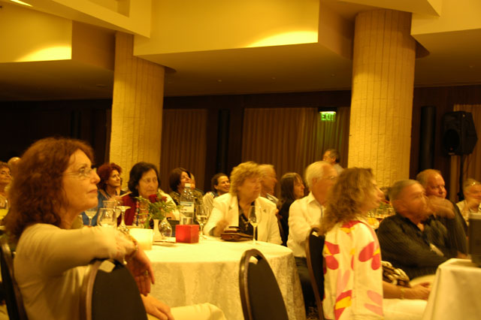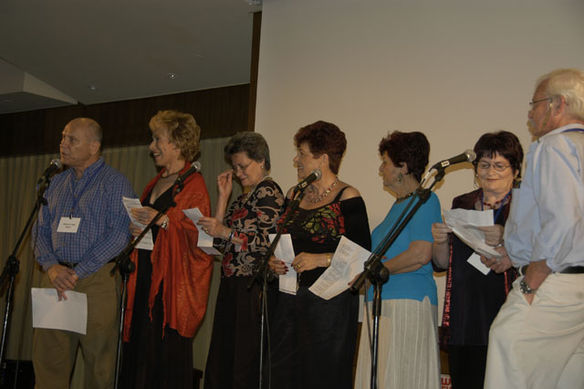

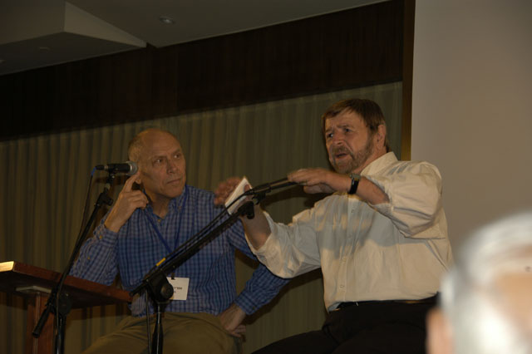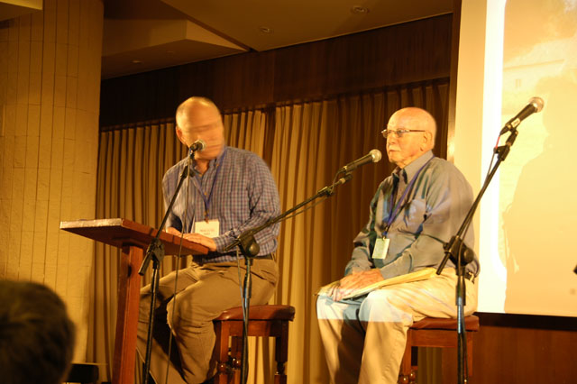

Students and Teachers tell their stories about the past

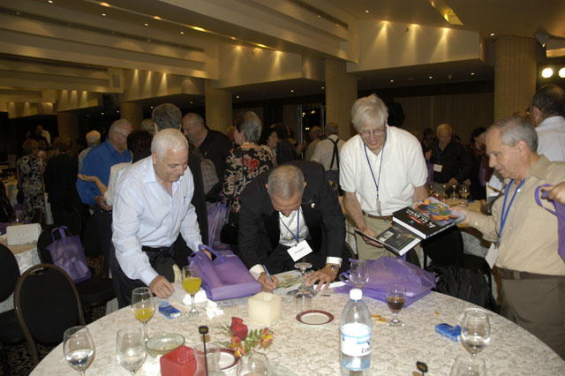

Signing the books

The reunion was amazing event. We have met together after so many years. All the “kids” in Hadassim accomplished so much in their life. The educational system produced great citizens that contribute to their country and their family.

I can summarize the Reunion as 360 degrees circle. I started with Hadassim which created my foundation and I finished with Hadassim which give me sense of accomplishment. I know all the “kids” feel the same. It was amazing journey. Uri and I put it in our Epilogue: From the Miracle to the Routine:

Sixty years have passed since the first eight holocaust survivors began their new

journeys in the unparalleled marvel of Hadassim. We, as authors and as fellow travelers

in that odyssey, view Hadassim as the one-of-a-kind experiment from which the world

can – nay, must – draw lessons and inferences, in order to remap and rejuvenate their

institutions of learning, now surely on the verge of collapse. The originals and the

geniuses will flourish despite such collapse, and it is perhaps best that they remain

outside the common fold, as in Einstein’s case. But the level of achievement possible for

the everyman in every realm is far greater than what we have ever seen. The World has

needed the model of Hadassim, needed it badly; now, as we look to the horizon, we see

no better solution for it than the one offered in this book.

Lessons can only be drawn from the *unordinary*, whether positive or negative,

and only so long as one first has the proper foundations. Otherwise, myth would

eviscerate understanding, and any attempt at separating the good from the bad would be

doomed to failure.

The conceptual stepping stone, the foundation for understanding, lies in the fifth

dimension – the dimension of meaning, perceived by the few and imparted to the

uncommon, not for any intellectual superiority but primarily because of the stultifying

influence of the anti-intellectual outlook, borne of “Original Sin,” the idea that

knowledge itself is corrupt. Hadassim was equally plagued by that outlook, one of the

reasons for an improved model.

The dogmatic and the mythological, the already known and self-evident – all

prevail not only in totalitarian cultures but in the most progressive of our universities.

The search for the unknown is everywhere hindered or obstructed: Gideon Ariel learned

it the hard way, in the course of his study in the US and later in the battle waged against

him by the bio-mechanics establishment. I learned it during my long career uncovering

the roots of human behavior and uncovering the truth about Israel’s wars. The Hadassim

project was a success, in our opinion, primary because of the complex, sometimes chaotic

evolution of a radical idea: creative dialogue. The concept was given to its founders,

Rachel and Jeremiah Shapirah, by Schwabe, Buber and Yehoshua Margolin – each

implementing his ideas in practice, in his own realm, unsatisfied with mere theory. But

Rachel and Jeremiah’s ability to fashion and crystallize that concept in institutional form

– a rare perspicacity among educational professionals – was the sustaining pillar of

Hadassim. They succeeded where others might have failed, because they took their

philosophical masters both seriously and critically, giving authentic material form to their

legacy.

The critical period for Rachel and Jeremiah, with regard to their eventual mission,

was their preparation in Schwabe’s “Teacher-Scout” group, where they absorbed theory,

and the “Scouts Legion” group where they applied their lessons directly. The same

creative dialogue was imbedded in the Ben Shemen Youth Village. I’d first heard about

the quality of discourse in the latter organizations from my uncle, Moshe Shiponi, a

central figure in both. I originally heard about the Shapirahs from him, as well. Until

their opportunity in Hadassim, Rachel and Jeremiah underwent more than ten further

years of preparation, combining theoretical study with practical work. Thus we arrive,

with Plato, at the same conclusion we would draw from the biography of Moses:

There are no born leaders. Men must persist through a long and thorough

grounding, both theoretical and practical, before they ascend to virtuous leadership. For

Rachel and Jeremiah in their youth, as for students of Hadassim in the forties and fifties,

“Careerism” was a particularly nasty pejorative. Many of us wondered why: where is the

vice in the desire to climb the peaks, to achieve the summit of success in one’s career?

During our work together, Gideon and I came to view the negative aspect of “careerism”

as the ambition for success without the multiple stages of effort, requiring great sacrifice,

implied in every field. Hence the distinction between a doctor who becomes a

professional after at least seven years of rigorous experimentation and study, and an IDF

officer who attains “professional” officer status after a mere six months in Training Base

1. No advanced study could compensate for what such a leader should truly endure in his

basic studies, requiring years of preparation. The same thing holds, mutatis mutandis, in

the realm of education. Even if today’s schools of education could suffice in preparing

worthy teachers, they still fall pathetically short when it comes to producing the likes of

Rachel and Jeremiah Shapirah. The education of leaders and originals requires

something wholly different.

Leaders conventionally plan and act in glorious, if bitter, isolation. Those

surrounding them exhibit loyalty or sycophancy, as the case may be, but generally don’t

engage them in meaningful dialogue. Yet history proves that a transcendent leader, he

who departs from the march of folly, tends to share in valuable company, as a *primus*

*inter pares*. The most iconic example is that of Moses and Aaron, who liberated the

Israelites and lit the torch of Jewish, Christian and Islamic religion.

According to the Torah, a dialogue between God and Moses preceded that of

Moses and his brother. The Hebrew God did not command Moses, but rather deliberated

with him on his mission – and only *after* his arduous trial in the house of the Pharaoh and

in the desert. Earlier still were the dialogues God held with the elder fathers Abraham,

Yitzhak and Yaakov; the most salient of these concerned the innocent inhabitants of

Sodom and Gomorrah.

The dialogue of all dialogues, between Socrates and his disciples, was eternalized

in Plato’s corpus; there, the founding father of Philosophy showed that truth, unfettered

by dogma, requires dialectic – i.e., a method of collaborative and creative dialogue.

The twin fathers of the Jewish settlement in Eretz Israel, David Ben-Gurion and

Berl Katzenelson -- the men most responsible for laying the foundation of an independent

Jewish state after two millennia of exile -- survived every threat on their leadership, and

there were indeed many, by virtue of the survival energies generated from the creative

dialogue enduring between them.

The WIZO idea of appointing two directors for Hadassim, and those leaders’

ability to maintain a creative dialogue between them, was a necessary condition for the

success of the Hadassim experiment. In political and defense establishments the common

paradigm is exclusivity of command and control, because unless control rests with one

person the decision-making process becomes inefficient. But how would an efficient

process leading to bad decisions be helpful? It is only creative dialogue that yields

optimal decisions, the same kind that obtained between Rachel and Jeremiah.

Rachel and Jeremiah chose teachers for Hadassim who were inexperienced, and

this was by design: they believed experienced teachers would bring their educational

baggage with them and either distort or disrupt their unique, Schwabian conception.

Hadassim was a place of learning not only for students, but for the teachers as well. At

the head of the pyramid stood Schwabe, whom the Shapirahs continued to visit in

Jerusalem – when he wasn’t visiting their educational teams in Hadassim – and whose

spirit was pervasive in the dialogue streaming from and between teachers and directors,

the teachers themselves, and teachers and students.

In an improved Hadassim model three aspects previously unemphasized must also

prevail.

Intellectuality: our progenitor, Abraham, gave birth to the principle of abstraction

when he discovered that God has real existence, only not physical. This was the greatest

discovery in history because it made science possible. An educational system must

develop the student’s faculty of abstraction to the maximal point, so that he has the

intellectual skills to analyze a wide set of phenomena and situations -- and comprehend

deeper meanings. Educational systems haven’t lived up to this function, because

Abraham’s discovery is still fundamentally misunderstood. It was so immense to begin

with that Faith literally swallowed it whole after stealing it from Reason. The student

must be shown that everything has a fifth dimension – the Abstract -- and only attend to it

will we improve our state in physical four-dimensional world.

Criticism: symmetry – and thus every idea and plan -- collapses in reality.

Therefore, everything we encounter in reality is already flawed, but will be even more so

if we don’t expose those flaws and correct them. The survival principle explains why

flaws remain in place by design, by structural tendency, so it follows that in order to

survive one has to neutralize the survival dialectics. Without a culture of criticism, that

wouldn’t be possible.

High technology: Moshe Schwabe had already observed that not enough use was

made of educational auxiliaries. In the 21st century, educational achievement must

include the sophisticated use of high technology. Technology enables us to grasp theory

and perform experiments in every field: Chemistry, Physics, Biology, History and

Geography, et cetera. Every student can now benefit from the widest array of subjects, as

against the narrow concentrations of the past. Gideon Ariel developed high level systems

for the advancement of sport, but by improving those same systems it can become

possible to study *any* subject matter better.

Human wisdom means converting the miracle into the routine. The Hadassim

miracle can be converted to the routine in education everywhere in the world. We hope

that writing this book has been the first step forward in that thousand mile journey.