Chapter 3: Unexpected Feats

My quest began and it was every bit as daunting as Don Quixote’s. I started training immediately. Fortunately for me, some incredible teachers were there to assist in my goals. They remain forever lodged in my heart and mind. My first mentor at Haddasim was the physical education teacher, Dani Dassa. He was a trim, muscular and a good looking man in his twenties and had heard about my devotion to body building exercises. One holiday period Dani was the counselor for the students who stayed at Hadassim rather than going home.
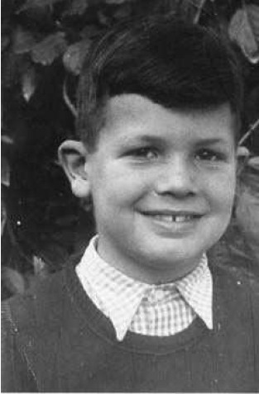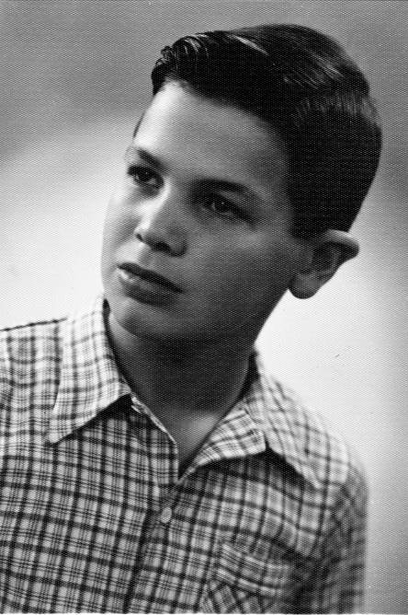
Me at 11 and 14 Years Old.

I was sitting on the grass in front of the dining hall. Dany suddenly came up to me on the grass and asked me if I wanted to go run with him. I was surprised and immediately agreed. I got up and together we started running toward the sand dunes bordering the Mediterranean beach. It was a pleasant day, cool, with a sea breeze but after only 5 minutes of running I felt that I could not go on anymore. However, I would never admit to Dany what I was sure was a fatal weakness. I never stopped running but thought for sure that I would die soon from exhaustion. Dany saw out of the corner of his eye that I was about to collapse and suggested, “Let’s walk for a while.”
“I’m sorry I interrupted your run,” I said. I felt I had let him down.
Dani stopped and put his hands on my shoulders, “Gideon, just run a little every day and in no time you will be able to run as long as you wish.”
“Really?” I replied. “Then I am going to run every day from now on.” (Although I am now 73 years old, I have not stopped running. I still run 5 miles every day. On those rare occasions that I miss due to traveling or other reasons, I feel guilty.)
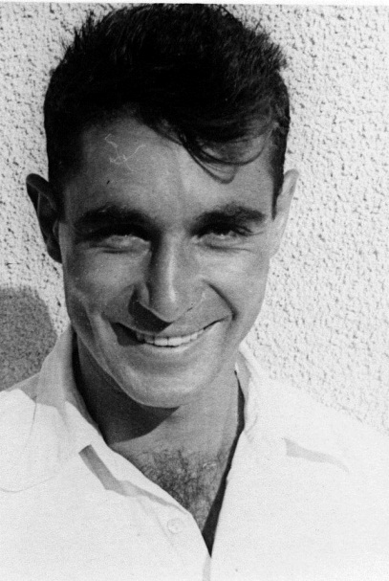
Dani Dassa – my Physical Education Teacher and Mentor
It was nearly 6 months later, after running every day, before I ventured out again with Dani. On this occasion, we ran approximately 5 Kilometers (3 miles). After the many months of training, it was much easier to keep up and, to my surprise, we ran farther than our first time.
I greatly admired Dani. He showed me new ways to exercise and one day even showed me how to throw a discus which was made out of hard rubber. I had longed to throw, since I spent evenings with my discus-throwing champions on my wall. I think I threw the discus only 50 feet while Dani threw it about 140 feet. The discus would fly flat and twist into wonderful patterns. These patterns played in my mind all day long. What a beautiful way of releasing an implement. What marvelous integration between body and nature, between physical laws of motion, and artistic dance-like movements.
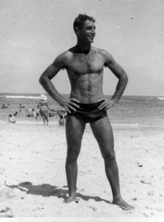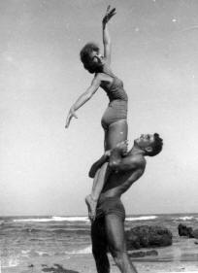
Dani Dassa

Another friend of mine at Hadassim was Shevach Wise. Shevach is now a Member of the Knesset, the Israeli Parliament, but when we were children, he was a great discus thrower. He threw nearly 140 feet and could easily compete against Dani. Shevach was a few years older than I was but I was fascinated with this event and wanted to emulate his successes. I asked Shevach to let me know whenever he was going to throw the discus and I would help him by retrieving the discus after each throw. His discus throwing technique was an older style, but amazed me none the less. For several years and thousands of throws, I ran back and forth to retrieve Shevach’s discus for him. He was a wonderful individual who I greatly admired then and now.
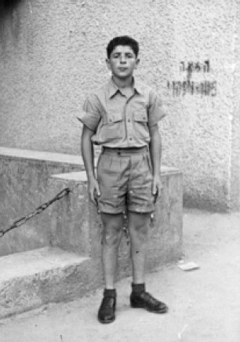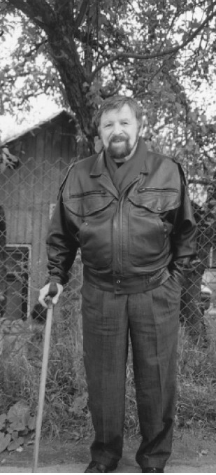
Shevach Wise then and now – Member of the Israeli Knesset
In addition to the discus, Dani also taught me how to throw the Shot Put. I started with the 5 Kg. (12 pound) youth shot. The normal adult shot put weighs 7.25 Kg. (16 pounds). After that, I threw the shot and the discus every day, during every break between classes, and every other opportunity I had during the day.
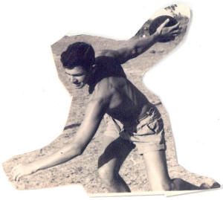
At the age of 15 throwing the rubber discus
I practiced so much that one of the teachers brought a shotput into class with a face drawn onto it. “This is Gideon Ariel,” he said. I was humiliated but not the least bit deterred from throwing. All I cared about was to improve my throwing skills.
Years later, this teacher said he regretted embarrassing me in front of the class this way. He had meant it as a warning to me, he said, to focus on matters other than sports. His warning went unheeded since I was out on the grass practicing every available chance including 5 minute breaks! From today’s perspective, I appreciate what he was trying to have me focus more on academic subjects instead of focusing so much on athletics and training. I think I would have been more appreciative then had if he had been more helpful and less insulting.
On the other hand, Dani was always available to help me with throwing tips or training exercises. At that time in my life, any attention was more than special for me since I had received so little positive encouragement previously.
Dani was also the proud owner of a big American Harley Davidson motorcycle. I was more than fascinated by this bike and willing devoted hours cleaning it. The motorcycle was not particularly dirty, however, since Dany did not have a license to drive it. At that time, I was a tall fifteen year old boy and, coupled with a forged birth certificate, was easily able to convince the woman at the Department of Motor Vehicles that I was 16 years old. So it came to pass, that I could drive Dani’s bike while he could merely hang on as a passenger. What a terrific time I enjoyed with that magnificent machine.
Dani’s Harley Davidson which I kept very clean
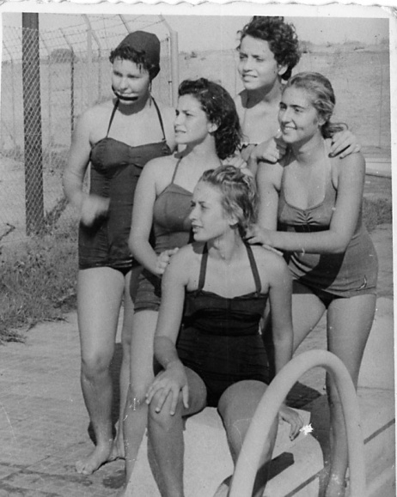
A Few of the Beautiful Girls of Hadassim

On Friday nights after dinner, all of the students from every grade and the teachers participated in Israeli Folk Dancing. Folk Dancing was a very big event in Hadassim. I never danced since I was too self-conscious and shy. But I always went to watch. My friends would be out all night under the Mediterranean star-lit night, clapping and kicking up their feet, and enjoying the fun and camaraderie.
Some of the students were great dancers but Dani Dassa was a master. It was during my 10th grade that a visitor from the US came on a Friday to watch the dancers. She was a famous dancer and choreographer by the name of Martha Graham. She was slim and graceful with focused attention. Martha Graham had traveled to Israel in search of talent for her school and dance troupe in America. Hadassim had been suggested to her as one of the places to look for talented dancers. Dani was superb that night, kicking up his heels, turning, spinning, and dancing expressively. He was so good that the next day he was offered a full scholarship from Martha Graham to come to America. What a dream for any Israeli man or woman.
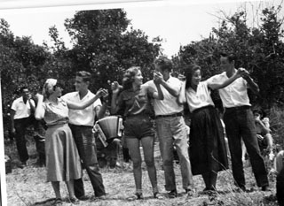
Hadassim Dancing Group

I had mixed feelings. I was happy for Dani but I was sad to see my best teacher and mentor leave. I told myself: “One day I will go to America too.” Unfortunately for me, Dani was not the first of my heroes who left for America.
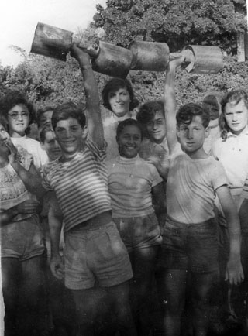
Dani and I made Dumbbells from Fruit Cans filled with Cement

In the summer, when I went to visit my Father in Tel Aviv, I would train in a plain, sweaty health club run by Raphael Halperin. Raphael was Mr. Israel in Body Building and his picture was above my bed among the others champions. I seldom saw Raphael at the gym, but when I did see him, I followed him round the club like a second skin. I heard one day that Raphael was going to America to be a professional wrestler. He became very famous in America and was called the David of Israel. At one time, he won the World Title in Professional Wrestling which I later learned in one of the Sports Magazines to which I was addicted.
So, I had “lost” my two heroes, Dany and Raphael to America. America became my dream. It became a land of heroes.
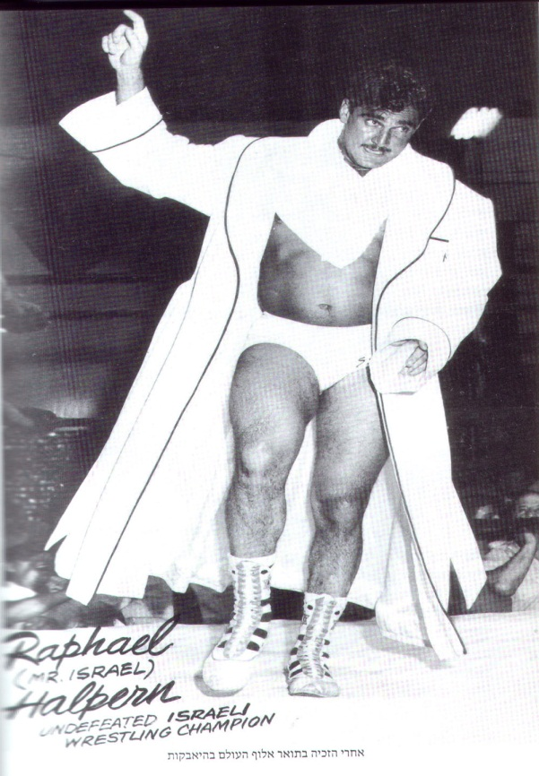
Raphael halperin – World Champion in Wrestling
After Dany had left for America, Tomy Shwartz became the Physical Education teacher at Hadassim. Tomy was a survivor of the Holocaust in Auschwitz. I became his helper. I would clean the gym, the halls, and his motorcycle. Any task Tomy wanted me to do; I would do with all my heart. I could not perform in sports very well at that time, but I could be around sports helping Tomy to do his work.
When I was in the tenth grade, Tomy learned that I very seldom went to visit my Father during holidays or vacations. In the summer of 1956, he asked if I would like to take a course near Tel Aviv in the city of Holon which would prepare me to be a Physical Education Teacher Aid. In this capacity, I would take the equipment to the field and be responsible for the various activities that the PE teacher organized. I was ecstatic. Instead of working 8 hours a day at the school, alone and bored, this was a dream. So I registered for the 3-week Course which was a type of summer camp for kids. The person who was in charge of this camp was Yariv Oren. Yariv was an athletic dark haired man with quick movements and penetrating eyes. When he had competed as an athlete, he had excelled in throwing the javelin and the shot.
I paid close attention to all the Teacher Aid instruction classes and was fascinated by the information. For the first time, I studied Anatomy and Physiology and learned more details about various sports including soccer and basketball. I was riveted to all of these studies about athletic movements and how the human body changed, adjusted, and adapted to performances.
In the evening, we all played basketball, tennis, soccer, and other games. I was not good at these activities but tried to do my best and put my whole heart in everything. One night, one of the activities was an arm wrestling competition. I knew from my experience at Haddassim that I was good at arm wrestling. In my group at Hadassim, no one had ever beaten me.
The competition began and I merely watched but did not volunteer to participate. There was one young fellow, named Zitooni, who happened to be an immigrant from the Middle East. He was bigger than the rest of us and beat every competitor in a matter of seconds. I decided to challenge Zitooni since I wanted to know how long it would take him to defeat me and I wanted to feel the force that he could produce.
Yariv was the judge. I doubt whether he had ever noticed me before this competition. He held our arms together making sure our elbows were on the table. At his command of “Ready, Go!” we started to arm wrestle. We struggled and strained for about 2 minutes at full effort. To my shock and the amazement of the others, I won. Zitooni was as shocked and surprised as everyone else since no one had ever defeated him. He even looked under the table to see if I had used any help. Then Zitooni asked for a second competition and asked that we change to opposite sides. We changed seats and started again. “Ready, Go!!!” Yariv commanded. I beat Zitooni the second time. People around were clapping and started shaking my hand. I did not look at their faces since I was too embarrassed and shy.
As I was leaving to return to Hadassim, I heard a voice call out to me. “Hey, you, what is your name?” It was Yariv Oren who the principal of the camp and the referee for the arm wrestling competition. I told him who I was and where I lived. Yariv told me that, in addition to conducting this three-week training camp, he was the Track and Field coach in Kfar Saba, a small village about 20 miles from Hadassim. He asked if I would be interested in training with him in Kfar Sabo.
I was too shy to look directly at his face, but asked, “What would I do?”
Yariv asked, “Do you do any event in Track and Field?”
“I try to throw the discus and shot but I’m not very good at either one of them.” was my response.
“Your arm seems strong enough to throw,” he said, thinking out loud. “Come join our club and we’ll get you started. I am sure that we will find something in which you will do well.”
For the first time in my life, someone told me that I could be good at something.
“I’ll be there,” I said smiling for the first time. In fact, I could not stop smiling.
A few weeks later I received my certificate for the course I had taken with Yariv in Holon. I had successfully completed an entire course. This was a unique accomplishment for me. I became somebody rather than just another child in the village. I was proud of myself for accomplishing this feat and achieving an academic goal. This certificate and the invitation from Yariv to train with him changed my life.
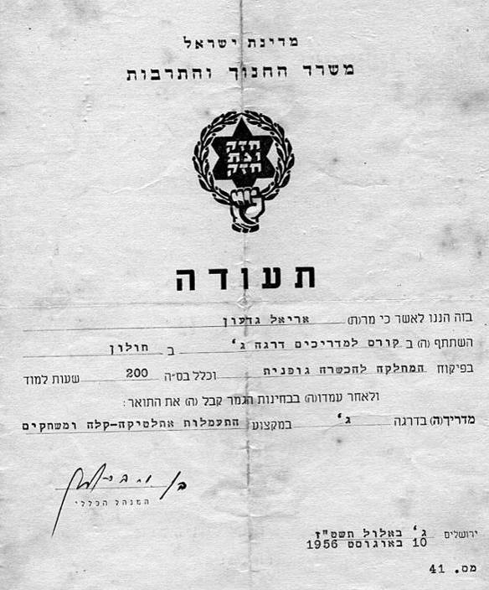
My certificate for completing the course with Yariv in Holon successfully and passing all the Exams.
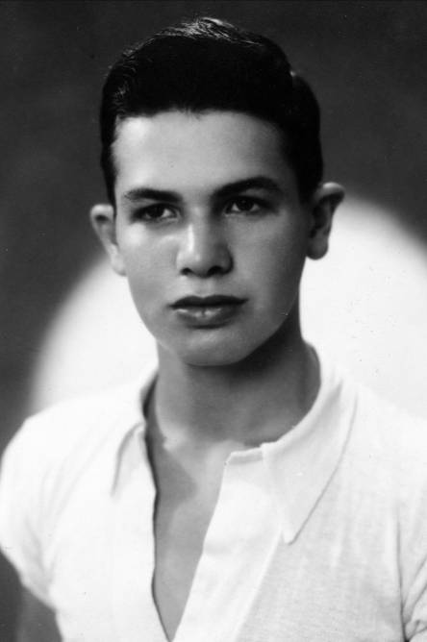
Me, at 16 Years Old
As soon as I returned to Hadassim, I went to Tomy to tell him about Yariv’s invitation to train with him at Kfar Saba. Tomy’s reaction was very positive and he thought that this would be a wonderful opportunity for me. Although he did not tell me, I suspect that my enthusiasm for sports and the elevation that the certificate from the Teacher’s Aid course had on my self-confidence were factors in his response.
On Tuesdays and Thursdays, school classes were finished at 1:00 pm. Usually, the students had to work on farm chores for four hours. Tomy Schwartz arranged for me to go to Kfar Saba to practice with Yariv. Kfar Saba is a small town approximately 20 Kilometers North East of Tel Aviv. However, to reach Kfar Saba from Hadassim, I had to walk one kilometer to the main road that connects Tel Aviv to Haifa in the North. Then I had to catch a “tramp” which means “hitchhike” in Hebrew. At that time in Israel, it was a relatively common and safe practice for young people, who had little or no money, to hitchhike. Usually within 10 to 15 minutes a kind person would stop and give a lift even for a short distance. The trip to the entrance to the town of Kfar Saba usually took about 30 minutes and then I had another 20 minute walk to the stadium. The stadium was actually a soccer field with a sand track around it surrounded by bleachers. There were no modern tracks in Israel in the 1950s.
That first Tuesday when I arrived at the Kfar Saba stadium, there were many young men and women already running around the track. Some were practicing long and high jumping, while others were throwing the javelin, discus, and the shot. I walked slowly toward Yariv Oren who was coaching one of the jumpers.
“Shalom, Gideon,” Yariv greeted me. I was too nervous answer and kept my eyes focused on the ground. “Come along, Gideon,” Yariv said and paternally put his arm around my shoulders. Although he was only 8 years older than me, for a fifteen year old kid, Yariv was a grownup and more – he was the “Head Coach”. “Let’s start with a warm up. Why don’t you run 3 laps around the track?” I ran the three laps, in bare feet, of course and waited for the next task. At that point, Yariv instructed all of us to follow him in various warm up exercises. There were quite a number of stretching and jumping routines. It felt so good to be part of a group and to be using my body.
During the warm up exercises, I could see a young man throwing the discus at the other corner of the stadium. I think the discus went about 160 feet. I had never seen a person throw so far. I discovered that this was Yehuda Hoz, who was the record discus thrower for the youth age group and represented the Kfar Saba team. Yariv introduced me to Yehuda and then began to instruct me in how to throw the discus. Yariv told me: “You need to learn how to throw it from a standing position before you will learn the turn.” I obeyed as perfectly as I could and never stopped practicing until the day ended. This was now becoming one of the best days of my life.
There was a beautiful sunset by the time practice concluded. “Gideon, how are you going back to Hadassim? Is someone coming to pick you up?” Yariv asked.
“No one is picking me up.” I replied. “I am going to catch a tramp back to Hadassim.”
“Well, will I see you again in two days?” Yariv asked.
“Yes, Sir, I will be here”. I had never felt so happy. Happiness enveloped me like never before in all my memory. During the entire tramp ride back to Hadassim, I could feel the fingers on my right hand burning a little from throwing the discus so many times. I was too shy to converse with the man who had picked me up in his car although I longed to tell him about my extraordinary day. Instead, I imagined myself throwing the discus as far as Yehuda had. How long would it take me to be that good? One year? Two years? Tears ran down my cheeks. I could picture myself throwing the discus farther than it had ever flown before and I knew there were many hours of training ahead of me.
When I arrived at Hadassim that evening, it was quite late but one of my friends had brought some food for me to eat in my room. Sleep eluded me but visions of my throwing the discus did not. I thought and practiced the throws all night and, when I finally fell asleep, I continued throwing in my dreams. The next morning I could not wait to meet Tomy and ask him if I could have a discus of my own. To my surprise, Tomy immediately gave me one of his rubber discuses. It was the same discus that Shevach Wise and Dani Dassa had thrown those many afternoons near my dorm when I had watched them throw and merely retrieved the discus.
The next morning, school started at 8AM as usual. I carried my books and my discus to class. Some of the kids asked me what that thing was that I was carrying. Proudly, I told them what it was. As usual, everyone thought I was just too obsessed about exercise training and athletics. At the class break, I ran to the yard and started throwing. Hillel and Asher joined me. I babbled on telling them about my first practice in Kfar Saba. We threw during the 15 minute break and then the bell rang to go to the next class. During every break I threw the discus and this pattern continued for the next 2 years.
Although I had tremendous drive to perfect my fitness, shot putting, and discus throwing skills, this did not negatively affect my school activities. I had the same drive and dedication to those subjects that were interested me. I loved biology, chemistry, math, trigonometry, and physics.
In one of the classes, I created a Nature Corner where I raised rabbits, snakes, lizards, frogs, as well as flowers and vegetables. There was an indoor and out-of-doors portion of this Nature Corner which was inspired by the teachers who taught us to value the natural world. Many of the kids at Hadassim had projects but I was especially drawn to the biological and physical sciences.
I also loved chemistry and found nearly every aspect fascinating. The day that the professor warned us to never ever open the sealed beaker of the hydrochloric acid (HCL) and mix it with sodium sulfide power (Na2S) was a great day for me as a budding scientist. His challenge could not go unanswered so I mixed the two compounds at the first opportunity. The combination created Hydrogen sulfide (H2S) which resulted terrible stink. The smell of rotten eggs permeated the air so horribly that the building had to be closed for two days.
Chemistry also fascinated my friend, Gideon Lavi. We decided to build our own chemistry laboratory in an old, deserted shed about a half a mile from the rest of the school. We “liberated” small quantities of various compounds and elements as well as the necessary laboratory equipment. We even hung Mendeleev’s periodic table of elements on the wall. Any element we could get our hands on was carefully and loving stored in our own lab. One day, we decided to create nitroglycerin. We were not terrorists or planned to blow up anything, but were just two curious and intellectually challenged boys who thought they had an especially fantastic idea. We mixed and weighted and balanced the various chemicals. Unfortunately, we had neglected to “liberate” the small metal tong used to hold test tubes. Perhaps it was fortunate rather than unfortunate as things developed. As our mixture began to bubble on the way to becoming nitroglycerin, the tube increasingly became hotter and hotter. When the glass vial was just too hot to hold with his bare hands, Gideon Lavi, dropped the partially created mixture and we burst out of the door of our chemistry lab as fast as we could. Just as we got outside, our entire laboratory exploded and blew a huge hole in the ground. People from all over Hadassim, kids, teachers, workers, and visitors ran to the location of this explosion. Gideon and I were basically unhurt, except for a few hairs and our clothes that were singed. The most damaged were our egos and our poor laboratory. Needless to say, we were expressly forbidden to have another one.
Despite this setback, Gideon and I remained close collaborators in chemistry class. Both of us enjoyed the work and the mystery of the science itself. Gideon Lavi later became a gifted chemist at the Technion in Haifa and has several inventions as well.
Hadassim was a wonderful place for children to explore their academic interests although usually these challenges were in the more normal classroom settings rather than Gideon’s and my elicit laboratory. I thrived in the math, trigonometry, and geometry courses. I was enthralled with the formulas and the people who had invented the many items we studied. I dreamed of one day going to the Technion and studying various biological and physical sciences there.
The one drawback of the school was they did not stress the need to study things that a child might not want to learn. For example, I was not at all interested in Bible studies or in learning English. Neither subject seemed necessary for my life nor did the contents appeal to my imagination. Eventually, this reluctance to apply myself in those areas cost me dearly.
The Israeli system for advancing to college was based on the English system. Students across the country take a series of standardized matriculation exams in each subject. The scores in the matriculation exams for all colleges, including the Technion, dictate which students will be accepted. Thus, high test results are required in every subject, not just the sciences. At that time, a poor result in Bible was not balanced by very high scores in math and chemistry. Perhaps my future would have been something else under a different educational system.
As is typical of most residential school, Hadassim tried to balance the life experiences of the children. We were exposed to first rate teachers in our academics because, at that time in Israel, the world situation was quite unique. The teachers who were drawn to our school were idealist who in previously lives had been experts in that area of study. Therefore, we had a world renowned physicist working in the fields and teaching the physics courses because that was his way of helping the world.
One day, I was talking with one of the older teacher who was repairing a fence around the animal enclosure. I asked him what he had done before he had immigrated to Israel.
“I taught history and philosophy at a great university in Europe” he answered.
“Why” I queried “are you here at a dorm school fixing the fence?”
His answer amazed me: “Because Israel needs me to fix this fence, not teach school in Europe.”
Another one of our teachers was a gifted violinist teaching music. Unfortunately, we were oblivious to the greatness and depth of the teachers, as so many children are, but in retrospect, we all realize how lucky we “damaged” and “lost” children were.
As part of the balanced life of study, work, and physical effort, I continued to exercise and throw the shot and discus. Between classes and my chores, I was completely dedication to these endeavors. One day, an errant discus throw crashed through a window. I cleaned up the mess and, undeterred, returned to my throwing practice.
I returned to Kfar Saba the following Thursday. Yariv was amazed at my progress. He told me that in no time I would start turning. He saw my fingers completely bruised from the friction with the discus.
“Why don’t we also try to improve how you put the Shot?” he asked.
“Absolutely,” I replied.
He took me to the Shot-put ring and showed me how to throw from a standing position. I spent the rest of the day practicing the way Yariv had instructed me. I was so happy to be in this wonderful place and thrilled that an adult was encouraging me with praise.
I continued every day to work, exercise, and train. I started running distances and sprints every day. I lifted my weights every day in a special, planned sequence that contributed to the throwing movement. I grew stronger and stronger by the month. After a few months I was surprised to discover that what had been a struggle to lift with two arms, I could now easily lift with one arm. After one year of unrelenting effort, I realized that the secret to success is dedication and efficient training.
I was completely obsessed with my quest to be on the Olympic team representing Israel in the upcoming 1960 Games to be held in Rome. Although I probably did not need more stimulation, I decided to change my name to reflect this goal. The name I selected for myself was “1650”.
“How can your name be that?” asked one of my friends.
I answered “It’s obvious. I am going to throw 16 Meters in the Shot put and 50 meters in the Discus. These results will break the current Israeli records and then I can represent Israel in the Olympics. Therefore, my name from now on is ‘1650’”.
“Gideon, I will not accept your papers with this signature,” said the same teacher who had drawn my face on the shot put. “I don’t know anyone called 1650. Please sign your proper name, if you plan to have your classwork reviewed.”
“Then don’t look at my work. It is your choice. However, that is my name,” I answered.
This teacher and I had many disputes during my years in Hadassim. Another battle was about a pin my father had given me. Although I was not close with my father, he had given me a pin that represented the Stern Group. It was an arm holding aloft a rifle with the slogan, ‘ONLY THIS WAY’, to represent their thinking on how to get the British out of Israel. I wore this pin proudly for its defiance and for how it represented one way I could admire my father. The teacher was from the Palmach group. The Palmach were diametrically opposed to the philosophy of the Stern Group. The Palmach were more moderate in their politics and eventually became part of the Israeli Defense Forces. It should have been no surprise that the teacher ripped my father’s symbol from my shirt. He never returned my pin. Since I had received so few things from my father, it hurt me terribly to lose this pin.
. Another example of these feuding philosophies was when, as a young boy, I had gone swimming at the beach in Tel Aviv. I had found an old, defunct gun that had sunk when a boat of Israeli rebels came into the harbor to deliver guns to the Stern Group. These rebels were killed by more moderate Israelis for their violation of the laws that the new Israel was trying to establish. When my father saw my proud new possession, he began shouting and went berserk. He wanted no memory, he said, of how these people had been mercilessly slaughtered for the Palmach ideology. This incident sheds some perspective on the passion of political feeling in Israel at that time and the setting which influenced all of us.
My 1650 name may have been a source of many jokes in my class but it demonstrates the power of positive thinking and my dedicated effort. I was determined not only to work to achieve this goal, but to claim the name as well as the ideal.
Meanwhile, I continued to grow taller and stronger. On holidays when I was in Tel Aviv with friends, I still trained in the Raphael Halperin Gymnasium. One of the trainers there was another dedicated lifter named Deen and he spent long hours helping and encouraging me. My strength and form were greatly enhanced which improved my self-confidence. I now looked more like a body builder than I had as a skinning little boy which can be seen in the following photographs:

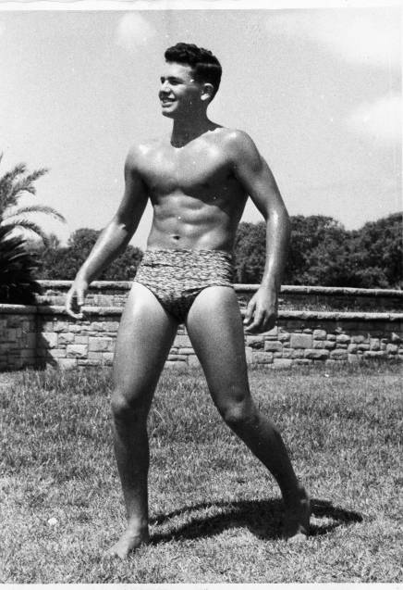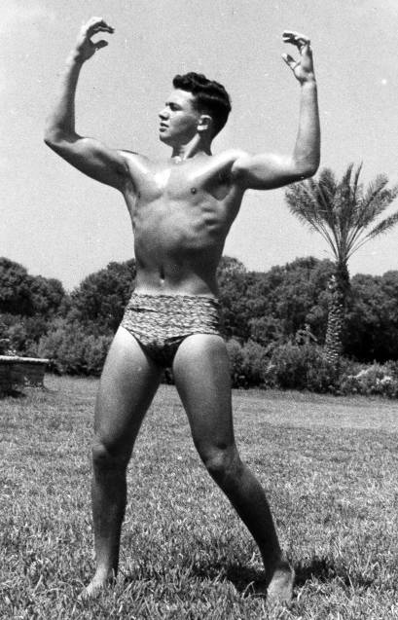
Body building shots in Tel Aviv at the age of 17

At school, I also practiced my throws at every opportunity during each and every day. I would perform Shot Put glides while I was going to the dining room. I would twist and turn throwing the discus while going to work at the farm. It looked to all as if I had gone crazy. But my technique continued to improve.
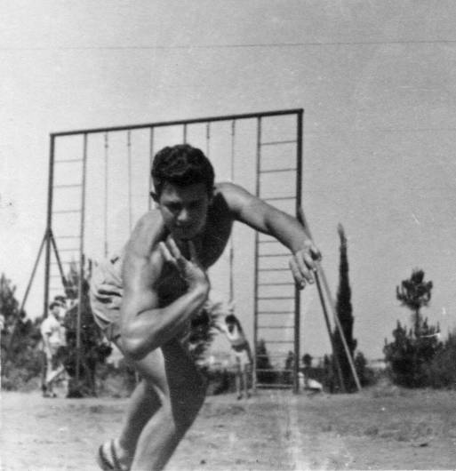
Putting the Shot at the age of 17

One Friday, after the training at Kfar Saba, I walked with Yariv to the bus station on my way back to Hadassim. We were discussing my progress and he told me that he wanted me to start competing in the upcoming meets. I looked at Yariv and asked him: “Yariv, do you think if I train hard I could break the Israeli Record and represent Israel in the Olympics?”
Yariv stopped, took my hand and held it against his chest, and said to me: “Gideon, if you will want it hard enough you will achieve it.” For me it was like a message from God. Another sleepless night of dreams followed as I held the discus and the shot in my arms in bed.
Unknown to me, Yariv had contacted my school’s head principal to learn about my family. Yariv was told about my parents and, on his own time, he visited my father. Yariv told my father that I was a good hard-working kid and a dedicated athlete. Yariv urged my father to encourage me in my efforts. Apparently my father was reluctant to embrace this idea. My father could not understand the merits of “throwing iron”, as he called it, but after that visit, he did not interfere with my efforts in athletics nor from attending the study courses that I began to take.
My classmates began to notice the changes in me as my physical shape became more pronounced and my attitude was more positive as I gained in confidence. They began to cheer for me in my performances of the Shot and the Discus. Some of my friends traveled with me to Kfar Saba to train in other events. Hillel, Miriam, and Asa all became serious sprinters.
On one Saturday, Yariv organized a National Competition for adults. I was still a youth and was unable to participate. However, I learned that Uri Galin, the Israeli Record holder in the discus, would compete. I gathered all my courage and went to see Iris, the beautiful blonde that I had secretly loved for so long. I knew Uri Galin was a distant family member of hers.
She was in her room. I knocked. “Hi, Gideon –“ she said.
I got right to the point. Less room for error. “Would you like to come with me to Kfar Saba for the track and field competitions? Uri Galin will be there to throw the discus?”
To my amazement, she agreed. We took a bus, went to the stadium, and found our seats. Yariv said hello to us which made my heart swell with happiness and helped my self-confidence especially since I was sitting there with a girl! During the meet, I could not believe how graceful Uri Galin was in throwing the Discus. In fact, he broke the Israeli Record in this completion and raised the record to 48.03 Meters. All the media pushed to interview Uri and he was surrounded by photographers.
I turned to Iris, “Iris, would you introduce Uri Galin to me?”
“Of course,” she said sweetly.
Once the meet was over, Iris and I walked over to Uri and he hugged her and said, “Hey Iris darling, I am so glad to see you here.”
“Uri, this is Gideon, my friend from Hadassim,” she said, introducing me. Uri shook my hand and I was ecstatic with joy and, to a certain degree, shocked to be shaking hand of the Israeli record holder in the discus.
Iris and I rode the bus back to Hadassim arriving after dark. It had been a long day, but we had both thoroughly enjoyed the experience. I thanked Iris for taking the trouble to introduce me to her relative, Uri.
She smiled up at me and said, “Well, Gideon, when are you going to throw against him?”
I laughed and replied with all the assurance of youth, “Soon! Plus I am going to break his record.”
“Okay then,” she nodded her head, “Good luck.”
For me, life at Hadassim continued, as before, and was full of study, work, my athletic endeavors, and fun with my friends. All of us were pretty energetic and sometimes this excess energy, especially among the boys, may have become excessive. One adventure involved my friend, Moomi. For years, Moomi and I had visited his Uncle and, at night when his uncle was asleep, we “borrowed” his car. We drove around the country by ourselves to explore and see things despite our lacking any particular plan of what to see or do. Surprisingly, his Uncle and the car mechanic were never able to discover what happened to the full tanks of gas that kept disappearing!
One day, Moomi and I decided to accept the challenge of going to visit Petra. Petra is a famous, world renowned historical site in Jordan. Many of the city’s ancient buildings were carved directly into the beautiful reddish colored stone of the hills. It was a sight to behold except that Israelis were not allowed into Jordan, at that time, because a state of war existed between the two countries. It was considered by teenagers as a special achievement to go to Petra and return with proof that you had actually been there. Moomi and I arrived at the border between our two countries one dark night, crawled under the fence, and removed our shoes. The Jordanian soldiers who patrolled the area knew that shoes were worn my Israelis and bare feet indicated local Bedouin tribes. We walked for many miles and reached as far as Wadi Musa which is a steep-sided valley. This was close to our destination, but not close enough to “win”. Suddenly, from above on the cliffs, soldiers began shooting at us. We turned and ran as fast as we could. We never looked back and prayed as we raced, that we would not be caught or shot dead. Miraculously, we made it back to the border, crawled under the fence, and were met by some irate Israeli border guards. These guards were almost more frightening than the Jordanians because they would take us back to Hadassim for even worse punishment. Fortunately for Moomi and I, the school was so relieved that we had survived, out punishment was not too severe.
On a Saturday following my trip with Iris to see one of my heroes, Uri Galin, Tomy organized an internal competition at Hadassim. This competition was only for the Hadassim kids. At that time, I was in the 11th grade. The entire day was to be a very special event. All the kids in Hadassim came to see the first Track and Field competition in their school. There were judges and the track was marked with chalk. Everyone was looking forward to the competition. I competed in both the shot and the discus against my friends in my class and the older students in the classes above me. I was so excited that my hands were shaking. My best discus throw was for a distance of 42.35 meters. This was good enough to win that day’s event, but I did not set a record in the discus.
In both the Shot put and the discus, competitors are allowed six attempts. The day’s competition began with the Shot Put event. When it was finally my turn I was so nervous that I fouled. However, on my second attempt, I threw 13 Meters. Then I fouled the 3rd and 4th throws, as well. Asher, my class mate, was in the lead with a 13.5 Meters throw. I knew that Asher was much bigger than I was, but I believed that my technique would prove to be the differential and I could win. My fifth throw was more than 14 meters, so I passed Asher in distance. In addition, this distance was the Hadassim record. I was quite happy at that point. But there was one more throw for all of the competitors and the winner is the person who throws the farthest on any of the attempts. I held my breath as each athlete threw. I never hope another competitor will perform poorly, only that I will do my personal best. After all of the other throwers had finished their sixth throw, I was still in the lead. Now it was time for my sixth throw. Since I had already won the competition, I had nothing to lose by going all out. I concentrated and put all of my ability into this last throw. The shot left my hand and kept going as if it would never come down. The entire crowd gasped as one. The shot landed. I could not believe it; I had thrown the shot 16.55 Meters and shattered the Israeli Record for the Youth age.
The next day all the newspapers in Israel reported these results:
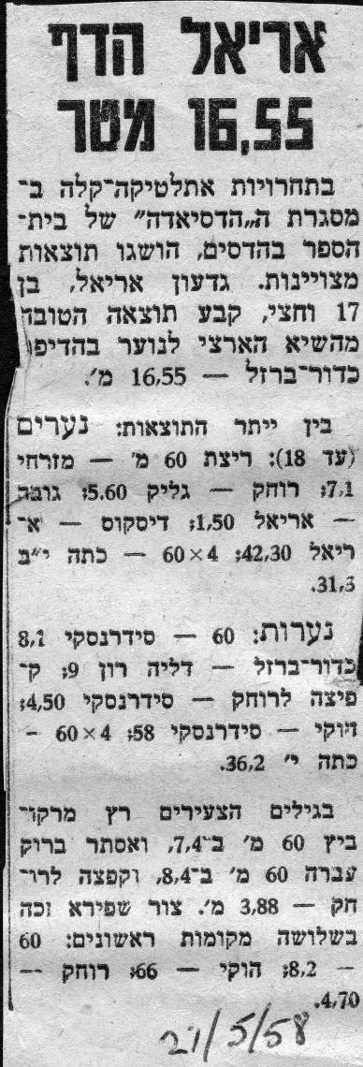
“ARIEL THREW THE SHOT 16.55”
In a track and field competition at Hadassim, there were excellent results. Gideon Ariel, 17 years old, surpassed the Israeli record in the Shot by throwing 16.55 meters.”

My 5 years of non-stop training had been worth all of the effort. I felt rewarded for the devotion and dedicated training. I could not wait to tell Yariv about my success. As soon as he learned of my achievement, Yariv initiated me as an official member of the Kfar Saba Track and Field Team. Tomy, my physical education teacher, was also proud of me. This child whom he sent a few years before to learn to be his aid had become his best athlete. I wished that Dani Dassa would hear about it since I owed so much to him for the help and guidance he had given me all of those years before. I wanted to thank him and let him realize that I had finally achieved a worthy goal that he could appreciate. I wrote him the following letter:

I got your address from Shimale and immediately I sat down to write you a letter. I wish you good luck and hope you are very happy. I heard you have a very good life in the United States. In a few years, I hope to meet you there. Are you still continuing with sports? I didn’t stop even one day from my training. I made progress in my throws. In the Macabean games, I took a gold medal in the shot put for youth, 15. 63 meters. In the discus, silver medal 43.72 meters. In my training, I already broke the Israeli record 16.21, in the Israeli championship. I was number one only 16.10 meters. After the Macabean is finished, I will be an adult and I will have to use the 16 pounds shot put. People tell me that I have a chance and since I am a little bit faster in the discus than the shotput, I think I will do better in the discus. So far I took about 30 medals this season. I was never beaten in the shot put. In the discus I was number 2 only once. It is very hard to train since I am in the 12th grade. But every break I train. If you could see how my body has changed, and my weight is now 86kg. I am not fat and my height is 6 foot. I hope you will answer this letter. I will send you pictures soon. At Hadassim there is no difference in the sports from when you were here. They put lights in the basketball court and there is a new teacher Tomy Shvartz who was the lifeguard in the summer with Franklyn. Tomy is in volleyball and he brought many things to Hadassim including Agness Keleti who was world champion in gymnastics and won 5 Gold Medals for Hungary in the Olympics. And your Harley Davidson is not as clean as I used to keep it for you. Shmi is riding it. I hope that you answer my letter. If I achieve anything, it’s only because of you. How good it is to remember the tradition we had near Bet Hanun when we were training with weights and shot put and discus. I will never forget. All the best, your student Gideon Ariel

In 1979, I was reacquainted with Dani while I was on a trip to California. On that visit, he went to one of the drawers in his desk and brought out my letter. He had kept it for twenty-one years. I was so touched by his friendship and attention when I was young and traumatized. Now, in 1979, I was again moved by his retention of this letter.
When I graduated from Hadassim, I was a well-known youth athlete. I had used what little I had understood of science to train myself and now I dreamed of going to Israel’s Technion College, the MIT of Israel. I had very high marks in Biology, Physics, and Math on the matriculation exams as well as from my Hadassim grades. But my Bible, Literature and English scores were sorely lacking. Despite my strong showings in the sciences, I was not accepted at the Technion.
Yariv, still my mentor at Kfar Saba, suggested that I apply to the 2-year Physical Education program at Wingate College. I had to take a psychoanalytic test for acceptance into the program. I have no recollection of what they asked since I have forgotten the details, but I failed that test. However, Yariv was the Officer and Minister of Sports at that time and he informed the school, “You’re going to accept him.” So they did.
During my first year at the Physical Education School, I biked to school every morning from my apartment in Tel Aviv. I had moved back in with my father after finishing at Hadassim. We did not speak much but I was so busy that it was a bearable situation. In the second year at Wingate, I studied some familiar topics as well as being introduced to some new subjects, such as statistics, anatomy, physiology, psychology, and kinesiology. Afternoons were spent in the Tel Aviv sports stadium training for 3 to 5 hours every day. I was dedicated to my studies and to my continuing athletic pursuits. By this time, I realized that I needed both to be successful.
During my second year, in 1959, the Wingate School of Physical Education moved to a location next to the sea, near the city of Netanya, about 20 miles north of Tel Aviv. There were 30 students, representing the first and second class, who lived in a dormitory. We lived, ate, studied, and trained at Wingate.
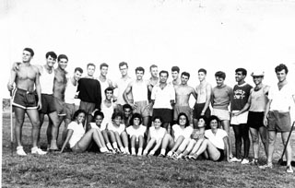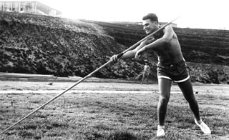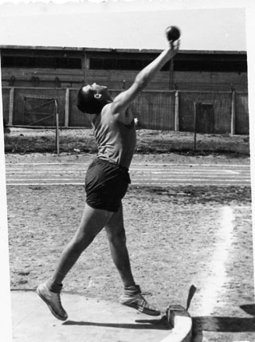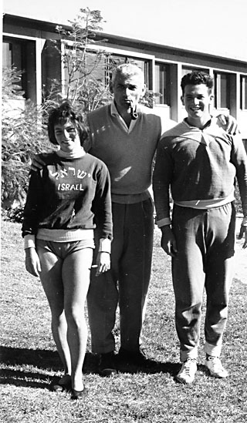
Training in Wingate College
The curriculum at Wingate primarily focused on studies of human anatomy especially those involving the biological aspects of training and the mechanics of movement. We studied English text books for most of the subjects. One book which had a powerful impact on me was “The Mechanics of Athletics” by Geoffrey Dyson.

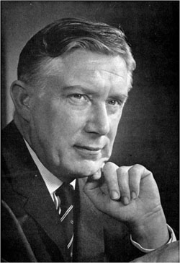
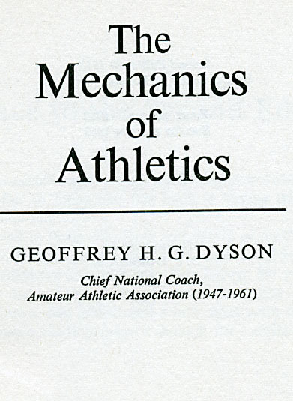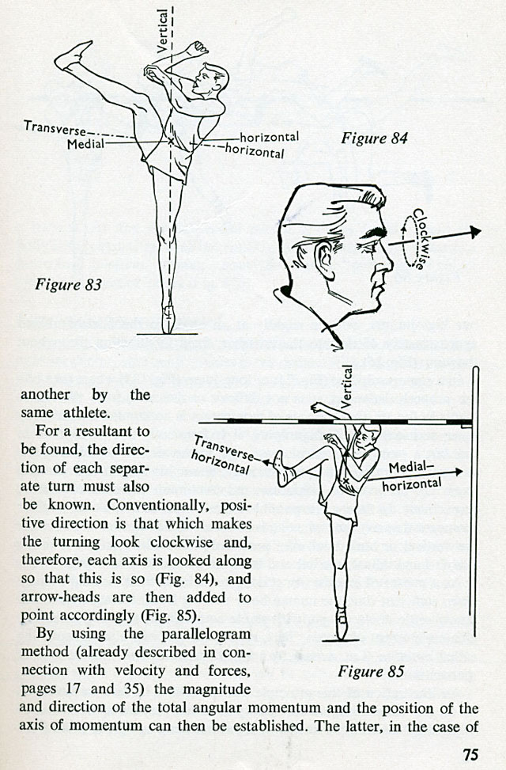

For the first time, I realized the connections between mechanics, physics, and the human body. Every athletic movement could be analyzed through its components to determine the physical parameters that control the movement. I realized that I could analyze my events by studying photos and trying to determine in what ways I could improve my technique. This book was my Bible for years to come. The biomechanical factors are the most essential aspect in every athletic movement. In other words, you could be sad and depressed with perfect mechanics and win. I realized that if your psychology is good and you have all the desire in the world to excel, but the physics of your movement is faulty, you will finish as a happy loser.
Fifty Four Years later I received the Geoffrey Dyson award in the ISBS (International Society of Biomechanics) conference in Melbourne 2012.
The recipient of the Geoffrey Dyson Award for the ISBS2012 conference will be Dr Gideon Ariel. Gideon is well known in the field of sports biomechanics due to his extensive knowledge of how physics applies to human motion, as well as his expertise in computer science. He is a former Olympic athlete, and completed his graduate and post-doctoral work at the University of Massachusetts, where he received a PhD in Exercise and Computer Science. He has published numerous scientific papers, founded an independent laboratory devoted to biomechanical research relating to human performance, and was chairman of the U.S. Olympic Biomechanical Committee.

My time at Wingate involved schooling, training with the Israeli Track and Field team, and competing. One of the first National competitions we had was held in Cyprus. I was not the leader in the shot. The best thrower in that event was Uri Zohar. He was three years older than I and was the Israeli national champion in Shot Put.
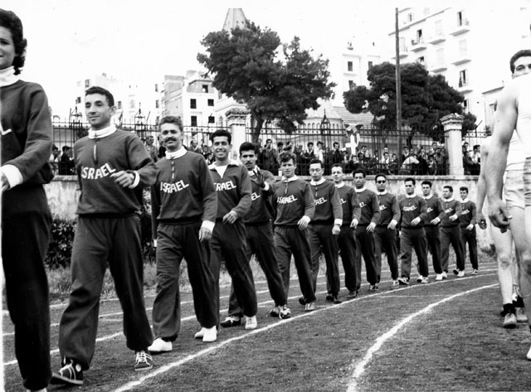
The Israeli Track and Field team in Cyprus

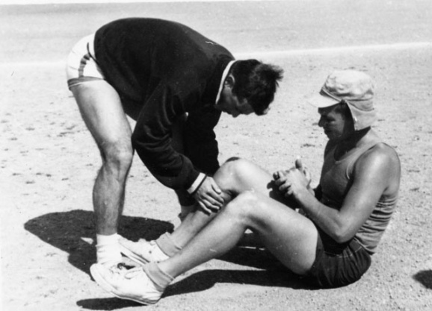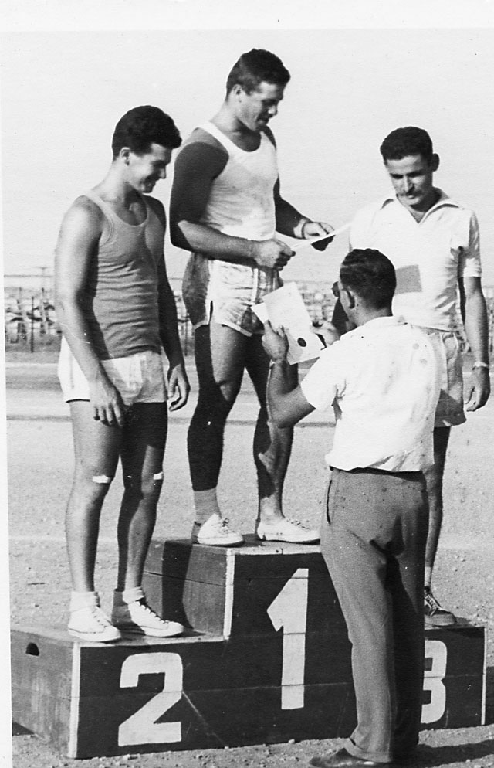
Uri taking care of a cramp in my leg. I am next to Uri receiving second place
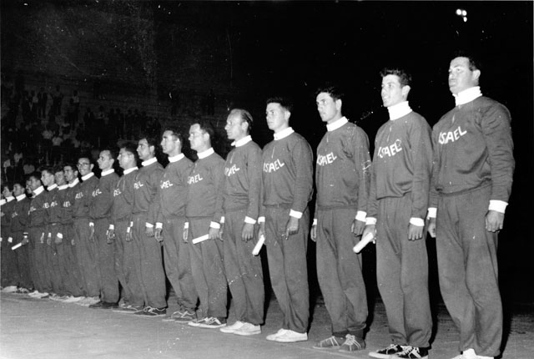
Israeli Track and Field team in Athens Greece
One of our competitions was in Greece and I was amazed since it was held in the Marble Stadium in Athens. The Greek Olympic games of 1896, which gave birth to the Modern Olympic Games, were held in this stadium. The historic significance of this locale was especially meaningful to me since I dreamed of competing in the Olympics representing Israel.
For all of the track and field events, there are minimum Olympic qualifying distances or times, as for the running events. During the discus competition in the Marble Stadium in Athens, I threw farther than this required minimum with an Israeli record of 51.51 meters. I made my own history in this historic venue. My discus result was the required distance needed to qualify for the next Olympiad to be held in Rome in 1960. As soon as my throw was declared an official result, Yariv and all of my Israeli teammates swarmed onto the field. They hugged me and cheered as a group for my marvelous success. As excited as we all were with this result, I actually finished third in the competition with Konadis from Greece in first place with a throw of 56 Meters. This was my best throw and, with it, I had achieved the opportunity to go to the Olympics. I felt my heart would burst with joy. Part of my name, “1650”, had come true and I was ecstatic after all those years of effort.
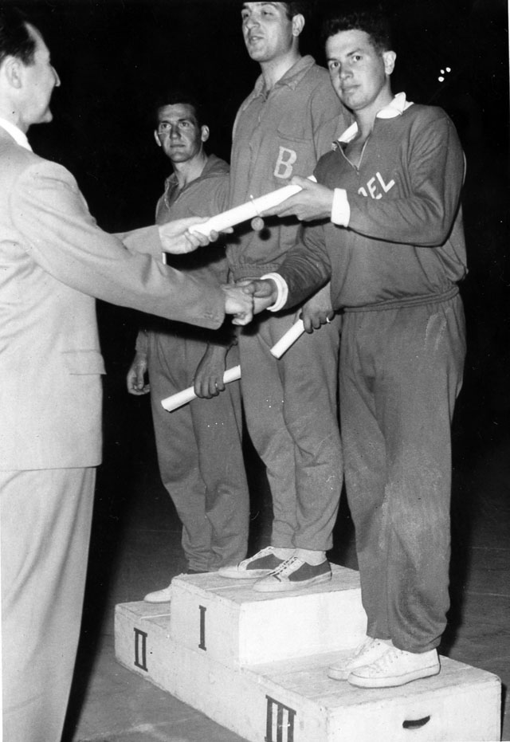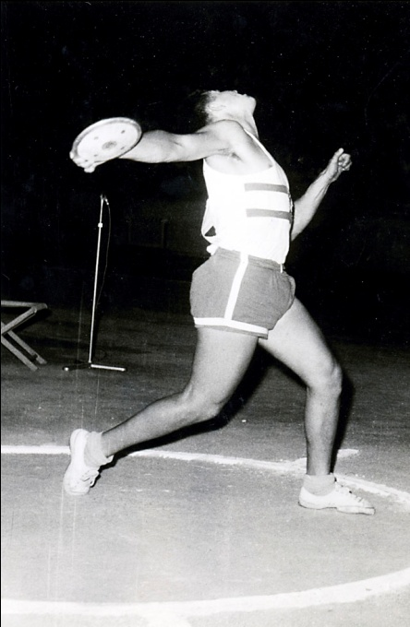
My record breaking throw at the Marble stadium in Athens
Competitions continued throughout the following year. Although I had held the Israeli Championship in the Discus since 1958, I was able to extend my distance results during the intervening years. However in the Shot competition, Uri Zohar still held the Israeli record with a distance of 15.98 Meters.
In 1960, prior to the Olympic Games in Rome, Israel conducted Olympic Trials. These Trials were held to determine which athletes would be sent to Rome to represent our country, Israel. Since I already had the Israeli Record in the discus, I hoped I would continue to perform well enough to be sent to participate in that event. However, now I was training to break the Israeli Record in the Shot Put. After all, I was still “Mr. 1650.”
In the shot put, Uri Zohar was the record holder and a serious contender. He was also a good friend since we had been team mates in the competitions against other countries. We had frequently discussed the merits and deficiencies of the various techniques available to us. Uri threw with the traditional technique, gliding from the side. I had adopted my hero, Perry O’Brien’s, technique which started the glide with the competitor’s at the rear of the circle facing away from the field. It may have seemed an awkward and unusual starting position, but it had worked for Perry O’Brien and I hoped it would do the same for me.
During this training time when all of us were focusing our efforts on the upcoming Olympic Trials, the United States Department of State sent an advisor, Leroy Walker, to help coach us. Later on Mr. Walker became the Olympic Coach for the United States. As soon as I realized how much knowledge Coach Walker had in my events, I attached myself to him like a shadow. Wherever he went, I followed, listening closely and asking questions. I think that he was impressed by my devotion because he spent extra time to help me understand the basics of throwing any implement. We did not have such a knowledgeable coach in Israel. Yariv Oren was a talented coach and motivator but, he lacked technical expertise in the events. Coach Walker was much more advanced than all of the Israeli coaches in techniques and in the required training routines. His suggestions and coaching hints helped me dramatically to improve all of my skills but especially in my shot put performance.
The time for the Olympic Trials finally arrived. The Shot Put trials were on Friday afternoon before the Sabbath and the Discus were on Saturday during the Sabbath. As usual, the media interviewed the participating athletes. I made a statement that I was going to break both the Israeli records in the Discus and in the Shot-put. The sports newspaper dubbed me: “Gideon the Arrogant!”
On Friday, the shot put competition consisted of each athlete having 6 throws. The trial recorded with the farthest distance, regardless of the sequence of the number of that particular throw, is declared the winning throw. Uri Zohar was leading after 4 rounds. But in the 5th throw, I broke his record by throwing 16.28 Meters. I was the first Israeli athlete to throw more than 16 Meters. This was the longest throw of the event, so I was declared as the Shot put winner. My name 1650 had finally achieved its first two digits.
My fellow teammate, Uri, could not believe that he had lost. He had been confident that he would win the event and go on to Rome. When I walked into the dressing room after the competition, I was told that Uri had been crying since he would be unable to compete in the Olympic Games. I felt very sorry that Uri would not be able to compete in Rome, but I was thrilled and proud of myself for reaching a goal set so many years ago in my childhood.
The next day, I broke my own record in the Discus with a throw of 52.78 Meters. Thus, in the Olympic trials of 1960, these two days in the discus and the shot put events had completed my high school name of “1650”.
After training so diligently and intensely since 1955, I could now reclaim my own name, Gideon Ariel. At that time I had no idea that my discus record would last for 30 years from 1960 to 1990. It was eventually broken by an athlete from another generation of throwers.
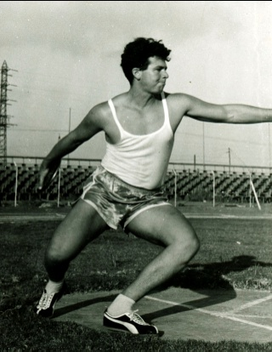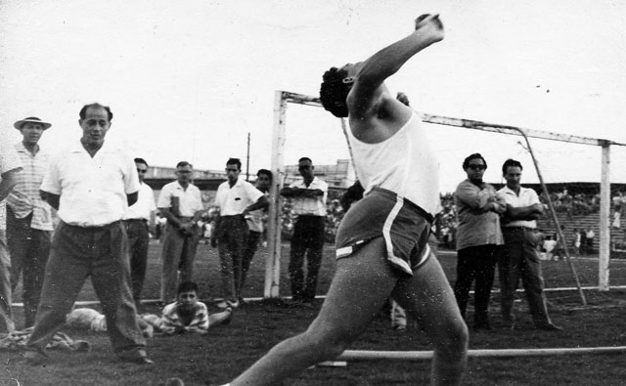
Olympic Trials Records Braking in the Discus and the Shot Put

